THE ENGLISH LANGUAGE UNIT  YANBU UNIVERSITY COLLEGE  YANBU INDUSTRIAL CITY  SAUDI ARABIA | 
Final Project
Academic Year 2019 – 20G (1440 – 41 H) Spring Semester 192

ENGL 211- Business Report Writing

Student's Name:
Student’s ID: |  |  |  |  |  |  |  |  | Section: | ________

General Instructions:
Follow the Instruction Given in Each Section of this Project + Class Instructions

FOR INSTRUCTOR'S USE ONLY
TOTAL MARK: 40 | MARK AWARDED: ______
MARKED BY: ______________________ | SIGNATURE: _______________

Some Economic Parameters in the Green Valley City

Name:
ID:
College:
Department:
Specialty:
Date:

Introduction

Economic parameters are the limiting factors that define the scope of economic activities that are carried out in Green valley city. This report provides insights into the economic parameters that inhibit economic activities in Green valley city. To achieve its goals the report used data and graphs to indicate some of the economic parameters and ways that Green valley city can solve some of these economic parameters.

Method
- Types of data used in this report (quantitative, qualitative, etc)
The report uses both quantitative and qualitative data. Quantitative data are data that can be measured, or counted. Quantitative data can be expressed using values and numbers, which makes it suitable for data analysis in graphs and tables used present data in these reports. On the other hand, Qualitative data is conceptual and descriptive and are normally categorized according to characteristics and traits. In the report, qualitative data is used to make a conclusion based on the data obtained in graphs and tables.
- Which graphics will be used to present data and why?
The report used bar graphs and pie charts to present the data. Bar graphs were used since it shows the relationship between two or more variables. For instance, in table 3.1, a comprehensive bar graph is used to show the relationship between years of production and the percentage of production within five years. Also, bar charts were preferred since they summarize large data sets, show proportions of multiple categories, and can be easily understood. Pia chart was used to present data in percentage or ratio. Similar to the bar chart, the pie chart presents a large data set into a visual form, allows a visual check of accuracy of the calculations, and is easier to read and understand as it requires minimal or no additional explanation.
(5 points)

Analysis and Discussion
(35 points)
In this section, you should convert the data given in the tables below into charts and graphs and to write a report of about 150 words to describe each of these charts and graphs. In case there is a diagram, you will directly write your report.
Table 3.1 Percentages of Production of Energy in the Green Valley City
 | 1990 | 1995 | 2000 | 2005 | 2010 | 2015
Oil | 48% | 45% | 46% | 35% | 23% | 16%
Natural gas | 24% | 25% | 20% | 12% | 19% | 14%
Coal | 16% | 17% | 17% | 15% | 15% | 12%
Wind | 2% | 3% | 3% | 4% | 5% | 7%
Solar | 2% | 2% | 2% | 5% | 5% | 9%
Hydropower | 6% | 6% | 6% | 21% | 22% | 24%
Biomass | 2% | 2% | 3% | 4% | 5% | 10%
Geothermal | 0% | 0% | 3% | 4% | 6% | 8%

The comprehensive bar charts compare two sets of series; the percentages of each energy production in Green Valley City to the year production. From the bar charts, one can have a clear vision of what percentage of energy production which was produced at a period of five years. The graphs show the percentage of each energy production within five years.
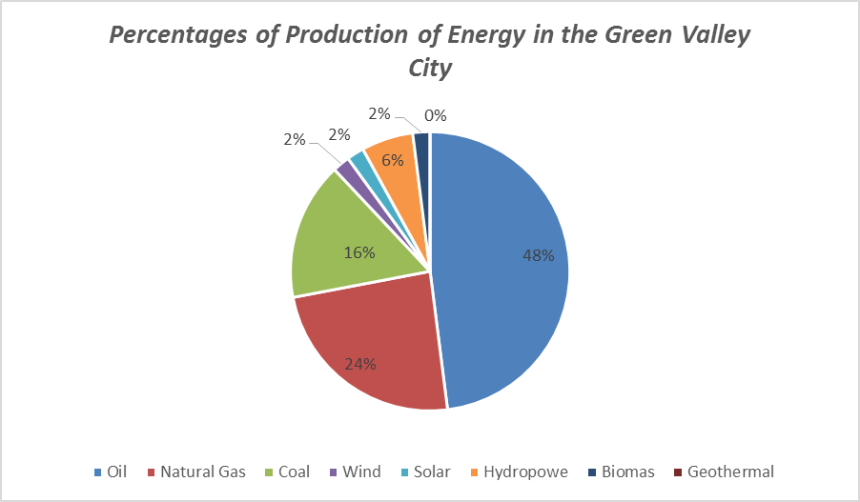
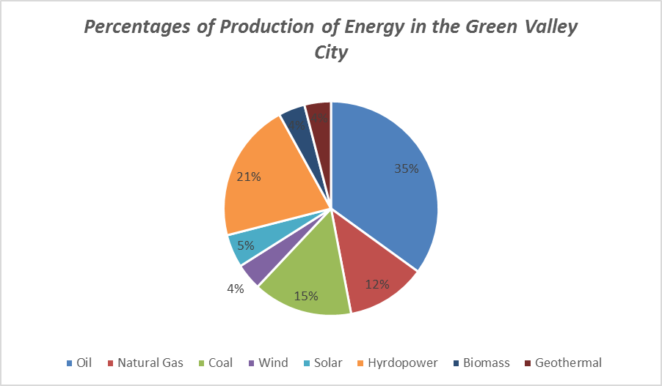

The pie chart present the total energy production in percentage within the five year period. The pie chart indicate that oil is the most produced energy with Geothermal the least produced energy. However, the other categories still were produced and consumed, therefore the pie chart show a clear difference in the production of each energy.

Process Diagram (3. 1): A Model of Hydroelectric Power Generation in the Green Valley

Table 3.2 Sales of in Oil and Natural Gas in Barrels in the Green Valley City
Month | Oil | Natural Gas
Jan | 208 | 265
Feb | 858 | 1630
March | 845 | 1276
April | 490 | 987
May | 955 | 889
June | 1217 | 1265
July | 2467 | 857
Aug | 3605 | 1228
Sept | 4876 | 1868
Oct | 2969 | 1290
Nov | 6876 | 1890
December | 2244 | 1236
(You need to change the table into a bar chart with a line graph on the same figure)
Example:
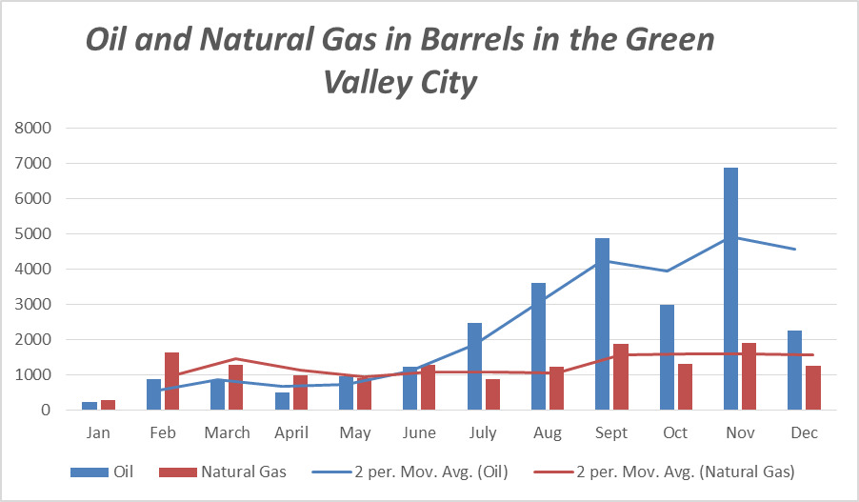
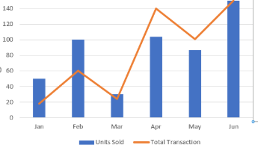

Table 3.3 Educational parameters in the Green Valley City in a decade
(Number of students in each level)
Month | 1995 | 2005 | 2015
Preschool | 423 | 657 | 814
Basic education | 567 | 886 | 1206
Secondary education | 456 | 678 | 1200
College | 678 | 987 | 2088
Graduate Schools | 12 | 68 | 208
(You need to change the table into a suitable graph/chart)

