Q1.
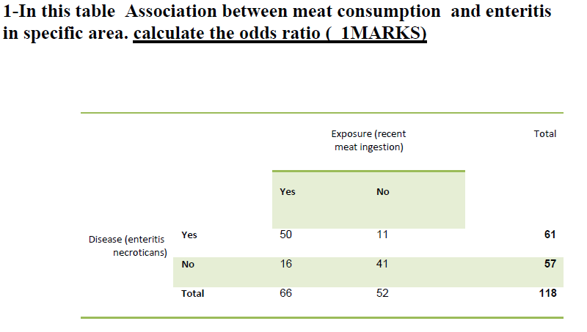
Ans1.
The odds ratio is calculated by dividing the odds of the first group by the odds in the second group
In our case $Odd ratio=\frac{50/16}{11/41}$
$Odd ratio=\frac{50*41}{11*16}=\frac{1025}{88}=11.64$

Q2.
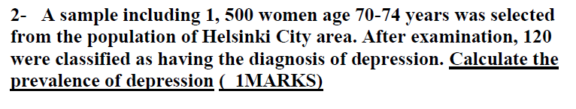
Ans2.
Prevalence of incidence = $\frac{no. of cases }{population} * 100$
Putting values, we get
$Prevalence of depression=\frac{120}{1500}*100=8\%$

Q3.
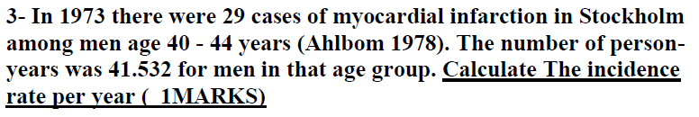
Ans.
Incidence rate per year is the number of new cases within a specified time period divided by the person time of the risk population
I.e. incidence rate = $\frac{no. of cases}{person years of population }*100$
Putting values, we get
$$Incidence rate=\frac{29}{41.532}*100=69.82\%$$

Q4.
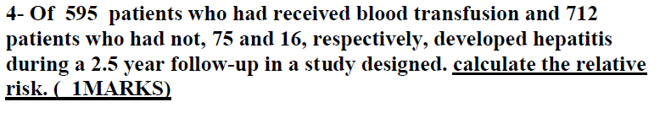
Ans.
First let us formulate data into contingency table.
 | Had blood transfusion | Didn’t had blood transfusion
Hepatitis positive | 75 | 16
No. of patients | 595 | 712

$$Relative risk =\frac{75/(75+16)}{595/(595+712)}=\frac{75/91}{595/712}= 1.81$$

Q5.
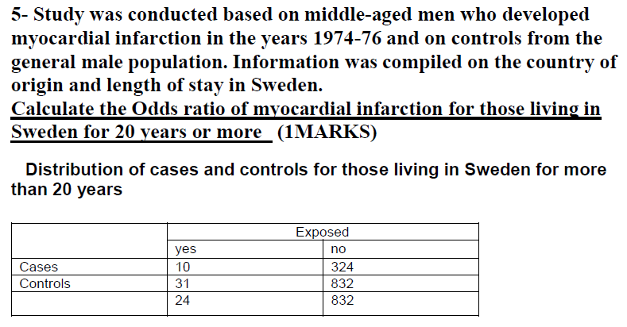

Ans.
The odds ratio is calculated by dividing the odds of the first group by the odds in the second group
In our case $Odd ratio=\frac{10/324}{31/832}$
$Odd ratio=\frac{10*832}{31*324}=\frac{8320}{10044}=0.828$

Q6.
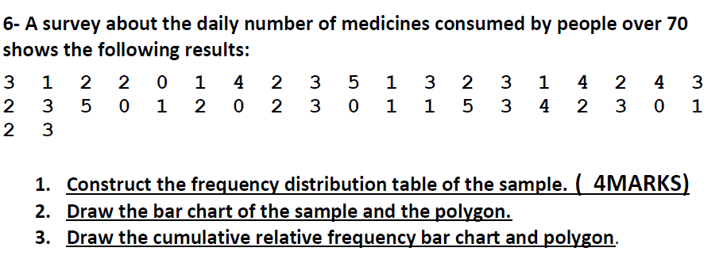
Ans.
We are given data about each people, no. of medicines they take.
To formulate everything in a table, we will count occurrence of same no. of medicines.
For e.g. 3 is occurred 10 times, 1 is occurred 8 times.
- So, frequency table is as follows.
Frequency Distribution Table
No. of medicines consumed | No. of patients
0 | 5
1 | 8
2 | 10
3 | 10
4 | 4
5 | 3

- Draw the bar chart of the sample and the polygon.
We, now plot the points on the bar chart, whose one axis will be “no. of medicines consumed” and on other axis “No. of patients”
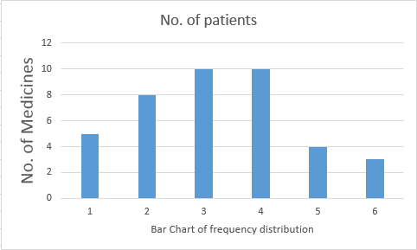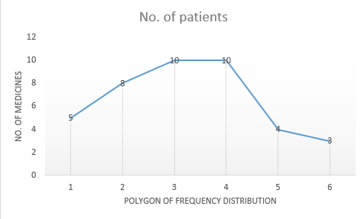

- Cumulative frequency bar chart and polygon.
To find Cumulative frequency we have add the values that come before it.
Frequency Distribution Table |  | Cumulative frequency
No. of medicines consumed | No. of patients | Cumulative frequency
0 | 5 | =5
1 | 8 | =5+8 = 13
2 | 10 | = 13+10 =23
3 | 10 | =23+10 = 33
4 | 4 | =33+4 = 37
5 | 3 | = 37+3 = 40

Bar chart and polygon of above cumulative distribution is as follows
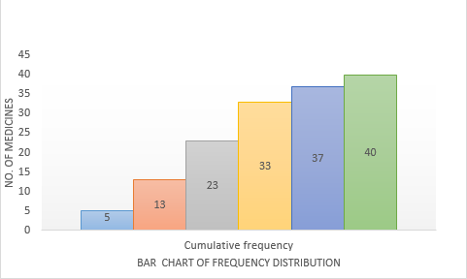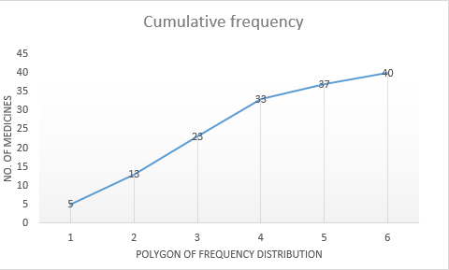

Q7.
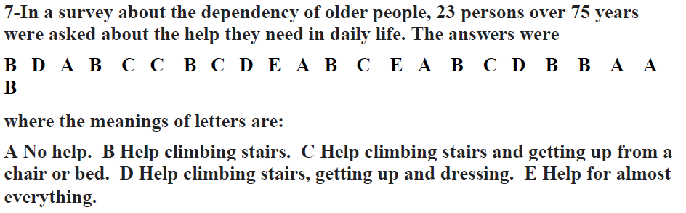
Ans.
We are given data about each people, type of help they need in daily life.
To formulate everything in a table, we will count occurrence of same type of help.
For e.g. B is occurred 8 times, D is occurred 3 times.
So, frequency table is as follows.
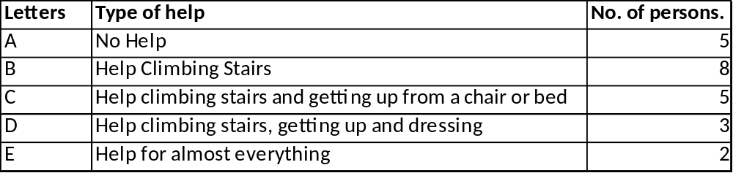
Bar chart and polygon of above cumulative distribution is as follows
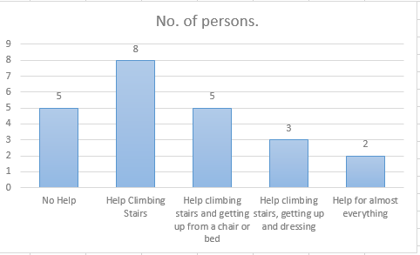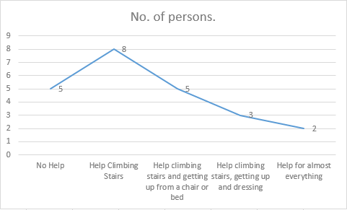

Q8.
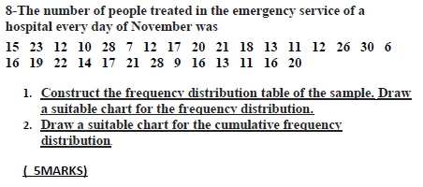
Ans.
- We are given data about no. of peopled treated in emergency service.
To formulate everything in a table, we will count occurrence in group
For e.g. Cases from 06 to 10 is occurred 32 times, 11 to 15 is occurred 113 times.
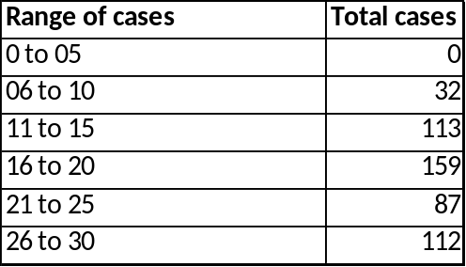
Bar chart and polygon of above cumulative distribution is as follows
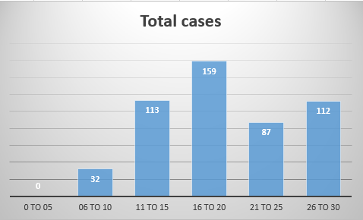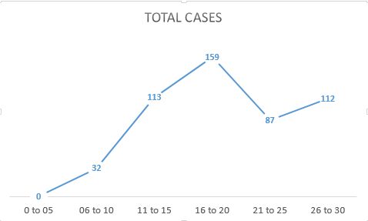

- Cumulative frequency bar chart and polygon.
To find Cumulative frequency we have add the values that come before it.
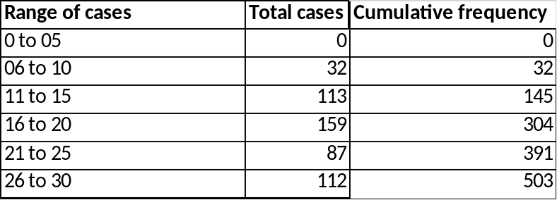
Bar chart and polygon of above cumulative distribution is as follows
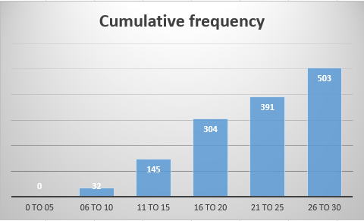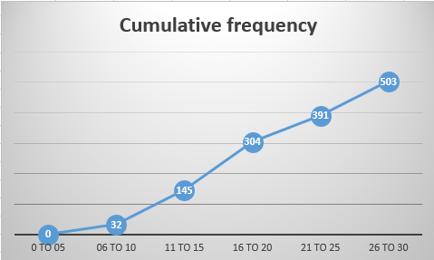

Q9.
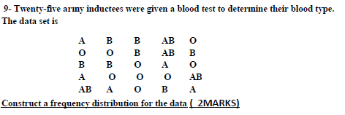
Ans.
We are given data about each blood test sample.
To formulate everything in a table, we will count occurrence of same type of help.
For e.g. A is occurred 5 times, O is occurred 9 times.
So, frequency table is as follows.
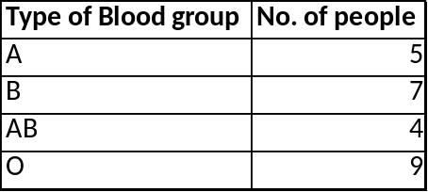
Bar chart and polygon of above cumulative distribution is as follows
