  - $C\left(x\right)=0.5x+120$
$$R\left(x\right)=2x$$

  - Break-even point occurs when $C\left(x\right)=R\left(x\right)$
$$Therefore →0.5x+120=2x →subtract both sides by 0.5x →$$
$$2x-0.5x=120 →1.5x=120 ⇒x=\frac{120}{1.5}=80$$
Break-even point = 80 cups

  - $Profit=P\left(x\right)=R\left(x\right)-C\left(x\right)=2x-0.05x-120=1.5x-120$
$$P\left(50\right)=1.5\left(50\right)-120=-\$45.00$$
Given break-even is at 80 cups, there is no profit at 50 cups, only loss of $45.00

  - $P\left(128\right)=1.5\left(128\right)-120=\$72.00$

  - 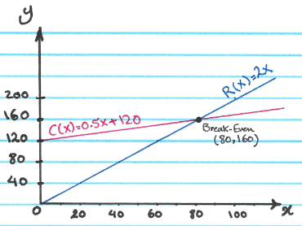

- Given:
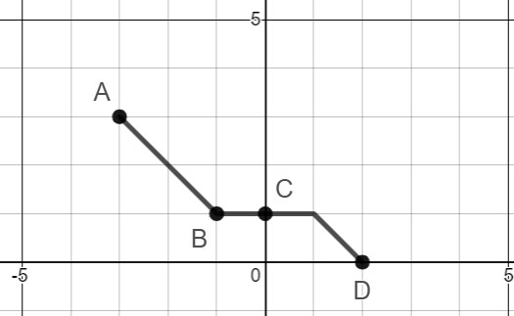

 | $$A(-3, 3)$$ | $$B(-1,1)$$ | $$C(0,1)$$ | $$D(2,0)$$
$$a. y=f(x+2)$$ | $$A(-5, 3)$$ | $$B(-3, 1)$$ | $$C(-2, 1)$$ | $$C(0, 0)$$
$$b. y=3f(x)$$ | $$A(-3, 9)$$ | $$B(-1,3)$$ | $$C(0,3)$$ | $$D(2,0)$$
$$c. y=-3f(x+2)$$ | $$A(-5, -9)$$ | $$B(-3, -3)$$ | $$C(-2,-3)$$ | $$C(0, 0)$$
$$d. y=-3f\left(x+2\right)-2$$ | $$A(-5, -11)$$ | $$B(-3, -5)$$ | $$C(-2,-5)$$ | $$C(0, -2)$$

- 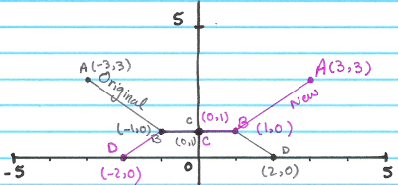

- $S\left(p\right)=50p-800∙D\left(p\right)=-10p+2950$
  - What is the equilibrium price per watch and what is the equilibrium quantity demanded? Show work.
$$To find D\left(p\right)→50p-800D\left(p\right)=-10p+2950 ⇒D\left(p\right)=\frac{60p-2950}{800}$$
$$D(p)=0.075p-3.6875$$
$$at Equilibirum, we have S\left(p\right)=D\left(p\right)$$
$$→ -10p+2950=\frac{60p-2950}{800} ⇒800\left(-10p+2950\right)=60p-2950$$
$$⟶ -8000p+2360000=60p-2950 ⇒8060p=2362950 ⇒$$
$$p=\frac{2362950}{8060}≅\$293.17$$

$$D\left(293.17\right)=\frac{60\left(293.17\right)-2950}{800}≅18.30≅18$$

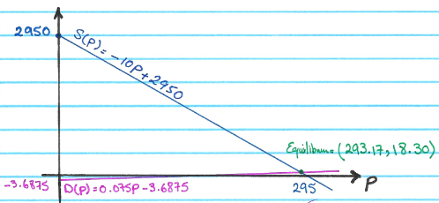

- $f\left(x\right)=\left\{\begin{aligned}x^{2}; -1≤x<0 \\ -2; 0≤x<2 \\ \sqrt{x-2}; x≥2 \end{aligned}\right.$

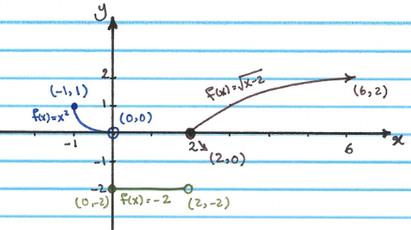
    - $D=\left[-1, ∞\right)$

    - $R=\left\{-2\right\} \bigcup{\left[0, ∞\right)}$

    - $\left\{\begin{aligned}local min: None \\ local max:(-1,1) \\ abs. min: None \\ abs. Max: None \end{aligned}\right.$

    - $\left\{\begin{aligned}Increasing:\left(2, ∞\right) \\ Decreasing:\left(-1,0\right) \\ Constant:\left(0,2\right) \end{aligned}\right.$

- Starting from the an original function $y=f(x)$ below, sketch the graph of
$f\left(x\right)=-2\sqrt{x+1}-3$.

      - $Graph of y=\sqrt{x}$$$Vertex=None \\ Point=\left(0,0\right), \left(4,2\right)$$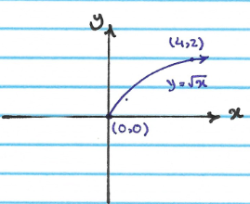

      - $Graph of y=\sqrt{x+1}$$$Transformation:shift one unit to left \\ Vertex=None \\ Point=\left(-1,0\right), \left(3,2\right)$$
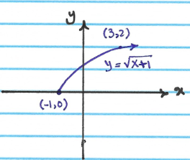

      - $Graph of y=2\sqrt{x+1}$$$Transformation:Vertical Stretch by a factor of 2 \\ Vertex=None \\ Point=\left(-1,0\right), \left(3,4\right)$$

      - $graph of y=-2\sqrt{x+1}$$$Transformation:Reflect againts the x-axis \\ Vertex=None \\ Point=\left(-1,0\right), \left(3,-4\right)$$
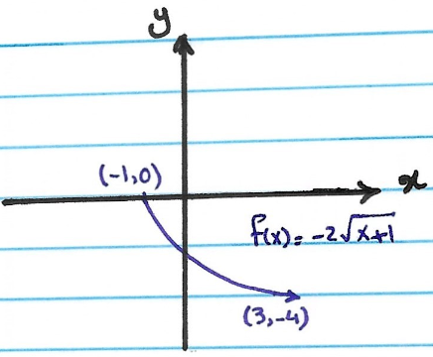

      - $graph of y=-2\sqrt{x+1}-3$$$Transformation: shift three units down \\ Vertex=None \\ Point=\left(-1,-3\right), \left(3,-7\right)$$
