Playtex Sipsters Spill-Proof Straw Training Cup Packaging Project
Contents
Instructions: 1
Problem and design: 1
Important considerations! 1
First design composite prism: 1
Package design 1
Measurements of the design 2
Rectangular prism 2
Half sphere 3
Surface area [Units in cm] 4
Rectangular prism (base) 4
Half sphere 5
Volume of package [Units in cm] 5
Rectangle (base) 5
Half circle 5
Cost 5
Second design cylinder design 5
Package design 6
Measurements of the design 6
Surface area [Units in cm] 7
Volume of package [Units in cm] 7
Cost 7
Third design: Rectangular prism 8
Package design 8
Measurements of the design 8
Surface area [Units in cm] 9
Volume of package [Units in cm] 9
Cost 9

Instructions:
You will design three differently shaped packages for this sippy cup.

Problem and design:
You must design 3 different packages for the following product:
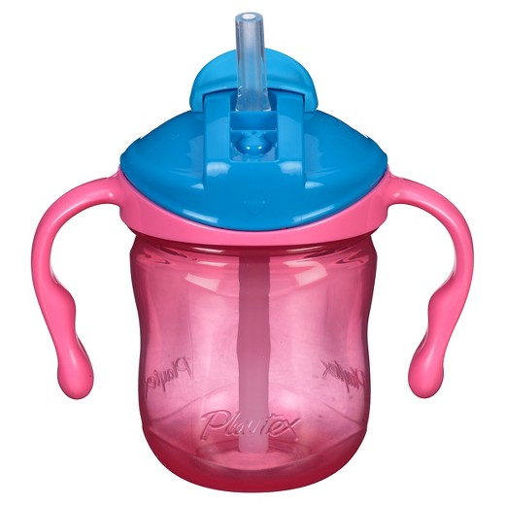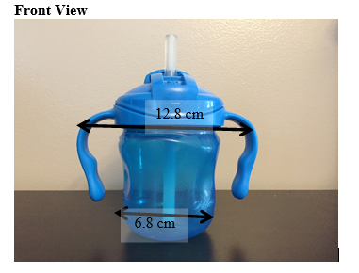

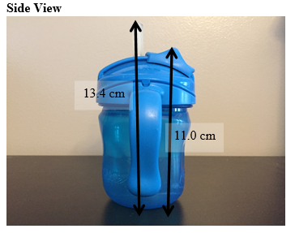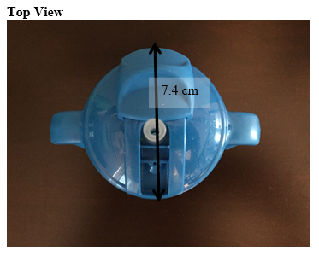

Important considerations!
All the units expressed in the document are cm.
A slack of 2 cm was left between each of the measurements of the bottle to easen the entry of the product.

First design composite prism:

Package design
The design of the first model is a composite prism of a cylinder with a rectangular prism and a half sphere, the product enters from the bottom part and fits smoothly with a little slack of +2 cm.
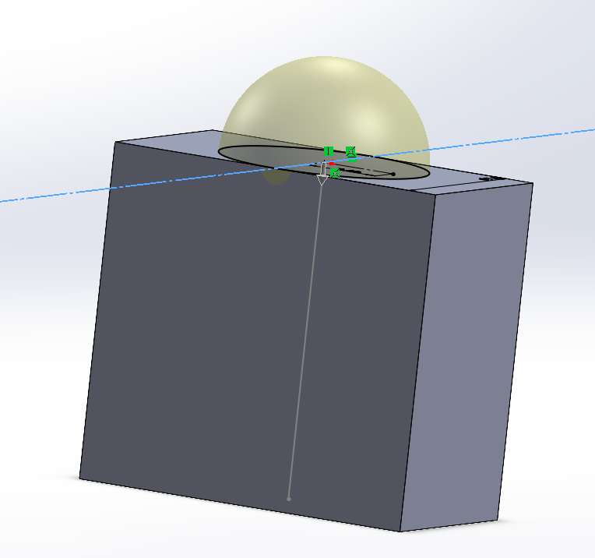

Measurements of the design

Rectangular prism
$$l=13 w=7.6 h=10.2$$
Image
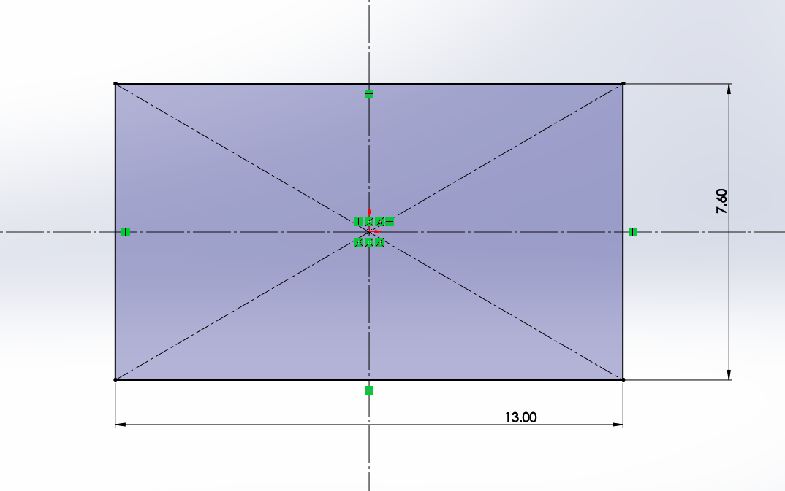
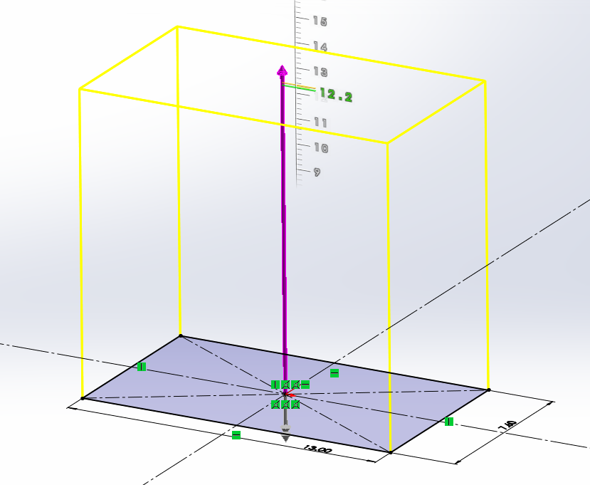

Half sphere
$$r=2.8$$
Image
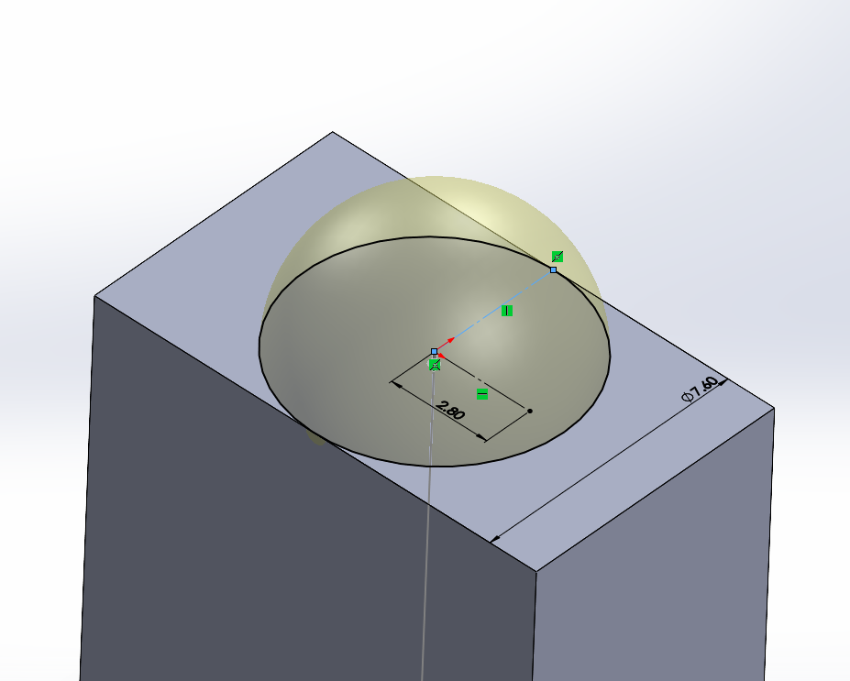

Surface area [Units in cm]

Rectangular prism (base)

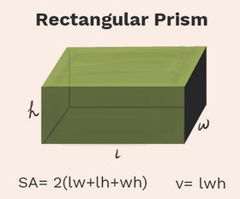$SA=2(\left(13\right)*\left(7.6\right)+\left(13\right)*\left(10.2\right)+\left(7.6\right)*(10.2)$
SA=617.84cm2

Half sphere
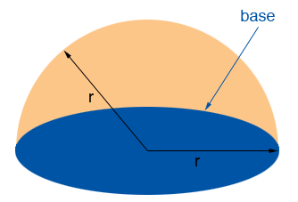Formula:

$$SA=2π*{\left(3.8\right)}^{2}$$
SA= 90.72cm2

Total surface area= 708.56

Volume of package [Units in cm]

Rectangle (base)
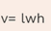 13*7.6* 10.2
V= 1007.76

Half circle
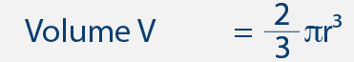
$$\frac{2}{3}π{3.8}^{2}$$

Cost
If the material cost is $0.10 for a 100 cm² of cardstock, calculate how much it will cost to create each of your designs.
The cost of this design would be
Total surface area= 708.56
Cost= $0.7085

Second design cylinder design

Package design
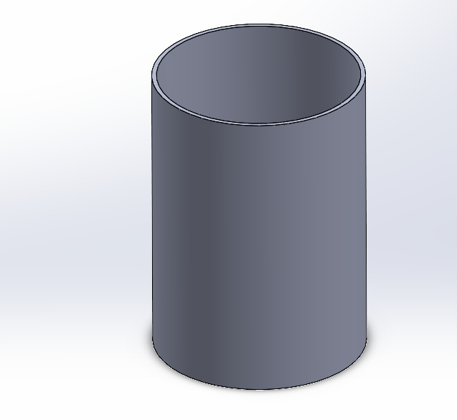

Measurements of the design
$$r=4cm h=11.2cm$$
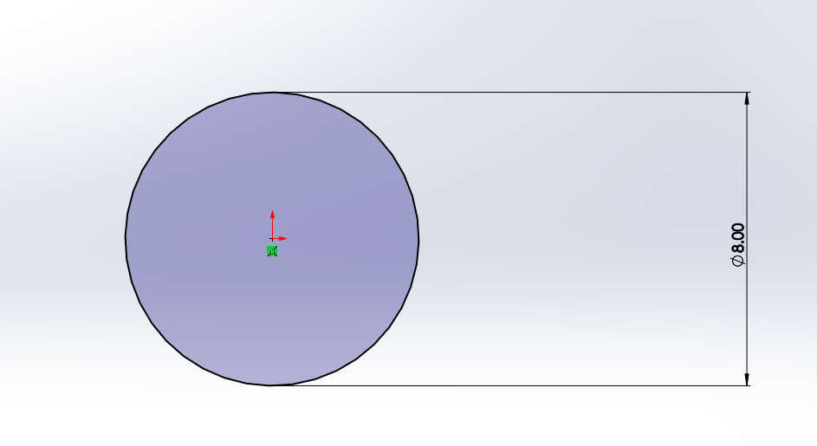
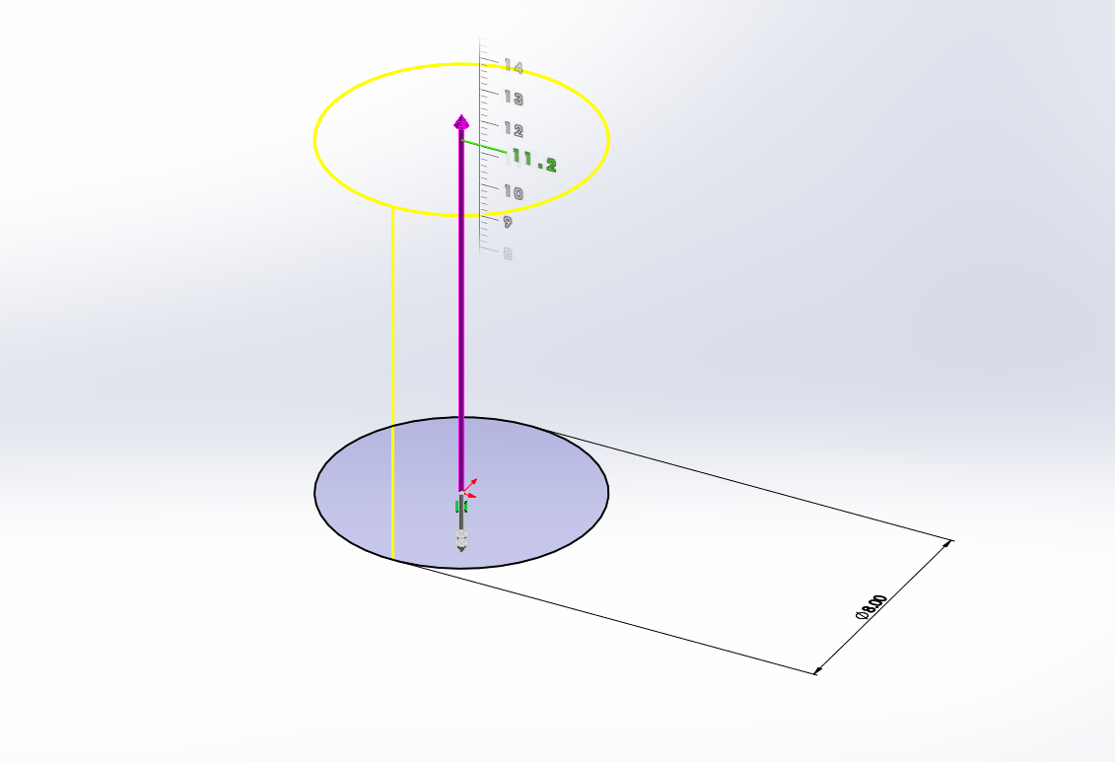

Surface area [Units in cm]
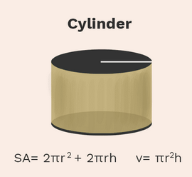$SA=2π{\left(4\right)}^{2}+2π\left(4\right)\left(11.2\right)$
SA= 382.01cm2

Volume of package [Units in cm]
$$π{\left(4\right)}^{2}*(11.2)$$
V= 562.97cm3

Cost
If the material cost is $0.10 for a 100 cm² of cardstock, calculate how much it will cost to create each of your designs.
Cost = $3.82

Third design: Rectangular prism

Package design
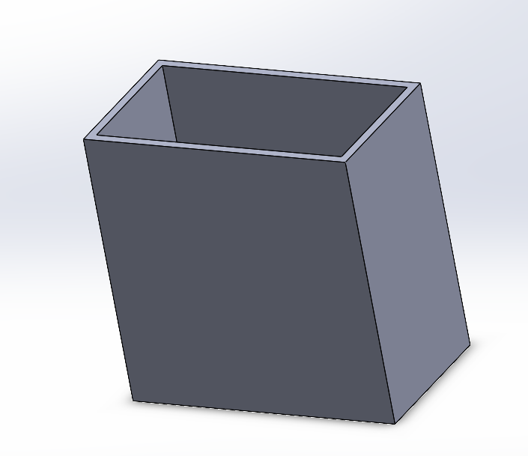

Measurements of the design
l=13
w=7.6
h=13.6
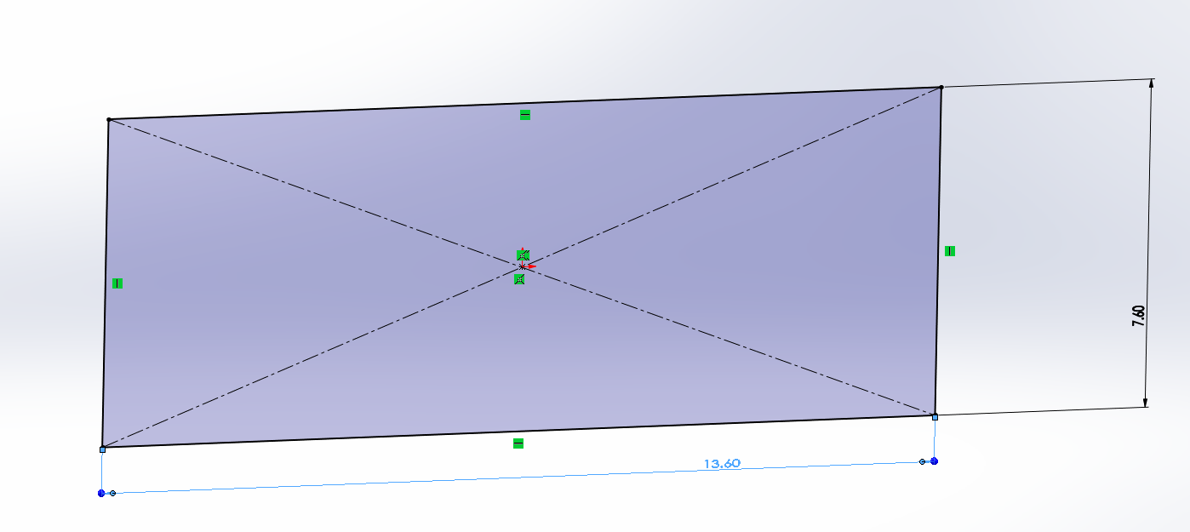
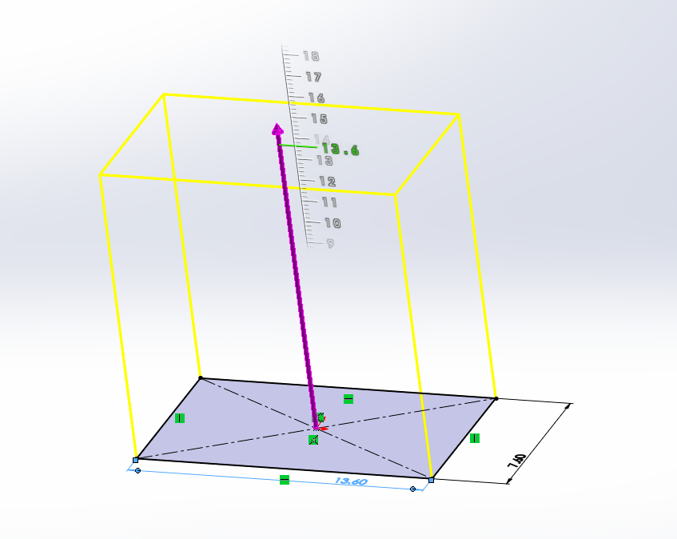

Surface area [Units in cm]
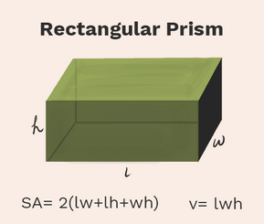$SA=2(\left(13\right)*\left(7.6\right)+\left(13\right)*\left(13.6\right)+\left(7.6\right)*(13.6)$
SA=757.92

Volume of package [Units in cm]
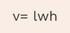 $v=13*7.6*13.6$
v=1343 cm3

Cost
If the material cost is $0.10 for a 100 cm² of cardstock, calculate how much it will cost to create each of your designs.

$0.10 per 100cm2
Cost= $0.757

