My Assignment 1 Title (.)
SS1234 (.)
September 26, 2020 (.)

Introduction
The aim of this assignment is to find out a regression equation that could calculate the hypothesis between the height of a person precisely and reproducibly from forearm length.

Data collection
Quantitative data collection method was applied where the sample “students” were randomly selected into group of ten students. The data collected was their height and forearm length.
Variables in this Assignment:
The dependent variable of this research was: Height (cm) and the independent variable was: Forearm Length (cm) of the students. The independent variable forearm length was selected because individual forearm does not depend on other sources to be measured an individual can measure his fore arm length but the for the height one have to depend on other people or other sources of measurement.

Exploratory Data Analysis
Group 2 Data
## 'data.frame': 10 obs. of 2 variables:
## $ height : num 173 171 182 158 165 ...
## $ forearm: num 24 28 26 22 25.4 23 22 22 23 23
Summary and Histograms
## height forearm
## Min. :157.5 Min. :22.00
## 1st Qu.:158.5 1st Qu.:22.25
## Median :163.5 Median :23.00
## Mean :166.3 Mean :23.84
## 3rd Qu.:172.4 3rd Qu.:25.05
## Max. :182.0 Max. :28.00

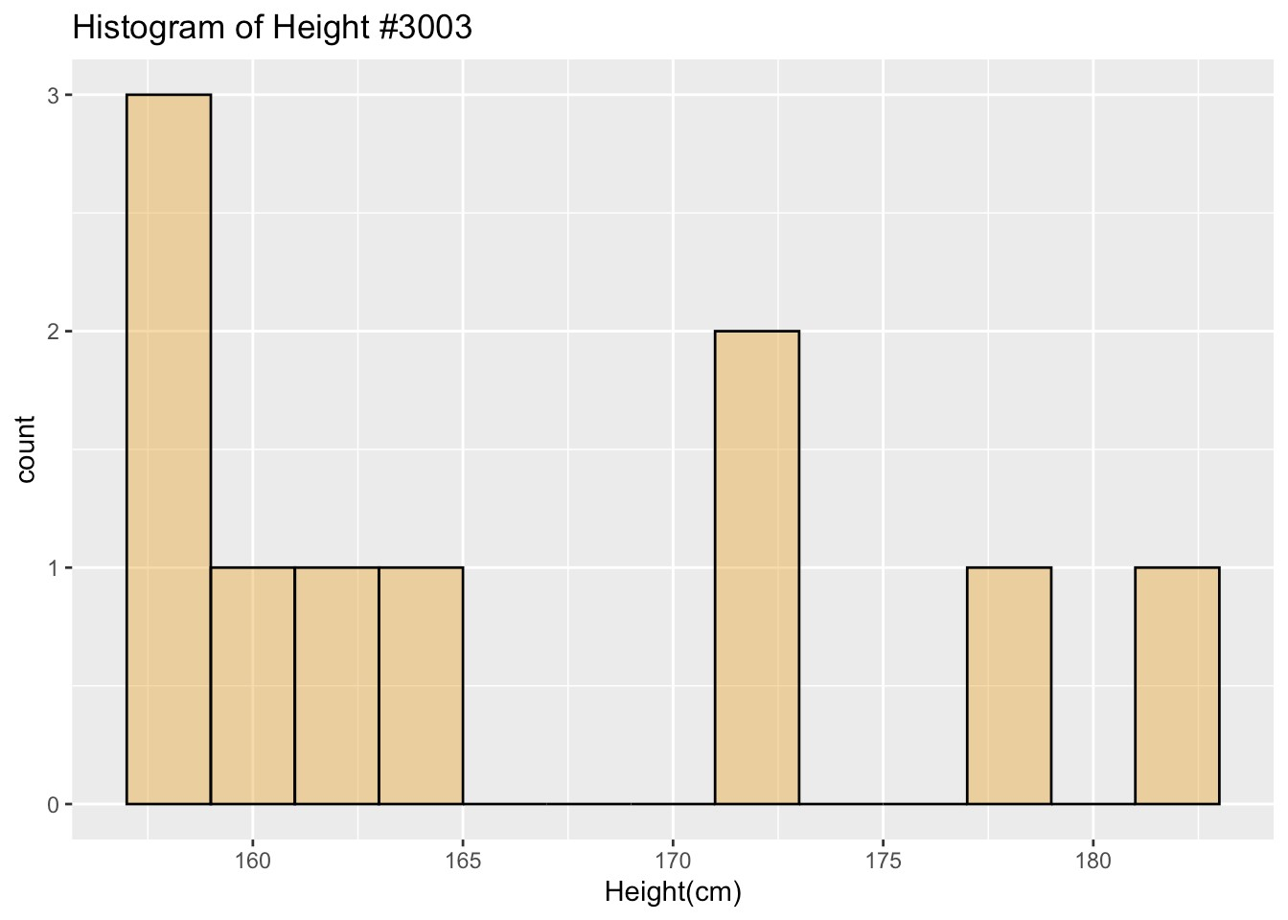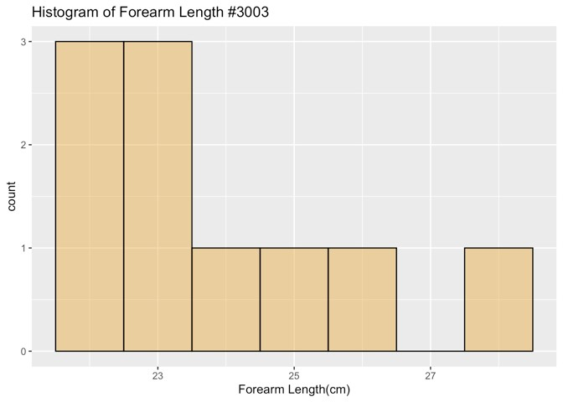

Height Distribution
This distribution seems to be bimodal with 2 clusters, they are both skewed right. The cluster in the right having a medium of about 161cm and the cluster in the right having a medium of about 177cm.The overall range is 24.5, the left cluster has a range of 7.5cm and right one has a range of 10.8cm. Obviously there has no outlier.

Forearm Length Distribution
This distribution is skewed right, with medium of 23cm and range 6cm.
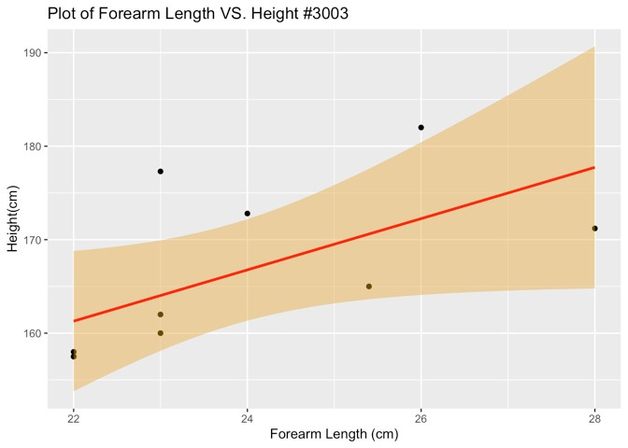
The relation between forearm length and height are weak, positive, linear relationship.
The point with forearm length 23cm and height 177.3cm falls far above the line, it could be a potential outlier, with forearm length 23cm we would expect a height of closer to 164cm.
##
## Call:
## lm(formula = height ~ forearm, data = group2data)
##
## Residuals:
## Min 1Q Median 3Q Max
## -6.535 -3.967 -3.535 4.017 13.273
##
## Coefficients:
## Estimate Std. Error t value Pr(>|t|)
## (Intercept) 100.970 29.327 3.443 0.00879 **
## forearm 2.742 1.226 2.236 0.05579 .
## ---
## Signif. codes: 0 '***' 0.001 '**' 0.01 '*' 0.05 '.' 0.1 ' ' 1
##
## Residual standard error: 7.429 on 8 degrees of freedom
## Multiple R-squared: 0.3846, Adjusted R-squared: 0.3076
## F-statistic: 4.999 on 1 and 8 DF, p-value: 0.05579

Methods and Model
Model: The Linear Regression (SLR)
The equation of the least squares line of best fit is y = 100.97 + 2.742x.
Y = Height of the individual
X = Arm length of the individual
The intercept in the scatterplot is 100.97, which is where the line of best fit crosses the height axis. The slope of the line in the scatterplot is 2.74. Thus, we say that each additional centimeter increase is predicted to add 2.742cm to the height. P-value is 0.05579 which means that we failed to reject the null hypothesis. R-squared = 0.3846, 38.46% of variability of height can be predict by the length of forearm. When X intercept is 0 the y intercept will cut the Y axis at the height of 100.97cm and when the Y intercept is equal to 0 the X intercept will cut the X axis at the Arm length of negative 36.45 so the arm length will be at 36.45cm.

Discussions and Limitations
Limitation
Some of the limitations that could have influenced the outcome of the results are Gender and Age. It is factual representation of the height data in the histogram that males tend to be taller than female. This could have limited to get the true representative of height. The study should also include the age group because as the bone growth of an adult stops after 21 year, implying that the ratio between the height and forearm length might remain constant after the age of 21 years
Lurking Variable
The lurking variable which could have the true relationship of the height and arm length variable is the size of the body of the sample taken. Some are slim and other have huge bodies.
Variables to explore a simple linear regression model.
Shoe size and Height could be variables to explore a simple linear regression model,

