The speed of sound in air Name: Kundt’s tube method
Include the same sections on your report that you always have. You will have to calculate a percent uncertainty this week. See below.
Theory: In a Kundt’s tube, a standing wave is formed and there is dust on the inside to help you see it. You will use the speaker at one end to generate different frequencies. The dust will hop upward at the antinodes! Since the distance between antinodes equals the distance between nodes, you’ll be able to calculate λ for each frequency.
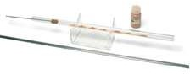
Here is a sample picture of a tube. Our version has the speaker built in at the end. Be sure to spread the dust around a little after each trial.
Data you’ll need:

Calculate what the speed of sound in air should be for the current room temperature. I’ll call this v below.

$v at room temp \left(20°C\right)=\sqrt{\frac{γRT}{M}}=\sqrt{\frac{1.4\left(8.314\frac{kg\frac{m^{2}}{s^{2}}}{mol K}\right)\left(293K\right)}{0.029\frac{kg}{mol}}}=342.93\frac{m}{s}$

For six different frequencies (choose between 1000 and 2000 Hz), complete the following table. For column two, measure the distance between the centers of two far-apart antinodes. We’re trying to find an average gap between antinodes. Note that if, for example, you see 6 antinodes in the dust, there are 5 gaps. You’ll see what the 1/f column is for later. Write out more than one sig fig for 1/f if possible.

Frequency (Hz) | Distance between two distant antinodes (m) | # of AA gaps | Average AA distance (m) | λ (m) | 1/f (s)
1100 | 1.800 | 3 | 0.600 | 0.300 | 9.091x10⁻⁴
1200 | 1.660 | 3 | 0.553 | 0.277 | 8.333x10⁻⁴
1400 | 1.920 | 4 | 0.480 | 0.240 | 7.143x10⁻⁴
1600 | 1.715 | 4 | 0.429 | 0.215 | 6.250x10⁻⁴
1800 | 1.860 | 5 | 0.372 | 0.186 | 5.556x10⁻⁴
1900 | 1.760 | 5 | 0.352 | 0.176 | 5.263x10⁻⁴

Now, we have f and λ. If you multiply these columns, you can get the speed of sound. Check this for one of your rows of data – make sure you get a result close to what you expect.

$v_{expt}=fλ=\left(\frac{1100}{s}\right)\left(0.300 m\right)=330.000 m/s$
For the other data:
Frequency (Hz) | λ (m) | Velocity=fλ, m/s
1100 | 0.300 | 330.0
1200 | 0.277 | 332.4
1400 | 0.240 | 336.0
1600 | 0.215 | 344.0
1800 | 0.186 | 334.8
1900 | 0.176 | 334.4
Average |  | 335.27

$$\%error=\frac{|v_{expt_ave}-v|}{v}x100\%=\frac{|335.27-342.92|}{342.92}x100\%=2.23\%$$

There’s a way to get the speed of sound using all your data graphically. The wave speed equation can look a bit weird to graph, since if we call “x” the frequency and “y” the wavelength you measure, the data will obey the equation xy = c, which is a hyperbola. It’s theoretically possible to deal with a hyperbola mathematically, but it would simplify matters if we can “linearize” the data.
Instead of saying: 𝑣 = 𝑓𝜆

let’s write the equation: 𝜆 = 𝑣 × 𝑓
1

Therefore, if you graph wavelength on the y-axis and 1/f on the x-axis, the graph will be linear with a slope equal to the speed of sound v. (Remember y = mx + b? It’s y = mx in cases where b = 0.)
Make this graph either by hand or on a computer, and find its slope. We’ll call this slope vexpt.

Using Excel the graph of 1/f vs. λ:
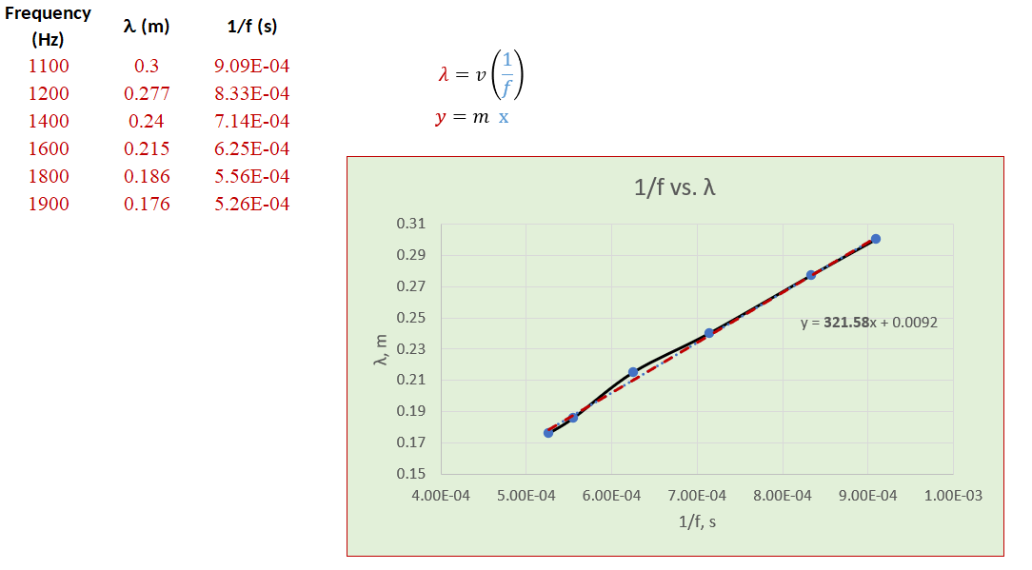
From this, the slope which is equal to the experimental speed of sound = 321.58 m/s.

For your report, you will need to calculate % error: % 𝑒𝑟𝑟𝑜𝑟 = |𝑣𝑒𝑥𝑝𝑡−𝑣| × 100%. v
is the speed of

𝑣 expt
sound you got in the experiment and v is the speed you expect for the current room temperature. Your conclusion should give values for both the speed of sound you expect from the room temperature as well as the speed you got from the slope of your graph. Also, include the percent error AND the biggest source of uncertainty in your group’s results.
$\%error=\frac{|v_{expt}-v|}{v}x100\%=\frac{|321.58-342.92|}{342.92}x100\%=6.22\%$

Title: The speed of sound in air: Kundt’s tube method

Purpose: The experiment aims to determine the speed of sound in air using the Kundt’s tube method and compare it to the theoretical value of the speed of air at room temperature.

Experimental Method: The experiment will determine the wavelength of the sound waves passing through the air by measuring the distance between nodes/antinodes in a Kundt’s tube at different frequencies. The wavelengths were calculated from averaged distances and was used to solve for the experimental speed of sound which is then compared to the theoretical value. The velocity equation was also linearized (transformed into the form y=mx+b) and to find the slope which is equivalent to the experimental value of the velocity of sound. The slope was found using the spreadsheet software excel which showed the equation of the linear trendline which represents the best fit estimate for the data of 1/f vs. λ.

Data: The data and calculations are attached above.

Conclusion: Therefore, from the data gathered in this experiment, the speed of sound in air can be calculated using the velocity formula v=fλ in which λ was found by averaging the distances between nodes in a Kundt’s tube at different values of f. The velocity of sound calculated by averaging the solved values for v using f and λ produced only 2.23% error from the calculated theoretical value based on the room temperature. The concept of linearization was also applied to determine the experimental velocity of sound in which the calculated percent error is 6.22%. Lastly, uncertainty in the experiment can be mainly attributed to the difficulty of accurately measuring the distances of the nodes in the Kundt’s tube which contributed greatly to the inaccuracy of the measurement and calculations.

