The Simple Pendulum (VIRTUAL) Name: _______________________

Written reports must have (a) a title, (b) the purpose (what is the experiment investigating?), (c) a description in words of the experimental method, (d) your data (clearly labeled), (e) a conclusion. This summarizes the experiment and lists some precise sources of uncertainty. The conclusion should respond to the purpose statement. Whatever you submit should be separate from this page.
BEFORE we start, let’s discuss the following things. These questions will help you write your report.
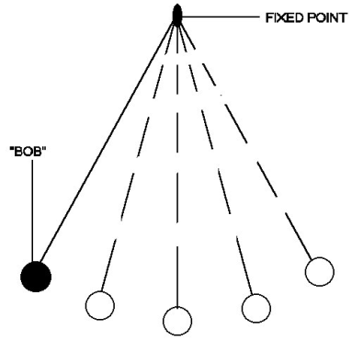
Please complete the quiz question online. In it, you’ll think about this: in a pendulum (shown at right), what things can you change with the setup that would affect the period?
The variables that can be changed that would affect the period are length of the string and the gravitational acceleration.
Also, answer the question about the trick you may have used in the mass-spring lab last time. Is there a way even in a simulation to more accurately measure the period?
To be able to accurately measure the period, one must have a very quick response in clicking the stopwatch to record the time when the pendulum is at a certain point. One possible way is to not start the stopwatch with the drop of the pendulum, rather, wait for the moment when it is about to reach the equilibrium position before starting the clock.
Which variable did the summary of the last lab indicate was best to test first (so you don’t have to worry about air resistance?
The best variable to test first is the friction, so you can adjust the calculations and account for losses such as in air resistance.
Visit this page (or search “phet pendulum”). Even the “intro” setup is enough. You can play around with the pendulum and stopwatch.

Q1: When you get a hang for this, test BOTH the amplitude and mass variables. Record on paper or document somehow the ways in which you changed those variables (keeping others constant). Did changing those affect the pendulum period at all?
Variable length. (Other variables constant: angle of release=45°, mass=1kg, gravity=earth, friction=none)
Length | Period
0.25 | 1.00
0.50 | 1.46
0.75 | 1.78
1.00 | 2.16

Variable mass. (Other variables constant: angle of release=45°, length=1m, gravity=earth, friction=none)
Mass | Period
0.25 | 1.97
0.50 | 2.05
0.75 | 2.13
1.00 | 1.99
1.25 | 2.03
1.50 | 2.15

Variable angle of release. (Other variables constant: length=1m, mass=1kg, gravity=earth, friction=none)
Angle of Release | Period
15° | 1.95
30° | 1.98
45° | 2.08
60° | 1.97
75° | 1.89
90° | 2.12

Variable gravity. (Other variables constant: angle of release=45°, mass=1kg, length=1m, friction=none)
Gravity | Period
Moon | 4.98
Earth | 1.97
Jupiter | 1.18
Planet X | 1.68

Q2: Did any other variables affect the period? How do you know?
All other variables did not change the period except for the length of the string and the acceleration due to gravity. As shown by the values recorded above, changing the mass and angle of release does not vary the period significantly since the values are very close to each other despite large intervals made on the changed variables.
Let’s do a more mathematically complicated variable now (length). We will measure the period of five different length pendulums (other classes will use 20, 40, 60, 80, 100 cm but you can make the range of your five bigger if you want). This data is part of your documentation. Report the string length as accurately as you can. Recall “t for all periods” is used if you’re timing multiple periods in a trial – that’s a raw stopwatch reading, then you divide by number of periods you counted to get T.
The last column looks weird, I know. Basically, to get it, take the T for a single period, and square it. The (s²) is simply the units of this column.
length (m) | t for all periods (s) | T – one period (s) | T² (s²)
0.20 | 1.84 | 0.92 | 0.8464
0.40 | 2.66 | 1.33 | 1.7689
0.60 | 3.22 | 1.61 | 2.5921
0.80 | 3.70 | 1.85 | 3.4225
1.00 | 4.16 | 2.08 | 4.3264

Now – this time, I won’t tell you in advance which relationship (T vs. length or T² vs. length) is more linear. You’ll have to graph both and make a judgment!
If you have something like Excel, you can use your computer to plot this data. Do that with two graphs. On one, put the lengths on the x-axis and period squared on the y-axis, and on the other put just the period on the y-axis. Use the guide given for the previous lab to help you.
This is the graph from Excel:
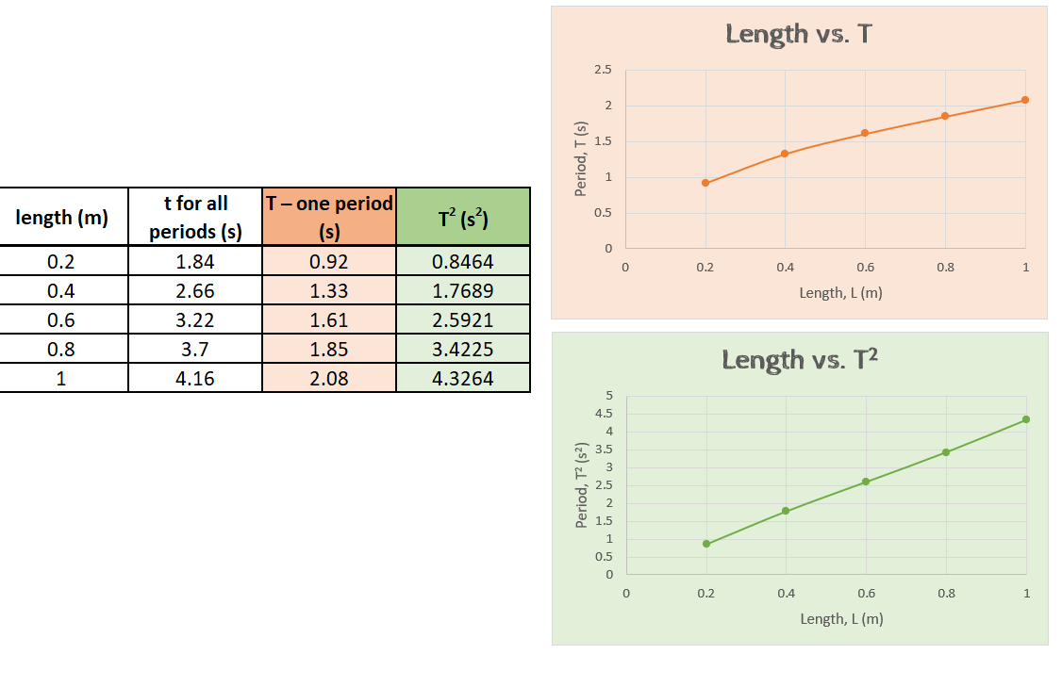
In your conclusion, indicate (based on your data) the variables we tested that did not affect period and the ones that did. For variables that do affect period, describe the relationship in your own words. Which graph is more linear? Be sure to discuss what sources of uncertainty you noticed in the lab.

Title: The Simple Pendulum
Purpose: The experiment aims to determine the variables (length of the string, mass of the bob, value of the gravitational acceleration, and angle for release) that affect the period of a simple pendulum.
Experimental Method: In the virtual experiment, different variables namely the length of the string, mass of the bob, value of the gravitational acceleration, and angle for release (for simplicity, friction is set to zero) can be adjusted in order to observe the motion of a simple pendulum. The observers (people doing the experiment) adjusted one variable into at least 4 different values while keeping the other variables constant and recorded using a stopwatch the time it takes for the pendulum to return to its original position (one period).
Data: The following data were collected.
Variable length. (Other variables constant: angle of release=45°, mass=1kg, gravity=earth, friction=none)
Length | Period
0.25 | 1.00
0.50 | 1.46
0.75 | 1.78
1.00 | 2.16

Variable mass. (Other variables constant: angle of release=45°, length=1m, gravity=earth, friction=none)
Mass | Period
0.25 | 1.97
0.50 | 2.05
0.75 | 2.13
1.00 | 1.99
1.25 | 2.03
1.50 | 2.15

Variable angle of release. (Other variables constant: length=1m, mass=1kg, gravity=earth, friction=none)
Angle of Release | Period
15° | 1.95
30° | 1.98
45° | 2.08
60° | 1.97
75° | 1.89
90° | 2.12

Variable gravity. (Other variables constant: angle of release=45°, mass=1kg, length=1m, friction=none)
Gravity | Period
Moon | 4.98
Earth | 1.97
Jupiter | 1.18
Planet X | 1.68

The following data is used to determine the relationship between length and T as well as length and T²
Conclusion: Therefore, from the data gathered in this experiment, the period of a simple pendulum depends only on the length of the string and the acceleration due to gravity and remains constant even when the angle of release and the mass of bob attached to the string is changed. Furthermore, it can be concluded that as the length of the string is increased, the period also increases while the inverse occurs when the gravitational acceleration increases. In addition, the graph of length vs T² is more linear than the plot obtained from the graph of length vs T. This indicates that the period is proportional to the square root of the length of the string. Lastly, uncertainty in the experiment can be mainly attributed to the response lag of the people operating the stopwatch thereby contributing greatly to the inaccuracy of the measurement

