The Vibrating Spring Name: _______________________

Written reports must have (a) a title, (b) the purpose (what is the experiment investigating?), (c) a description in words of the experimental method, (d) your data (clearly labeled), (e) a conclusion. This summarizes the experiment and lists some precise sources of uncertainty. This doesn’t necessarily mean mistakes – and “human error” is not specific. You want to think about what factors may have caused your measurements to deviate from the true numbers. The conclusion should respond to the purpose statement. Whatever you submit should be separate from this page.

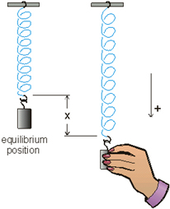
BEFORE we start, let’s discuss the following things. These questions will help you write your report.
Please complete the quiz question online. In it, you’ll think about this. In a mass/spring system (shown at right), what things can you change with this setup that would affect the period?
The variables that can be varied on a mass-spring system that would affect its period would be the mass of the load and the type of spring being used (meaning, the spring constant of the spring).
The online quiz contained a question about how to measure the thickness of a piece of paper. Given an idea one can think of there (I’ll clear it up if needed), can that help you think of a way to more accurately use a stopwatch to measure the period of a mass/spring system? Are there potential problems with this method?
To be able to accurately measure the period, one must have a very quick response in clicking the stopwatch to record the time where the mass is at a certain point. One possible way is to not start the stopwatch immediately, rather, wait for the moment when it is about to reach the equilibrium position before starting the clock. The potential problem of human error in manipulating the stopwatch still exists but with practice, this can help minimize error.
Given concerns about decay, which variable should we vary first, while controlling the others?
The decay is caused because of friction in the spring causing it to loss energy so the amplitude of the spring oscillation decreases and eventually stop. We can vary the mass of the load first while keeping all other variables constant.
Visit this page (or search “phet mass spring”). Even the “intro” setup is enough, but “lab” gives you more options for mass. You can play around with the experiment and timing devices.
Q1: When you get a hang for this, test BOTH the amplitude and mass variables. Record on paper or document somehow the ways in which you changed those variables (keeping others constant). Did changing those affect the pendulum period at all?
Variable load. (Other variables constant: spring constant=3 units, initial spring stretch = 0 (except for stretch caused by load), gravity=earth, friction=none, damping=0)
Mass, g | Period, s
50 | 0.60
100 | 0.78
250 | 1.63
Pink? | 0.74
Teal? | 0.98
Orange? | 1.13
Variable spring constant. (Other variables constant: load=100 g, initial spring stretch = 0 (except for stretch caused by load), gravity=earth, friction=none, damping=0)
Spring constant | Period, s
small | 1.14
1 unit | 0.99
2 units | 0.87
3 units | 0.82
4 units | 0.76
5 units | 0.71
6 units | 0.69
7 units | 0.67
8 units | 0.61
large | 0.60
Variable initial stretch. (Other variables constant: spring constant=3 units, mass=100 g, gravity=earth, friction=none, damping=0)
Initial Stretch, cm | Period, s
10 | 0.74
20 | 0.70
30 | 0.76
Variable gravity. (Other variables constant: spring constant=3 units, mass=100 g, initial spring stretch = 0 (except for stretch caused by load), friction=none, damping=0)
Gravity | Period, s
Moon | 0.78
Earth | 0.81
Jupiter | 0.80
Planet X | 0.82

Q2: Did any other variables affect the period? How do you know?
All other variables did not change the period except for the amount of load and the spring constant. As shown by the values recorded above, changing other variables such as the initial stretch and gravitational acceleration does not change the value of the period significantly since the values are very close to each other despite large intervals made on the changed variables.
Let’s do a more complicated variable now in detail (mass). We will measure the period of five different masses (record in kg!). You’ll type a table of this data in your report, but you can use this page to record. Make columns for mass, whatever times you measure/calculate. Recall “t for all periods” is used if you’re timing multiple periods in a trial – that’s a raw stopwatch reading, then you divide by number of periods you counted to get T.
The last column looks weird, I know. Basically, to get it, take the T for a single period, and square it. The (s²) is simply the units of this column.
mass (kg) | t for all periods (s) | T – one period (s) | T² (s²)
0.050 | 1.24 | 0.62 | 0.3844
0.100 | 1.52 | 0.76 | 0.5776
0.250 | 3.20 | 1.60 | 2.5600
Pink? | 1.40 | 0.70 | 0.4900
Teal? | 2.01 | 1.02 | 1.0404
Orange? | 2.32 | 1.16 | 1.3456

Notice that the T numbers do not go up very consistently, but the T² numbers do. That’s because m and T² have a linear relationship.
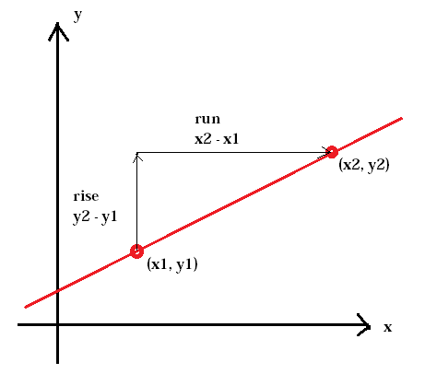
If you have spreadsheet access like Excel, you can use your computer to plot this data. Do that. Put the masses on the x-axis and time squared on the y-axis (Put the mass numbers in a column and the time squared numbers in the next column over. If you highlight all that data, your software chart options should be able to make a scatter plot for you.) If you can right (or command?) click on a data point, you should get the option to add a trendline and even find an equation! See my supplemental instructions on Canvas for help. If you don’t have a plotting program, you’ll have to graph the data by hand and sketch a best-fit line on your own, then find slope by calculating the rise over run. See the picture below.
Slope = (rise) / (run)
Remember in a linear equation of the form
$$y=mx+b$$
the number in place of “m” is the slope and “b” is the y-intercept.

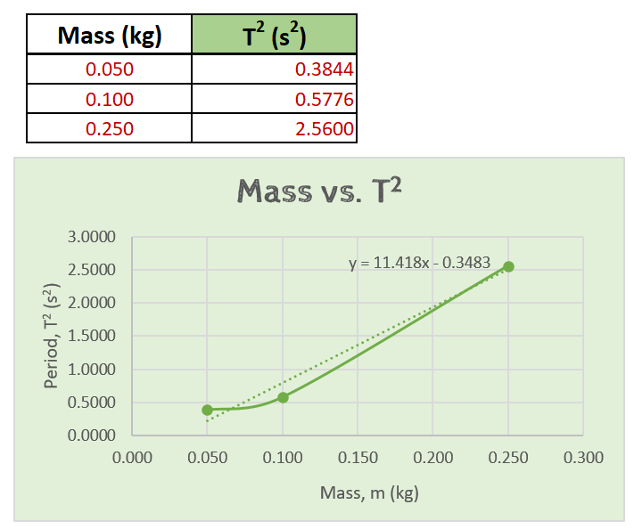
Title: The Vibrating Spring
Purpose: The experiment aims to determine the variables (mass, spring constant, initial spring stretch, and gravity) that affect the period of a vibrating spring.
Experimental Method: In the virtual experiment, different variables namely the mass of the load, spring constant, initial spring stretch, and gravity (for simplicity, friction is set to zero) can be adjusted in order to observe the motion and to record the period of a vibrating spring. The observers (people doing the experiment) adjusted one variable into at least 4 different values while keeping the other variables constant and recorded using a stopwatch the time it takes for the pendulum to return to its original position (one period).
Data: The following data were collected.
Variable load. (Other variables constant: spring constant=3 units, initial spring stretch = 0 (except for stretch caused by load), gravity=earth, friction=none, damping=0)
Mass, g | Period, s
50 | 0.60
100 | 0.78
250 | 1.63
Pink? | 0.74
Teal? | 0.98
Orange? | 1.13

Variable spring constant. (Other variables constant: load=100 g, initial spring stretch = 0 (except for stretch caused by load), gravity=earth, friction=none, damping=0)
Spring constant | Period, s
small | 1.14
1 unit | 0.99
2 units | 0.87
3 units | 0.82
4 units | 0.76
5 units | 0.71
6 units | 0.69
7 units | 0.67
8 units | 0.61
large | 0.60

Variable initial stretch. (Other variables constant: spring constant=3 units, mass=100 g, gravity=earth, friction=none, damping=0)
Initial Stretch, cm | Period, s
10 | 0.74
20 | 0.70
30 | 0.76

Variable gravity. (Other variables constant: spring constant=3 units, mass=100 g, initial spring stretch = 0 (except for stretch caused by load), friction=none, damping=0)
Gravity | Period, s
Moon | 0.78
Earth | 0.81
Jupiter | 0.80
Planet X | 0.82

The following data is used to determine the relationship between mass and T² which was plotted using Excel.
Conclusion: Therefore, from the data gathered in this experiment, the period of a vibrating spring depends only on the spring constant and the mass of the load attached to the spring and remains constant even when the initial stretched and gravity is changed. Furthermore, it can be concluded that as the mass of the load is increased, the period also increases while the inverse occurs when the spring constant increases. In addition, the graph of mass vs T² is more linear than the plot obtained from the graph of mass vs T. This indicates that the period is proportional to the square root of the mass of the load. Lastly, uncertainty in the experiment can be mainly attributed to the response lag of the people operating the stopwatch thereby contributing greatly to the inaccuracy of the measurement.

