The Science of Acoustics – McCaskey Assignment #9
Due next week at the beginning of class. Please write out or type your answers, and hand them in then. No homework will be accepted after solutions are posted. Show your work!
Go to the Chapter 9 notes and do problems #1-7 and 9.

Chapter 9

1. Go to either the PhET website or Falstad applet listed in the Powerpoint slides online.
Make a complex wave where all harmonics have the same amplitude. Don’t make the
harmonic amplitudes too big, or the whole shape won’t fit on screen. Sketch and
describe the shape you get. Or remember what you saw when I did it (if I did).
Solution:
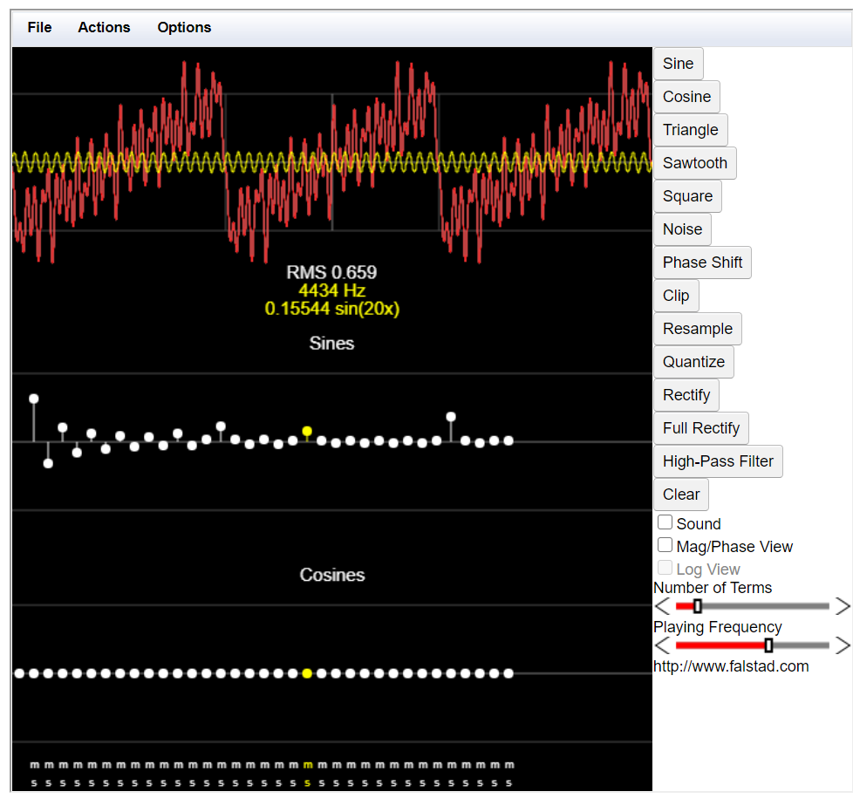
I used a sawtooth graph the shape of the graph looked like a saw with ragged teeth that was formed when I varied the harmonics of the sine. Just for additional notes, the sound produced by this graph is like a buzzing chain saw.

For 2-4, give the amplitude you would use (amplitudes are always positive!) for the first
seven harmonics of these waves. If a certain harmonic is not used, mark the amplitude as
zero. You shouldn’t need the applets for these – just indicate what amplitudes you would
use for such a program.
2. A sawtooth wave where the fundamental frequency has amplitude 4.
Solution:
4, 2, 4/3, 1, 4/5, 2/3, 4/7

3. A triangle wave where the fundamental frequency has amplitude 1.
Solution:
1, 0, 1/3², 0, 1/5², 0, 1/7²

4. A square wave where the fundamental frequency has amplitude 6.
Solution:
1, 0, 1/3, 0, 1/5, 0, 1/7

5. (a) A tone has a harmonic sounding at 39000 Hz. If the sampling rate is 42000 Hz, where
would there be an alias frequency? (b) What is the frequency (called the Nyquist frequency)
we should use as a filter cutoff to prevent lower frequency aliases?
Solution:
- $f_{alias}=|f_{original}-Nxf_{sampling rate}|$
$$f_{alias}=\left|39000-1x42000\right|=3000 Hz$$
- At 42 kHz of sampling rate, the cut-off frequency must be half so 21000Hz

6. Here’s a decibel question for quiz review. If one clarinet playing quietly has intensity of
61 dB, how many dB would a group of 11 of them playing at that intensity produce?
Solution:
$β=10\log\left(\frac{I}{{10}^{-12}}\right)$
$61=10\log\left(\frac{I}{{10}^{-12}}\right)$ $I=1.2589x{10}^{-6}\frac{W}{m^{2}}$
$β=10\log\left(\frac{11I}{{10}^{-12}}\right)=10\log\left(\frac{11\left(1.2589x{10}^{-6}\right)}{{10}^{-12}}\right)=71.41 dB$

7. Consider the function f(x) shown here:
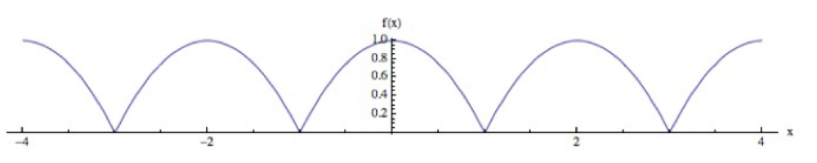

- What is the period of this function?
Solution:
The period of the function is T=2.0.
(b) One way to write the Fourier series for a function f(x) and period L is:
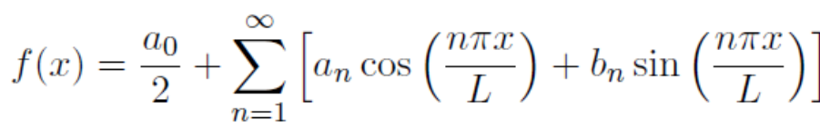
Which of these coefficients (a0, or the an cosine coefficients or bn sine coefficients) can
we say for sure will be zero or non-zero? Why?
Solution:
We are sure that a_{n} cosine coefficient is not zero because the graph is only composed of the cosine functions while the b_{n} sine coefficient is certainly zero.
9. Consider the function f(x) = 5. Is this function even or odd? Can we write this as a Fourier
series at all?
Solution:
f(x)=5 is an even function. No, it cannot be written as a Fourier Series because the value of the function is constant all throughout.

