Problem No. 1 - Beer Analysis
1. To setup pivot table, we first highlight our source data (all the way up to worker number 400):
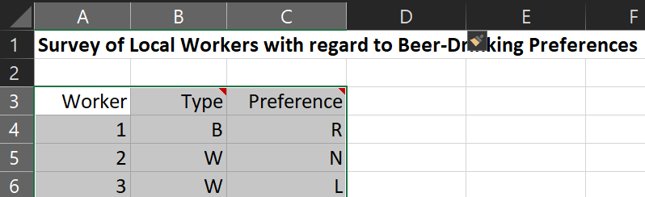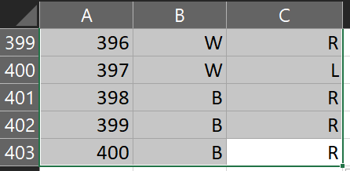

2. Now, hit ALT + N + V on your keyboard. This is the shortcut for Pivot Table. I placed the pivot table in the same worksheet and selected a cell just near the source data as shown below. Hit OK:
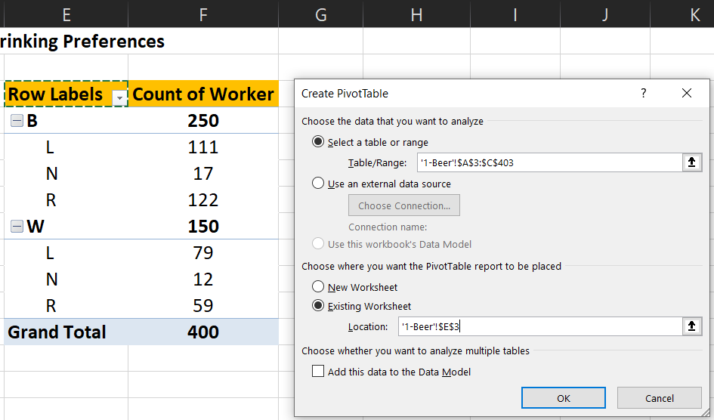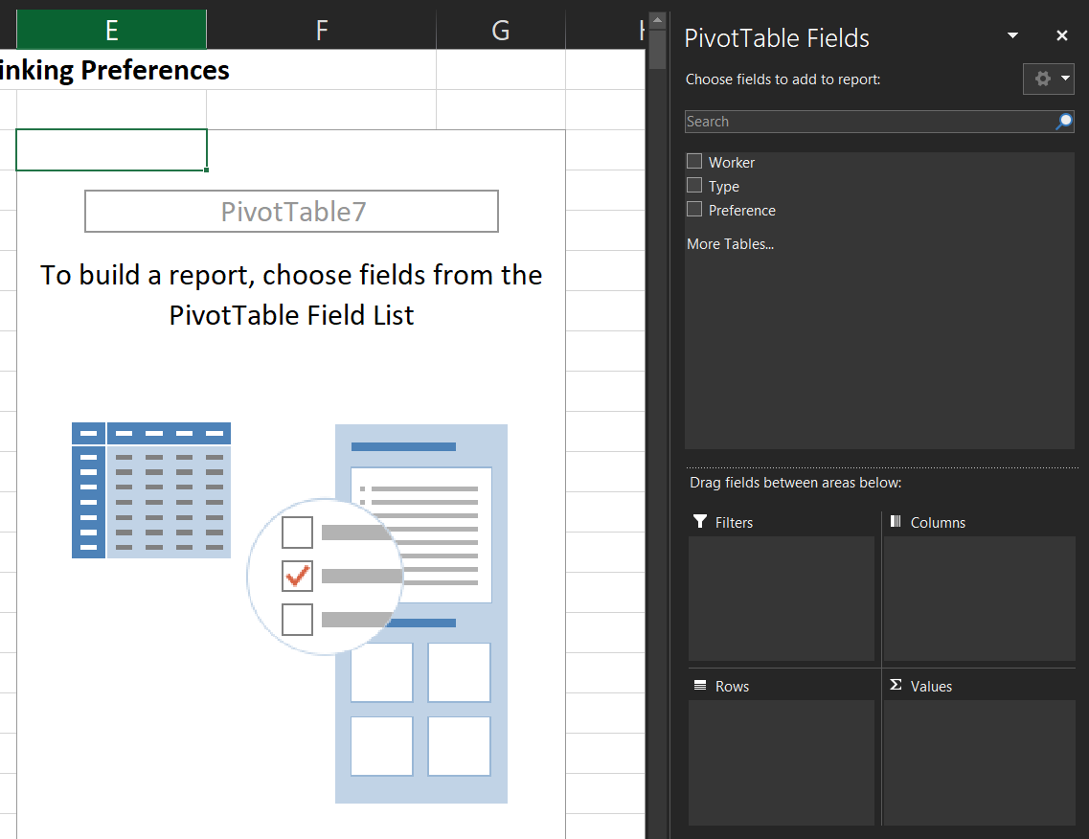

3. In the pivot table panel, check all fields. More importantly, in the Values section (lower right) change the “sum of worker” into “count of worker”. Hit OK.
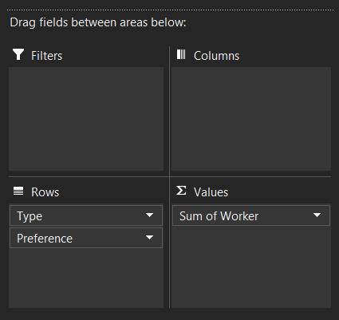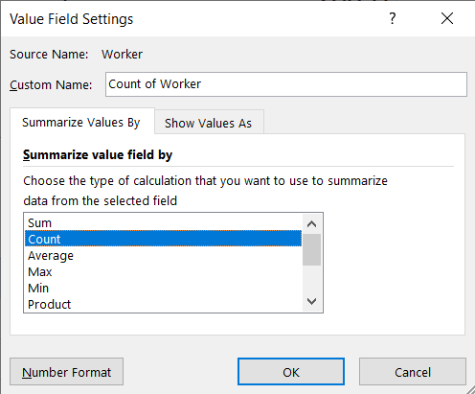

4. Now, we have the following table. We can now answer the questions.
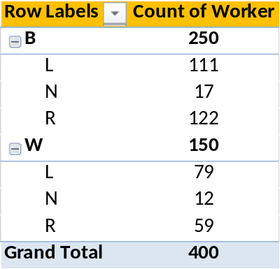

Answers to Problem 1 (please refer to the Pivot Table):

a. 122 BCW want regular beer.
b. 79 WCW want light beer.
c. 12 WCW does not want to drink beer.
d. Since 111 BCW out of 400 total workers favor light beer, they represent 27.75% of the total workers.
e. Moreover, 12 WCW chose not to drink. This is 3% of the survey sample (i.e., 12 / 400)
f. Lastly, 79 WCW want light beer, and this represents 19.75 percent (i.e., 79/400).

Legend: BCW = blue collar workers; WCW = white collar workers.

Problem No. 2 - Internet Users
1. For this question, we will follow the similar steps above. Select entire data source, press ALT + N + V on your keyboard and select a cell near the data source to place the pivot table in the existing sheet:
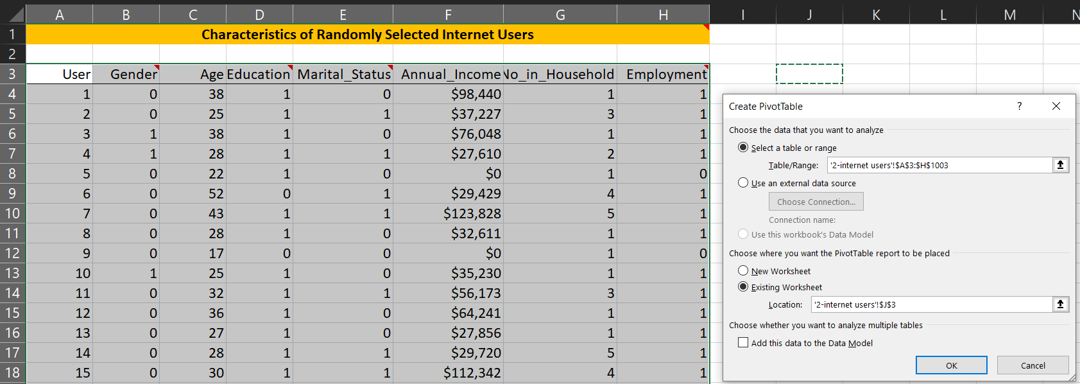

2. Now in the Pivot Table Pane, check all field except “No_in_Household” (this is not important in our case):
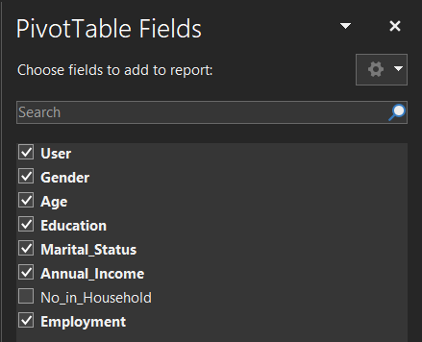

3. This section is important! In the Pivot Table Pane, we must make sure that we have this order under the “Rows” section. This is important to answer the questions efficiently later on.
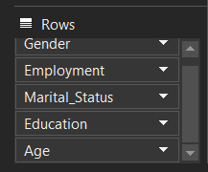

4. Moreover, we have to make several adjustments for our table. First, go to the Values section and change the “Sum of Annual Income” into Average as shown below:
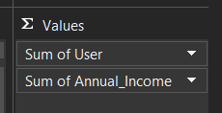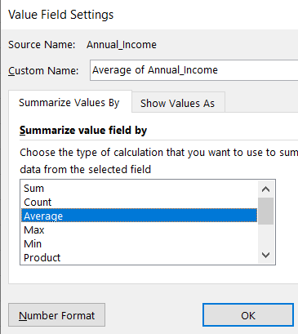

5. Also, change “sum of user” into count as shown below:

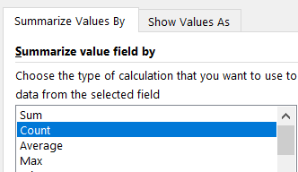

6. Finally, we have our Pivot Table:
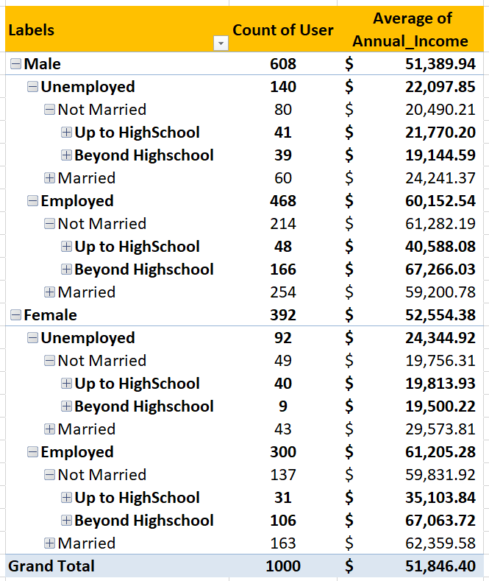

Now we can start answering the questions.

Answers to Problem 2 (please refer to the Pivot Table):
a. To determine the percentage of women over 30 years old out of the total 1000 internet users, I propose an alternative easier way to find this (instead of expanding all the Pivot Table sections for “female” and counting all above 30). We will use COUNTIF function (I included this in our solution):

- LONG WAY (thru Pivot Tables, obtain sum of all above 30 years; like highlighted in red below)
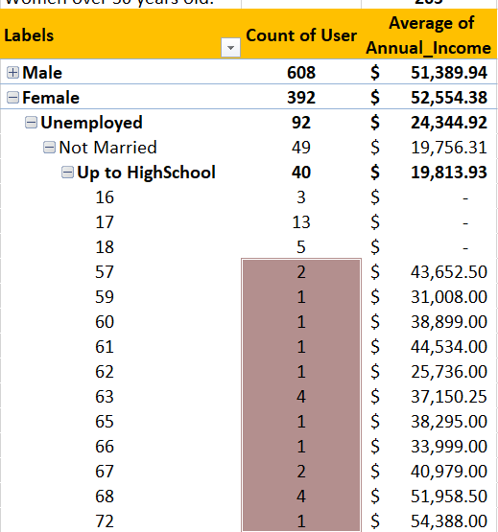

- Shortcut (or checking mechanism):

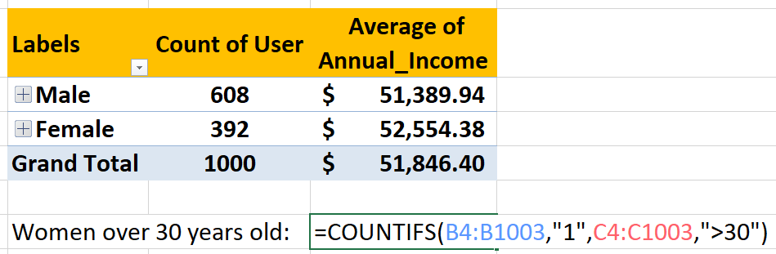

b. To obtain the percentage of married Internet users with no formal education beyond high school, expand the Table like this (Excel will do the same for the following fields, just do one):
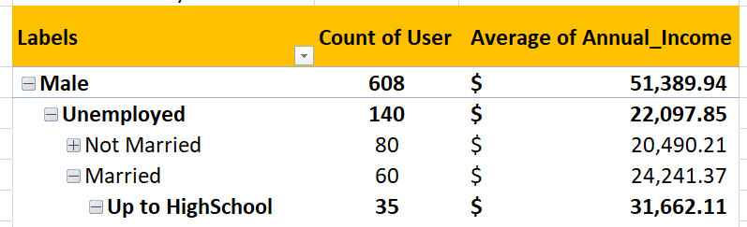

- Note: Excel will do the similar ‘expansions’ for you:
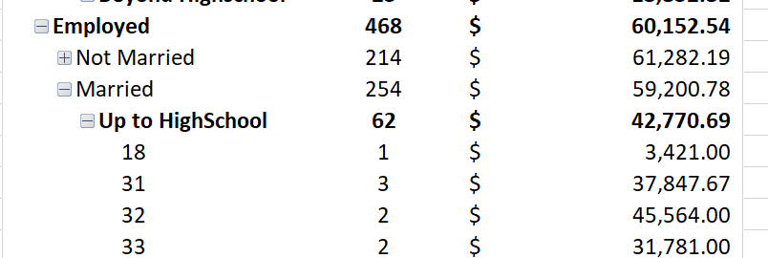
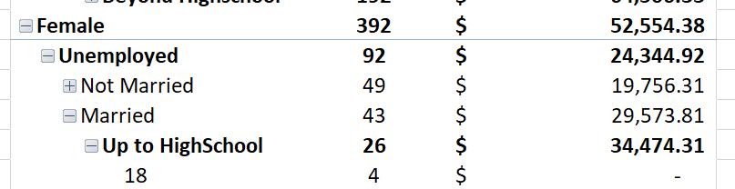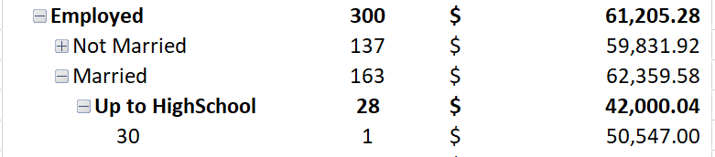

- Now, simply look at the number right next to “Up to Highschool.” This is the figure that we want. Simply obtain the sum of these users. I got 151 users (35 + 62 + 26 + 28); they compose 15.10% of the sample (i.e., 151/1000).

c. To obtain percentage of these unemployed Internet users, simply minimize the table as shown below. The total unemployed is 140 for male and 92 for female. All in all, they comprise 23.20% of the sample (i.e., 232/1000).
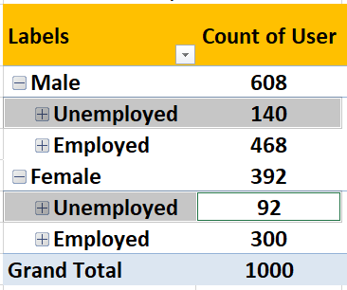
d. Lastly, to find the average salary of the employed Internet users, we refer to the Table. Since average for 468 males is 60152.54 and average for 300 females is 61205.28, we can just obtain their weighted average:

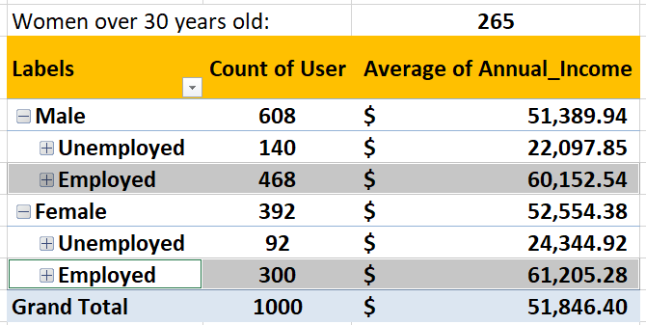

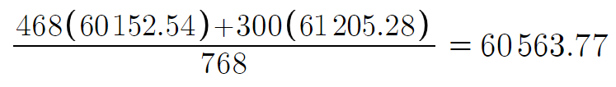

Note: I also performed alternative check. This is correct.
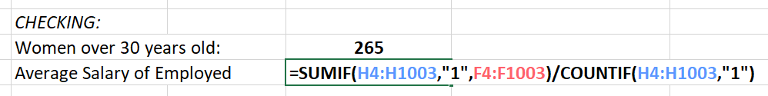

Answers to Problem 3 (Linear Programming):
1. To solve these types of problems, setup all of the given data as shown below:
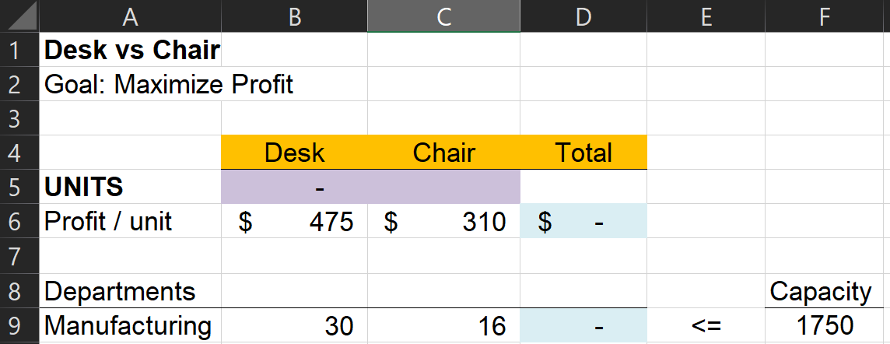

The violet cells are empty. Solver will place the answer in these cells. Meanwhile, the sky-blue cells have formulas in them. We basically multiply the blank cells (units) by the profit or hours for both products:

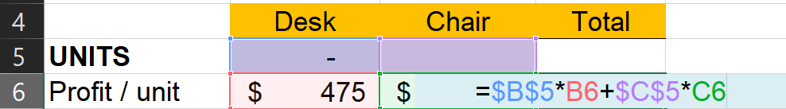

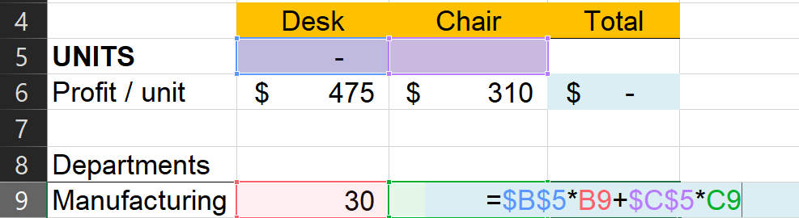

To use Solver, simply Hit ALT + A + Y + 2. Set D6 as objective to max (maximize) profit by changing cells b5:c5. Also, take note of the constraint total (D9) must not exceed F9 (capacity). Hit Solve.
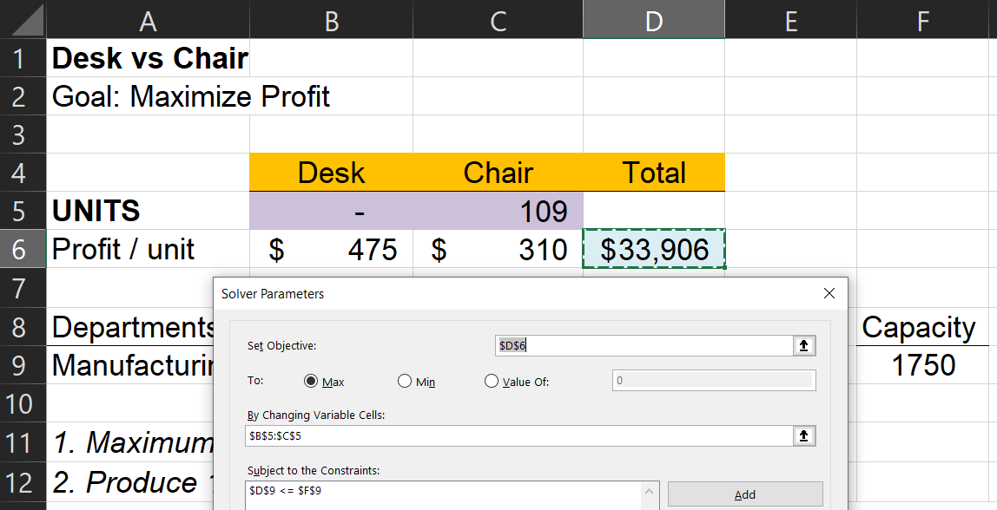

ANSWER: Our maximum profit is 33,906 with 109 chairs utilizing 1750 hours.
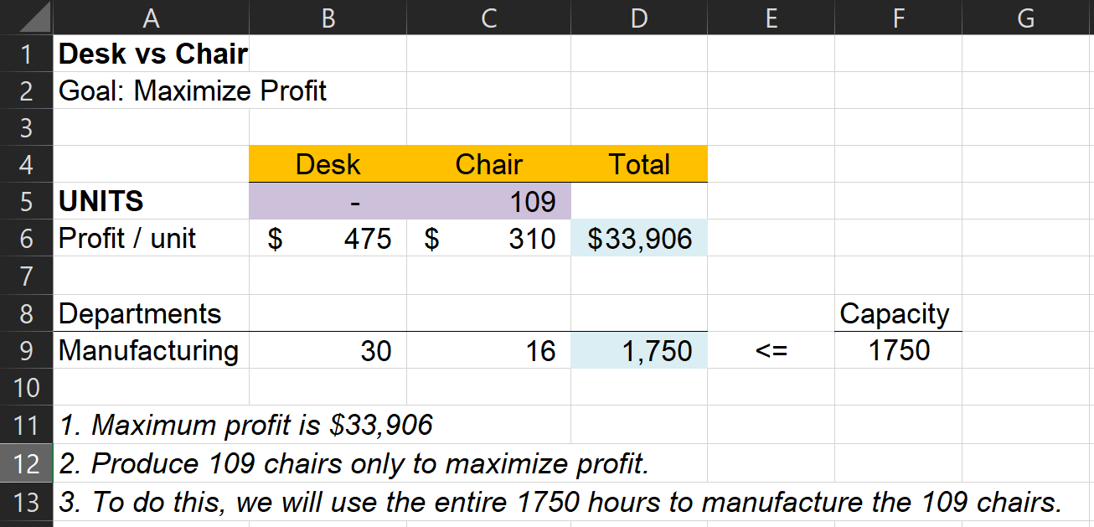

Answers to Problem 4 (Linear Programming):
1. This is our setup:
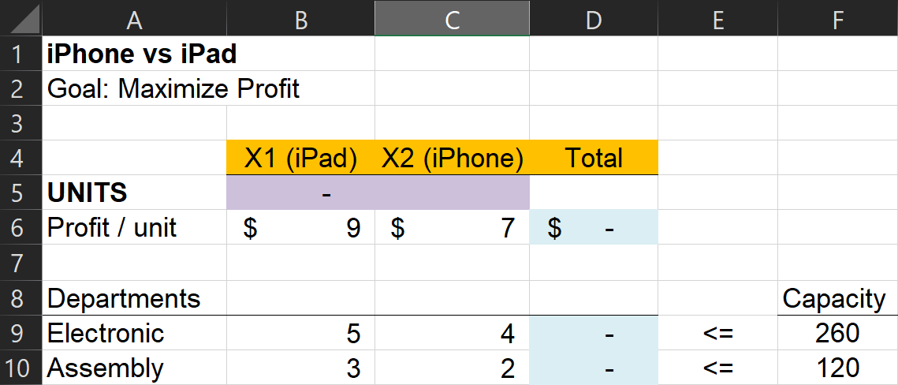

2. Simply follow the similar steps above. We obtained the following:
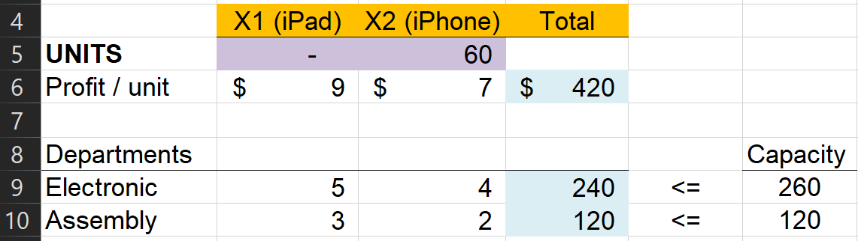

3. ANSWER: By producing 60 units of iPhone, we’ll achieve optimal profit of $420 using 240 hours under Electronic Department and 120 hours under Assembly department.

Answers to Problem 5 (Linear Programming):
1. We plot our data in a table as shown below:
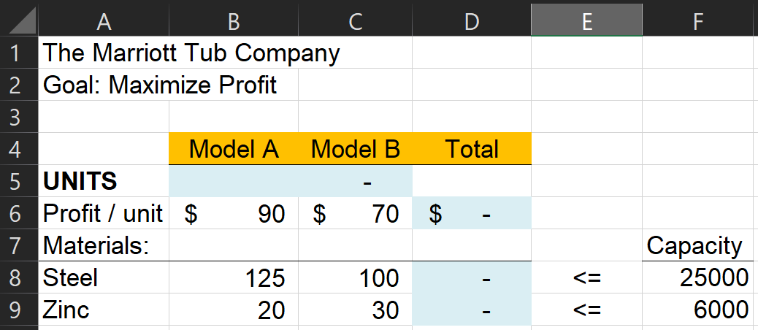

2. By using Solver, we obtained 200 units of Model A bathtub for a maximum profit of 18,000.
