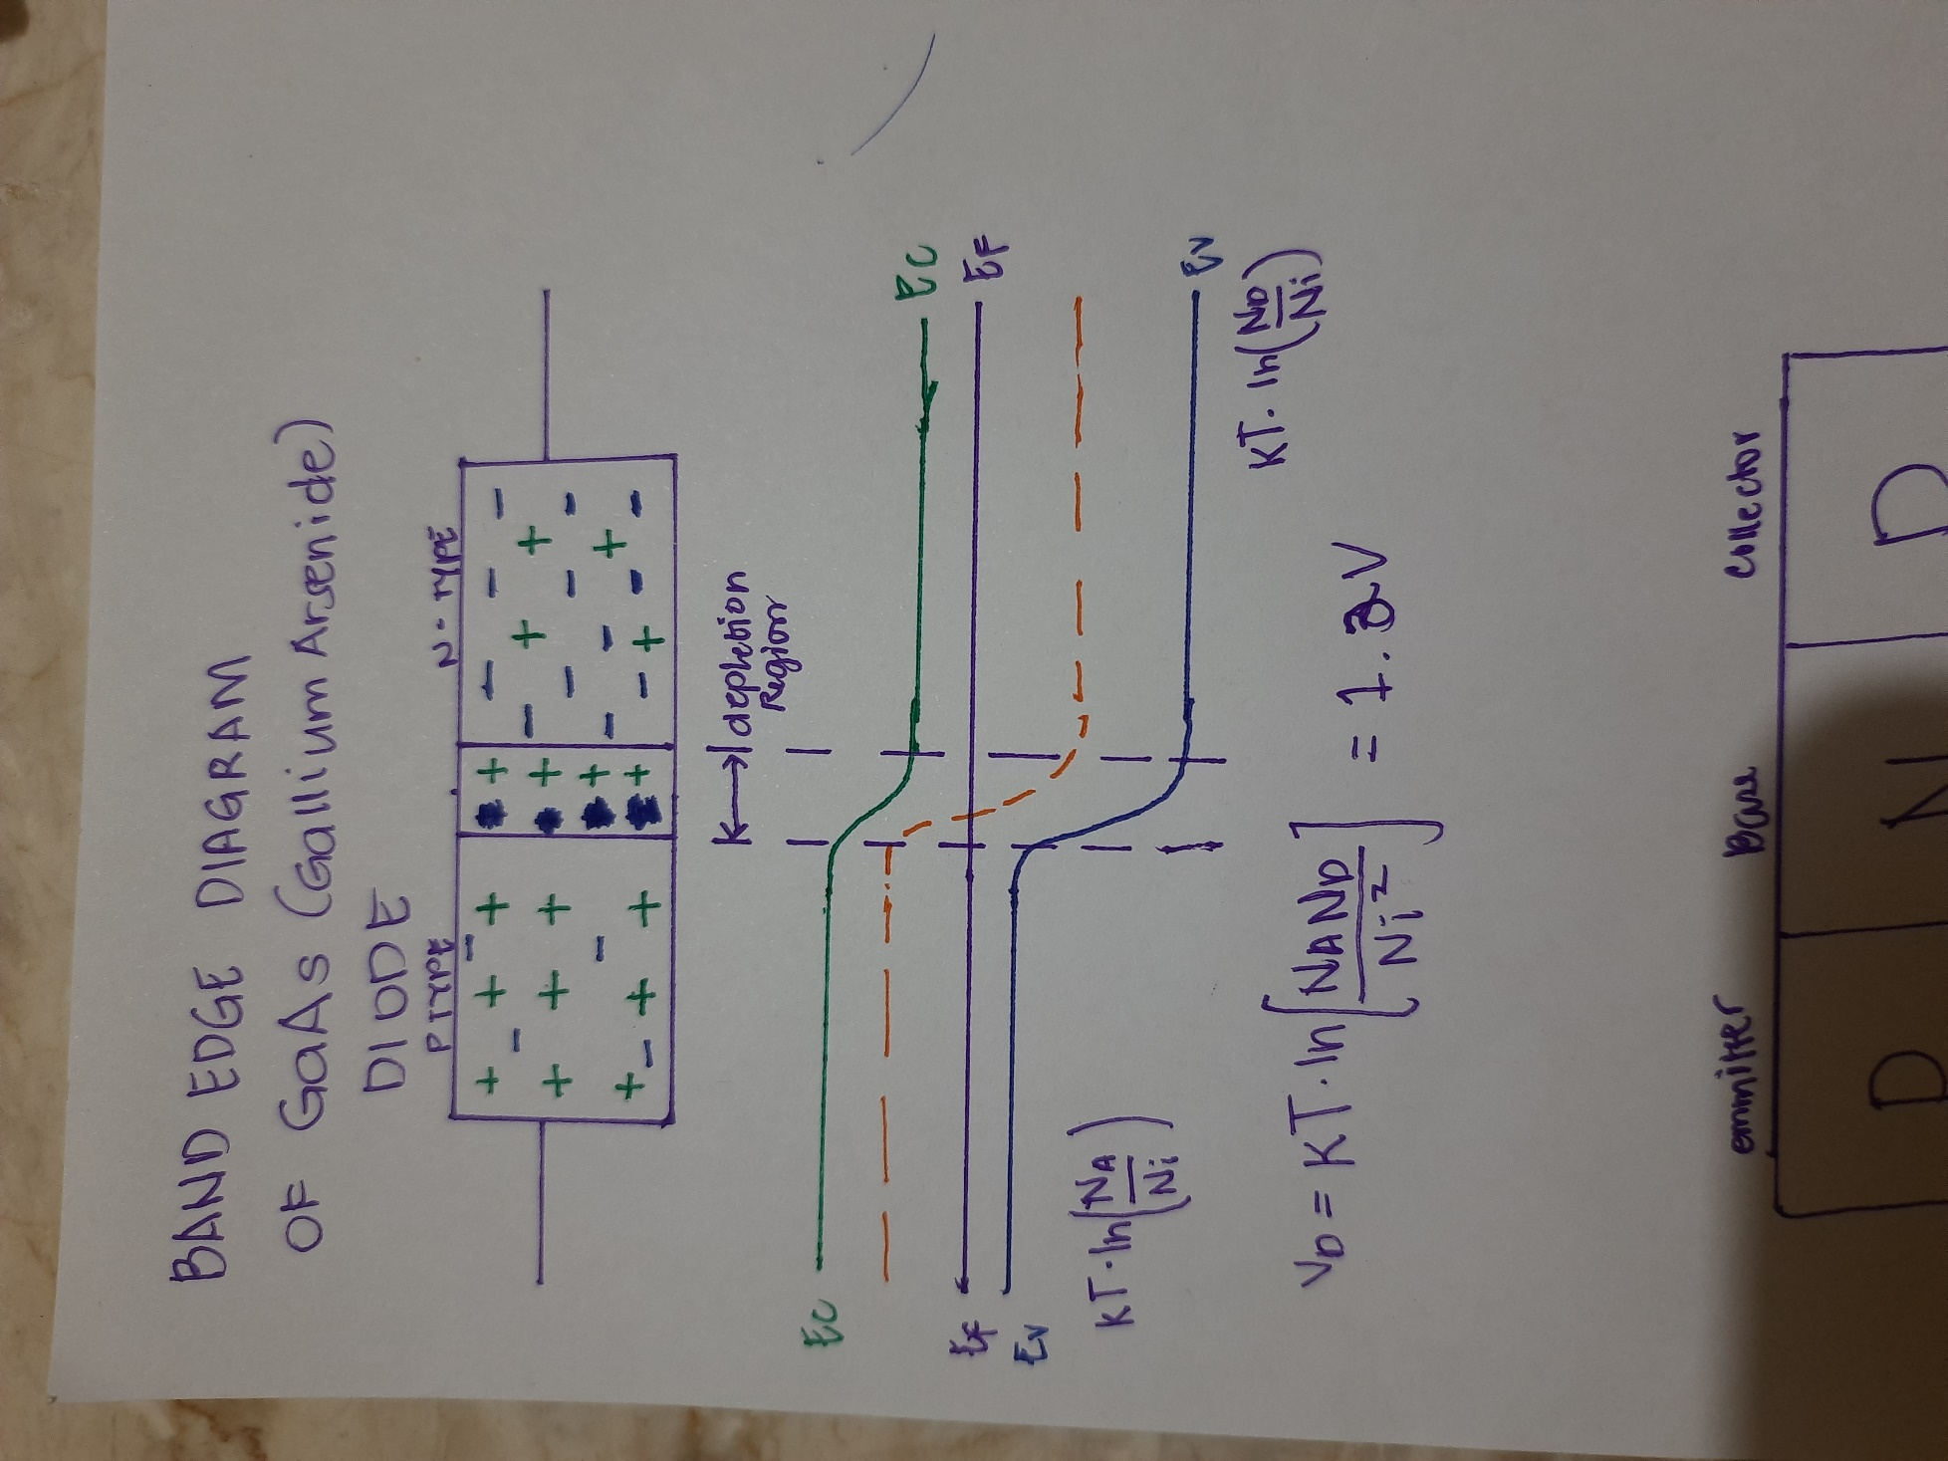

A photodetector functions as light detector by conducting current when exposed to photo radiation or light. A P-N diode can be modified into a photodetector; photodetector is connected in reversed-biased condition. Initially, current cannot flow since there is a buildup of depletion region in the junction; this is not yet exposed in light. When exposed to radiation, the heat increases in the depletion region which loosens the buildup and creating current flow.

- A.

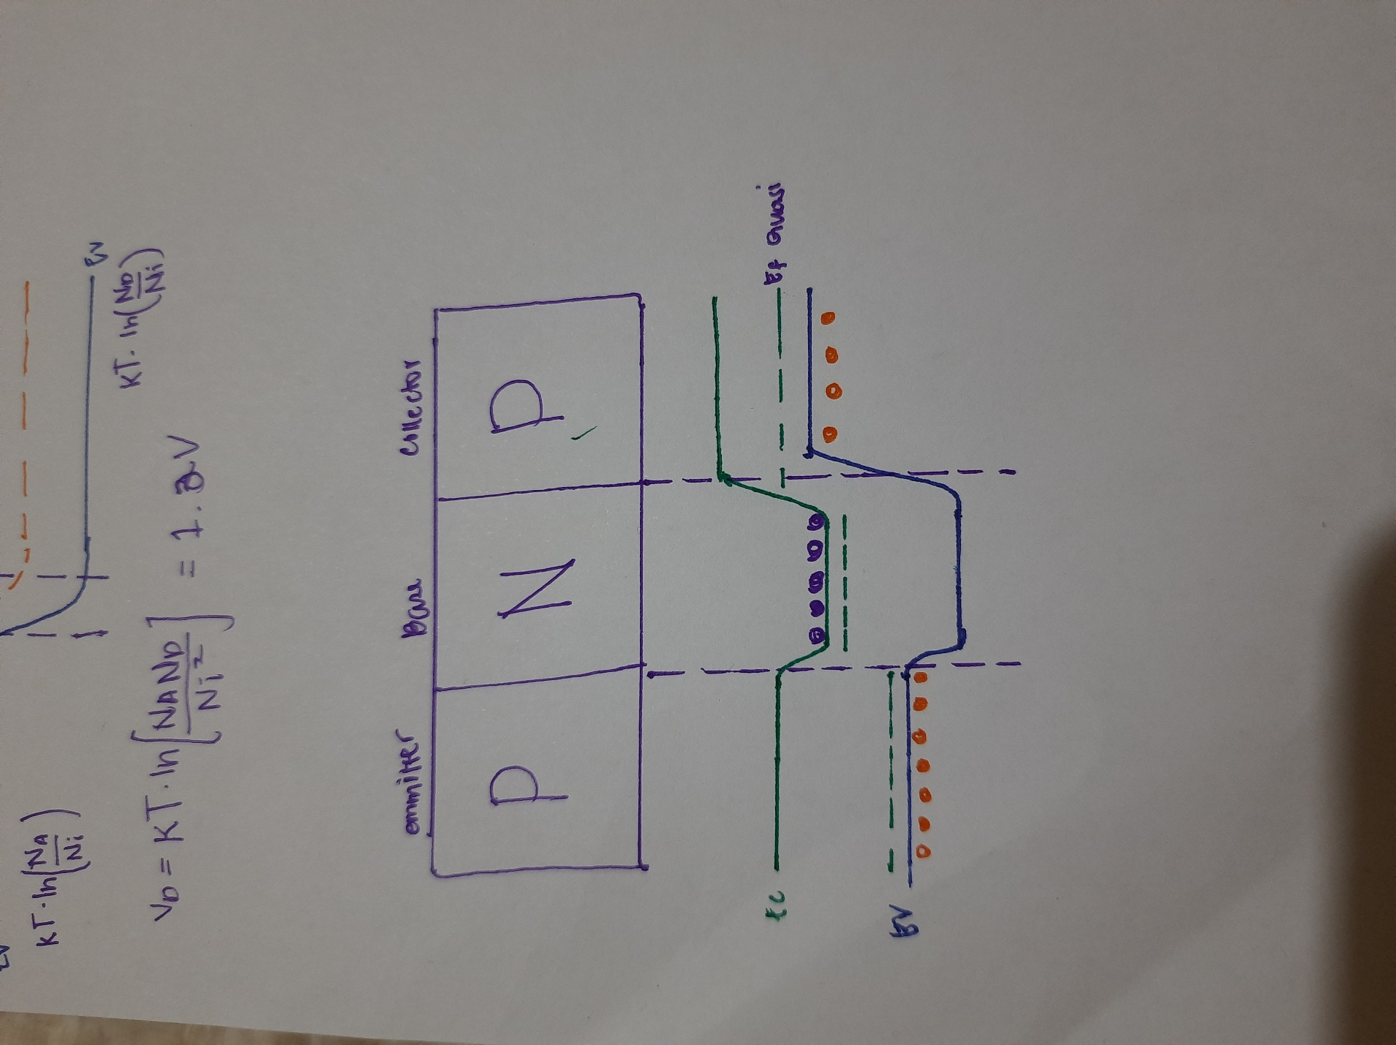

B.

Basically, PNP BJT are composed of two diodes that are reversed. There are two junctions and two depletion regions, thus, a transistor, for it to operate, must be forward biased or be subjected to a certain amount of voltage in order to allow current to flow from the emitter going to the collector.

The polarity that must be connected to the base to forward-bias a PNP transistor is negative.

