English 4 Semester 1

Unit 2 - The Canterbury Tales: Exploring Motivation through Satire

The Pardoner Reading and Questions (30 points)
Read the following description of the PARDONER that appears in the “Prologue” to The Canterbury Tales. Answer the questions that follow.
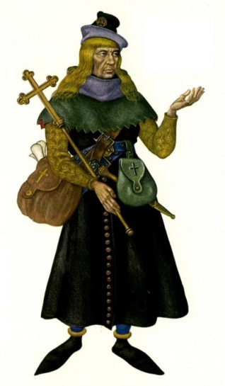With him there rode a gentle PARDONER
Of Rouncival, his friend and his compeer;
Straight from the court of Rome had journeyed he.
Loudly he sang "Come hither, love, to me,"
The summoner joining with a burden round; 5
Was never horn of half so great a sound.
This pardoner had hair as yellow as wax,
But lank it hung as does a strike of flax;
In wisps hung down such locks as he'd on head,
And with them he his shoulders overspread; 10
But thin they dropped, and stringy, one by one.
But as to hood, for sport of it, he'd none,
Though it was packed in wallet all the while.
It seemed to him he went in latest style,
Dishevelled, save for cap, his head all bare. 15
As shiny eyes he had as has a hare.
He had a fine veronica sewed to cap.
His wallet lay before him in his lap,
Stuffed full of pardons brought from Rome all hot.
A voice he had that bleated like a goat. 20
No beard had he, nor ever should he have,
For smooth his face as he'd just had a shave;
I think he was a gelding or a mare.
But in his craft, from Berwick unto Ware,
Was no such pardoner in any place. 25
For in his bag he had a pillowcase
The which, he said, was Our True Lady's veil:
He said he had a piece of the very sail
That good Saint Peter had, what time he went
Upon the sea, till Jesus changed his bent. 30
He had a latten cross set full of stones,
And in a bottle had he some pig's bones.
But with these relics, when he came upon
Some simple parson, then this paragon
In that one day more money stood to gain 35
Than the poor dupe in two months could attain.
And thus, with flattery and suchlike japes,
He made the parson and the rest his apes.
But yet, to tell the whole truth at the last,
He was, in church, a fine ecclesiast. 40
Well could he read a lesson or a story,
But best of all he sang an offertory;
For well he knew that when that song was sung,
Then might he preach, and all with polished tongue.
To win some silver, as he right well could; 45
Therefore he sang so merrily and so loud.
- List everything you know about the Pardoner’s appearance. (Generally, the more Chaucer says about the appearance of a character, the less he likes them.)
- Stuffed in the Pardoner’s wallet are pardons. Pardons were sold by the church at the time Chaucer wrote. Essentially, one could buy a pardon, or in other words, pay money to get forgiveness for a sin. Many people at the time, including Chaucer, disliked this practice of selling pardons. How might Chaucer be showing his dislike of the selling of pardons through the description of the Pardoner?
- Holy relics are usually personal effects of dead saints or actual physical remains such as bones. Is the pardoner selling real holy relics, or are they fake? How do you know?
- Chaucer states that the Pardoner could read well and tell stories, but his favorite song is the “offertory.” The offertory is the part of the Christian church service where the money is collected from parishioners. Why do you think this is his favorite song?
- Do you think that Chaucer holds members of the clergy (church) to a higher standard? In other words, is it worse if the Pardoner cheats people out of money than when the Miller cheats people out of money? (The Pardoner has taken vows of poverty and obedience to the church. The Miller has not.)
- Put a check by each of the 7 deadly sins that you think the Pardoner commits:
Pride
Avarice (greed)
Wrath (anger)
Sloth (laziness)
Lust
Envy
Gluttony (eating or drinking in excess)
- Review the chart above. What is Chaucer’s opinion of the Pardoner? Remember: the pilgrims are either praised, made fun of for mild flaws, or harshly criticized. Which does Chaucer seem to be doing to the Pardoner? Explain your choice.

