Instructions:
Home | Portal (psm.edu)
User name nthompson21
Password William28
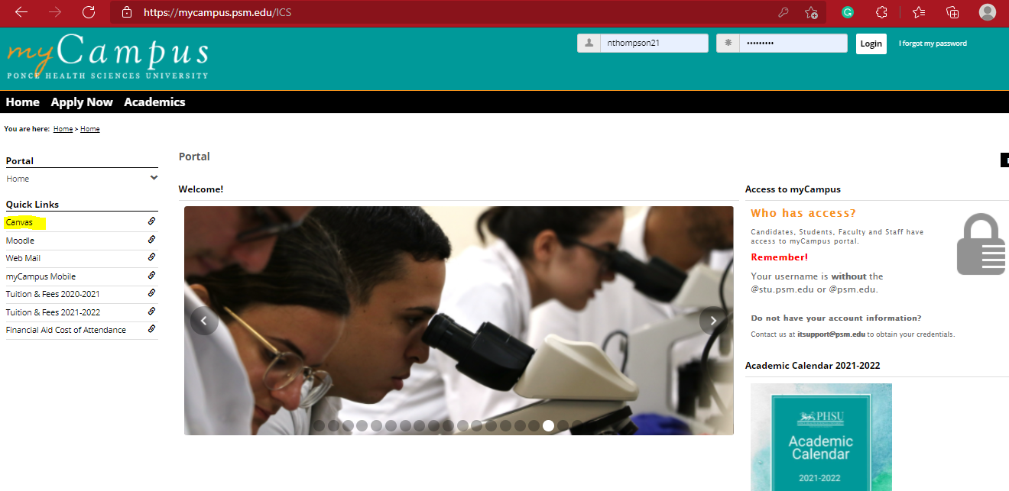
Click on canvas on left hand side

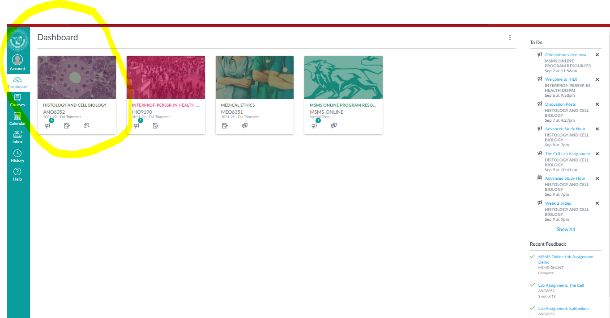
Click on Histology and cell biology
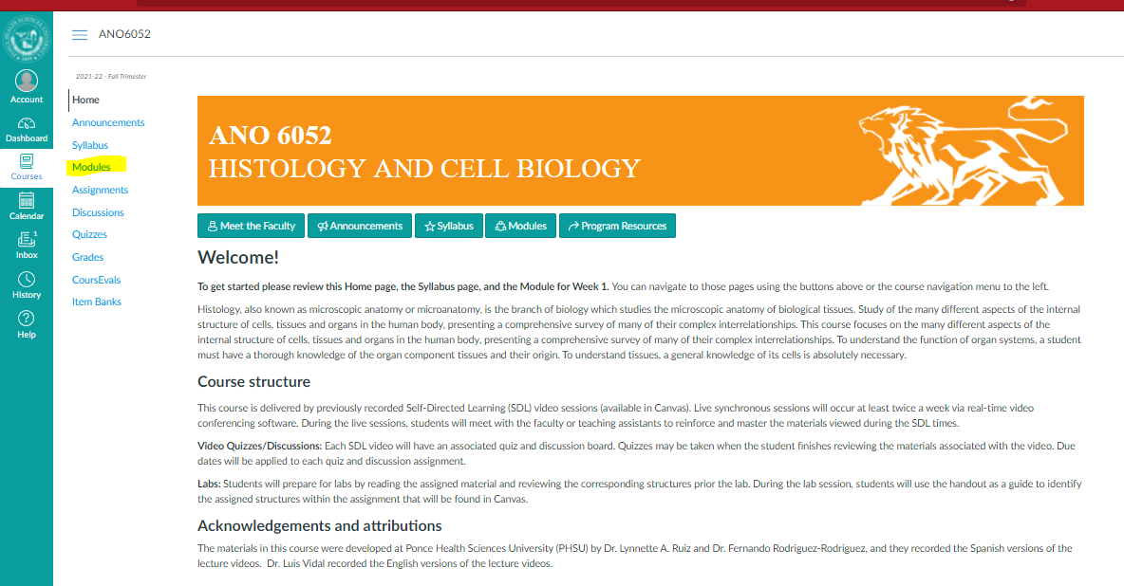
Click on modules
Follow instructions: Week 3 is where I left all at there is an upcoming due date 9/18/21 Class ends November let me know if you have any questions
Thank you so much

