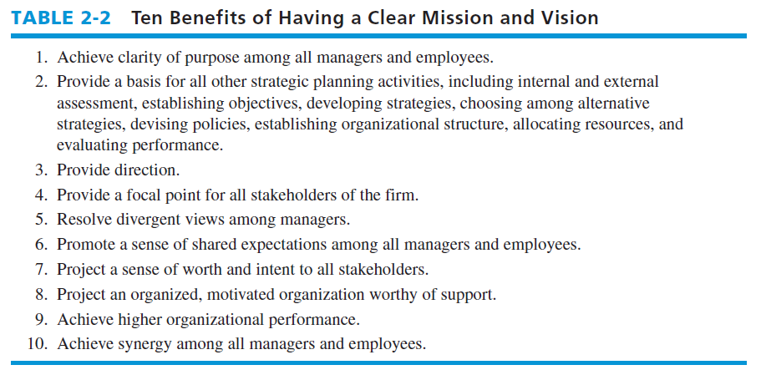

WHAT MISSION STATEMENT SHOULD INCLUDE.
1. Customers—Who are the firm’s customers?
2. Products or services—What are the firm’s major products or services?
3. Markets—Geographically, where does the firm compete?
4. Technology—Is the firm technologically current?
5. Survival, growth, and profitability—Is the firm committed to growth and financial soundness?
6. Philosophy—What are the basic beliefs, values, aspirations, and ethical priorities of the firm?
7. Self-concept (distinctive competence)—What is the firm’s major competitive advantage?
8. Public image—Is the firm responsive to social, community, and environmental concerns?
9. Employees—Are employees a valuable asset of the firm?

