Supply chain management
There are four key ways in which an effective supply chain management can assist new businesses such as increase in output, increase in efficiency, reduction in cost and increase in profit. I want to start a business of brand canon whose headquarter is in Tokyo, Japan. This brand deals with the manufacturing of lenses, camera, scanners, printers etecetra. According to demand of the public I have decided to build the product cameras of canon.
Global supply chain is to develop the new business and make its name in the market. Networks that can span across number of continents and countries for the supplying goods and services. I have two workshops in Canada, Westminster out of which one I will use to manufacture the product and other one is as a retail store named as camera crew to sell and deliver the product across customers . I will manufacture the product in our store at lower labour rates as comparative to other countries which will reduce its overall operational cost and that is the key to attract more customer globally.
Quality is the part of my business I will always strive for quality. To satisfy your customer quality is critical and retain their loyalty, So they continue to buy from you in the future. From customers review we judge what the quality is and develop strategies to implement quality management system.
Canon has different models of cameras but we mainly focus on the manufacturing of DSLR whose starting price is about 1100CAD in other other countries including shipment. So we will provide the same piece of product at a cost 800 CAD in addition to its shipment price to various countries. Based on research I found that in today’s time people want a quality product at a reasonable price. So our company is satisfying the needs of customers worldwide. Customers can buy the product from our company store named as ‘camera crew’ and can also order it online as well we will deliver the product at customers address in the target time. In Canada the maximum time for the delivery is 1-2 days and for worldwide it will take a time lap of 10-15 days. We are planning to establish our branches in other countries to fulfil the customers’ needs and to reduce the delivery time because our motive is fulfil the demand of the customer.
Customer value is the perception of what a product is worth to a customer. It is versus the possible alternatives available in the market. Our customer should feels that he or she received benefits and services over what was paid. We are selling this product at a cost of CAD 800 without shipping charges. Some tools such as rebate, contest, online advertisement are very necessary for the promotion of the product. I am explaining these tools in the subsequent points -
- We will create some contest for the customers to participate and show their interest in our brand and should be praised winners with awards such as small cameras or additional discount for their purchase.
- Online advertisement is the strongest key to spread your business worldwide through social media. We can provide some offers , for instance one is free on the purchase of two products and some others gifts with the product which will help to increase our sale.
- Rebate is an essential thing in today’s competitive to grow your bushiness and to spread it globally. It can be done through the advertisement, availing a discount on companies website, channels, by social media applications because nowadays people mostly use social media so when they go through it they may attract towards your product.
Here is the picture below showing that how these tools works -
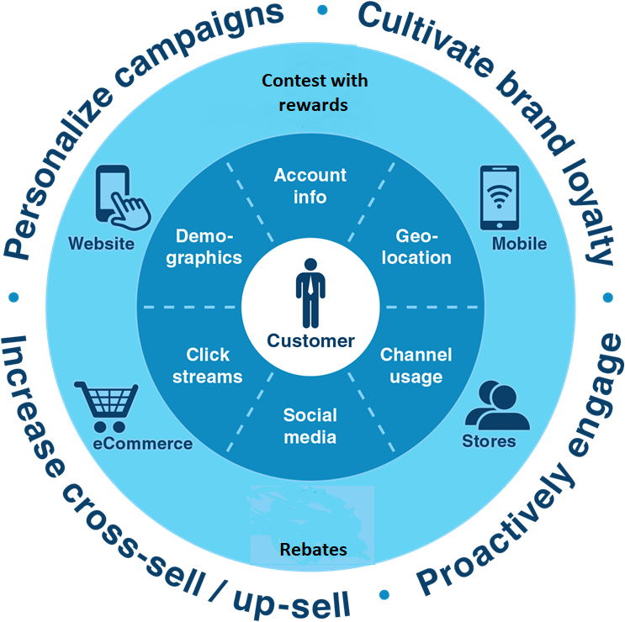

So we will sell our product on the qualities it has and what make it different from others by providing them special offer, the contest and early product delivery which attract them towards our product.

