Visual Taxonomic Representation

Create a visual representation of an animal’s taxonomic classification. Before I explain, here is a visual example of what you will be creating:

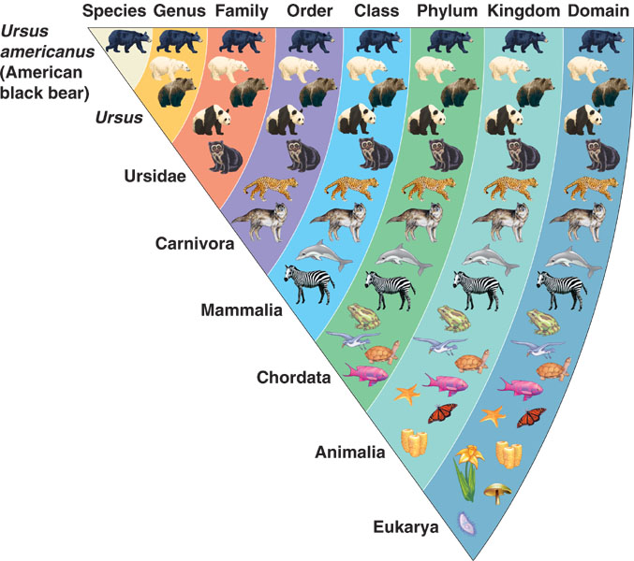

- Choose an animal.
- Research it’s classification (Domain, Kingdom, Phylum, Class, Order, Family, Genus, and Species).
- Research 10 organisms in its Domain.
- Of those ten, make sure 8 of them are in the same Kingdom.
- Of those 8, make sure 7 of them are in the same Phylum.
- Of those 7, make sure 6 of them are in the same Class.
- Of those 6, make sure 5 of them are in the same Order.
- Of those 5, make sure 4 of them are in the same Family.
- Of those 4, make sure 3 of them are in the same Genus.
- List your animal’s species.
- Create a visual representation like the one shown above.

