Creating a Dichotomous Key:
- Use the animals listed to create a dichotomous key.
- Decide upon a way to divide the items into two groups. Think of identifying characteristics such as shape, size, position, colour, texture, etc. One characteristic must be defined and used to decide which items are placed in which group. For example: a group of big cats could be divided into those with long tails and those with short tails. The groups created must be opposites of each other.
- Record what factor was used to make the division and note which members of the original group belonged to each resulting group.
- After two groups (A and B) have been created, divide the first group (A) into two more groups based again on one criterion (C and D). For example, if group A were the short tailed cats, group C might be short tailed cats with a plain colored coat. Group D would then be short tailed cats with a patterned coat.
- Do the same with Group B.
- Continue to divide the groups until each item is by itself. Keep careful records of the groups that were created and the dividing criteria.
- Looking at your records and the divisions you made, create a dichotomous key that would lead someone else to make the same distinctions you did. Begin your key by recalling the first factor you used to divide into two groups. Again using the big cat example: The first group was created depending on tail length. So, the first question in the key should be: Does the cat have a short tail? If so, go to step 2. The second question should be the other choice: Does the cat have a long tail? If so, go to step ??? (You may need to wait until you have worked through several steps of the key to assign the second destination).

Animals to use:
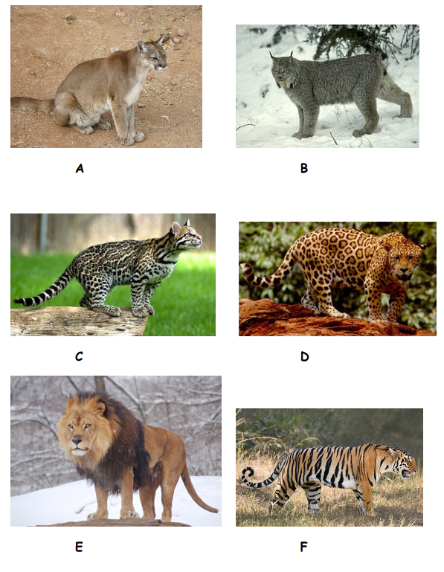
Example Dichotomous Key Template:
