CHEM
Students’’ Name
Institution Affiliation
Professor’s Name
Course
Date

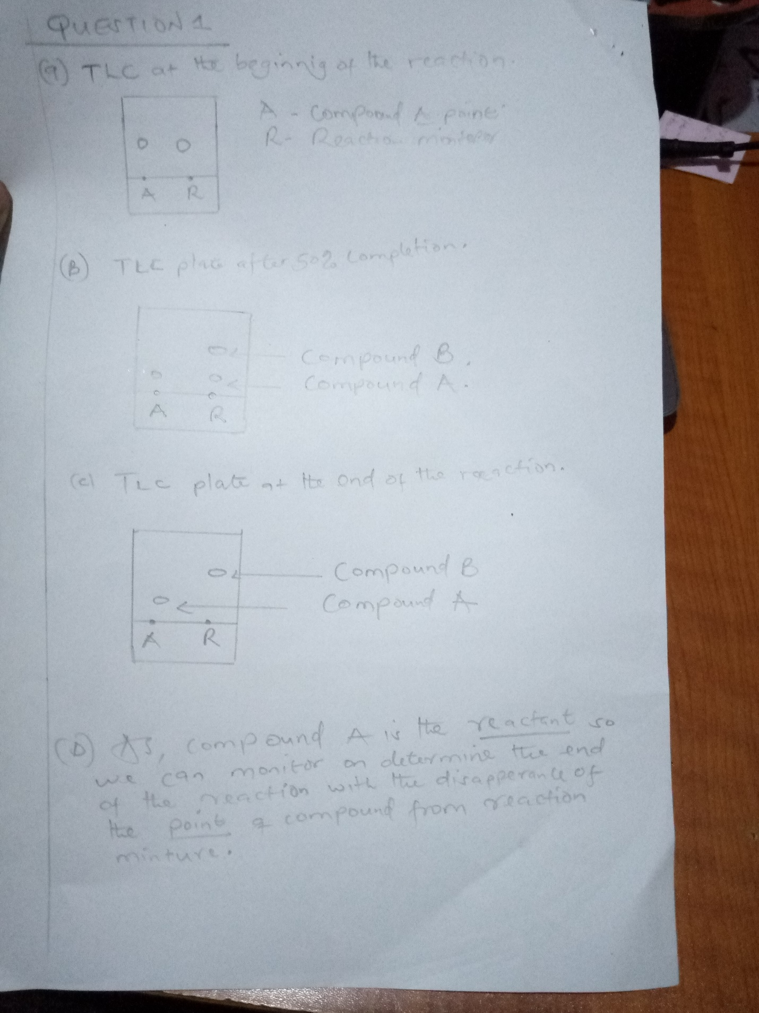
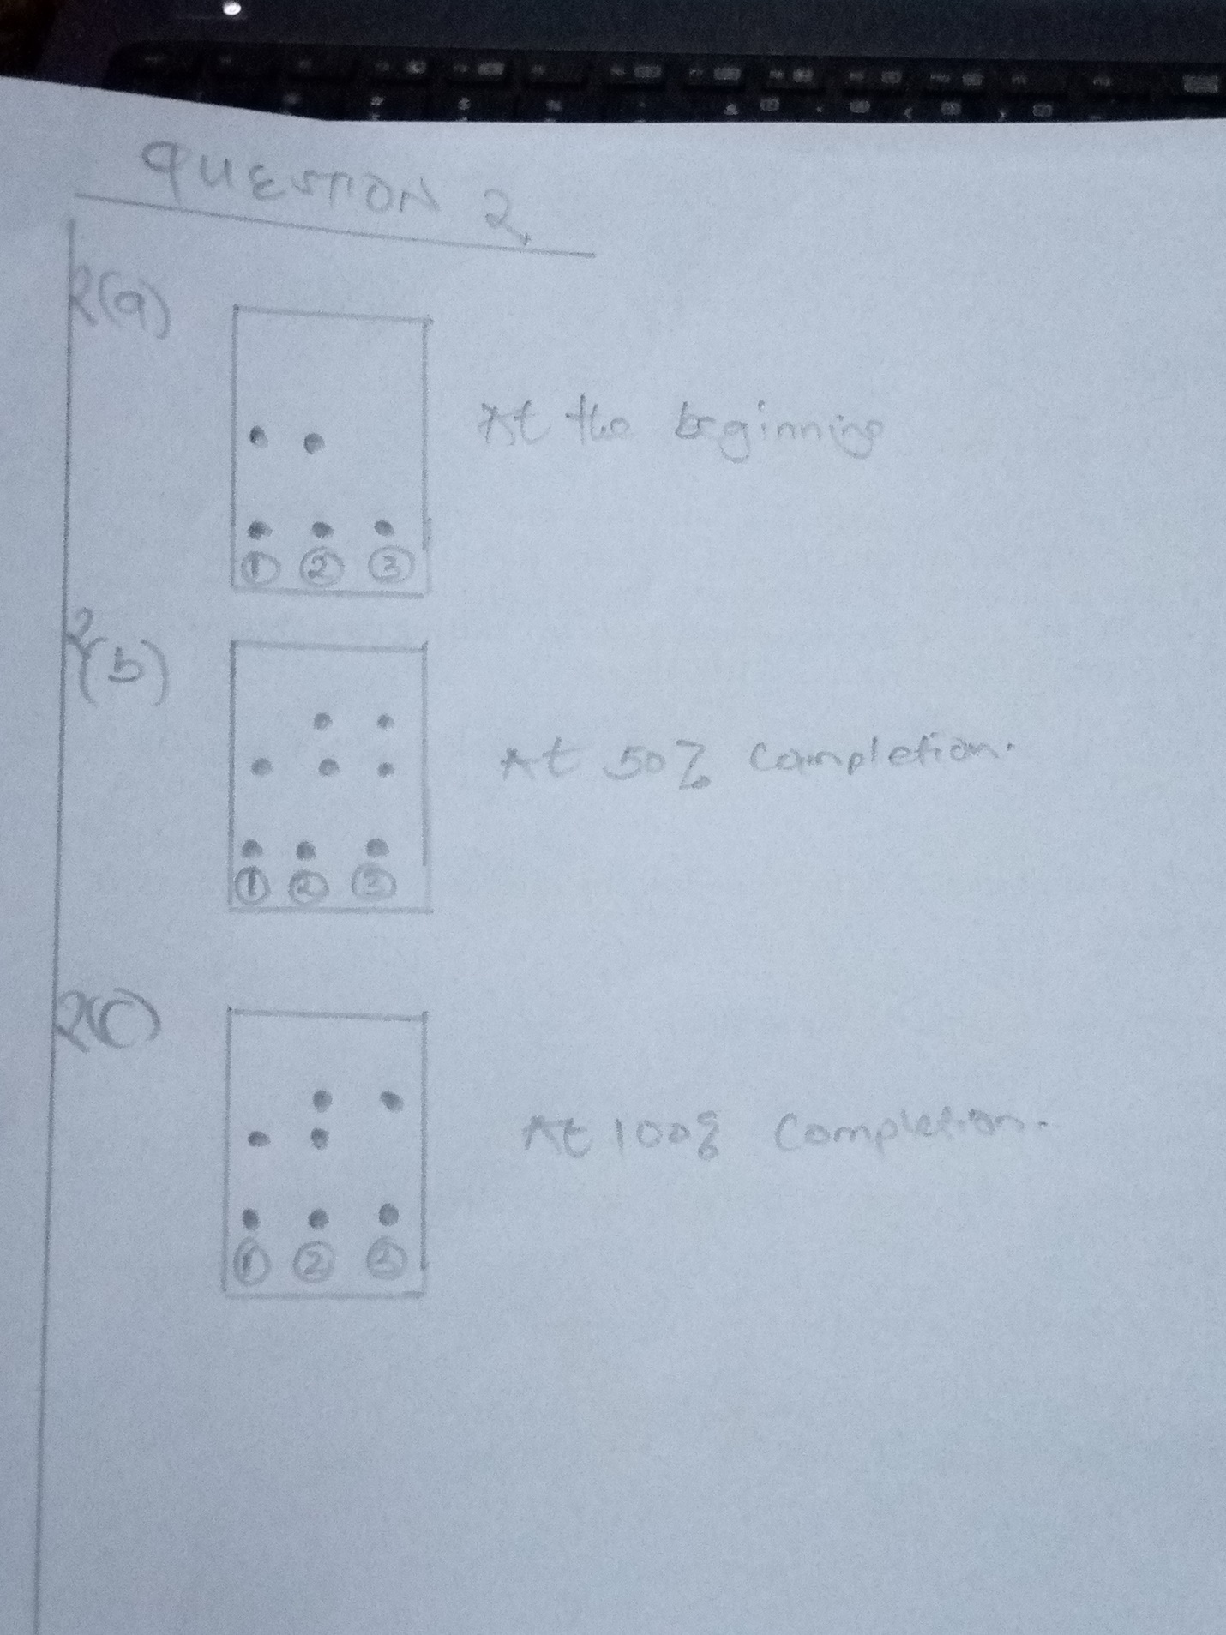

In the above diagrams, spot 1 is for reactant, 2 is co spot while 3 is for product.
At the beginning of the reaction, no product is formed, therefore we do not get any spot for the D.
At 50% completion, we get two equal sized spots for C and D in the product lane.
At the end of the reaction, all C molecules has got converted into D. Therefore, only one spot is obtained in the product lane.
2d. The Co spot helps in distinguishing the reactant and product spot when the difference is their retention factors is low

