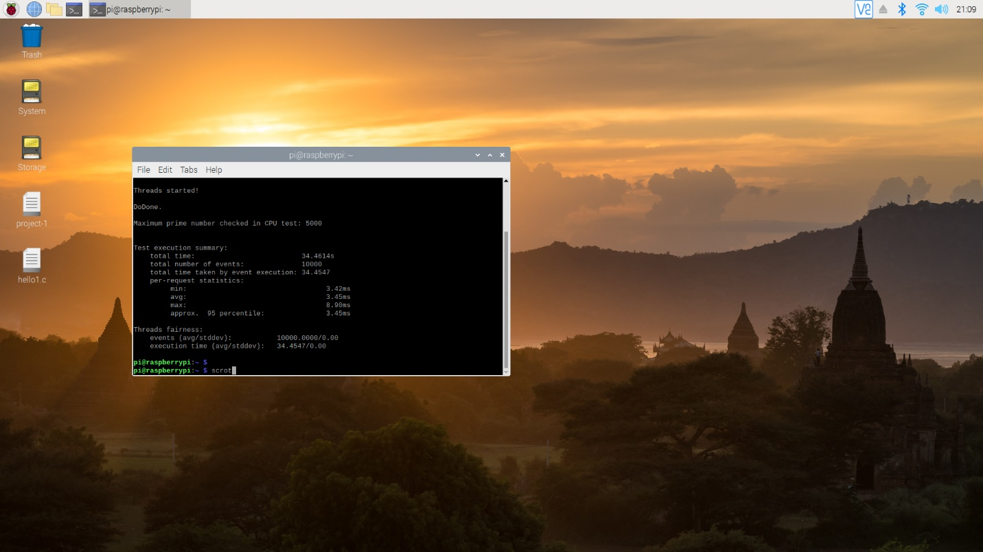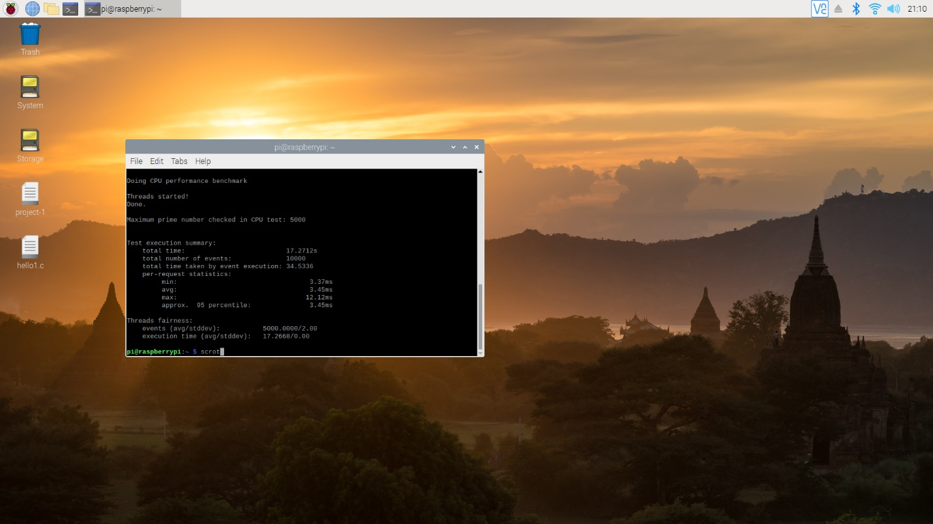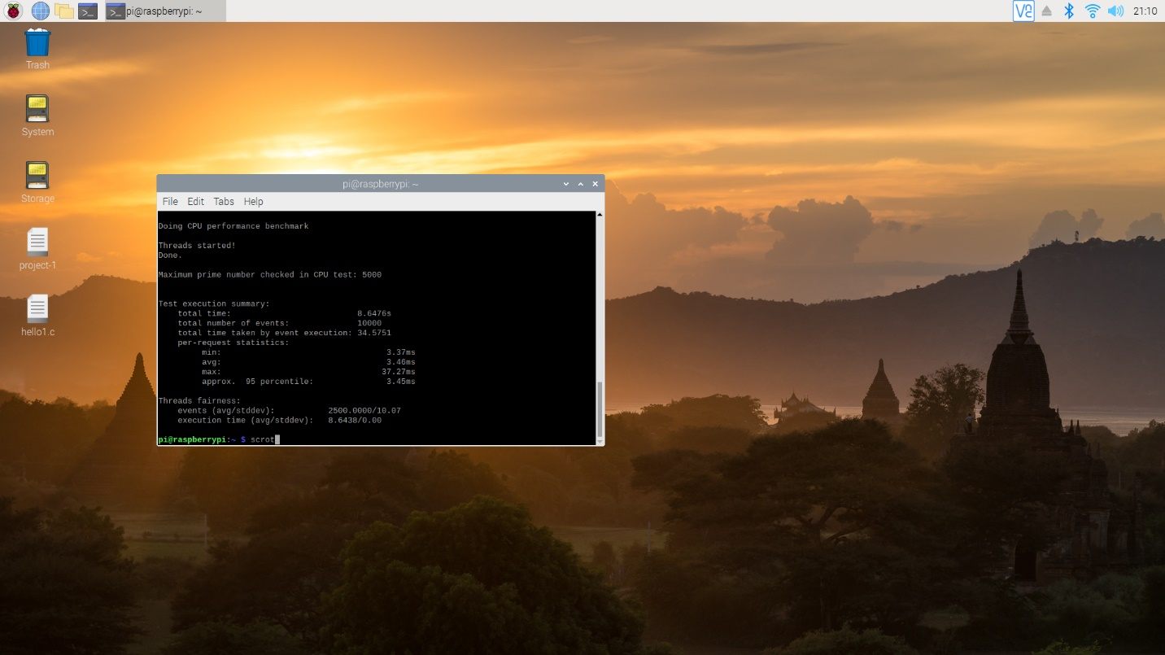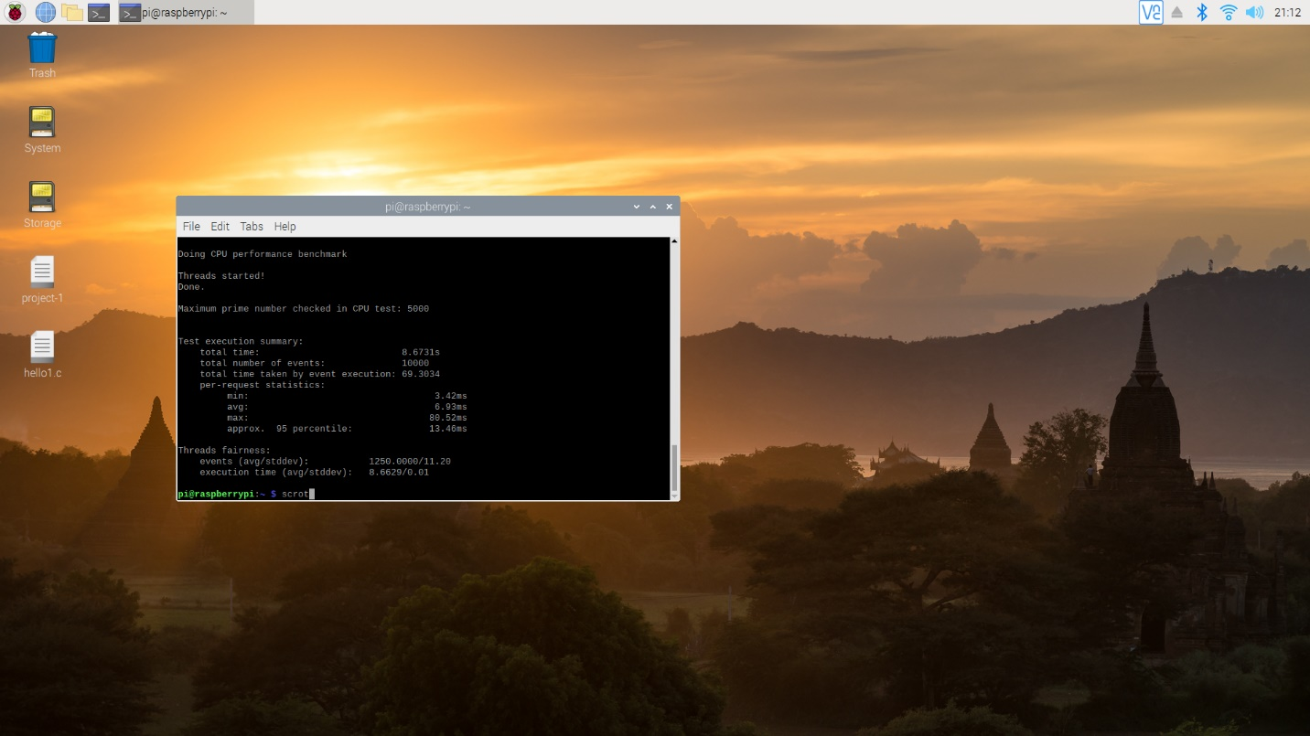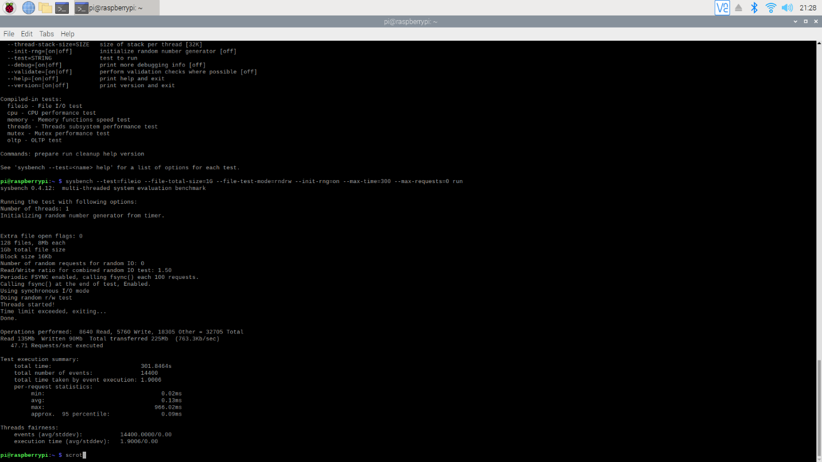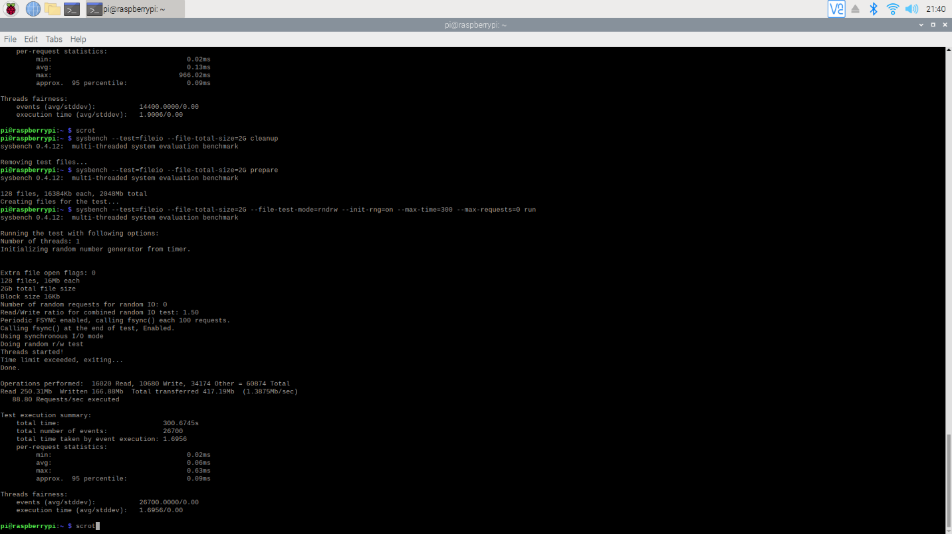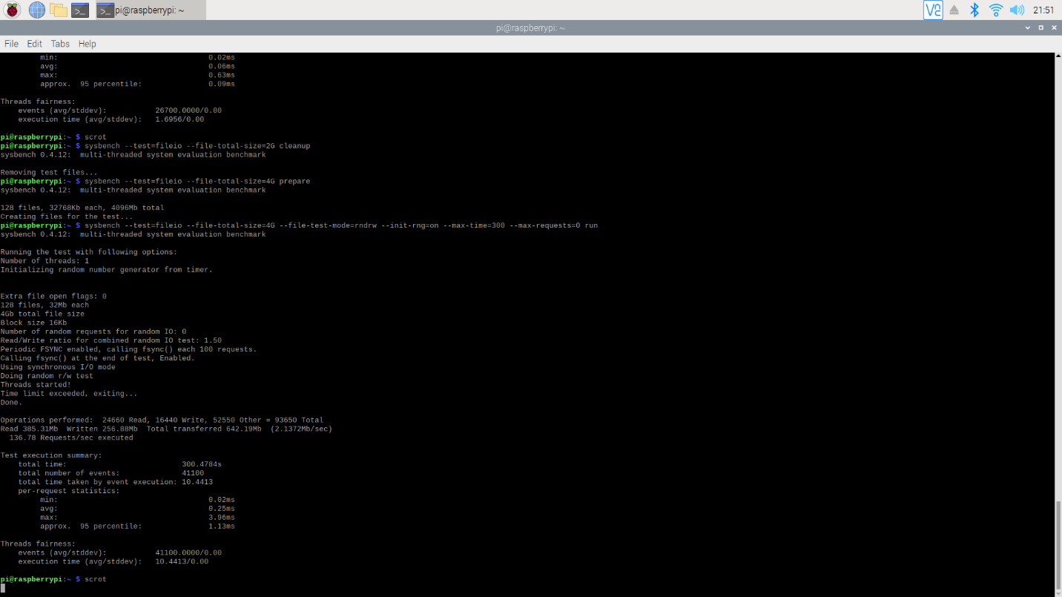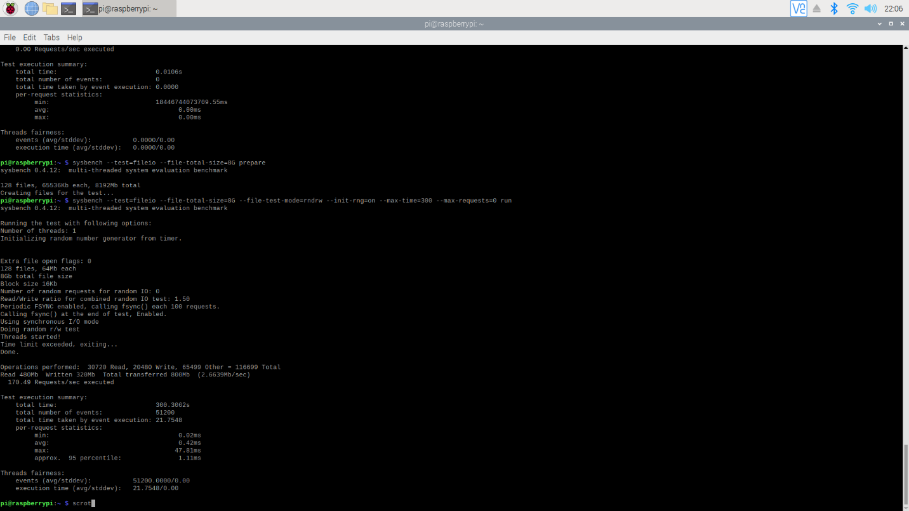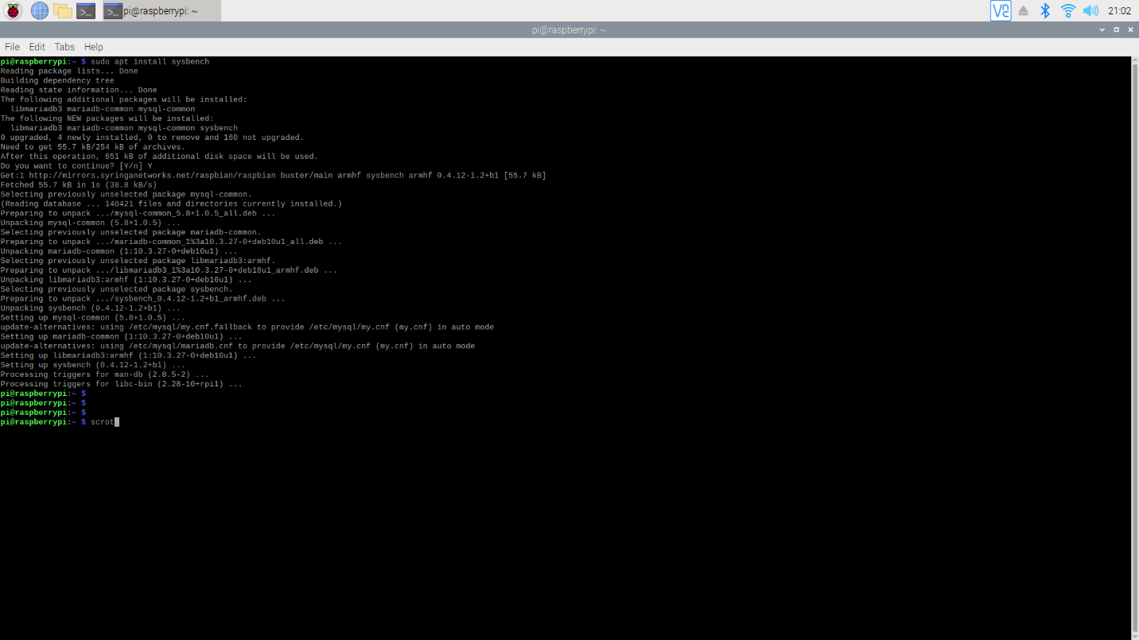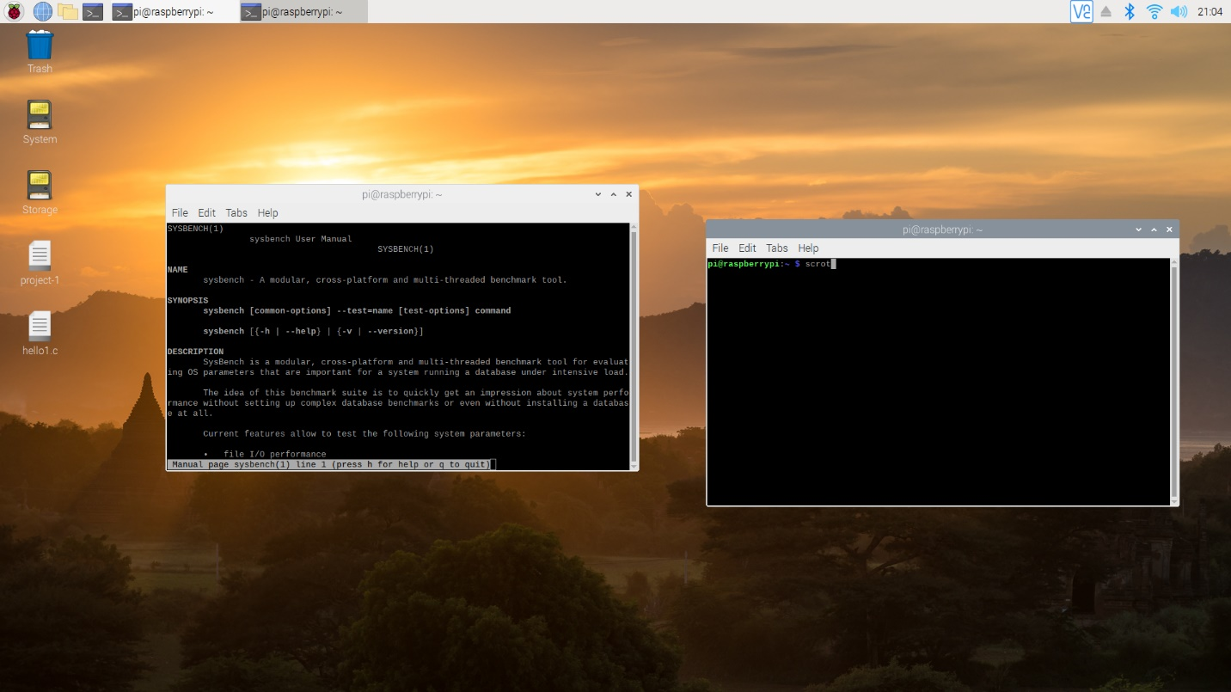

pi@raspberrypi:~ $ man sysbench
pi@raspberrypi:~ $ sysbench --test=cpu --cpu-max-prime=5000 --num-threads=1 run
sysbench 0.4.12: multi-threaded system evaluation benchmark

Running the test with following options:
Number of threads: 1

Doing CPU performance benchmark

Threads started!

DoDone.

Maximum prime number checked in CPU test: 5000

Test execution summary:
total time: 34.4614s
total number of events: 10000
total time taken by event execution: 34.4547
per-request statistics:
min: 3.42ms
avg: 3.45ms
max: 8.90ms
approx. 95 percentile: 3.45ms

Threads fairness:
events (avg/stddev): 10000.0000/0.00
execution time (avg/stddev): 34.4547/0.00

pi@raspberrypi:~ $
pi@raspberrypi:~ $ scrot
pi@raspberrypi:~ $ sysbench --test=cpu --cpu-max-prime=5000 --num-threads=2 run
sysbench 0.4.12: multi-threaded system evaluation benchmark

Running the test with following options:
Number of threads: 2

Doing CPU performance benchmark

Threads started!
Done.

Maximum prime number checked in CPU test: 5000

Test execution summary:
total time: 17.2712s
total number of events: 10000
total time taken by event execution: 34.5336
per-request statistics:
min: 3.37ms
avg: 3.45ms
max: 12.12ms
approx. 95 percentile: 3.45ms

Threads fairness:
events (avg/stddev): 5000.0000/2.00
execution time (avg/stddev): 17.2668/0.00

pi@raspberrypi:~ $ scrot
pi@raspberrypi:~ $ sysbench --test=cpu --cpu-max-prime=5000 --num-threads=4 run
sysbench 0.4.12: multi-threaded system evaluation benchmark

Running the test with following options:
Number of threads: 4

Doing CPU performance benchmark

Threads started!
Done.

Maximum prime number checked in CPU test: 5000

Test execution summary:
total time: 8.6476s
total number of events: 10000
total time taken by event execution: 34.5751
per-request statistics:
min: 3.37ms
avg: 3.46ms
max: 37.27ms
approx. 95 percentile: 3.45ms

Threads fairness:
events (avg/stddev): 2500.0000/10.07
execution time (avg/stddev): 8.6438/0.00

pi@raspberrypi:~ $ scrot
pi@raspberrypi:~ $ sysbench --test=cpu --cpu-max-prime=5000 --num-threads=8 run
sysbench 0.4.12: multi-threaded system evaluation benchmark

Running the test with following options:
Number of threads: 8

Doing CPU performance benchmark

Threads started!
Done.

Maximum prime number checked in CPU test: 5000

Test execution summary:
total time: 8.6731s
total number of events: 10000
total time taken by event execution: 69.3034
per-request statistics:
min: 3.42ms
avg: 6.93ms
max: 80.52ms
approx. 95 percentile: 13.46ms

Threads fairness:
events (avg/stddev): 1250.0000/11.20
execution time (avg/stddev): 8.6629/0.01

pi@raspberrypi:~ $ scrot
pi@raspberrypi:~ $ sysbench --test=fileio --file-total-size=1G prepare
sysbench 0.4.12: multi-threaded system evaluation benchmark

128 files, 8192Kb each, 1024Mb total
pi@raspberrypi:~ $ sysbench --test=fileio --file-total-size=1G --file-test-mode=rudrw --init-rug=on --max-time=300 --max-requests=0
Unknown option: --init-rug.
Usage:
sysbench [general-options]... --test=<test-name> [test-options]... command

General options:
--num-threads=N number of threads to use [1]
--max-requests=N limit for total number of requests [10000]
--max-time=N limit for total execution time in seconds [0]
--forced-shutdown=STRING amount of time to wait after --max-time before forcing shutdown [off]
--thread-stack-size=SIZE size of stack per thread [32K]
--init-rng=[on|off] initialize random number generator [off]
--test=STRING test to run
--debug=[on|off] print more debugging info [off]
--validate=[on|off] perform validation checks where possible [off]
--help=[on|off] print help and exit
--version=[on|off] print version and exit

Compiled-in tests:
fileio - File I/O test
cpu - CPU performance test
memory - Memory functions speed test
threads - Threads subsystem performance test
mutex - Mutex performance test
oltp - OLTP test

Commands: prepare run cleanup help version

See 'sysbench --test=<name> help' for a list of options for each test.

pi@raspberrypi:~ $ sysbench --test=fileio --file-total-size=1G --file-test-mode=rudrw --init-rug=on --max-time=300 --max-requests=0 run
Unknown option: --init-rug.
Usage:
sysbench [general-options]... --test=<test-name> [test-options]... command

General options:
--num-threads=N number of threads to use [1]
--max-requests=N limit for total number of requests [10000]
--max-time=N limit for total execution time in seconds [0]
--forced-shutdown=STRING amount of time to wait after --max-time before forcing shutdown [off]
--thread-stack-size=SIZE size of stack per thread [32K]
--init-rng=[on|off] initialize random number generator [off]
--test=STRING test to run
--debug=[on|off] print more debugging info [off]
--validate=[on|off] perform validation checks where possible [off]
--help=[on|off] print help and exit
--version=[on|off] print version and exit

Compiled-in tests:
fileio - File I/O test
cpu - CPU performance test
memory - Memory functions speed test
threads - Threads subsystem performance test
mutex - Mutex performance test
oltp - OLTP test

Commands: prepare run cleanup help version

See 'sysbench --test=<name> help' for a list of options for each test.

pi@raspberrypi:~ $ sysbench --test=fileio --file-total-size=1G --file-test-mode=rndrw --init-rug=on --max-time=300 --max-requests=0 run
Unknown option: --init-rug.
Usage:
sysbench [general-options]... --test=<test-name> [test-options]... command

General options:
--num-threads=N number of threads to use [1]
--max-requests=N limit for total number of requests [10000]
--max-time=N limit for total execution time in seconds [0]
--forced-shutdown=STRING amount of time to wait after --max-time before forcing shutdown [off]
--thread-stack-size=SIZE size of stack per thread [32K]
--init-rng=[on|off] initialize random number generator [off]
--test=STRING test to run
--debug=[on|off] print more debugging info [off]
--validate=[on|off] perform validation checks where possible [off]
--help=[on|off] print help and exit
--version=[on|off] print version and exit

Compiled-in tests:
fileio - File I/O test
cpu - CPU performance test
memory - Memory functions speed test
threads - Threads subsystem performance test
mutex - Mutex performance test
oltp - OLTP test

Commands: prepare run cleanup help version

See 'sysbench --test=<name> help' for a list of options for each test.

pi@raspberrypi:~ $ sysbench --test=fileio --file-total-size=1G --file-test-mode=rndrw --init-rng=on --max-time=300 --max-requests=0 run
sysbench 0.4.12: multi-threaded system evaluation benchmark

Running the test with following options:
Number of threads: 1
Initializing random number generator from timer.

Extra file open flags: 0
128 files, 8Mb each
1Gb total file size
Block size 16Kb
Number of random requests for random IO: 0
Read/Write ratio for combined random IO test: 1.50
Periodic FSYNC enabled, calling fsync() each 100 requests.
Calling fsync() at the end of test, Enabled.
Using synchronous I/O mode
Doing random r/w test
Threads started!
Time limit exceeded, exiting...
Done.

Operations performed: 8640 Read, 5760 Write, 18305 Other = 32705 Total
Read 135Mb Written 90Mb Total transferred 225Mb (763.3Kb/sec)
47.71 Requests/sec executed

Test execution summary:
total time: 301.8464s
total number of events: 14400
total time taken by event execution: 1.9006
per-request statistics:
min: 0.02ms
avg: 0.13ms
max: 966.02ms
approx. 95 percentile: 0.09ms

Threads fairness:
events (avg/stddev): 14400.0000/0.00
execution time (avg/stddev): 1.9006/0.00

pi@raspberrypi:~ $ scrot
pi@raspberrypi:~ $ sysbench --test=fileio --file-total-size=2G cleanup
sysbench 0.4.12: multi-threaded system evaluation benchmark

Removing test files...
pi@raspberrypi:~ $ sysbench --test=fileio --file-total-size=2G prepare
sysbench 0.4.12: multi-threaded system evaluation benchmark

128 files, 16384Kb each, 2048Mb total
Creating files for the test...
pi@raspberrypi:~ $ sysbench --test=fileio --file-total-size=2G --file-test-mode=rndrw --init-rng=on --max-time=300 --max-requests=0 run
sysbench 0.4.12: multi-threaded system evaluation benchmark

Running the test with following options:
Number of threads: 1
Initializing random number generator from timer.

Extra file open flags: 0
128 files, 16Mb each
2Gb total file size
Block size 16Kb
Number of random requests for random IO: 0
Read/Write ratio for combined random IO test: 1.50
Periodic FSYNC enabled, calling fsync() each 100 requests.
Calling fsync() at the end of test, Enabled.
Using synchronous I/O mode
Doing random r/w test
Threads started!
Time limit exceeded, exiting...
Done.

Operations performed: 16020 Read, 10680 Write, 34174 Other = 60874 Total
Read 250.31Mb Written 166.88Mb Total transferred 417.19Mb (1.3875Mb/sec)
88.80 Requests/sec executed

Test execution summary:
total time: 300.6745s
total number of events: 26700
total time taken by event execution: 1.6956
per-request statistics:
min: 0.02ms
avg: 0.06ms
max: 0.63ms
approx. 95 percentile: 0.09ms

Threads fairness:
events (avg/stddev): 26700.0000/0.00
execution time (avg/stddev): 1.6956/0.00

pi@raspberrypi:~ $ scrot
pi@raspberrypi:~ $ sysbench --test=fileio --file-total-size=2G cleanup
sysbench 0.4.12: multi-threaded system evaluation benchmark

Removing test files...
pi@raspberrypi:~ $ sysbench --test=fileio --file-total-size=4G prepare
sysbench 0.4.12: multi-threaded system evaluation benchmark

128 files, 32768Kb each, 4096Mb total
Creating files for the test...
pi@raspberrypi:~ $ sysbench --test=fileio --file-total-size=4G --file-test-mode=rndrw --init-rng=on --max-time=300 --max-requests=0 run
sysbench 0.4.12: multi-threaded system evaluation benchmark

Running the test with following options:
Number of threads: 1
Initializing random number generator from timer.

Extra file open flags: 0
128 files, 32Mb each
4Gb total file size
Block size 16Kb
Number of random requests for random IO: 0
Read/Write ratio for combined random IO test: 1.50
Periodic FSYNC enabled, calling fsync() each 100 requests.
Calling fsync() at the end of test, Enabled.
Using synchronous I/O mode
Doing random r/w test
Threads started!
Time limit exceeded, exiting...
Done.

Operations performed: 24660 Read, 16440 Write, 52550 Other = 93650 Total
Read 385.31Mb Written 256.88Mb Total transferred 642.19Mb (2.1372Mb/sec)
136.78 Requests/sec executed

Test execution summary:
total time: 300.4784s
total number of events: 41100
total time taken by event execution: 10.4413
per-request statistics:
min: 0.02ms
avg: 0.25ms
max: 3.96ms
approx. 95 percentile: 1.13ms

Threads fairness:
events (avg/stddev): 41100.0000/0.00
execution time (avg/stddev): 10.4413/0.00

pi@raspberrypi:~ $ scrot
pi@raspberrypi:~ $ sysbench --test=fileio --file-total-size=4G cleanup
sysbench 0.4.12: multi-threaded system evaluation benchmark

Removing test files...
pi@raspberrypi:~ $ sysbench --test=fileio --file-total-size=8G --file-test-mode=rndrw --init-rng=on --max-time=300 --max-requests=0 run
sysbench 0.4.12: multi-threaded system evaluation benchmark

Running the test with following options:
Number of threads: 1
Initializing random number generator from timer.

Extra file open flags: 0
128 files, 64Mb each
8Gb total file size
Block size 16Kb
Number of random requests for random IO: 0
Read/Write ratio for combined random IO test: 1.50
Periodic FSYNC enabled, calling fsync() each 100 requests.
Calling fsync() at the end of test, Enabled.
Using synchronous I/O mode
Doing random r/w test
Threads started!
FATAL: Failed to read file! file: 79 pos: 4816896 errno = 0 (�z��)
Done.

Operations performed: 0 Read, 0 Write, 0 Other = 0 Total
Read 0b Written 0b Total transferred 0b (0b/sec)
0.00 Requests/sec executed

Test execution summary:
total time: 0.0106s
total number of events: 0
total time taken by event execution: 0.0000
per-request statistics:
min: 18446744073709.55ms
avg: 0.00ms
max: 0.00ms

Threads fairness:
events (avg/stddev): 0.0000/0.00
execution time (avg/stddev): 0.0000/0.00

pi@raspberrypi:~ $ sysbench --test=fileio --file-total-size=8G prepare
sysbench 0.4.12: multi-threaded system evaluation benchmark

128 files, 65536Kb each, 8192Mb total
Creating files for the test...
pi@raspberrypi:~ $ sysbench --test=fileio --file-total-size=8G --file-test-mode=rndrw --init-rng=on --max-time=300 --max-requests=0 run
sysbench 0.4.12: multi-threaded system evaluation benchmark

Running the test with following options:
Number of threads: 1
Initializing random number generator from timer.

Extra file open flags: 0
128 files, 64Mb each
8Gb total file size
Block size 16Kb
Number of random requests for random IO: 0
Read/Write ratio for combined random IO test: 1.50
Periodic FSYNC enabled, calling fsync() each 100 requests.
Calling fsync() at the end of test, Enabled.
Using synchronous I/O mode
Doing random r/w test
Threads started!
Time limit exceeded, exiting...
Done.

Operations performed: 30720 Read, 20480 Write, 65499 Other = 116699 Total
Read 480Mb Written 320Mb Total transferred 800Mb (2.6639Mb/sec)
170.49 Requests/sec executed

Test execution summary:
total time: 300.3062s
total number of events: 51200
total time taken by event execution: 21.7548
per-request statistics:
min: 0.02ms
avg: 0.42ms
max: 47.81ms
approx. 95 percentile: 1.11ms

Threads fairness:
events (avg/stddev): 51200.0000/0.00
execution time (avg/stddev): 21.7548/0.00

pi@raspberrypi:~ $ scrot
pi@raspberrypi:~ $ sysbench --test=fileio --file-total-size=8G cleanup
sysbench 0.4.12: multi-threaded system evaluation benchmark

Removing test files...
pi@raspberrypi:~ $

