Step 1: Finding a Car
Search on the internet for a car that you would like to purchase. This should be a car that you would actually be interested in purchasing, but it can otherwise be anything you want. Find the asking price for the vehicle. Make sure you include information about the car (make, model, year, color) and include a picture of the car
solution
The new car I want to purchases its make is Ford of the year 2014, whose model is Explorer limited maximum of seven people. The car has been driven for 94K miles from the manufacturing region. Since the car is new has it not been involved in any type damage or accident.

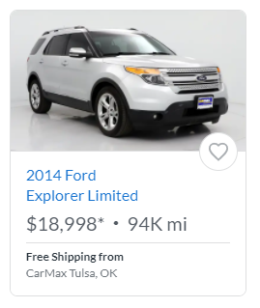

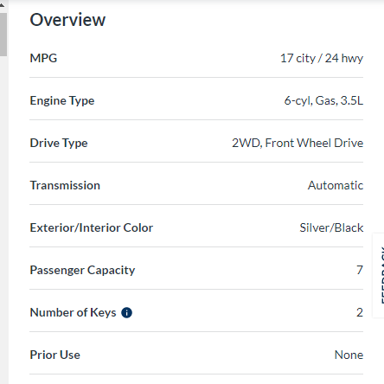

Step 2: Finding a Loan
In this step, you will identify two different loan options for purchasing your vehicle. You are welcome to contact your current bank if you would like, but you are also welcome to use a website such as BankRate or NerdWallet to find your rates. When you decide on a loan, make sure that you pick two different lengths (a 48 and a 60, for instance). If the place you are getting your loan from doesn't specify a length, then you can select the length on your own. In addition, NerdWallet gives ranged of possible interest rates. Select an interest rate in the range.
Describe the first loan /what is the APR? what is the length of the loan
Solution
First loan option is to take loan of $30,000 using interest rate of 3.424% and APR of %3.793 for 5 years (60 months). 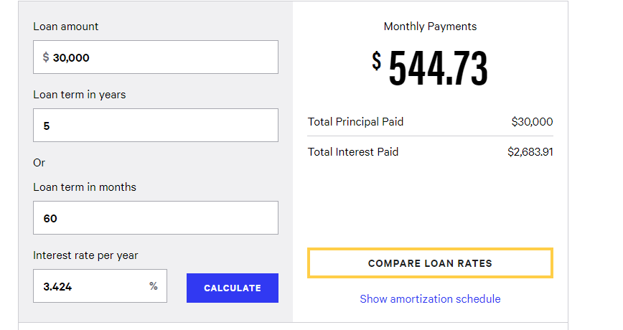
Describe the second loan here. What is the APR? what is the length of the loan
Solution
The second loan option is to take a loan of $25,000 using the interest rate of %4.250 and APR of %3.451 for 3 years (36 months) 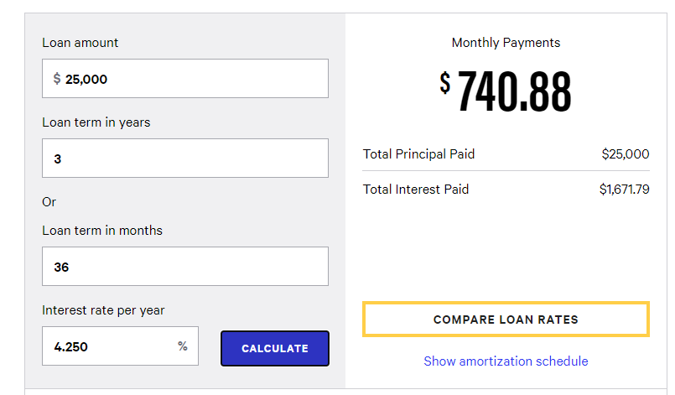

Which loan do you think will result in you having to pay back the most interest? What is it about the loan that makes you think this way?
Loan option I that is to take loan of $30,000 using interest rate of 3.424% and APR of %3.793 for 5 years (60 months). Among the two loans option, the loan taking several months that is 60 months will pay more interest compared to the loan taking short time irrespective of the loan amount, since the loan accumulates every month.

Step 3: Repaying the Car Loan All at Once
Using the information you have gathered in the previous two steps, calculate the value of the loan at the end of your selected time period. Use the compound interest above. Often, people who purchase cars put some money down. Calculate a 10% down payment of the loan, and subtract this to find the principal of the loan.
What is the down payment for your car
The down-payment for the car is $9,500, principle = $9500-($9500x0.10)=$8550
What is the amount you need to borrow to purchase your car.
Amount needed to be borrowed for buying of the car is given by $18,889
If you wait until the end of the loan period tpo pay off the first loan, how much money will you pay back to your car? How much interest will you have to pay using this loan
First option interest = $i=8550({1+\frac{0.10}{12})}^{12x5}$= $14,067.39,amount = $14,067.39+ $8550=$22,617.39
second option interest $i=8550({1+\frac{0.10}{12})}^{12x3}$= $11,526.95,amount = $11,526.95+ $8550 =20,076.95
If you wait until the end of the loan period to pay off the second loan, how much money will you pay back to your car? How much interest will you have to pay using this loan
The interest for the second option is smaller than the interest for the first option since its loan is smaller than the first option’s loan.
Compare the interest amounts you calculated for questions 3 and 4 what stand out to you about these interest amounts
The first option in step two had $30000 and second step $25000 , but in step 3 the amount are $22,617.39 and $20,076.95 respectively which varies with some positive deviation.
How close was your prediction from step 2 to the reality you found above? Be sure to include any insight that you have gained from this process?
For option I = $30000-$22,617.39=$7,382.61
Option 2=$25000-$20,076.95 =$ 4923.05
The process shows that the predicted value is large than the actual value obtained after calculation.
Step 4: Repaying the Car through Amortization
Amortization is the process of paying off a loan by making regular payments. Unlike savings annuities, where the goal is to increase the base amount through repeated payments, the goal of amortization is to lower the base amount so that less interest is compounded at each step. For this step, you will amortize both car loans using the same criteria for the loans (interest rate, time, loan principal).
Find the monthly payment for the first loan. How much will you pay in total for the car? How much total will you pay in interest.
Monthly payment for the first option is $544.73, interest is 2683.91, total amount is $32,683.91
Find the monthly payment for the second loan. How much will you pay in total for the car? How much total will you pay in interest
The monthly payment for the second option is $740.88, interest is $1671.79, and amount is $26671.79.
How much close your prediction from step 2 to the reality you found above? Be sure to include any insight that you have gained from this process. Did amortization change the result of which loan had a higher interest? What do you think this means?
Buying the car at $18998 which will be an approximated loan needed by other issues like fuel makes me take a very larger loan which will satisfy my needs. Taking the cost of the fuel consumption to be $ 20 for 90 days we get $180 added to the amount required to buy the car it comes to $19176, but the amortization’s interests are 2683.91 and $1671.79 for option 1 and 2 respectively then which makes the loan limit closer to the predicted value of the car. And subsequent higher interest in the loan.
Compare the interest for each loan from the step 3 and 4. why do you think the amortization has such a lower of interest
First option interest = $i=8550({1+\frac{0.10}{12})}^{12x5}$= $14,067.39, amount = $14,067.39+ $8550=$22,617.39. Second option interest $i=8550({1+\frac{0.10}{12})}^{12x3}$= $11,526.95, amount = $11,526.95+ $8550 =20,076.95 thus the amortization’s interests are 2683.91 and $1671.79 respectively, so the amortization interest are low than the calculated.
Houses are often one of the most expensive loans that people take out. These loans are typically done in 30 years o 15 years’ time period are almost always amortized. Consider a home that need a $ 150,000 loan. If the loan charges 2.597% APR, compounded monthly for 30 years. Calculate the loan as a compound interest loan strep (2) and as an amortised step3 find the interest paid for both loan . What have you learned about borrowing money based on this comparison?
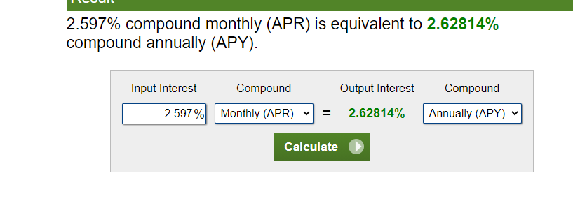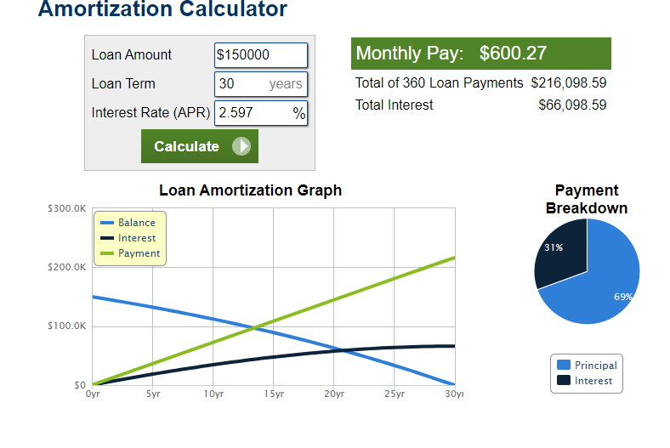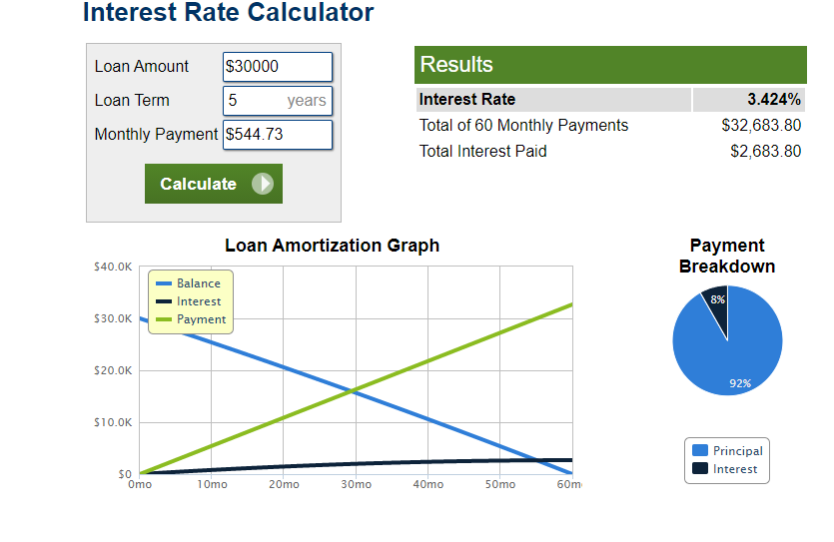
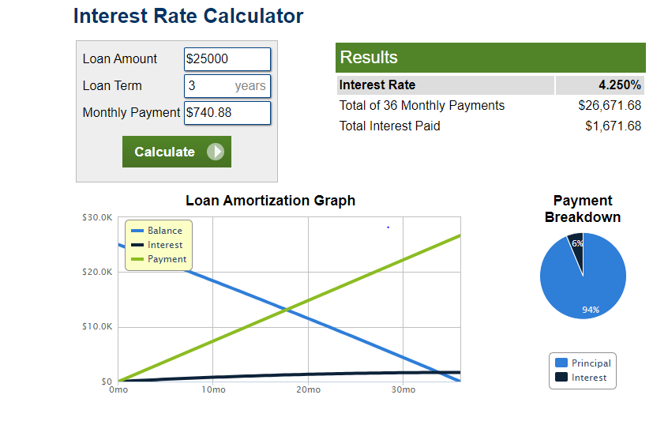

The amortized interest is $66098.59 and the interest rate for the two loan $are 161.68 and $ $2683.91, whereby the amortization loan is greater, hence the amortization interest will be larges the loan increases.

Step 5: Comparison of Loan Types

What is the value of the compound interest loan? What consideration would you have about the type of items you might purchase in this way

Value of compound interest loan is interest is $2683.91 and $1671.79 for two options. Purchasing an item using the compound interest accumulates higher interest.
What is the value of the amortized loan? What consideration would you have about the type of items you might purchase in this way?
The value of the amortized loan is $30,000 and $25,000. Taking a loan requires repaying so buying an item on loan requires completion of the payment or else the financial institution offered you a loan will snatched the item away.
What have you learned about borrowing money as a result of this assignment
Borrowing money attracts a lot of profits to the person borrowing and payment of an extremely higher amount to the lending institution.

