Primary Source – Isabel deOlvera Arrives in New Mexico
Source: George P. Hammond, ed, and Agapito Rey, trans., Don Juan de Onate: Colonizer of New Mexico, 1598-1628 (Albuquerque: University of New Mexico Press, 1953), 560-62.
The 16th and 17th Century historical records of the U.S. Southwest are replete with examples of persons of African ancestry who accompanied Spanish explorers and colonizers. The Juan de Onate party that established a colony along the upper Rio Grande near Santa Fe, in 1598, included at least five blacks and mulattoes, two of whom were soldiers. Most of those explorers and settlers were men. However in 1600 one black woman, Isabel De Olvera of Queretaro, the daughter of a black father and Indian mother, accompanied the Juan Guerra de Resa relief expedition to Santa Fe to strengthen the Spanish claim on the region. Her arrival predates by 19 years the first known landing at Jamestown, Virginia, of twenty persons of African ancestry in British North America. De Olvera, who was a servant for one of the Spanish women, was apparently concerned about her safety and status in the frontier region and gave the following deposition to the alcalde mayor of Queretaro. To buttress her claim, Olvera presented three witnesses, Mateo Laines, a free black man living in Queretaro, Anna Verdugo, a mestiza who lived near the city, and Santa Maria, a black slave of the alcalde mayor.
(Above text from Quintard Taylor and Shirley Ann Wilson Moore, eds. African American Women Confront the West, 1600-2000 (Norman: University of Oklahoma Press, 2003), 31.)
In the town of Queretaro in New Spain, January 8, 1600, there appeared before Don Pedro Lorenzo de Castilla, his majesty's alcalde mayor in this town, a mulatto woman named Isabel, who presented herself before his grace in the appropriate legal manner and declared:
As I am going on the expedition to New Mexico and have reason to fear that I may be annoyed by some individual since I am a mulatto, and as it is proper to protect my rights in such an eventuality by an affidavit showing that I am a free women, unmarried, and the legitimate daughter of Hernando, a negro and an Indian named Magdalena, I therefore request your grace to accept this affidavit, which show that I am free and not bound by marriage or slavery. I request that a properly certified and signed copy be given to me in order to protect my rights, and that it carry full legal authority. I demand justice.
The alcalde mayor instructed her to present the affidavits which she thought could be used and ordered that they be examined in accordance with this petition and that she be given the original. He so ordered and signed. DON PEDRO LORENZO DE CASTILLA. Before me, BALTASAR MARTINEZ, royal notary.

Map of North America

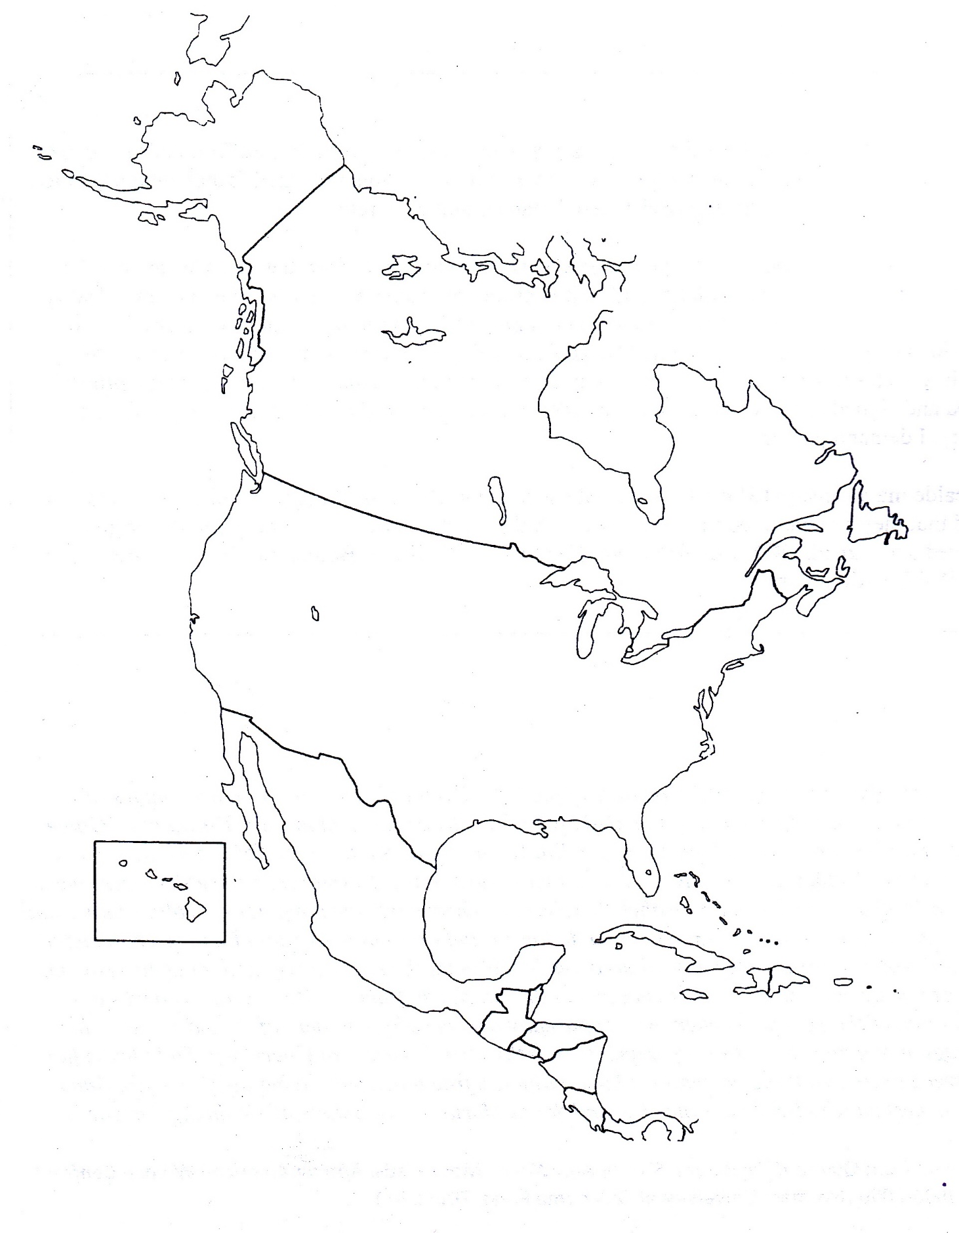
Primary Source – The Trappan’d Maiden (folk ballad, c 1600s)
Source: “The Trappan’d Maiden: or, the Distressed Damsel,” An American Garland: Being a Collection of Ballads Relating to America, 1563-1759, ed. C.H. Firth (Oxford University Press, 1915), pp. 251-253.
Give ear unto a maid that lately was betrayed
And sent into Virginny O.
In brief I shall declare what I have suffered there,
When that I was weary, weary, weary, weary O.
It's since that first I came unto this land of fame
Which is called Virginny O,
The axe and the hoe have wrought my overthrow
When that I was weary, weary, weary, weary O.
Five years and more served I all under Master Guy
In the land of Virginny O,
Which made me for to know sorrow, grief and woe
When that I was weary, weary, weary, weary O.
O when my dame says go, it's then I must do so
In the land of Virginny O.
When she sits at meat then I have none to eat
When that I am weary, weary, weary, weary O.
Instead of beds of ease to lie down when I please
In the land of Virginny O.
Upon a bed of straw I lie down full of woe
When that I am weary, weary, weary, weary O.
Oh I have played my part both at plough and cart
In the land of Virginny O.
Billets from the wood upon my back they load
When that I am weary, weary, weary, weary O.
And when the mill doth stand I'm ready at command
In the land of Virginny O.
The mortar for to make which makes my heart to ache
When that I am weary, weary, weary, weary O.
And when the child doth cry I must sing bye-a-bye
In the land of Virginny O.
No rest that I can have while I am here a slave
When that I am weary, weary, weary, weary O.
But if it be my chance homeward to advance
In the land of Virginny O,
If that I once more should land on England's shore
I'll no more be weary, weary, weary, weary O.

Primary Source - Anne Bradstreet (1612-1672) Poems
Source: Available at http://www.annebradstreet.com/anne_bradstreet_poems.htm
An Epitaph On my dear and ever honored Mother Mrs. Dorothy Dudley Who deceased Decem. 27. 1643 as of her age 61.
Here lyes
A worthy Matron of unspotted life,
A loving Mother and obedient wife,
A friendly Neighbor pitiful to poor,
Whom oft she fed and clothed with her store,
To Servants wisely aweful but yet kind,
And as they did so they reward did find;
A true Instructer of her Family,
The which she ordered with dexterity.
The publick meetings ever did frequent,
And in her Closet constant hours she spent;
Religious in all her words and wayes
Preparing still for death till end of dayes;
Of all her Children, Children lived to see,
Then dying, left a blessed memory.
To My Dear and Loving Husband
If ever two were one, then surely we.
If ever man were lov'd by wife, then thee.
If ever wife was happy in a man,
Compare with me, ye women, if you can.
I prize thy love more than whole Mines of gold
Or all the riches that the East doth hold.
My love is such that Rivers cannot quench,
Nor ought but love from thee give recompetence.
Thy love is such I can no way repay.
The heavens reward thee manifold, I pray.
Then while we live, in love let's so persever
That when we live no more, we may live ever.
From The Prologue
I am obnoxious to each carping tongue
Who says my hand a needle better fits.
A Poet's Pen all scorn I should thus wrong,
For such despite they cast on female wits.
If what I do prove well, it won't advance,
They'll say it's stol'n, or else it was by chance.
Let Greeks be Greeks, and Women what they are.
Men have precedency and still excel;
It is but vain unjustly to wage war.
Men can do best, and Women know it well.
Preeminence in all and each is yours;
Yet grant some small acknowledgement of ours.

Primary Source – Anne Hutchinson,Trial (1637)
Sources: John Winthrop, The Short Story of the Rise, Reign, and Ruin of the Antinomians of New England (London, 1644) and Thomas Hutchinson, History of the Colony and Province of Massachusetts (Boston, 1767).
One Mistris Hutchinson, the wife of Mr. William Hutchinson of Boston (a very honest and peaceable man of good estate) and the daughter of Mr. Marbury, sometimes a Preacher in Lincolnshire, after of London [was] a woman of haughty and fierce carriage, of a nimble wit and active spirit, and a very voluble tongue, more bold than a man, though in understanding and judgment, inferior to many women. This woman had learned her skill in England, and had discovered some of her opinions in the Ship, as she came over, which has caused some jealousie of her, which gave occasion of some delay of her admission, when she cunningly dissembled and coloured her opinions; as she soon got over that block, and was admitted into the Church, then she began to go to work, and became a woman very helpfull in the times of child-birth, and other occasions of bodily infirmities, and well furnished with means for those purposes, she easily insinuated her selfe into the affections of many. . . .

But when she had thus prepared the way by such wholesome truths, then she begins to set forth her own stuffe, and taught that no sanctification was nay evidence of a good estate, except their justification were first cleared up to them by the immediate witnesse of the Spirit, and that to see any work of grace (either faith or repentance, &c.) before this immediate witnesse, was a Covenant of works: whereupon many good soules, that had been of long approved godlinesse, were brought to renounce all the work of grace in them, and to wait for this immediate revelation. . . .

Indeed it was a wonder upon what a sudden the whole Church of Boston (some few excepted) were become her new converts, and infected with her opinions, and many also out of the Church, and of other Churches also, yea, many profane persons became of her opinion, for it was a very easie, and acceptable way to heaven, to see nothing, to have nothing, but waite for Christ to do all; so that after she had thus prevailed, and had drawn some of eminent place and parts to her party (whereof some profited so well, as in a few months they outwent their teacher) then she kept open house for all comers, and set up two Lecture dayes in the week, when they usually met at her house, threescore or fourescore persons, the pretense was to repeate Sermons, but when that was done, she would comment upon the Doctrines, and interpret all passages at her pleasure. . . .

COURT: What say you to your weekly publick meetings? can you shew a warrant for them?

HUTCH: I will shew you how I took it up, there were such meetings in use before I came, and because I went to none of them, this was the speciall reason of my taking up this course, wee began it but with five or six, and though it grew to more in future time, yet being tolerated at the first, I knew not why it might not continue.

COURT: There were private meetings indeed, and arte still in many places, of some few neighbours, but not so publick
and frequent as yours, and are of use for increase of love, and mutuall edification, but yours are of another nature, if they
had been such as yours they had been evil, and therefore no good warrant to justifie yours; but answer by what authority, or rule, you uphold them.

HUTCH: By Tit. 2 where the elder women are to teach the younger.

COURT: So wee allow you to do, as the Apostle there meanes, privately, and upon occasion, but that gives no warrant of such set meetings for that purpose; and besides, you take upon you to teach many that are elder than your selfe, neither do you teach them that which the Apostle commands, viz, to keep at home.

HUTCH: Will you please to give mee a rule against it, and I will yield?

COURT: You must have a rule for it, or else you cannot do it in faith, yet you have a plaine rule against it; I permit not a woman to teach…..

…HUTCH: It is said, I will poure my Spirit upon your Daughters, and they shall
prophesie, &c. If God give mee a gift of Prophecy, I may use it. . . .

….HUTCH: Here is my authority, Aquila and Priscilla, tooke upon them to instruct Apollo, more perfectly, yet he was a man of good parts, but they being better instructed might teach him.

…HUTCH: I call them not, but if they come to me, I may instruct them.

COURT: Yet you shew us not a rule.

HUTCH: I have given you two places of Scripture.

COURT: But neither of them will sute your practise.

HUTCH: Must I shew my name written therein?

Primary Source – Thomas Jefferson, Declaration of Independence Preamble (July 4, 1776)
Source: Full Text available at the National Archives, America’s Founding Documents
The unanimous Declaration of the thirteen united States of America,
When in the Course of human events, it becomes necessary for one people to dissolve the political bands which have connected them with another, and to assume among the powers of the earth, the separate and equal station to which the Laws of Nature and of Nature's God entitle them, a decent respect to the opinions of mankind requires that they should declare the causes which impel them to the separation.
We hold these truths to be self-evident, that all men are created equal, that they are endowed by their Creator with certain unalienable Rights, that among these are Life, Liberty and the pursuit of Happiness.--That to secure these rights, Governments are instituted among Men, deriving their just powers from the consent of the governed, --That whenever any Form of Government becomes destructive of these ends, it is the Right of the People to alter or to abolish it, and to institute new Government, laying its foundation on such principles and organizing its powers in such form, as to them shall seem most likely to effect their Safety and Happiness. Prudence, indeed, will dictate that Governments long established should not be changed for light and transient causes; and accordingly all experience hath shewn, that mankind are more disposed to suffer, while evils are sufferable, than to right themselves by abolishing the forms to which they are accustomed. But when a long train of abuses and usurpations, pursuing invariably the same Object evinces a design to reduce them under absolute Despotism, it is their right, it is their duty, to throw off such Government, and to provide new Guards for their future security --Such has been the patient sufferance of these Colonies; and such is now the necessity which constrains them to alter their former Systems of Government. The history of the present King of Great Britain is a history of repeated injuries and usurpations, all having in direct object the establishment of an absolute Tyranny over these States. To prove this, let Facts be submitted to a candid world….
Primary Source – Abigail Adams, Letters to John Adams and His Reply (1776)
Source: Adams Family Papers: An Electronic Archive. Massachusetts Historical Society. http://www.masshist.org/digitaladams/
Abigail Adams to John Adams
Braintree March 31, 1776
… -- I long to hear that you have declared an independency -- and by the way in the new Code of Laws which I suppose it will be necessary for you to make I desire you would Remember the Ladies, and be more generous and favourable to them than your ancestors. Do not put such unlimited power into the hands of the Husbands. Remember all Men would be tyrants if they could. If perticuliar care and attention is not paid to the Laidies we are determined to foment a Rebelion, and will not hold ourselves bound by any Laws in which we have no voice, or Representation.
That your Sex are Naturally Tyrannical is a Truth so thoroughly established as to admit of no dispute, but such of you as wish to be happy willingly give up the harsh title of Master for the more tender and endearing one of Friend. Why then, not put it out of the power of the vicious and the
Lawless to use us with cruelty and indignity with impunity. Men of Sense in all Ages abhor those customs which treat us only as the vassals of your Sex. Regard us then as Beings placed by providence under your protection and in immitation of the Supreem Being make use of that power only for our happiness.

John Adams to Abigail Adams
Ap. 14 1776
As to Declarations of Independency, be patient. Read our Privateering Laws, and our Commercial Laws. What signifies a Word.
As to your extraordinary Code of Laws, I cannot but laugh. We have been told that our Struggle has loosened the bands of Government every where. That Children and Apprentices were disobedient -- that schools and Colledges were grown turbulent -- that Indians slighted their Guardians and Negroes grew insolent to their Masters.
But your Letter was the first Intimation that another Tribe more numerous and powerfull than all the rest were grown discontented. -- This is rather too coarse a Compliment but you are so saucy, I wont blot it out.
Depend upon it, We know better than to repeal our Masculine systems. Altho they are in full Force, you know they are little more than Theory. We dare not exert our Power in its full Latitude. We are obliged to go fair, and softly, and in Practice you know We are the subjects. We have only the Name of Masters, and rather than give up this, which would compleatly subject Us to the Despotism of the Peticoat, I hope General Washington, and all our brave Heroes would fight. I am sure every good Politician would plot, as long as he would against Despotism, Empire, Monarchy, Aristocracy, Oligarchy, or Ochlocracy.

Abigail Adams to John Adams
B[raintree] May 7 1776
…I can not say that I think you very generous to the Ladies, for whilst you are proclaiming peace and good will to Men, Emancipating all Nations, you insist upon retaining an absolute power over Wives. But you must remember that Arbitary power is like most other things which are very hard, very liable to be broken -- and notwithstanding all your wise Laws and Maxims we have it in our power not only to free ourselves but to subdue our Masters, and without voilence throw both your natural and legal authority at our feet
"Charm by accepting, by submitting sway
Yet have our Humour most when we obey."
I thank you for several Letters which I have received since I wrote Last. They alleviate a tedious absence, and I long earnestly for a Saturday Evening, and experience a similar pleasure to that which I used to find in the return of my Friend upon that day after a weeks absence….

Primary Source – John Abbott, The Mother at Home (1833)
Source: John S. C. Abbott, The Mother at Home: Principles of Maternal Duty, 1833.
“A good boy, generally makes a good man.” Said the mother of Washington, “George was always a good boy.” Here we see one secret of his greatness. George Washington had a mother, who made him a good boy, and instilled in his heart those principles, which raised him to be the benefactor of his country, and one of the brightest ornaments of the world. The Mother of Washington is entitled to a nation’s gratitude. She taught her boy the principles of obedience, and moral courage, and virtue. She, in a great measure, formed the character of the Hero, and the Statesman. It was by her own fire side, that she taught her playful boy to govern himself, and thus was he prepared for the brilliant career of usefulness which he afterwards pursued. We are indebted to God for the gift of Washington; but we are no less indebted to him for the gift of his inestimable mother. Had she been a weak and indulgent and unfaithful parent, the unchecked energies of Washington might have elevated him to the throne of a tyrant, or youthful disobedience, might have prepared the way for a life of crime and a dishonored grave.
…Mothers have as powerful an influence over the welfare of future generations, as all other causes combined. Thus far, the history of the world has been composed of the narrations of oppression and blood. War has scattered its unnumbered woes. The cry of the oppressed has unceasingly ascended to heaven. Where are we to look for the influence which shall change this scene, and fill the earth with the fruits of peace and benevolence? It is to Christianity, as taught from a mother’s lips. In nine cases out of ten, the first six or seven years decide the character of the man. If the boy leaves the paternal roof, uncontrolled, turbulent, and vicious, he will, in all probability, rush on in the mad career of self-indulgence. There are exceptions. But these exceptions are rare. If, on the other hand, your son goes from home, accustomed to control himself, he will most undoubtedly retain that habit through life. If he has been taught to make sacrifices of his own enjoyment, that he may promote the happiness of those around him, he will continue to practice benevolence, and consequently will be respected, and useful, and happy. If he has adopted firm resolutions to be faithful in all the relations of life, he in all probability will be a virtuous man, and an estimable citizen, and a benefactor of his race.
When our land is filled with virtuous and patriotic mothers, then will it be filled with virtuous and patriotic men. This world’s redeeming influence must come from a mother’s lips. She who was first in the transgression [i.e., Eve], must be yet the principal earthly instrument in the restoration. Other causes may greatly aid. Other influences must be ready to receive the mind, as it comes from the mother’s hand, and carry it onward in its improvement. But the mothers of our race must be the chief instruments in its redemption. The brightest rays of the millennial morn must come from the cradle. This sentiment will bear examining. And the more it is examined, the more manifestly true will it appear. It is alike the dictate of philosophy and experience. The mother, who is neglecting personal effort, and relying upon other influences for the formation of virtuous character in her children, will find, when it is too late, that she has fatally erred. The patriot, who hopes that schools, and lyceums, and the general diffusion of knowledge, will promote the good order and happiness of the community, while family government is neglected, will find that he is attempting to purify the streams which are flowing from a corrupt fountain.
It is maternal influence, which must be the great agent, in the hands of God, in bringing back our guilty race to duty and happiness. Oh that mothers could feel this responsibility as they ought. Then would the world assume a different aspect. Then should we less frequently behold unhappy families and broken hearted parents. A new race of men would enter upon the busy scene of life, and cruelty and crime would pass away. Oh mothers! reflect upon the power your Maker has placed in your hands. There is no earthly influence to be compared with yours. There is no combination of causes so powerful, in promoting the happiness or the misery of our race, as the instructions of home. In a most peculiar sense God has constituted you the guardians and controllers of the human family.

Primary Source – Harriet H. Robinson, Lowell Textile Workers (1898)
Source: Harriet H. Robinson, "Early Factory Labor in New England," in Massachusetts Bureau of Statistics of Labor, Fourteenth Annual Report (Boston: Wright & Potter, 1883), pp. 38082, 38788, 39192.
In what follows, I shall confine myself to a description of factory life in Lowell, Massachusetts, from 1832 to 1848, since, with that phase of Early Factory Labor in New England, I am the most familiar-because I was a part of it.
In 1832, Lowell was little more than a factory village. Five "corporations" were started, and the cotton mills belonging to them were building. Help was in great demand and stories were told all over the country of the new factory place, and the high wages that were offered to all classes of workpeople; stories that reached the ears of mechanics' and farmers' sons and glave new life to lonely and dependent women in distant towns and farmhouses .... Troops of young girls came from different parts of New England, and from Canada, and men were employed to collect them at so much a head, and deliver them at the factories.
At the time the Lowell cotton mills were started the caste of the factory girl was the lowest among the employments of women. In England and in France, particularly, great injustice had been done to her real character. She was represented as subjected to influences that must destroy her purity and self respect. In the eyes of her overseer she was but a brute, a slave, to be beaten, pinched and pushed about. It was to overcome this prejudice that such high wages had been offered to women that they might be induced to become millgirls, in spite of the opprobrium that still clung to this degrading occupation....
The early mill girls were of different ages. Some were not over ten years old; a few were in middle life, but the majority were between the ages of sixteen and twenty five. The very young girls were called "doffers." They "doffed," or took off, the full bobbins from the spinning frames, and replaced them with empty ones. These mites worked about fifteen minutes every hour and the rest of the time was their own. When the overseer was kind they were allowed to read, knit, or go outside the millyard to play. They were paid two dollars a week. The working hours of all the girls extended from five o'clock in the morning until seven in the evening, with one half hour each, for breakfast and dinner. Even the doffers were forced to be on duty nearly fourteen hours a day. This was the greatest hardship in the lives of these children. Several years later a ten hour law was passed, but not until long after some of these little doffers were old enough to appear before the legislative committee on the subject, and plead, by their presence, for a reduction of the hours of labor.
Those of the mill girls who had homes generally worked from eight to ten months in the year; the rest of the time was spent with parents or friends. A few taught school during the summer months. Their life in the factory was made pleasant to them. In those days there was no need of advocating the doctrine of the proper relation between employer and employed. Help was too valuable to be illtreated....
The most prevailing incentive to labor was to secure the means of education for some male member of the family. To make a gentleman of a brother or a son, to give him a college education, was the dominant thought in the minds of a great many of the better class of mill girls. I have known more than one to give every cent of her wages, month after month, to her brother, that he might get the education necessary to enter some profession. I have known a mother to work years in this way for her boy. I have known women to educate young men by their earnings, who were not sons or relatives. There are many men now living who were helped to an education by the wages of the early mill girls.

It is well to digress here a little, and speak of the influence the possession of money had on the characters of some of these women. We can hardly realize what a change the cotton factory made in the status of the working women. Hitherto woman had always been a money saving rather than a money earning, member of the community. Her labor could command but small return. If she worked out as servant, or "help," her wages were from 50 cents to $1 .00 a week; or, if she went from house to house by the day to spin and weave, or do tailoress work, she could get but 75 cents a week and her meals. As teacher, her services were not in demand, and the arts, the professions, and even the trades and industries, were nearly all closed to her.
As late as 1840 there were only seven vocations outside the home into which the women of New England had entered. At this time woman had no property rights. A widow could be left without her share of her husband's (or the family) property, an "encumbrance" to his estate. A father could make his will without reference to his daughter's share of the inheritance. He usually left her a home on the farm as long as she remained single. A woman was not sup posed to be capable of spending her own, or of using other people's money. In Massachusetts, before 1840, a woman could not, legally, be treasurer of her own sewing society, unless some man were responsible for her. The law took no cognizance of woman as a money spender. She was a ward, an appendage, a relict. Thus it happened that if a woman did not choose to marry, or, when left a widow, to remarry, she had no choice but to enter one of the few employments open to her, or to become a burden on the charity of some relative.
One of the first strikes that ever took place in this country was in Lowell in 1836. When it was announced that the wages were to be cut down, great indignation was felt, and it was decided to strike or "turn out" en masse. This was done. The mills were shut down, and the girls went from their several corporations in procession to the grove on Chapel Hill, and listened to incendiary speeches from some early labor reformers.
One of the girls stood on a pump and gave vent to the feelings of her companions in a neat speech, declaring that it was their duty to resist all attempts at cutting down the wages. This was the first time a woman had spoken in public in Lowell, and the event caused surprise and consternation among her audience …
They had neither flags nor music, but sang songs, a favorite (but rather inappropriate) one being a parody on “I won’t be a nun.”
“Oh! Isn’t it a pity, such a pretty girl as I-
Should be sent to the factory to pine away and die
Oh I cannot be a slave,
I will not be a slave
For I’m so fond of liberty
That I cannot be a slave.”
It is hardly necessary to say that, so far as practical results are concerned, this strike did no good. The corporation would not come to terms. The girls were soon tired of holding out, and they went back to their work at the reduced rate of wages. The ill success of this early attempt at resistance on the part of the wage element seems to have made a precedent for the issue of many succeeding strikes.

Primary Source - Catharine Beecher, Evils Suffered by American Women and Children (1846)
Source: Beecher, Catharine Esther, The evils suffered by American women and American children: The Causes and the Remedy. Presented in an Address by Miss C. E. Beecher to the meetings of the Ladies in Cincinnati, Washington, Baltimore, Philadelphia, New York and other Cities also an address to the Protestant Clergy of the United States. New York: Harper & Bros., c1846.
Full text digital text available at: Harvard Library
The immediate object which has called us together, is an enterprise now in progress, the design of which is to educate destitute American children, by the, agency American women. It is an effort which has engaged the exertions of a large number of ladies of various sects, and of all sections in our country, and one which, though commencing in a humble way on a small scale, we believe is eventually to exert a most extensive and saving influence through the nation….
Few are aware of the deplorable destitution of our country in regard to the education of the rising generation, or of the long train of wrongs and sufferings endured by multitudes of young children from the neglect… Ten thousand teachers are now needed in Ohio and Kentucky alone, to furnish schools for more than two hundred thousand children, who otherwise must grow up in utter ignorance….
Let us now turn to another class of our countrywomen-the female operatives in our shops and mills. Unfortunately, this subject cannot be freely discussed without danger of collision with the vast pecuniary and party interests connected with it. I therefore shall simply state facts, without expressing the impressions of my own mind. Last year, I spent several days in Lowell, for the sole purpose of investigating this subject….
Let us now present the facts I learned by observation or inquiry on the spot. I was there in mid-winter. and every morning I was wakened at five, by the bells calling to labor. The time allowed for dressing and breakfast was so short, as many told me, that both were preformed hurriedly, and then work at the mills was begun by lamplight, and proceeded without remission till twelve, and chiefly in the standing position. Then half an hour only allowed for dinner, from which the time for going and returning was deducted. Then back to the mills, to work till seven o’clock, the last part of the time by lamplight. Then returning, washing, dressing, and supper occupied another hour…. Deduct eight hours for sleep and only two hours remain for shopping, mending, making, recreation, social intercourse, and breathing the pure air. For it must be remembered that all the hours of labor are spent in rooms where lamps, together with from forty to eighty persons, are exhausting the healthful principle of the air, where the temperature, both summer and winter, on account of the work… in some rooms at 80 1/4, and where the air is loaded with particles of cotton thrown from thousands of cards, spindles, and looms….
In regard to intellectual advantages, such as night schools, lectures, reading and composition, all time devoted to these must be taken from the hours required for recreation or needful repose…. All writing by actual operatives is probably done in hours which should have been given to sleep…. Now, without expressing any opinion as to the influence, on health and morals, of taking women away from domestic habits and pursuits, to labor with men in shops and mills, I simply ask if it would not be better to put the thousands of men who are keeping school for young children into the mills, and employ the women to train the children?
Another cause of depression to our sex if found in the fact that there is no profession for women of education and high position which like law, medicine, and theology, opens the way to competence. Influence and honor and presents motive for exertion. Woman ought never to be led to married life except under the promptings of pure affection….

Primary Source – Sale of Slaves and Stock Broadside (1859)
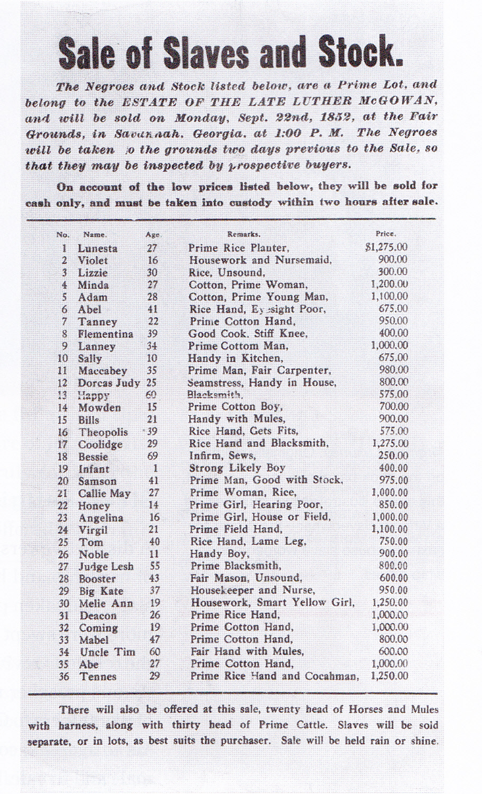
Primary Source – Slave Bill of Sale (1856)
Source: Kansas State Historical Society, David Burge to Thomas Johnson, May 24, 1856.
Available at Territorial Kansas Online 1854-1861
Text: Rec d of Thomas Johnson Eight hundred dollars in full payment for a Negro girl named Martha of a Black complexion aged about fifteen years. The above described Negro girl I warrant sound in body & mind & a slave for life & free from all claims – Westport Mo. May 26 th 1856 David Burger
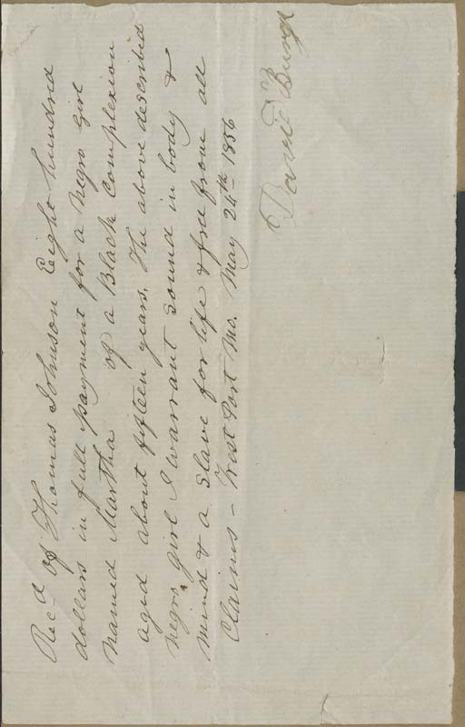

Primary Source – Runaway Slave Ad (1828)
Source: Thomas Balch Library, Leesburg, VA. http://www.balchfriends.org/

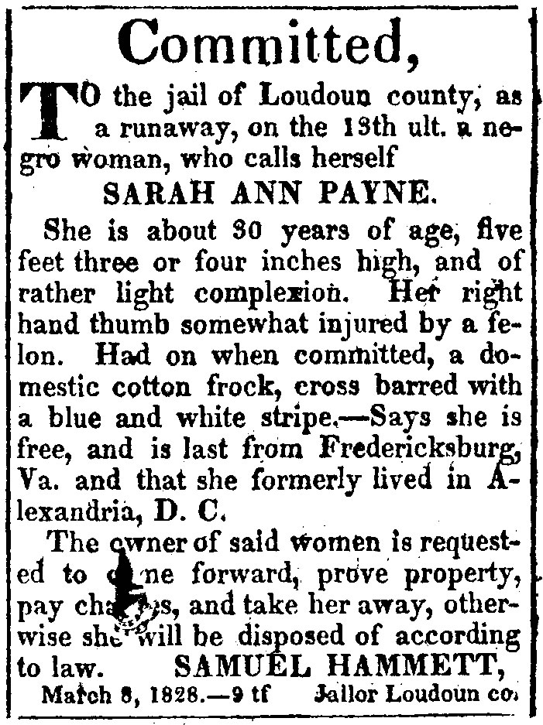
Primary Source – Sojourner Truth, Ain’t I a Woman Speech(1851)
Source: Sojourner Truth, "Ain't I a Woman?" in History of Woman Suffrage, Elizabeth Cady Stanton, Susan B.Anthony, and Matilda J. Gage, eds. (Rochester: Charles Mann, 1881), I: 403-04.
Sojourner Truth, Mrs. Stowe's "Lybian Sibyl," was present at this Convention.
Some of our younger readers may not know that Sojourner Truth was once a slave in the State of New York, and carries today as many marks of the diabolism of slavery, as ever scarred the back of a victim in Mississippi. Though she can neither read nor write, she is a woman of rare intelligence and commonsense on all subjects. She is still living, at Battle Creek, Michigan, though now 110 years old. Although the exalted character and personal appearance of this noble woman have been often portrayed, and her brave deeds and words many times rehearsed, yet we give the following graphic picture of Sojourner's appearance in one of the most stormy sessions of the Convention, from reminiscences by Frances D. Gage.
The leaders of the movement trembled on seeing a tall, gaunt black woman in a gray dress and white turban, surmounted with an uncouth sunbonnet, march deliberately into the church, walk with the air of a queen up the aisle, and take her seat upon the pulpit steps. A buzz of disapprobation was heard allover the house, and there fell on the listening ear, "An abolition affair!" "Woman's rights and niggers!" "I told you so!" "Go to it, darkey!"
I chanced on that occasion to wear my first laurels in public life as president of the meeting. At my request order was restored, and the business of the Convention went on. Through all these sessions old Sojourner, quiet and reticent as the "Lybian Statue," sat crouched against the wall on the corner of the pulpit stairs, her sunbonnet shading her eyes, her elbows on her knees, her chin resting upon her broad, hard palms. At intermission she was busy selling the "Life of Sojourner Truth," a narrative of her own strange and adventurous life. Again and again, timorous and trembling ones came to me and said, with earnestness, "Don't let her speak, Mrs. Gage, it will ruin us. Every newspaper in the land will have our cause mixed up with abolition and niggers, and we shall be utterly denounced." My only answer was, "We shall see when the time comes."
The second day the work waxed warm. Methodist, Baptist, Episcopal, Presbyterian and Universalist ministers came in to hear and discuss the resolutions presented….There were very few women in those days who dared to "speak in meeting"; and the august teachers of the people were seemingly getting the better of us, while the boys in the galleries, and the sneers among the pews, were hugely enjoying the discomfiture, as they supposed, of the "strong-minded." Some of the tender-skinned friends were on the point of losing dignity, and the atmosphere betokened a storm. When, slowly from her seat in the comer rose Sojourner Truth, who, till now, had scarcely lifted her head.
"Don't let her speak!" gasped half a dozen in my ear. She moved slowly and solemnly to the front, laid her old bonnet at her feet, and turned her great speaking eyes to me. There was a hissing sound of disapprobation above and below. I rose and announced "Sojourner Truth," and begged the audience to keep silence for a few moments.
The tumult subsided at once, and every eye was fixed on this almost Amazon form, which stood nearly six feet high, head erect, and eyes piercing the upper air like one in a dream. At her first word there was a profound hush. She spoke in deep tones, which, though not loud, reached every ear in the house, and away through the throng at the doors and windows.
"Wall, chilren, whar dar is so much racket dar must be somethin' out o' kilter. I tink dat 'twixt de niggers of de Sof and de womin at de Noft, all talkin' 'bout rights, de white men will be in a fix pretty soon. But what's all dis here talkin' 'bout? "Dat man ober dar say dat womin needs to be helped into carriages, and lifted ober ditches, and to hab de best place everywhar. Nobody eber helps me into
carriages, or ober mud-puddles, or gibs me any best place!" And raising herself to her full height, and her voice to a pitch like rolling thunder, she asked, "And a'n't I a woman?
Look at me! Look at my arm! (and she bared her right arm to the shoulder, showing her tremendous muscular power). I have ploughed, and planted, and gathered into barns, and no man could head me! And a'n't I a woman?
I could work as much and eat as much as a man-when I could get it-and bear de lash as well! And a'n't I a woman? I have borne thirteen chilren, and seen 'em mos' all sold off to slavery, and when I cried out with my mother's grief, none but Jesus heard me! And a'n't I a woman?
"Den dey talks 'bout dis ting in de head; what dis dey call it?" ("Intellect," whispered some one near.) "Dat's it, honey. What's dat got to do wid womin's rights or nigger's rights? If my cup won't hold but a pint, and yours holds a quart, wouldn't ye be mean not to let me half my little half-measure full?" And she pointed her significant finger, and sent a keen glance at the minister who had made the argument. The cheering was long and loud.
"Den dat little man in black dar, he say women can't have as much rights as men
'cause Christ wan't a woman! Whar did your Christ come from?" Rolling thunder couldn't have stilled that crowd, as did those deep, wonderful tones, as she stood there with outstretched arms and eyes of fire. Raising her voice still louder, she repeated, "Whar did your Christ come from? From God and a woman! Man had nothin' to do wid Him." Oh, what a rebuke that was to that little man.
Turning again to another objector, she took up the defense of Mother Eve. I cannot follow her through it all. It was pointed, and witty, and solemn; eliciting at almost every sentence deafening applause, and she ended by asserting: "If de fust woman God ever made was strong enough to turn the world upside down all alone, dese women togedder, .....(and she glanced her eyes over the platform) ought to be able to turn in back, and get it right side up again! And now dey is asking to do it, de men better let 'em." Long continued cheering greeted this. " 'Bleeged to ye for hearin' on me, and now ole Sojourner han't got nothin' more to say."
Amid roars of applause, she returned to her corner, leaving more than one of us with streaming eyes, and hearts beating with gratitude. She had taken us up in her strong arms and carried us safely over the slough of difficulty by turning the whole tide in our favor.
I have never in my life seen anything like the magical influence that subdued the mobbish spirit of the day, and turned the sneers and jeers of an excited crowd into notes of respect and admiration. Hundreds rushed up to shake hands with her, and congratulate the glorious old mother, and bid her Godspeed on her mission of "testifyin' again concerning the wickedness of this 'ere people."

Primary Source – Elizabeth Cady Stanton, Declaration of Sentiments (1848)
Source: Report of the Woman's Rights Convention, Held at Seneca Falls, N.Y., July 19th and 20th, 1848 (Rochester, 1848). From the Selected Papers of Elizabeth Cady Stanton and Susan B. Anthony, vol. 1, In the School of Anti-Slavery, 1840 to 1866, ed. Ann D. Gordon (New Brunswick, N.J., 1997).
When, in the course of human events, it becomes necessary for one portion of the family of man to assume among the people of the earth a position different from that which they have hitherto occupied, but one to which the laws of nature and of nature's God entitle them, a decent respect to the opinions of mankind requires that they should declare the causes that impel them to such a course.
We hold these truths to be self-evident: that all men and women are created equal; that they are endowed by their Creator with certain inalienable rights; that among these are life, liberty, and the pursuit of happiness; that to secure these rights governments are instituted, deriving their just powers from the consent of the governed. Whenever any form of Government becomes destructive of these ends, it is the right of those who suffer from it to refuse allegiance to it, and to insist upon the institution of a new government, laying its foundation on such principles, and organizing its powers in such form as to them shall seem most likely to effect their safety and happiness. Prudence, indeed, will dictate that governments long established should not be changed for light and transient causes; and accordingly, all experience hath shown that mankind are more disposed to suffer, while evils are sufferable, than to right themselves by abolishing the forms to which they are accustomed. But when a long train of abuses and usurpations, pursuing invariably the same object, evinces a design to reduce them under absolute despotism, it is their duty to throw off such government, and to provide new guards for their future security. Such has been the patient sufferance of the women under this government, and such is now the necessity which constrains them to demand the equal station to which they are entitled.
The history of mankind is a history of repeated injuries and usurpations on the part of man toward woman, having in direct object the establishment of an absolute tyranny over her. To prove this, let facts be submitted to a candid world.
He has never permitted her to exercise her inalienable right to the elective franchise.
He has compelled her to submit to laws, in the formation of which she had no voice.
He has withheld from her rights which are given to the most ignorant and degraded men—both natives and foreigners.
Having deprived her of this first right of a citizen, the elective franchise, thereby leaving her without representation in the halls of legislation, he has oppressed her on all sides.
He has made her, if married, in the eye of the law, civilly dead.
He has taken from her all right in property, even to the wages she earns.
He has made her, morally, an irresponsible being, as she can commit many crimes with impunity, provided they be done in the presence of her husband. In the covenant of marriage, she is compelled to promise obedience to her husband, he becoming, to all intents and purposes, her master—the law giving him power to deprive her of her liberty, and to administer chastisement.

He has so framed the laws of divorce, as to what shall be the proper causes of divorce; in case of separation, to whom the guardianship of the children shall be given; as to be wholly regardless of the happiness of women—the law, in all cases, going upon the false supposition of the supremacy of man, and giving all power into his hands.
After depriving her of all rights as a married woman, if single and the owner of property, he has taxed her to support a government which recognizes her only when her property can be made profitable to it.
He has monopolized nearly all the profitable employments, and from those she is permitted to follow, she receives but a scanty remuneration.
He closes against her all the avenues to wealth and distinction, which he considers most honorable to himself. As a teacher of theology, medicine, or law, she is not known.
He has denied her the facilities for obtaining a thorough education—all colleges being closed against her.
He allows her in Church as well as State, but a subordinate position, claiming Apostolic authority for her exclusion from the ministry, and, with some exceptions, from any public participation in the affairs of the Church.
He has created a false public sentiment, by giving to the world a different code of morals for men and women, by which moral delinquencies which exclude women from society, are not only tolerated but deemed of little account in man.
He has usurped the prerogative of Jehovah himself, claiming it as his right to assign for her a sphere of action, when that belongs to her conscience and her God.
He has endeavored, in every way that he could to destroy her confidence in her own powers, to lessen her self-respect, and to make her willing to lead a dependent and abject life.
Now, in view of this entire disfranchisement of one-half the people of this country, their social and religious degradation,—in view of the unjust laws above mentioned, and because women do feel themselves aggrieved, oppressed, and fraudulently deprived of their most sacred rights, we insist that they have immediate admission to all the rights and privileges which belong to them as citizens of these United States.
In entering upon the great work before us, we anticipate no small amount of misconception, misrepresentation, and ridicule; but we shall use every instrumentality within our power to effect our object. We shall employ agents, circulate tracts, petition the State and national Legislatures, and endeavor to enlist the pulpit and the press in our behalf.We hope this Convention will be followed by a series of Conventions, embracing every part of the country.
Firmly relying upon the final triumph of the Right and the True, we do this day affix our signatures to this declaration.

Primary Source - Clara Barton, Medical Life at the Battlefield (1862)
Source: Perry Epler, Life of Clara Barton, New York: Macmillan, 1915. p. 31-98
I was strong and thought I might go to the rescue of the men who fell. . . . What could I do but go with them, or work for them and my country? The patriot blood of my father was warm in my veins. The country which he had fought for, I might at least work for. . . .
But I struggled long and hard with my sense of propriety-with the appalling fact that I was only a woman whispering in one ear, and thundering in the other the groans of suffering men dying like dogs-unfed and unsheltered, for the life of every institution which had protected and educated me!
I said that I struggled with my sense of propriety and I say it with humiliation and shame. I am ashamed that I thought of such a thing.
When our armies fought on Cedar Mountain, I broke the shackles and went to the field. . . .
Five days and nights with three hours sleep-a narrow escape from capture-and some days of getting the wounded into hospitals at Washington, brought Saturday, August 30. And if you chance to feel, that the positions I occupied were rough and unseemly for a woman-I can only reply that they were rough and unseemly for men. But under all, lay the life of the nation. I had inherited the rich blessing of health and strength of constitution-such as are seldom given to woman-and I felt that some return was due from me and that I ought to be there. . . .
…At 10 o'clock Sunday (August 31) our train drew up at Fairfax Station. The ground, for acres, was a thinly wooded slope-and among the trees on the leaves and grass, were laid the wounded who pouring in by scores of wagon loads, as picked up on the field the flag of truce. All day they came and the whole hillside was red. Bales of hay were broken open and scattered over the ground littering of cattle, and the sore, famishing men were laid upon it.
And when the night shut in, in the mist and darkness about us, we knew that standing apart from the world of anxious hearts, throbbing over the whole country, we were a little band of almost empty handed workers literally by ourselves in the wild woods of Virginia, with 3,000 suffering men crowded upon the few acres within our reach.
After gathering up every available implement or convenience for our work, our domestic inventory stood 2 water buckets, 5 tin cups, 1 camp kettle, 1 stew pan, 2 lanterns, 4 bread knives, 3 plates, and a 2-quart tin dish, and 3,000 guest to serve.
You will perceive by this, that I had not yet learned to equip myself, for I was no Pallas, ready armed, but grew into my work by hard thinking and sad experience. It may serve to relieve your apprehension for the future of my labors if I assure you that I was never caught so again.
But the most fearful scene was reserved for the night. I have said that the ground was littered with dry hay and that we had only two lanterns, but there were plenty of candles. The wounded were laid so close that it was impossible to move about in the dark. The slightest misstep brought a torrent of groans from some poor mangled fellow in your path.

Consequently here were seen persons of all grades from the careful man of God who walked with a prayer upon his lips to the careless driver hunting for his lost whip,-each wandering about among this hay with an open flaming candle in his hands. The slightest accident, the mere dropping of a light could have enveloped in flames this whole mass of helpless men.
How we watched and pleaded and cautioned as we worked and wept that night! How we put socks and slippers upon their cold feet, wrapped your blankets and quilts about them, and when we no longer these to give, how we covered them in the hay and left them to their rest! . . .
The slight, naked chest of a fair-haired lad caught my eye, dropping down beside him, I bent low to draw the remnant of his blouse about him, when with a quick cry he threw his left arm across my neck and, burying his face in the folds of my dress, wept like a child at his mother's knee. I took his head in my hands and held it until great burst of grief passed away. "And do you know me?" he asked at length, "I am Charley Hamilton, we used to carry your satchel home from school!" My faithful pupil, poor Charley. That mangled right hand would never carry a satchel again.
About three o'clock in the morning I observed a surgeon with a little flickering candle in hand approaching me with cautious step up in the wood. "Lady," he said as he drew near, "will you go with me? Out on the hills is a poor distressed lad, mortally wounded, and dying. His piteous cries for his sister have touched all our hearts none of us can relieve him but rather seem to distress him by presence."
By this time I was following him back over the bloody track, with great beseeching eyes of anguish on every side looking up into our faces, saying so plainly, "Don't step on us."

Primary Source – Sentencing in the Case of United States v Susan B. Anthony (1873)
Source: Full Trial available at: Famous Trials, Susan Anthony Trial (1873)
Judge Hunt -(Ordering the defendant to stand up), "Has the prisoner anything to say why sentence shall not be pronounced?"
Miss Anthony- Yes, your honor, I have many things to say; for in your ordered verdict of guilty, you have trampled under foot every vital principle of our government. My natural rights, my civil rights, my political rights, my judicial rights, are all alike ignored. Robbed of the fundamental privilege of citizenship, I am degraded from the status of a citizen to that of a subject; and not only myself individually, but all of my sex, are, by your honor's verdict, doomed to political subjection under this, so-called, form of government.
Judge Hunt- The Court cannot listen to a rehearsal of arguments the prisoner's counsel has already consumed three hours in presenting.
Miss Anthony- May it please your honor, I am not arguing the question, but simply stating the reasons why sentence cannot, in justice, be pronounced against me. Your denial of my citizen's right to vote, is the denial of my right of consent as one of the governed, the denial of my right of representation as one of the taxed, the denial of my right to a trial by a jury of my peers as an offender against law, therefore, the denial of my sacred rights to life, liberty, property and-
Judge Hunt- The Court cannot allow the prisoner to go on.
Miss Anthony- But your honor will not deny me this one and only poor privilege of protest against this high-handed outrage upon my citizen's rights. May it please the Court to remember that since the day of my arrest last November, this is the first time that either myself or any person of my disfranchised class has been allowed a word of defense before judge or jury-
Judge Hunt- The prisoner must sit down-the Court cannot allow it.
Miss Anthony- All of my prosecutors, from the 8th ward corner grocery politician, who entered the compliant, to the United States Marshal, Commissioner, District Attorney, District Judge, your honor on the bench, not one is my peer, but each and all are my political sovereigns; and had your honor submitted my case to the jury, as was clearly your duty, even then I should have had just cause of protest, for not one of those men was my peer; but, native or foreign born, white or black, rich or poor, educated or ignorant, awake or asleep, sober or drunk, each and every man of them was my political superior; hence, in no sense, my peer. Even, under such circumstances, a commoner of England, tried before a jury of Lords, would have far less cause to complain than should I, a woman, tried before a jury of men. Even my counsel, the Hon. Henry R. Selden, who has argued my cause so ably, so earnestly, so unanswerably before your honor, is my political sovereign. Precisely as no disfranchised person is entitled to sit upon a jury, and no woman is entitled to the franchise, so, none but a regularly admitted lawyer is allowed to practice in the courts, and no woman can gain admission to the bar-hence, jury, judge, counsel, must all be of the superior class.
Judge Hunt- The Court must insist-the prisoner has been tried according to the established forms of law.

Miss Anthony- Yes, your honor, but by forms of law all made by men, interpreted by men, administered by men, in favor of men, and against women; and hence, your honor's ordered verdict of guilty; against a United States citizen for the exercise of "that citizen's right to vote," simply because that citizen was a woman and not a man. But, yesterday, the same man made forms of law, declared it a crime punishable with $1,000 fine and six months imprisonment, for you, or me, or you of us, to give a cup of cold water, a crust of bread, or a night's shelter to a panting fugitive as he was tracking his way to Canada. And every man or woman in whose veins coursed a drop of human sympathy violated that wicked law, reckless of consequences, and was justified in so doing. As then, the slaves who got their freedom must take it over, or under, or through the unjust forms of law, precisely so, now, must women, to get their right to a voice in this government, take it; and I have taken mine, and mean to take it at every possible opportunity.
Judge Hunt- The Court orders the prisoner to sit down. It will not allow another word.
Miss Anthony- When I was brought before your honor for trial, I hoped for a broad and liberal interpretation of the Constitution and its recent amendments, that should declare all United States citizens under its protecting gis-that should declare equality of rights the national guarantee to all persons born or naturalized in the United States. But failing to get this justice-failing, even, to get a trial by a jury not of my peers-I ask not leniency at your hands-but rather the full rigors of the law:
Judge Hunt- The Court must insist-
(Here the prisoner sat down.)
Judge Hunt- The prisoner will stand up.
(Here Miss Anthony arose again.)
The sentence of the Court is that you pay a fine of one hundred dollars and the costs of the prosecution.
Miss Anthony- May it please your honor, I shall never pay a dollar of your unjust penalty. All the stock in trade I possess is a $10,000 debt, incurred by publishing my paper- The Revolution -four years ago, the sole object of which was to educate all women to do precisely as I have done, rebel against your manmade, unjust, unconstitutional forms of law, that tax, fine, imprison and hang women, while they deny them the right of representation in the government; and I shall work on with might and main to pay every dollar of that honest debt, but not a penny shall go to this unjust claim. And I shall earnestly and persistently continue to urge all women to the practical recognition of the old revolutionary maxim, that "Resistance to tyranny is obedience to God."
Judge Hunt- Madam, the Court will not order you committed until the fine is paid.

Primary Source - Victoria Woodhull, The Truth Shall Make You Free (1871)
Source: Victoria C. Woodhull, And The Truth Shall Make You Free: A Speech On The Principles Of Social Freedom November 20, 1871
…Our government is based upon the proposition that: All men and women are born free and equal and entitled to certain inalienable rights, among which are life, liberty and the pursuit of happiness. Now what we, who demand social freedom, ask, is simply that the government of this country shall be administered in accordance with the spirit of this proposition. Nothing more, nothing less….
…To love is a right higher than Constitutions or laws. It is a right which Constitutions and laws can neither give nor take, and with which they have nothing whatever to do, since in its very nature it is forever independent of both Constitutions and laws, and exists-comes and goes-in spite of them. Governments might just as well assume to determine how people shall exercise their right to think or to say that they shall not think at all, as to assume to determine that they shall not love, or how they may love, or that they shall love.
The proper sphere of government in regard to the relations of the sexes, is to enact such laws as in the present conditions of society are necessary to protect each individual in the free exercise of his or her right to love, and also to protect each individual from the forced interference of every other person, that would compel him or her to submit to any action which is against their wish and will. If the law do this it fulfills its duty. If the law do not afford this protection, and worse still, if it sanction this interference with the rights of an individual, then it is infamous law and worthy only of the old-time despotism; since individual tyranny forms no part of the guarantee of, or the right to, individual freedom.
It is therefore a strictly legitimate conclusion that where there is no love as a basis of marriage there should be no marriage…. It is certain by this Higher Law, that marriages of convenience, and, still more, marriages characterized by mutual or partial repugnance, are adulterous. And it does not matter whether the repugnance arises before or subsequently to the marriage ceremony. Compulsion, whether of the law or of a false public opinion, is detestable, as an element even, in the regulation of the most tender and important of all human relations….
It can now be asked: What is the legitimate sequence of Social Freedom? To which I unhesitatingly reply: Free Love, or freedom of the affections. "And are you a Free Lover? is the almost incredulous query.
I repeat a frequent reply: "I am; and I can honestly, in the fullness of my soul, raise on my voice to my Maker, and thank Him that I am, and that I have had the strength and the devotion to truth to stand before this traducing and vilifying community in a manner representative of that which shall come with healing on its wings for the bruised hearts and crushed affections of humanity."
And to those who denounce me for this I reply: "Yes, I am a Free Lover. I have an inalienable, constitutional and natural right to love whom I may, to love as long or as short a period as I can; to change that love every day if I please, and with that right neither you nor any law you can frame have any right to interfere. And I have the further right to demand a free and unrestricted exercise of that right, and it is your duty not only to accord it, but, as a community, to see that I am protected in it. I trust that I am fully understood, for I mean just that, and nothing less!

…I claim that freedom means to be free, let the mob claim to the contrary as strenuously as they may. And I claim that love means an exhibition of the affections, let the mob claim what they may. And therefore, in compounding these words into Free Love, I claim that united they mean, and should be used to convey, their united definitions, the mob to the contrary notwithstanding. And when the term Free Love finds a place in dictionaries, it will prove my claim to have been correct, and that the mob have not received the attention of the lexicographers, since it will not be set down to signify sexual debauchery, and that only, or in any governing sense.
… The press have stigmatized me to the world as an advocate, theoretically and practically, of the doctrine of Free Love, upon which they have placed their stamp of moral deformity; the vulgar and inconsequent definition which they hold makes the theory an abomination….
…The false and hollow relations of the sexes are thus resolved into the mere question of the dependence of women upon men for support, and women, whether married or single, are supported by men because they are women and their opposites in sex. I can see no moral difference between a woman who marries and lives with a man because he can provide for her wants, and the woman who is not married, but who is provided for at the same price. There is a legal difference, to be sure, upon one side of which is set the seal of respectability, but there is no virtue in law. In the fact of law, however, is the evidence of the lack of virtue, since if the law be required to enforce virtue, its real presence is wanting; and women need to comprehend this truth.
The sexual relation, must be rescued from this insidious form of slavery. Women must rise from their position as ministers to the passions of men to be their equals. Their entire system of education must be changed. They must be trained to be like men, permanent and independent individualities, and not their mere appendages or adjuncts, with them forming but one member of society. They must be the companions of men from choice, never from necessity….

Primary Source - Victoria Woodhull Cartoon (1872)
Source: Harper’s Weekly, February 17, 1872
Available at http://harpweek.com/Images/SourceImages/CartoonOfTheDay/February/021772m.jpg
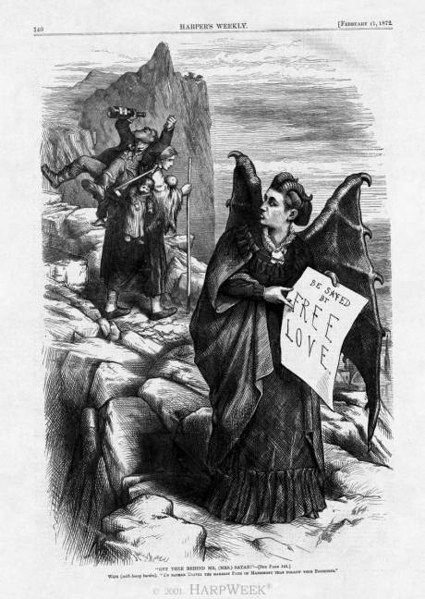

Primary Source - Narrative of Mrs. Rosalia Vallejo de Leese (1874)
Source: Cerruti, Enrique. "Narrative of Mrs. Rosalia Leese, Who Witnessed the Hoisting of the Bear Flag in Sonoma on the 14th of June, 1846." In Testimonios: Early California through the Eyes of Women, 1815-1848, translated and edited by Rose Marie Beebe and Robert W. Senkewicz. Berkeley: Heyday Books, 2006.
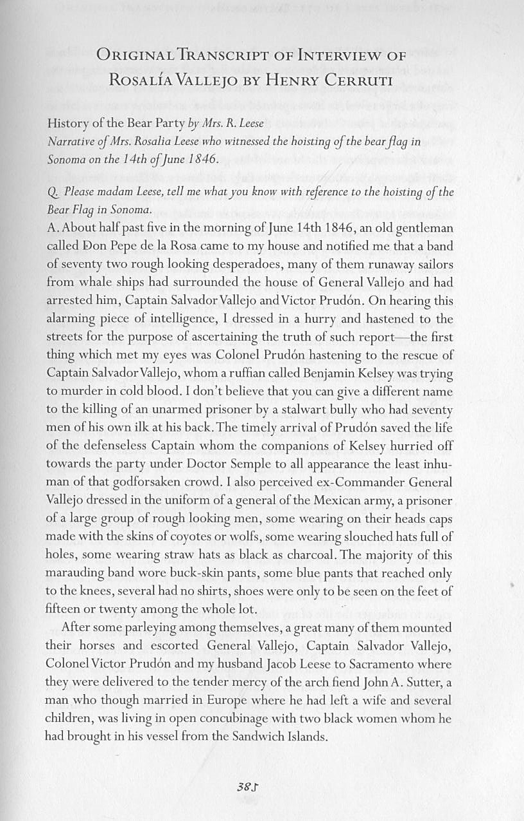
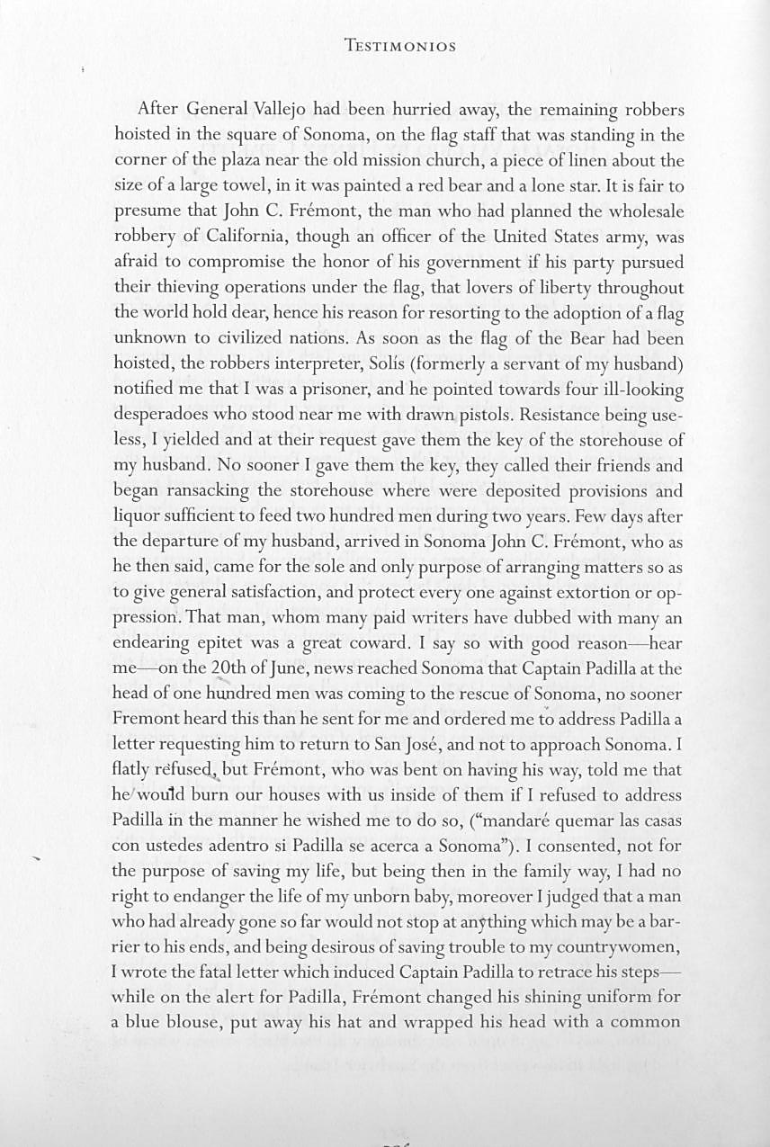

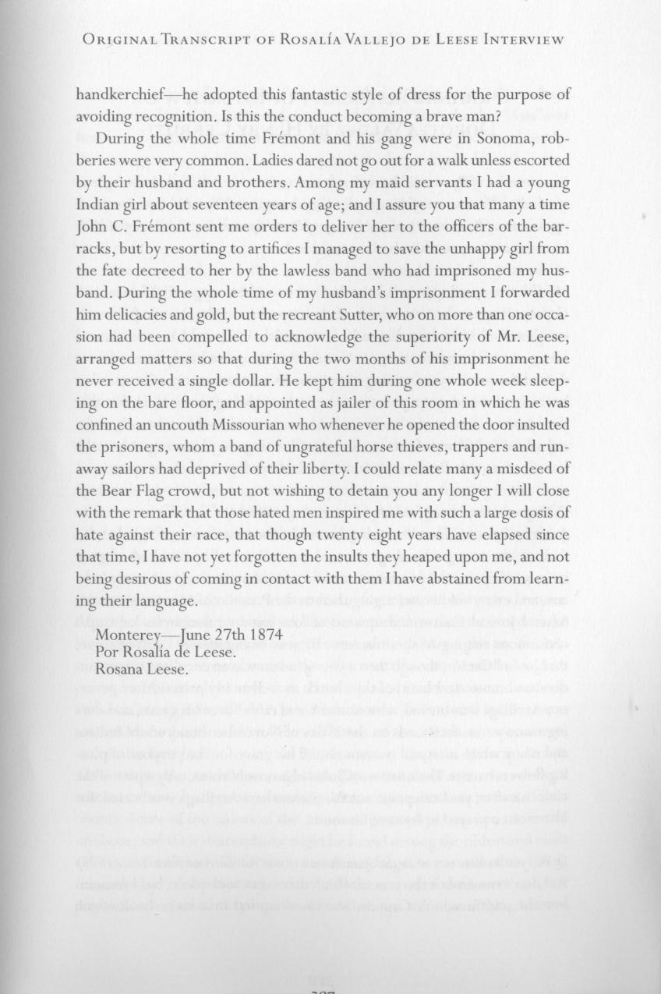

Primary Source - Mary Tape, Letter to School Board (1885)
Source: Alta, April 16, 1885, p. 1
*NOTE: spelling and grammatical errors are intact from original printing of the letter
1769 Green Street,
San Francisco, April 8, 1885
To the Board of Education – DEAR SIRS: I see that you are going to make all sorts of excuses to keep my child out of the Public school. Dear sirs, Will you please to tell me! Is it a disgrace to be Born a Chinese? Didn’t God make us all??? What right have you to bar my children out of the school because she is a Chinese Decend. Hay is no other worldly reason to that you could keep her out, except that. I suppose, you all goes to churches on Sundays! O you call that a Christian act to compel my little children to go far to a school that is made in purpose for them. My children don’t dress like the other Chinese. They look just as phunny amongst them as the Chinese dress in a Chinese look amongst you in Caucasian. Besides, if I have any wish to send them to a Chinese school I would have sent them two years ago without going to all this trouble. You have expended a lot of the Public money foolishly, all because of a one poor little Child. Her playmates is all Caucasian ever since she could toddle around. Is she is good enough to pay with Them! Then is she not good enough to be in the same room and studie with them? You had better come and see for yourselves. See if the Tape’s is not the same as other Caucasians, except in features. It seems no matter how a Chinese may live and dress so long as you know they Chinese. They are hated as one. There is not any right of justice for them.
You have seen my husband and child. You told him it wasn’t Mamie Tape you object to. If it were not Mamie Tape you object to, they why don’t you let her attend the school nearest her home! Instead of first making one pretense then another pretense of some kind to keep her out? It seems to me Mr. Moulder has a grudge against this Eight-year-old Mamie Tape. I know there is no other child I mean Chinese child! Care to go to your public Chinese school. May you Mr. Moulder, never be persecuted like the way you have persecuted little Mamie Tape. Mamie Tape will never attend any other Chinese schools of your making! Never!!! I will let the world see sir what justice there is when it is governed by the Race prejudice men! Just because she is of the Chinese decend, not because she don’t dress like you because she does. Just because she is descended of Chinese parents I guess she is more of a American then a good many of you that is going to prevent her being Educated. MRS. M. TAPE.

Primary Source - Rose Schneiderman, The Triangle Fire (1911)
Source: Speech by Rose Schneiderman at Metropolitan Opera House meeting to protest the Triangle Shirtwaist Factory fire, April 2, 1911.
I would be a traitor to these poor burned bodies if I came here to talk good fellowship. We have tried you good people of the public and we have found you wanting. The old Inquisition had its rack and its thumbscrews and its instruments of torture with iron teeth. We know what these things are today; the iron teeth are our necessities, the thumbscrews are the highpowered and swift machinery close to which we must work, and the rack is here in the firetrap structures that will destroy us the minute they catch on fire.
This is not the first time girls have been burned alive in the city. Every week I must learn of the untimely death of one of my sister workers. Every year thousands of us are maimed. The life of men and women is so cheap and property is so sacred. There are so many of us for one job it matters little if 146 of us are burned to death. We have tried you citizens; we are trying you now, and you have a couple of dollars for the sorrowing mothers, brothers and sisters by way of a charity gift. But every time the workers come out in the only way they know to protest against conditions which are unbearable the strong hand of the law is allowed to press down heavily upon us.
Public officials have only words of warning to us – warning that we must be intensely peaceable, and they have the workhouse just back of all their warnings. The strong hand of the law beats us back, when we rise, into the conditions that make life unbearable. I can't talk fellowship to you who are gathered here. Too much blood has been spilled. I know from my experience it is up to the working people to save themselves. The only way they can save themselves is by a strong working-class movement.

Primary Source – “Holding the Door Closed” Cartoon c. 1911
Source unknown, Artist illegible. (ILGWU Archives. Kheel Center. Cornell University)
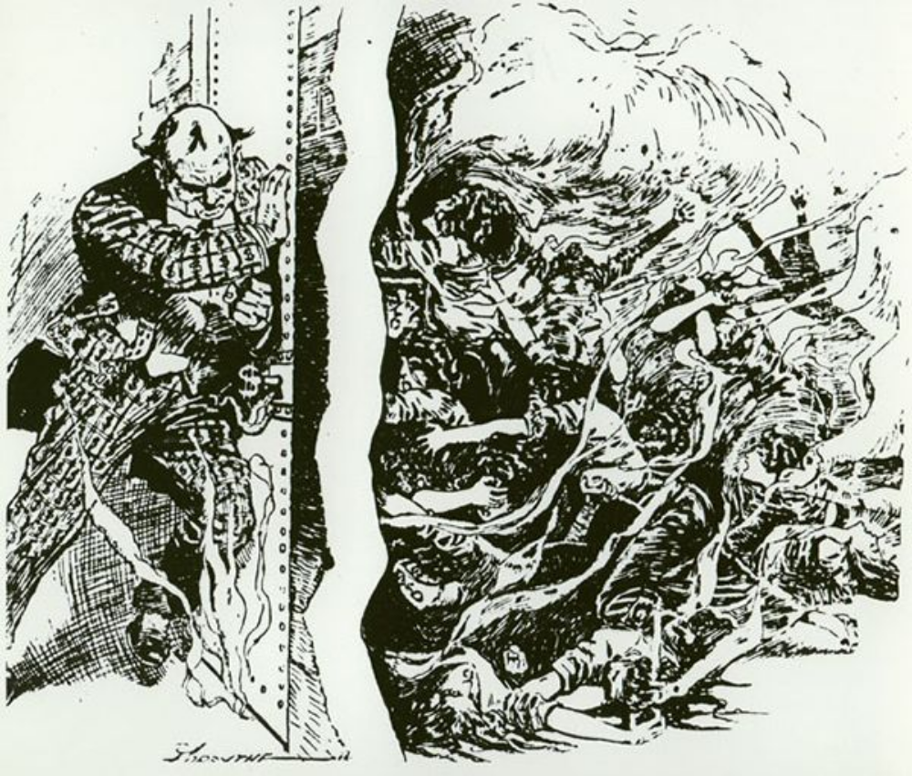

Primary Source - Anna Howard Shaw, NAWSA Convention Speech (1913)
Source: Anna Howard Shaw, “Remarks on Emotionalism in Politics Given at the National American Women Suffrage Association Convention in 1913,” in History of Woman Suffrage, Susan B. Anthony ed. (Indianapolis: Hollenbeck Press: 1920), 5.
By some objectors women are supposed to be unfit to vote because they are hysterical and emotional and of course men would not like to have emotion enter into a political campaign. They want to cut out all emotion and so they would like to cut us out. I had heard so much about our emotionalism that I went to the last Democratic national convention, held at Baltimore, to observe the calm repose of the male politicians. I saw some men take a picture of one gentleman whom they wanted elected and it was so big they had to walk sideways, as they carried it forward; they were followed by hundreds of other men screaming and yelling, shouting and singing the "Houn' Dawg;" then, when there was a lull, another set of men would start forward under another man's picture, not to be outdone by the "Houn' Dawg" melody, whooping and howling still louder. I saw men jump upon on the seats and throw their hats in the air... Then, when those hats came down, other men would kick them back into the air, shouting at the top of their voices. No hysteria about it - just patriotic loyalty, splendid manly devotion to principle. And so they went on and on until 5 o'clock in the morning ... I saw men jump up on their seats and jump down again and run around in a ring. I saw two men run towards another man to hug him both at once and they split his coat up the, middle of his back and sent him spinning around like a wheel. All this with the prefect poise of the legal male mind in politics!
I have been to many women's conventions in my day but I never saw a woman leap up on a chair and take off her bonnet and toss it in the air and shout: “What’s the matter with” somebody. I never saw a woman knock another woman’s bonnet off her head as she screamed: “She’s alright!” I never heard a body of women whooping and yelling for five minutes when somebody's name was mentioned in the convention. But we are willing to admit that we are emotional. I have actually seen women stand up and wave their handkerchiefs. I have even seen them take hold of hands and sing, “Blest be the tie that binds. Nobody denies that women are excitable. Still when I hear how emotional and excitable we are, I cannot help seeing in my mind’s eye the fine repose and dignity of this Baltimore and other political conventions I have attended.
Primary Source - Carrie Chapman Catt. An Address to the Congress of the United States Program (c. WWI)
Source: Bryn Mawr College Library
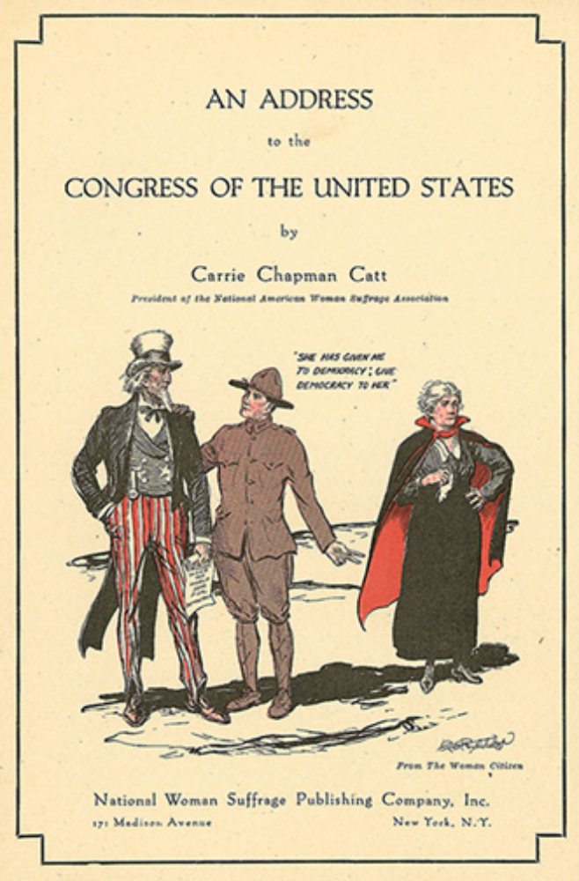
Text: “She has given me for democracy, give democracy to her”

Primary Source - Doris Stevens, Account of NWP Picketing (1920)
Source: Doris Stevens, Jailed for Freedom, New York, August 1920.
On the first arrests of the pickets, June 26, 1917
There was the criticism in the press and on the lips of men that we were embarrassing our Government before the eyes of foreign visitors. ..Of course it was embarrassing. We meant it to be. The truth must be told at all costs. This was not time for manners.
Hurried conferences behind closed doors! Summoning of the military to discuss declaring a military zone around the White House! ...Closing the Woman's Party headquarters was discussed. Perhaps a raid! And all for what? Because women were holding banners asking for the precious principle at home that men were supposed to be dying for abroad.
Finally a decision was reached embodying the combined wisdom of the all the various conferees. The Chief of Police, Major Pullman, was detailed to "request" us to stop "picketing" and to tell us that if we continued to picket, we would be arrested.
"We have picketed for six months without interference," said Miss Paul. "Has the law been changed?"
"No," was the reply, "but you must stop it."
"But, Major Pullman, we have consulted our lawyers and know we have a legal right to picket."
"I warn you, you will be arrested if you attempt to picket again."
The following day Miss Lucy Burns and Miss Katharine Morey of Boston carried to the White House gates [a banner reading] "We shall fight for the things we have always held nearest our hearts, for democracy, for the right of those who submit to authority to have a voice in their own government," and were arrested...
Miss Burns and Miss Morey upon arriving at the police station, insisted, to the great surprise of all the officials, upon knowing the charge against them. Major Pullman and his entire staff were utterly at a loss to know what to answer. The Administration had looked ahead only as far as threatening arrest. They doubtless thought this was all they would have to do. People could not be arrested for picketing. Picketing is a guaranteed right under the Clayton Act of Congress. Disorderly conduct? There had been no disorderly conduct. Inciting to riot? Impossible! The women had stood as silent sentinels holding the President's own eloquent words."
Doors opened and closed mysteriously. Officials and subofficials passed hurriedly to and fro. Whispered conversations were heard... Hours passed. Finally the two prisoners were pompously told that they had "obstructed the traffic" on Pennsylvania Avenue....

…When the Administration refused to grant the demands of the prisoners and of that portion of the public which supported them, for the rights of political prisoners, it was decided to resort to the ultimate protest-weapon inside prison. A hunger strike was undertaken....
Little is known in this country about the weapon of the hunger strike. And so at first it aroused tremendous indignation. "Let them starve to death," said the thoughtless one, who did not perceive that that was the very thing a political administration could least afford to do. "Mad fanatics," said a kindlier critic. The general opinion was that the hunger strike was "foolish."
During the suffrage campaign in England this weapon was used for the double purpose of forcing the release of imprisoned militant suffragettes and of compelling the British government to act….
With thirty determined women on hunger strike, of whom eight were in a state of almost total collapse, the Administration capitulated. It would not afford to feed thirty women forcibly and risk the social and political consequences; nor could it let thirty women starve themselves to death, and likewise taken the consequences... And so all the prisoners were unconditionally released on November 27th and November 28th.... Immediately following the release of the prisoners and the magnificent demonstration of public support of them ... political events happened thick and fast. Committees on Congress acted on the amendment. President Wilson surrendered and a date for the vote was set.

Primary Source - The Flapper (1915)
Source: (From "The Flapper," by H. L. Mencken, in The Smart Set 45, no. 2, (February 1915): 1-2.
The American language, curiously enough, has no name for her. In German she is der Backfisch, in French she is l’ingénue, in English she is the Flapper. But in American, as I say, she is nameless, for Chicken will never, never do. Her mother, at her age, was a Young Miss; her grandmother was a Young Female. But she herself is no Young Miss, no Young Female. Oh, dear, no!...
Observe, then, this nameless one, this American Flapper. Her skirts have just reached her very trim and pretty ankles; her hair, newly coiled upon her skull, has just exposed the ravishing whiteness of her neck. A charming creature! Graceful, vivacious, healthy, appetizing. It is a delight to see her bite into a chocolate with her pearly teeth. There is music in her laugh. There is poetry in her drive at tennis. She is an enchantment through the plate glass of a limousine. Youth is hers, and hope, and romance, and-
Well, well, let us be exact: let us not say innocence. This flapper, to tell the truth, is far, far, far from a simpleton. An Ingénue to the Gaul, she is actually as devoid of ingenuousness as a newspaper reporter, a bartender or a midwife. The age she lives in is one of knowledge. She herself is educated. She is privy to dark secrets. The world bears to her no aspect of mystery. She has been taught how to take care of herself.
For example, she has a clear and detailed understanding of all the tricks of white slave traders, and knows how to circumvent them. She is on the lookout for them in matinee lobbies and railroad stations-benevolent-looking old women who pretend to be ill, plausible young men who begin business with "Beg pardon," bogus country girls who cry because their mythical brothers have failed to meet them. She has a keen eye for hypodermic needles, chloroform masks, closed carriages. She has seen all these sinister machines of the devil in operation on the screen.... She has followed the war upon them in the newspapers. Life, indeed, is almost empty of surprises, mysteries, horrors to this Flapper of 1915.She knows the exact percentage of lunatics among the children of drunkards.... She knows exactly what the Wassermann reaction [a blood test for venereal disease] is, and has made up her mind that she will never marry a man who can't show an unmistakable negative.... She is opposed to the double standard of morality, and favors a law prohibiting it.
This Flapper has forgotten how to simper; she seldom blushes; it is impossible to shock her. She saw "Damaged Goods" without batting an eye, and went away wondering what the row over it was all about. The police of her city having prohibited "Mrs. Warren's Profession," [a novel about prostitution] she read it one rainy Sunday afternoon, and found it a mass of platitudes.... She slaved at French in her finishing school in order to read Anatole France She plans to read Havelock Ellis during the coming summer.
As I have said, a charming young creature. There is something trim and trig and confident about her. She is easy in her manners. She bears herself with dignity in all societies. She is graceful, rosy, healthy, appetizing. It is a delight to see her sink her pearly teeth into a chocolate, a macaroon, even a potato. There is music in her laugh. She is youth, she is hope, she is romance—she is wisdom!

Primary Source - Eleanor Wembridge, Petting on the College Campus (1925)
Source: Eleanor Rowland Wembridge, "Petting and the Campus," Survey (July 1, 1925)
Last summer I was at a student conference of young women comprised of about eight hundred college girls from the middle western states. The subject of petting was very much on their minds, both as to what attitude they should take toward it with the younger girls, (being upperclassmen themselves) and also how much renunciation of this pleasurable pastime was required of them. If I recall correctly, two entire mornings were devoted to discussing the matter, two evenings, and another overflow meeting. . .
Before the conference I made it my business to talk to as many college girls as possible. I consulted as many, both in groups and privately, as I had time for at the conference. And since it is all to be repeated in another state this summer, I have been doing so, when opportunity offered, ever since. . . .
One fact is evident, that whether or not they pet, they hesitate to have anyone believe that they do not. It is distinctly the mores of the time to be considered as ardently sought after, and as not too priggish to respond. As one girl said--"I don't particularly care to be kissed by some of the fellows I know, but I'd let them do it any time rather than think I wouldn't dare. As a matter of fact, there are lots of fellows I don't kiss. It's the very young kids that never miss a chance."
That petting should lead to actual illicit relations between the petters was not advised nor countenanced among the girls with whom I discussed it. They drew the line quite sharply. That it often did so lead, they admitted, but they were not ready to allow that there were any more of such affairs than there had always been. School and college scandals, with their sudden departures and hasty marriages, have always existed to some extent, and they still do. But only accurate statistics hard to arrive at, can prove whether or not the sex carelessness of the present day extends to an increase of sex immorality. . . .
I sat with one pleasant college Amazon, a total stranger, beside a fountain in the park, while she asked if I saw any harm in her kissing a young man whom she liked, but whom she did not want to marry. "It's terribly exciting. We get such a thrill. I think it is natural to want nice men to kiss you, so why not do what is natural?" There was no embarrassment in her manner. Her eyes and her conscience were equally untroubled. I felt as if a girl from the Parthenon frieze had stepped down to ask if she might not sport in the glade with a handsome faun. Why not indeed? Only an equally direct forcing of twentieth century science on primitive simplicity could bring us even to the same level in our conversation, and at that, the stigma of impropriety seemed to fall on me, rather than on her.
Primary Source - Letter to Eleanor Roosevelt and Reply (1938)
Source: “http://newdeal/feri.org/Eleanor/db0238.htm, The New Deal Network
Greensboro N.C.
February 12, 1938

Mrs. Eleanor Roosevelt
Washington D.C.

Dear Mrs. Roosevelt
On January 1st I was layed off from my work leaving my father the whole support of our family. Just recently he was cut down to three days a week with a cut in salary. With seven of us in the family it is just about impossible for us to live on this amount.
My mother has been sick for over two months having had a nervous breakdown and we are unable to buy or furnish her with the medicine required for her recovery.
I am 18 years of age the oldest girl in the family, and it just seems impossible for me to get a job any where. I have been to Mills, Stores and Firms of all sorts. I am willing and able to work. Can furnish excellent references but at this time of the year it just seems impossible to find work.
We are so in debt and each week the bills are piling higher and higher that it just seems as if there was no way out. We must make a payment on our furniture bill. And if it isn't paid soon they will be out any day for our furniture. And on top of this we are behind in our rent.
It would be a big help if we could get some of our bills paid as they are already impatient for their money. If you could help us out with from $35.00 to S50.00 I believe we would be the happiest family in the world. We have a good respectable family, none of us have ever been in any trouble, and our characters are above reproach. Just as soon as I get back to work and the family on their feet again I will pay you back as much a week as possible until your kind favor has been fully repaid.
My father's work has been very poor for the past year. He is an advertising salesman, and his work right now is practically nothing; and as he has had kidney trouble for some time, taking more than he could make, for medicine. He has been improving recently, since he had his teeth extracted, and is looking forward to a job but which will not be available for a month or more. We went through the depression without asking for relief. I registered January 14th for unemployment compensation, and although promised $6.25 a week, have not received a cent as yet.
Won't you please grant me the aforementioned favor, please make it a personal favor, Mrs. Roosevelt, for if you would refer it to a local agency, I would suffer untold delay and embarrassment. Although we are poor, we try to hold off embarrassment, you know it is "hard to be broke, and harder to admit it."
Please grant me this favor and I will ever be
Gratefully Yours,
D.B.
This is not intended for publication
Reply to the Letter:
February 15, 1938
My dear Miss B.:
Mrs. Roosevelt has asked me to acknowledge your letter which she read with sympathy. She is indeed sorry to know of your difficult situation, but regrets that she unable to lend you the money needed. The number of demands on her resources make it impossible for her to respond to the many requests for loans, much as she would like to do so.
Mrs. Roosevelt suggests that you get in touch with the National Youth Administration, and the United States Employment Service Department of Labor, as these agencies may be able to assist you in finding employment.
Very sincerely yours.
Secretary to
Mrs. Roosevelt

Primary Source – “Wonder Woman” (Jan 1945)
Source: DC Comics, Sensation, Janauary 1945, DC Entertainment, Inc.


Primary Source – US War Bond Advertisement (1943)
Source: Duke University Archives
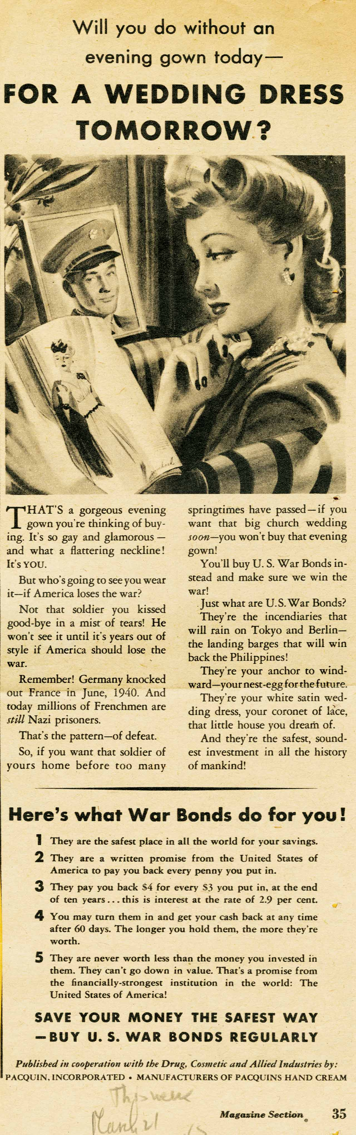

Primary Source - Salvaging Romance (1945)
Source: The American Weekly, Week of Oct 21, 1945, p 33.

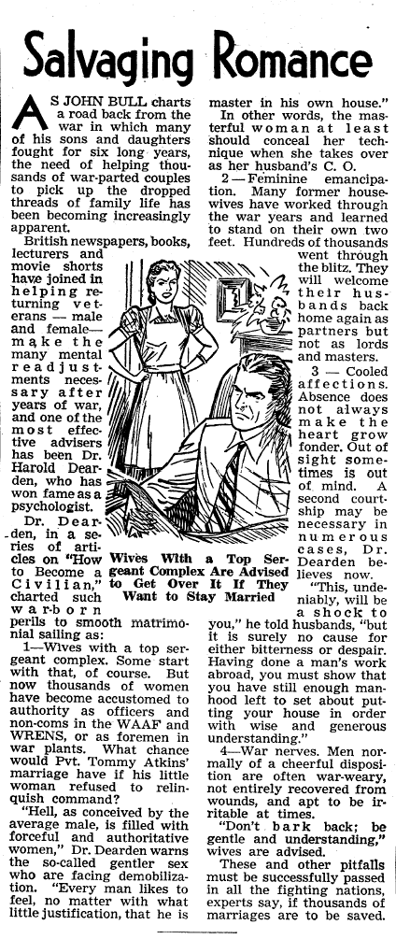
Primary Source - Bride’s Preference List (c. 1960)
Source: Marshall Fields’ Archive, Chicago
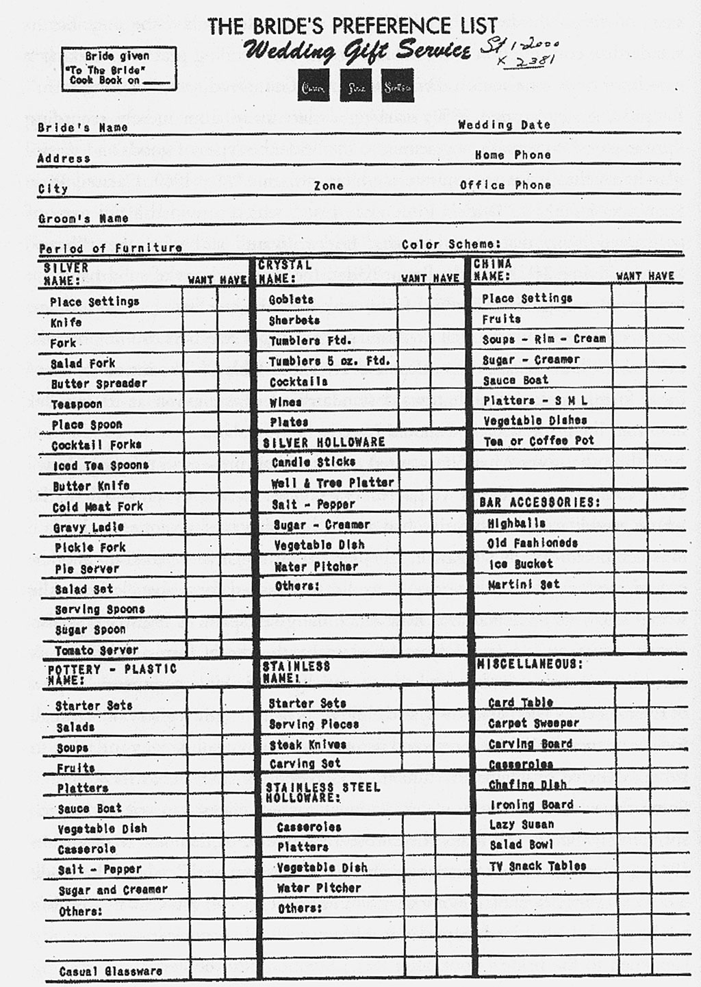

Primary Source - Fannie Lou Hamer Testimony (1964)
Source: Fannie Lou Hamer Testimony Before the Credentials Committee, Democratic National Convention, Atlantic City, New Jersey, August 22, 1964
Mr. Chairman, and to the Credentials Committee, my name is Mrs. Fannie Lou Hamer, and I live at 626 East Lafayette Street, Ruleville, Mississippi, Sunflower County…
It was the 31st of August in 1962 that eighteen of us traveled twenty-six miles to the county courthouse in Indianola to try to register to become first-class citizens. We was met in Indianola by policemen, Highway Patrolmen, and they only allowed two of us in to take the literacy test at the time. After we had taken this test and started back to Ruleville, we was held up by the City Police and the State Highway Patrolmen and carried back to Indianola where the bus driver was charged that day with driving a bus the wrong color.
After we paid the fine among us, we continued on to Ruleville, and Reverend Jeff Sunny carried me four miles in the rural area where I had worked as a timekeeper and sharecropper for eighteen years. I was met there by my children, who told me that the plantation owner was angry because I had gone down to try to register.
After they told me, my husband came, and said the plantation owner was raising Cain because I had tried to register. Before he quit talking the plantation owner came and said, "Fannie Lou, do you know - did Pap tell you what I said?" And I said, "Yes, sir." He said, "Well I mean that." He said, "If you don't go down and withdraw your registration, you will have to leave." Said, "Then if you go down and withdraw," said, "you still might have to go because we are not ready for that in Mississippi." And I addressed him and told him and said, "I didn't try to register for you. I tried to register for myself." I had to leave that same night.
On the 10th of September 1962, sixteen bullets was fired into the home of Mr. and Mrs. Robert Tucker for me. That same night two girls were shot in Ruleville, Mississippi. Also Mr. Joe McDonald's house was shot in. And June the 9th, 1963, I had attended a voter registration workshop; was returning back to Mississippi. Ten of us was traveling by the Continental Trailway bus. When we got to Winona, Mississippi, which is Montgomery County, four of the people got off to use the washroom, and two of the people - to use the restaurant - two of the people wanted to use the washroom.
The four people that had gone in to use the restaurant was ordered out. During this time I was on the bus. But when I looked through the window and saw they had rushed out I got off of the bus to see what had happened. And one of the ladies said, "It was a State Highway Patrolman and a Chief of Police ordered us out."
I got back on the bus and one of the persons had used the washroom got back on the bus, too. As soon as I was seated on the bus, I saw when they began to get the five people in a highway patrolman's car. I stepped off of the bus to see what was happening and somebody screamed from the car that the five workers was in and said, "Get that one there." When I went to get in the car, when the man told me I was under arrest, he kicked me.
I was carried to the county jail and put in the booking room. They left some of the people in the booking room and began to place us in cells. I was placed in a cell with a young woman called Miss Ivesta Simpson. After I was placed in the cell I began to hear sounds of licks and screams, I could hear the sounds of licks and horrible screams. And I could hear somebody say, "Can you say, 'yes, sir,' nigger? Can you say 'yes, sir'?"
And they would say other horrible names.
She would say, "Yes, I can say 'yes, sir.'"
"So, well, say it."
She said, "I don't know you well enough."
They beat her, I don't know how long. And after a while she began to pray, and asked God to have mercy on those people.

And it wasn't too long before three white men came to my cell. One of these men was a State Highway Patrolman and he asked me where I was from. I told him Ruleville and he said, "We are going to check this." They left my cell and it wasn't too long before they came back. He said, "You are from Ruleville all right," and he used a curse word. And he said, "We are going to make you wish you was dead."
I was carried out of that cell into another cell where they had two Negro prisoners. The State Highway Patrolmen ordered the first Negro to take the blackjack. The first Negro prisoner ordered me, by orders from the State Highway Patrolman, for me to lay down on a bunk bed on my face. I laid on my face and the first Negro began to beat. I was beat by the first Negro until he was exhausted. I was holding my hands behind me at that time on my left side, because I suffered from polio when I was six years old. After the first Negro had beat until he was exhausted, the State Highway Patrolman ordered the second Negro to take the blackjack.
The second Negro began to beat and I began to work my feet, and the State Highway Patrolman ordered the first Negro who had beat me to sit on my feet - to keep me from working my feet. I began to scream and one white man got up and began to beat me in my head and tell me to hush. One white man - my dress had worked up high - he walked over and pulled my dress - I pulled my dress down and he pulled my dress back up.
I was in jail when Medgar Evers was murdered.
All of this is on account of we want to register, to become first-class citizens. And if the Freedom Democratic Party is not seated now, I question America. Is this America, the land of the free and the home of the brave, where we have to sleep with our telephones off the hooks because our lives be threatened daily, because we want to live as decent human beings, in America?
Thank you.
Primary Source - Elaine Brown, Black Panther (August 1974)
Source: Elaine Brown, A Taste of Power: A Black Woman's Story (New York: Pantheon Books, 1992, pp. 3-8.
"I have all the guns and all the money. I can withstand challenge from without and from within. Am I right, Comrade?" Larry snapped back his answer to my rhetorical question: "Right on!" His muscular body tilted slights as he adjusted the .45 automatic piston under his jacket.
I was standing on the stage, with him at my side. Several of the key Brothers from the security squads were standing just in the back of us. To my left I found feel Big Bob, Huey Newton's personal bodyguard, all six feet eight inches and four hundred pounds of him. In front of me, extending all the way to the back of the auditorium, were several hundred other members of the Black Panther Party, a sea of predominately male faces. They were black men and women from the party's Central Committee and from various local leadership cadres, from the West Side of Chicago, from North Philadelphia, Harlem, New Orleans, Los Angeles, Washington, D.C., and elsewhere. They had come to Oakland this August of 1974 at my command.
I watched them carefully, noting that no one moved in response to my opening remarks. Here I was, a woman, proclaiming supreme power over the most militant organization in America. It felt natural to me. I had spent the last seven years as a dedicated member of the Black Panther Party, the last four at Huey's right hand.
"I haven't called you together to make threats, Comrades," I continued. "I've called this meeting simply to let you know the realities of our situation. The fact is, Comrade Huey is in exile. The other fact is, I'm taking his place until we make it possible for him to return."
I allowed them a moment to grasp the full meaning of my words. "I'm telling you this because it's possible some of you may balk at a woman as the leader of the Black Panther Party... If this is your attitude, you'd better get out of the Black Panther Party. Now. I am saying this also because there may be some individuals in our ranks who have private ambitions and, in Comrade Huey's absence, may imagine themselves capable of some kind of coup." I paused again. No one spoke.
Cocking my head to the side, I continued in the manner I knew was required. "If you are such an individual, you'd better run--and fast. I am, as your chairman, the leader of this party as of this moment. My leadership cannot be challenged. I will lead our party above ground and underground. I will lead the party not only in furthering our goals but also in defending the party by any and all means..."
I watched a few of the Brothers slap their palms together in common recognition. A subdued laughter of agreement rippled through the auditorium. I began to walk up and down the state, purposely emphasizing my words with the sound of the heels of my black leather boots. I punctuated each sentence with a nod to one or another of the soldiers standing on stage with me, backing me up.
"I repeat, I have control over all the guns and all the money of this party. There will be no external or internal opposition I will not resist and put down. I will deal resolutely with anyone or anything that stands in the way. So if you don't like what we're going to do, here is your chance to leave. You'd better leave because you won't be tolerated."
They began to applaud loudly, then louder, and then suddenly they were standing. The Sisters and the Brothers were on their feet. "Return to your chapters and branches throughout this country with renewed dedication... Let us get busy and prepare a place for the return of Comrade Huey. Let us get busy and prepare a place for the introduction of revolution!" I raised my fist in the air and shouted: "All power to the people! Panther power to the vanguard!"
They leaped to their fee, fists raised in salute: "POWER TO THE PEOPLE! POWER TO THE PEOPLE! POWER TO THE PEOPLE!"

Primary Source - Gloria Steinem, I was a Playboy Bunny (1963)
Source: Gloria Steinem, Outrageous Acts and Everyday Rebellions (New York: Holt, 1995), pp. 50-56.

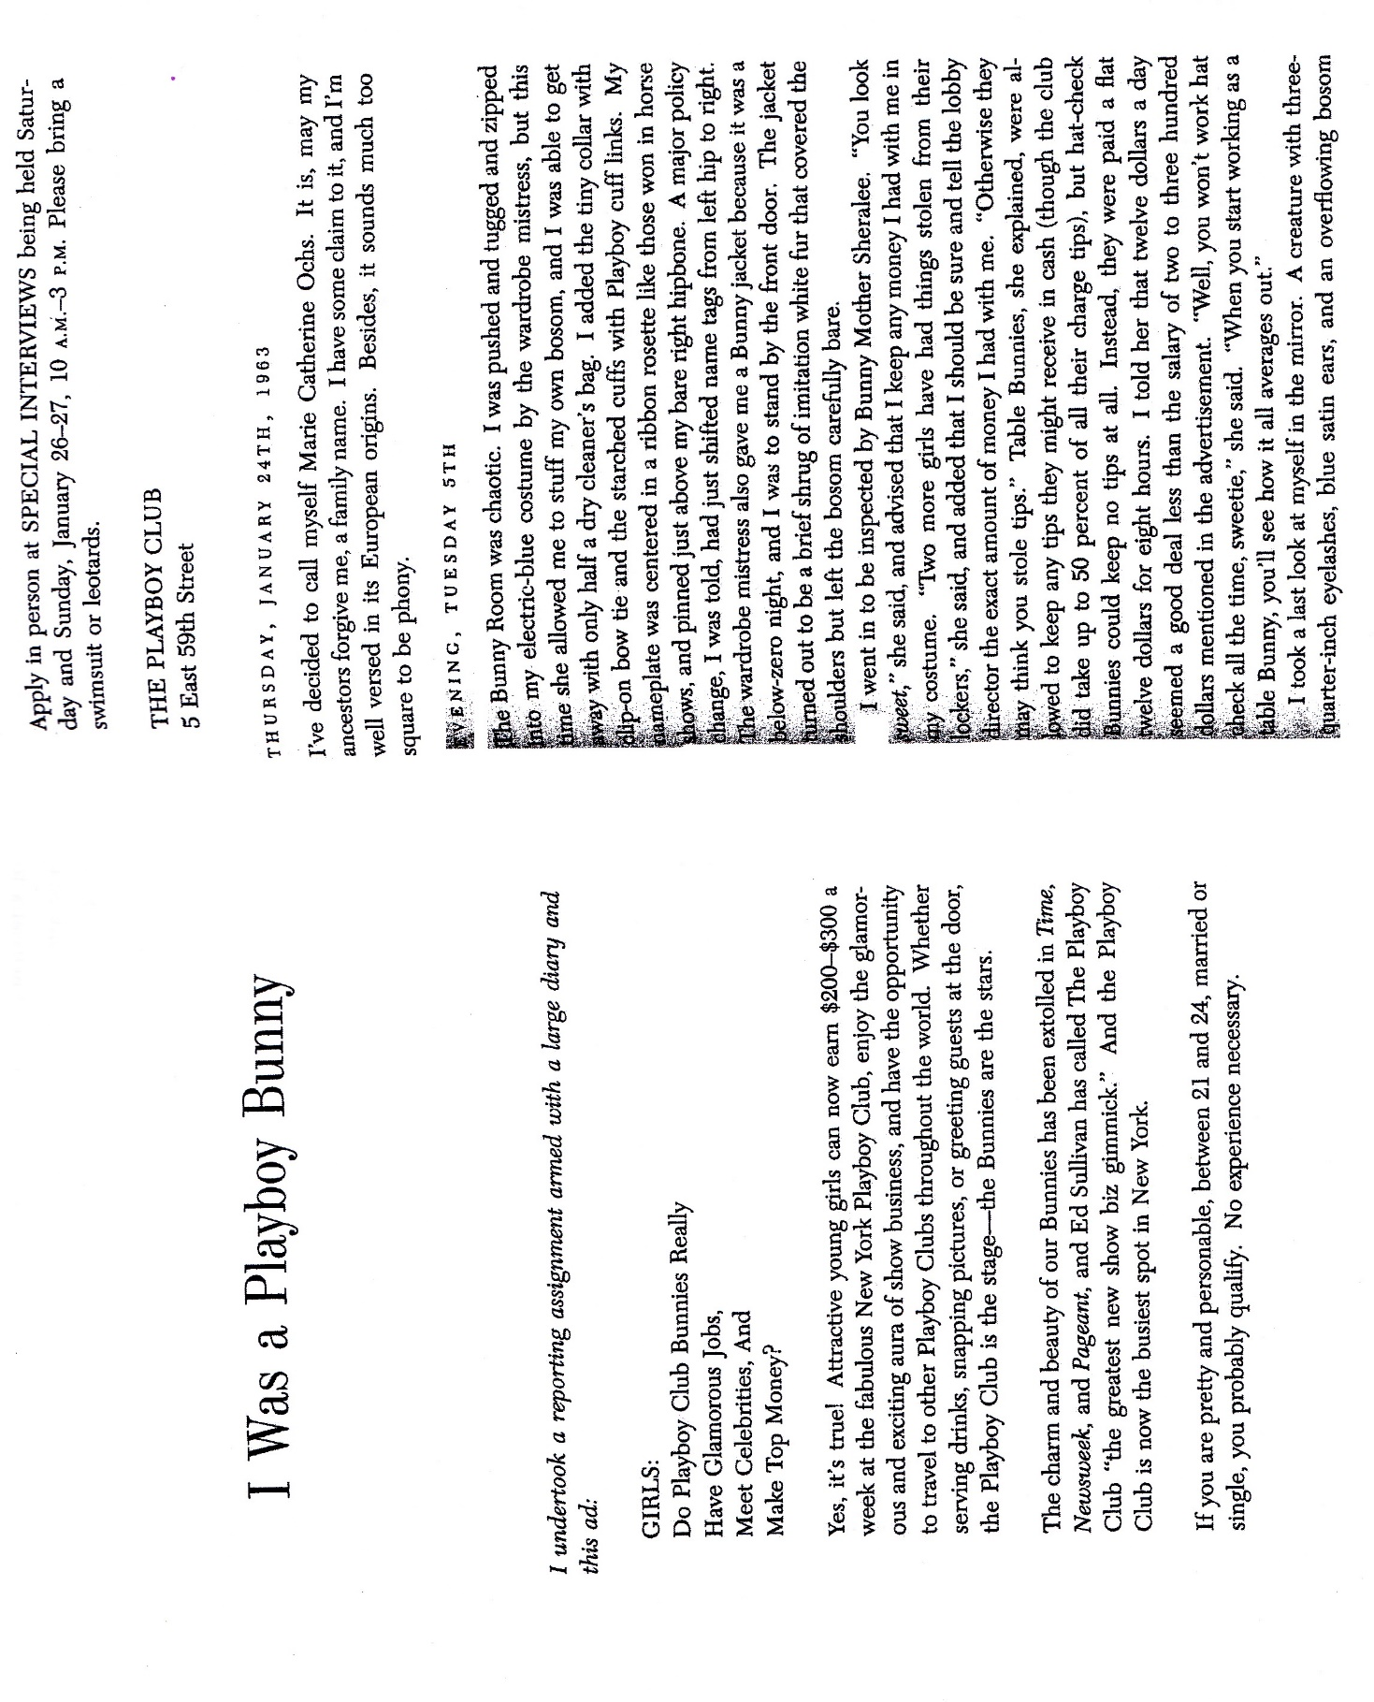

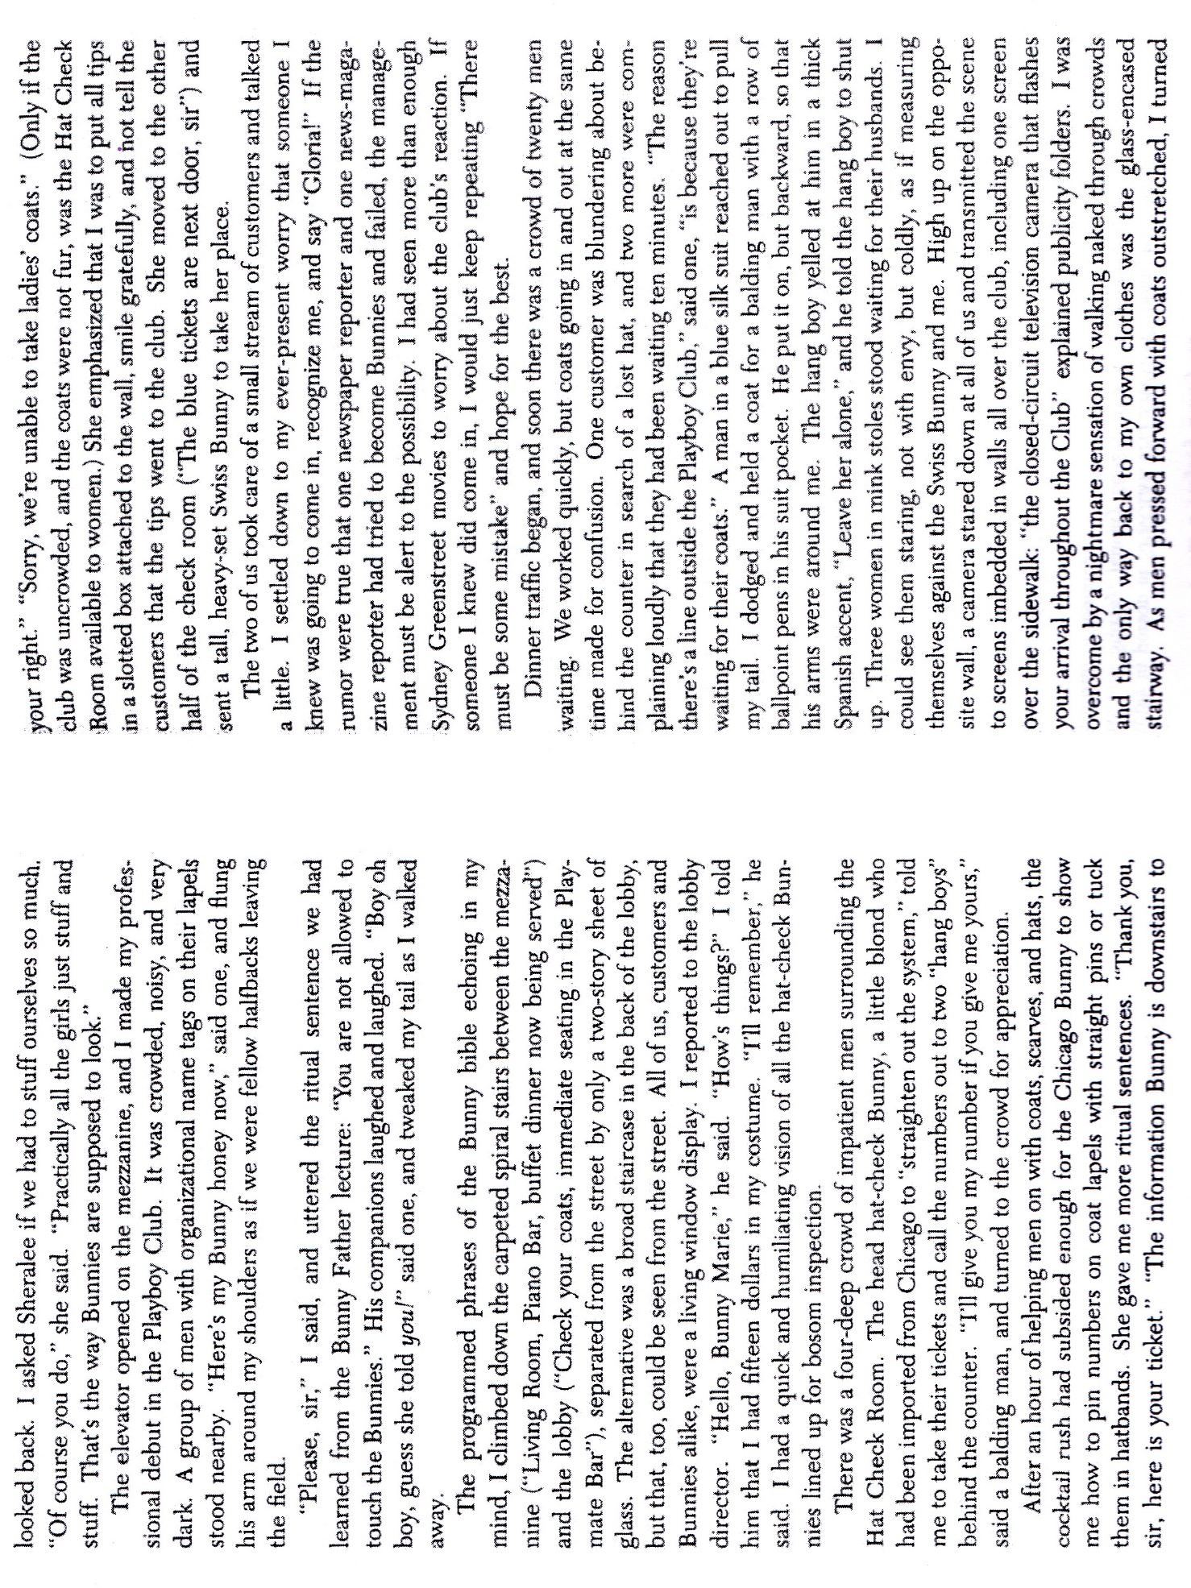
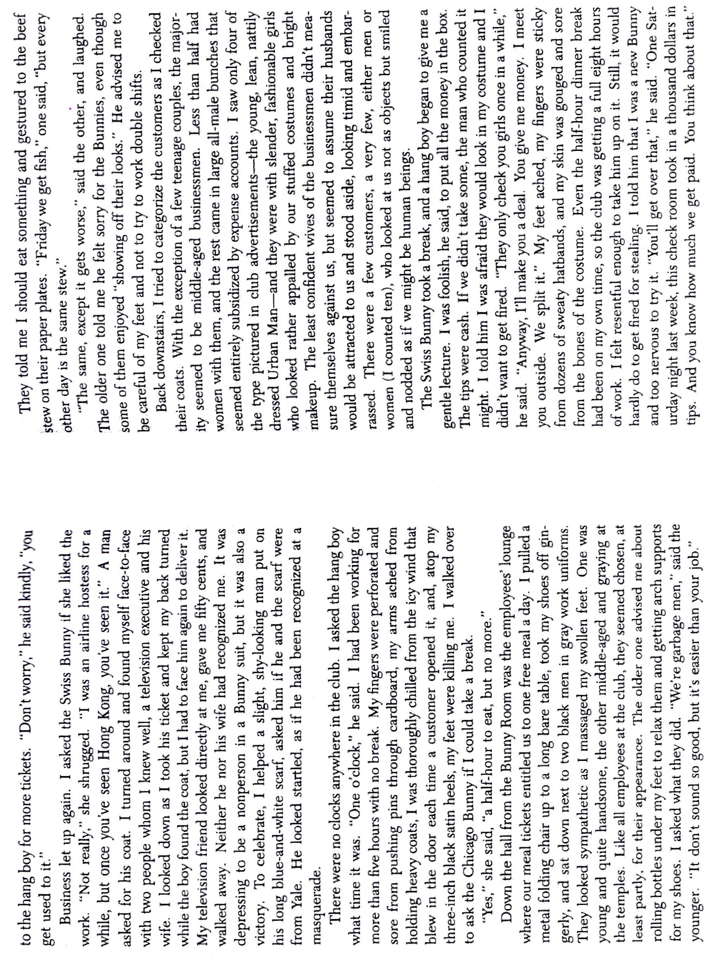
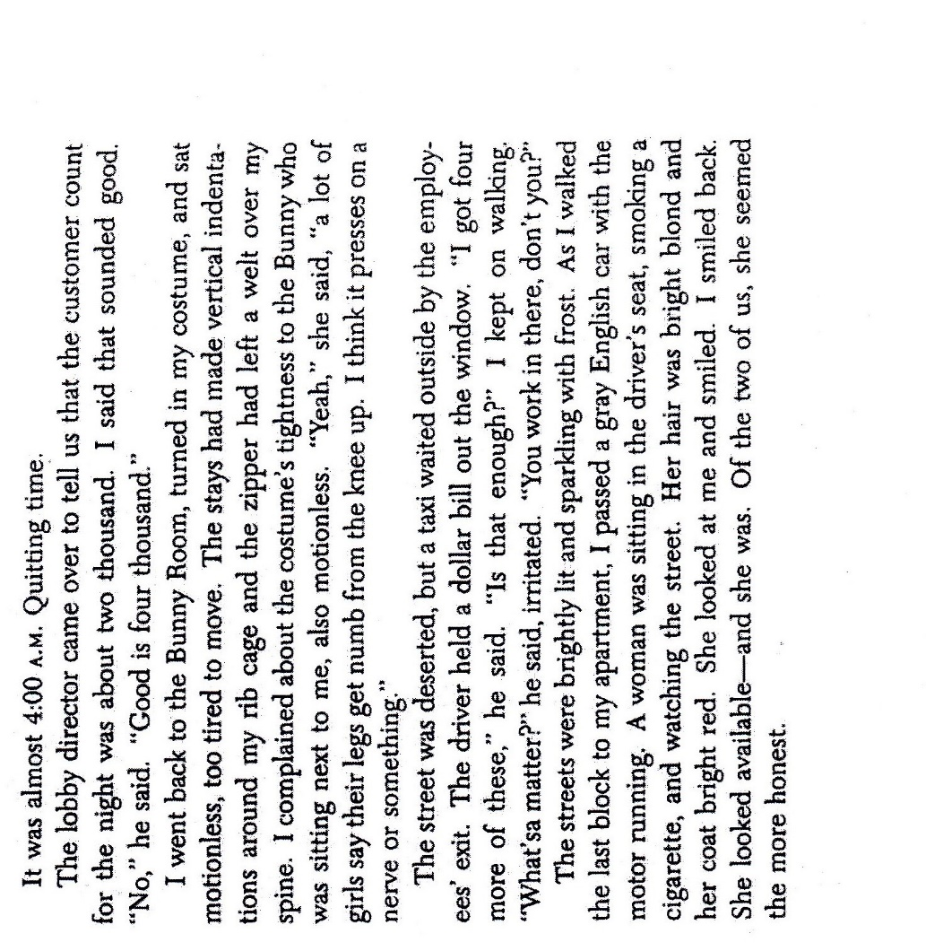
Primary Source - No More Miss America (1968)
Source: www.redstockings.org
We Protest:
- The Degrading Mindless-Boob-Girlie Symbol. The Pageant contestants epitomize the roles we are all forced to play as women. The parade down the runway blares the metaphor of the 4-H Club county fair, where the nervous animals are judged for teeth, fleece, etc., and where the best "Specimen" gets the blue ribbon. So are women in our society forced daily to compete for male approval, enslaved by ludicrous "beauty" standards we ourselves are conditioned to take seriously.
- Racism with Roses. Since its inception in 1921, the Pageant has not had one Black finalist, and this has not been for a lack of test-case contestants. There has never been a Puerto Rican, Alaskan, Hawaiian, or Mexican-American winner. Nor has there ever been a true Miss America- an American Indian.
- Miss America as Military Death Mascot. The highlight of her reign each year is a cheerleader-tour of American troops abroad- last year she went to Vietnam to pep-talk our husbands, fathers, sons and boyfriends into dying and killing with a better spirit. She personifies the "unstained patriotic American womanhood our boys are fighting for." The Living Bra and the Dead Soldier. We refuse to be used as Mascots for Murder.
- The Consumer Con-Game. Miss America is a walking commercial for the Pageant's sponsors. Wind her up and she plugs your product on promotion tours and TV-all in an "honest, objective" endorsement. What a shill.
- Competition Rigged and Unrigged. We deplore the encouragement of an American myth that oppresses men as well as women: the win-or-you’re-worthless competitive disease. The "beauty contest" creates only one winner to be "used" and forty-nine losers who are "useless."
- The Woman as Pop Culture Obsolescent Theme. Spindle, mutilate, and then discard tomorrow. What is so ignored as last year's Miss America? This only reflects the gospel of our Society, according to Saint Male: women must be young, juicy, malleable-hence age discrimination and the cult of youth. And we women are brainwashed into believing this ourselves!
- The Unbeatable Madonna-Whore Combination. Miss America and Playboy's centerfold are sisters over the skin. To win approval, we must be both sexy and wholesome, delicate but able to cope, demure yet titillatingly bitchy. Deviation of any sort brings, we are told, disaster: "You won't get a man!!"
- The Irrelevant Crown on the Throne of Mediocrity. Miss America represents what women are supposed to be: inoffensive, bland, apolitical. If you are tall, short, over or under what weight The Man prescribes you should be, forget it. Personality, articulateness, intelligence, and commitment- unwise. Conformity is the key to the crown- and, by extension, to success in our Society.
- Miss America as Dream Equivalent To-? In this reputedly democratic society, where every little boy supposedly can grow up to be President, what can every little girl hope to grow to be? Miss America. That's where it's at. Real power to control our own lives is restricted to men, while women get patronizing pseudo-power, an ermine clock and a bunch of flowers; men are judged by their actions, women by appearance.
- Miss America as Big Sister Watching You. The pageant exercises Thought Control, attempts to sear the Image onto our minds, to further make women oppressed and men oppressors; to enslave us all the more in high-heeled, low-status roles; to inculcate false values in young girls; women as beasts of buying; to seduce us to our selves before our own oppression.

Primary Source - Pantsuit, Yves Saint Laurent (1970)
Source: Metropolitan Museum of Art
