Accounting
Student’s Name:
Instructor’s Name:
Institution Affiliation:
Date:
Cash vs. Accrual Accounting
The accounting for the revenue and the expenses by the business organizations can be done using two methods of cash accounting and the accrual accounting. The comparison between the cash accounting and the accrual accounting is reflected in the diagram that has been attached below.
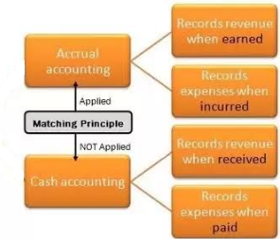
Summary
The diagram that has been drawn above demonstrates the difference between the cash accounting and the accrual accounting. The cash accounting approach entails the cash payment on time once a transaction has been conducted. In contrast, the accrual accounting involves a postponed payment after the transaction has been carried between two or different parties. Thus, one of the major differences between the accrual accounting and the cash accounting is the application of the matching principle as provided under the generally accepted accounting principles (GAAP). The matching principle provides that expenses should be matched during the period in which they helped in generating the revenue. Accordingly, the accrual accounting method applies the matching principle in the recognition of the expenses. This aspect means that a business will record an expense in the period it is attached even without paying for the expense that has been incurred. In contrast, the cash accounting approach does not employ the matching principle in recognition of the expenses.
The expenses are recognized once the cash payment is made by an entity. Thus, an expense is associated with the accounting period in which it has been paid rather than the period it is matched with the revenue generated. Similarly, the accrual accounting approach recognizes the sales revenue once the sale has been earned instead of the period it has been paid in cash. In contrast, the cash accounting approach recognizes the sales revenue once the cash for the goods or services offered is received. Consequently, an entity that employs the cash basis of accounting does not have receivables and payables in its accounting records since all transactions are recognized based cash payment or receiving. However, an entity that employs the accrual basis of accounting has the potential of recording receivables and payables since the revenue does not have to receive in cash and expenses paid in cash.

