Unit 7 Exam

- Sound waves travel at about 1,500 m/s through sea water. Suppose a sound wave travels from the ocean ﬂoor back to ship in 7.5 seconds. What is the depth of the ocean ﬂoor being explored?

0.005 km 150,000 m 200 m 11,250 m
- Which of the following is not a dissolved gas found in ocean water?

Cl N CO O
- If you wanted to know where to locate an ideal ﬁshing spot, which type of equipment would you use?

Sonar Radar Doppler Satellite
- What is formed when water carried onto a beach by breaking waves is pulled back into deeper water, forming an irregul

Rip current Undertow Breaker Tsunami

- Modern oceanography commenced .

with the HMS Challenger and its research and discoveries with the Industrial Age
with the advent of sonar

when ancient civilizations started using submersibles

- Match the deﬁnition with the correct term: the shallow sea ﬂoor between the shore and the deep-ocean bottom.

Continental slope Continental shelf Continental rise Continental margin
- If you are on a ﬁeld trip to the ocean and you recovered 100 grams of ocean salts from a sample of ocean water, based of dissolved solids in ocean water, what would be the mass of all elements in the sample that are not Na or Cl?

25%

15%

85%

55%

- You are a scientist working on the coast of Alaska, monitoring the ocean for signs of tsunamis. You will be looking for s following except .

incredibly strong, lengthy winds earthquakes
volcanic eruptions underwater landslides

- The removal of which tropic level of the food chain would have the biggest effect on the ecosystem?

Crabs Fish Plankton Whales
- Why does the effect of rising global temperatures in the ocean have such a broad effect on Earth?

As water warms, it can hold more carbon dioxide, so less CO is released into the atmosphere, where it is a greenhou As water cools, it can hold less carbon dioxide, so more CO is released into the atmosphere, where it is a greenhous There is no overwhelming effect due to rising global temperatures.
As water warms, it can hold less carbon dioxide, so more CO is released into the atmosphere, where it is a greenhouse.

- Colder water sinks because it is denser.

True False
- Ocean water is dense than fresh water because .

less; the dissolved solids add mass

more; the dissolved solids have less volume more; the dissolved solids add mass
less; because it is generally colder

- If you were drilling core samples in the ocean basin and the core samples you brought up had lower levels of biogenic upper levels were composed of inorganic sediments, what could you conclude?

That location used to have less organisms dying there. That location used to have more organisms living there. That location is colder than usual.
That location is warmer than usual.

- Correctly match the oceanic zone with its ocean basin location.

Bathypelagic: continental slope Hadal: abyssal plain Epipelagic: trench
Abyssopelagic: continental shelf

- Distillation is very expensive because of the high cost of energy needed for the process.

True False
- What is so unusual about the mid-ocean ridge that runs through Iceland?

It is very long.

The plates there spread fast. It is above sea level
There is nothing special about it.

- Why might you ﬁnd more biodiversity in the lower layers of the ocean?

They contain more dissolved gases. Animals tend to like colder temperatures. They are more saline.
There are less dissolved gases there.

- The Antarctic Circumpolar Current crosses how many major oceans?

ﬁve three two four

- A biogenic sediment can be composed of all the following except .

shells dead ﬁsh bones rocks
- Which of the following is a valuable resource retrieved from the oceans?

Drinking water Petroleum Salt
All of the above

- What is the main difference between an ocean and a sea?

A sea is smaller.

A sea is always surrounded by land. A sea contains salt water.
An ocean contains salt water.

- The soft, ﬁne material that covers about 40 percent of the ocean ﬂoor is a mud.

True False

- Which ocean is the fourth-largest and contains water in more than one matter phase?
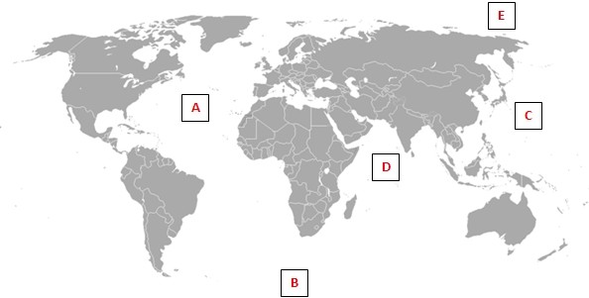

A D B E
- What would happen if we experienced another ice age?

Nothing would happen to the continental margin.

The continental slope would become farther away from the coastline. Less of the continental shelf would be exposed.
More of the continental shelf would be exposed.

- In a science ﬁction movie, a group of scientists needs to go to the center of the Earth with a special machine. To make they want to enter Earth’s crust at the deepest point on Earth. Where would they want to enter?

A trench

An abyssal plain A seamount
A submarine canyon

- Longshore currents move in a zigzag pattern.

True False
- What best describes a thermocline?

An area of extremely cold temperatures

An area where the temperature of the ocean sharply increases An area where the temperature of the ocean sharply decreases An area of warm temperatures in the ocean
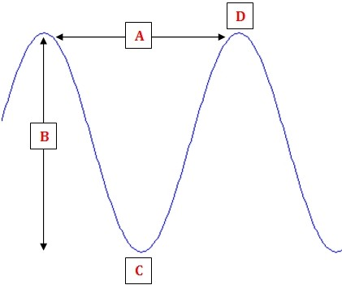

Which wave part is indicated by “D”?

Wave height Crest
Wave length Trough

- What causes the warmer climates on the southern coast of Iceland?

East Greenland Current Canary Current Sargasso Sea
North Atlantic Current

- Inorganic sediments are transported to ocean basins via all the following methods except .

Asteroids wind meteorites icebergs
- Where would you ﬁnd the thickest abyssal plain sediment?

Younger oceanic crusts without trenches Younger oceanic crusts with trenches Older oceanic crusts without trenches Older oceanic crusts with trenches

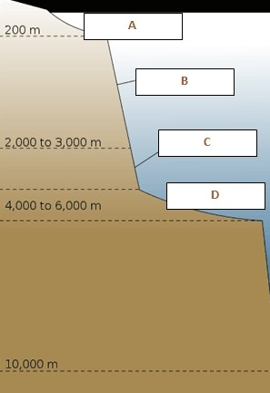

Which two areas of the diagram below are comprised of sediment?

B, C

A, B

C, E

A, C

- If you are on a ﬁeld trip to the ocean and you recovered 250 grams of ocean salts from a sample of ocean water, base percentages of dissolved solids in ocean water, what would be the mass of chlorine in the sample?

0.0022 g

4.55 g

137.5 g

0.22 g

- You can ﬁnd warm surface currents in all of the following areas except the .

Southern Ocean Atlantic Ocean Indian Ocean Paciﬁc Ocean
- What is the main difference between a bathysphere and a bathyscaph?

People can be on a bathyscaph, while they cannot be on a bathysphere.

A bathyscaph remains attached to the main research vessel, while the bathysphere is detached and free-moving. A bathysphere is much larger than a bathyscaph.
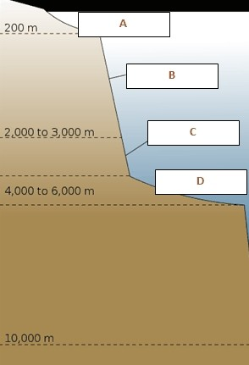
A bathysphere remains attached to the main research vessel, while the bathyscaph is detached and free-moving.

A submarine canyon would occur in which of the following regions?

E C A D

- As you get deeper in the ocean, you ﬁnd more marine life.

True False
- What percentage of Earth’s ocean water mass is composed of dissolved solids?

85.0%

30.6%

3.5%

55.0%

- How can the mining of nodules strain relations between countries?

Nodules are hard to harvest and cause ﬁnancial strain. Nodules exist in areas beyond national boundaries.
Nodules are very rare and hard to ﬁnd.

Nodules can bring a lot of money to the black market.

- What do we call an area of Earth that can hold large amounts of carbon dioxide?

Reservoir CO station Tank
Sink

