Title: 3D Printing
Professor:
Date:

List of components in each of the two locations
The Frame
A casing to hold the machine together. Modern models are typically encased in the dull dark plastic. One decision could be to influence the printer to "look attractive", to sort like a pimped up auto where the motor is noticeable and chromed. Suited for show in the lounge room of the facilities. The framework that moves the head can be the casing or part of the casing. The frames’ main role and most critical outline is it must be strong. As the make a beeline for and fro, the machine will shake, and if the casing is flimsy, at that point exactness endures and it will in the end break. On the off chance that the looks don't make a difference, the extremely shoddy and powerful arrangement is to discover a container that has a place with something. That would give a generally precise (as in, corners are square, sides are parallel) casing.

Head development mechanics
The head must have the capacity to move with respect to the bed in every one of the three spatial bearings, normally X, Y and Z. It doesn't make a difference if the head or the bed moves. On the off chance that the bed moves, however, the casing should be twofold the width/length. Every one of the outlines I've seen so far are cartesian, ie. X and Y are a flat development and Z is the tallness. One may likewise utilize polar directions. This obviously makes drawing a straight line somewhat harder, yet that is only a little matter of count, and is no harder than the square cartesian framework drawing a circle. The test for me is that development of this requires some mechanical designing, specifically access to workshop and apparatuses to make it. Some accuracy is required so points are precisely 90° and parallel tracks are parallel where required. A seat bore would be a decent begin. Hand devices won't make it.
(Stepper) Motors
Engines are required, four in any event – three for the spatial development (regardless what mechanical game plan is picked), and one for the extruder. A noteworthy outline decision is whether they are "customary" DC or "stepper" (which additionally utilizes DC, yet you need to beat it on a few wires).
The print head/extruder
The "print head" (commonly) expels the warm plastic. Or on the other hand something unique. While each segment needs to work for the printer to work, I feel this part is most essential, and under the heaviest anxiety. As it were, it is first to flop if not construct accurately. The outline considerations at this moment is to get one from one of the home printer gatherings, additionally on the grounds that the parts are exceptional. The plastic extruder parts are: An engine to push the crude material, a chamber/spout, a warming loop, a temperature sensor, and, a comment everything together.
Hardware
There will be "PC" or "controller" that controls the entire printing process. The Electronics segment is two sections; the controller itself and the hardware changing over the controllers moderately frail electrical flags sufficiently capable to drive the engines. Finally, not to overlook, control supplies for all.

Firmware (Security)
The Arduino has a highlevel compiler running on the pc, which creates the code that at that point keeps running on the controller. This program must be composed. It needs to play out a few activities. Open source code is accessible from the CupCake and RepRap ventures. I will likely change it or even compose my own particular starting with no outside help. The plan of the firmware is in part compelled by the dialect/arrangement of the Arduino dialect which is C/C++. A primary circle is persistently executed, and it needs to call or survey each subcomponent to give it a chance to do a bit of work. All parts must be short in nature (no "hold up" directions) doing work incrementally with the goal that each subcomponent gets called regularly enough. It isn't suited to hinder driven code.

3D Software
Not some portion of the printer, but rather the printer is futile without a partner pc with programming that can:
▪ create/control 3D models, see on a pc.
▪ convert these models into "cuts" for the 3D-printer now and again to naturally adapt to making "bolster" for overhangs.
▪ convert cuts into movement charges that give great edges and fill territories.

IT changes
The MX3D framework utilizes mechanical robots to fabricate structures additively. The robot's arms are fitted with uniquely created welding heads. Rather than delivering blobs of liquid metal to combine parts, the robots, as a result, continue welding—including one drop of weld best of another, and "drawing" out long bars of steel. To print the scaffold, the robots will either sit on it, printing their own help structure as they go, or work from freight boats moored on the waterway underneath. In any case, the procedure is probably going to take around three months. The task is being bolstered via Autodesk, an American maker of plan and designing programming; Heijmans, a Dutch development firm; and ABB, a Swiss-based creator of mechanical robots.
The utilization of 3D imprinting in development is "never again a curiosity" in giving inside enrichment highlights, lighting impacts and furniture, as indicated by a current report by Lux Research, a Boston consultancy. Intrigue is developing in printing substantial basic parts or even whole structures as a result of the chances to spare development time and accomplish a more prominent adaptability in outline, the report found. Be that as it may, challenges stay, specifically creating printable development materials and meeting construction laws

Difference
The new 3D printing is giving the architects and colleagues in the company the capacity to both model and make end-utilize items and it offers huge points of interest over conventional assembling forms. These preferences incorporate empowering mass customization, expanding plan flexibility, taking into consideration the decrease of gathering, and can fill in as a financially savvy low volume generation process. This beneficial when contrasted with the previous 3D printing forms which is a particular Laser Sintering (SLS), Binder Jetting, Stereolithography (SLA), Poly-Jet, Fused Deposition Modeling/Fused Filament Fabrication (FDM/FFF), and so forth and has least highlights, for example, moderate printing speed, low stockpiling.

Part 4
Graphical representation of the facilities
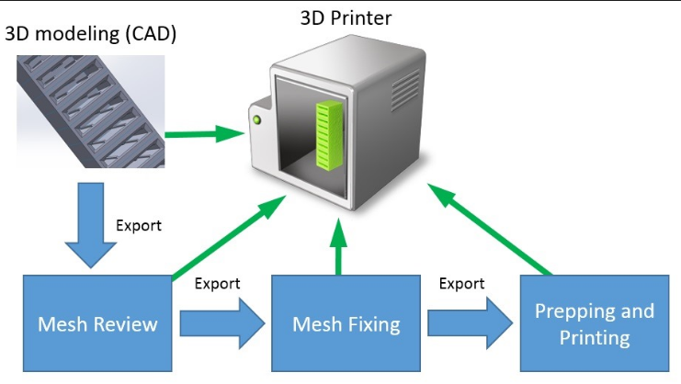

Works Cited
Bhatia, Sujata K, and Krish W. Ramadurai. 3d Printing and Bio-Based Materials in Global Health: An Interventional Approach to the Global Burden of Surgical Disease in Low-and Middle-Income Countries. Cham: Springer, 2017. Internet resource
Kocovic, Petar. 3d Printing and Its Impact on the Production of Fully Functional Components: Emerging Research and Opportunities. Hershey, PA: Engineering Science Reference, 2017. Internet resource.
Ren, Chiang H. How Systems Form and How Systems Break: A Beginner's Guide for Studying the World. , 2016. Internet resource.
van, den B. B, der H. S. van, and Eleni Kosta. 3d Printing: Legal, Philosophical and Economic Dimensions. The Hague: T.M.C. Asser Press, 2016. Internet resource.

