Single Stories in Life
Name
Institutional Affiliation
Course
Instructor
Date
Single Stories in Life
What are the examples of ‘single stories’ in your personal life?
Poverty is one of the single stories. Lack of enough finances amongst my friends makes me just look poor whereas I have other ways of using my money. Laziness is another one where I define people as lazy just because they don’t like nature walks as I do. Seeing people as terrorists just by their looks is another single story in my life.
What are the examples of ‘single stories’ in your education?
Some subjects having challenging topics makes me think that the subject does not favor me at all.
Ugly teachers might also be a case where some teachers’ beauty makes me dislike them not considering their abilities (Camminga, 2020). Exams colors. I see colored examination papers looking hard as compared to the commonly printed papers which are white. Poor performance in class is also a single story that affects students amongst themselves. Additionally, many believe that some subjects are just supposed to be taken by a specific gender.
How might we begin to 'reject the single story in our lives to regain Adichie's so-called “paradise”?
These negative or too positive thoughts make one story become the only story. It should not be the case as the negativity flattens the experience of individuals. It leads to the creation of stereotypes that are incomplete in their thoughts. The same robs the dignity of the affected and shows just how different we are rather than how similar we are.
All this can be avoided by the literature specialized and news editors not specifically talking of the single story of some people (Camminga, 2020). Exposure may also help where individuals travel and interact with more people to allow them to have an open mind. We can reject the single story by working hard and proving that we have strengths and at the same time proving that our weaknesses can become strengths.
Special Education
Special education is the kind of education offered to people with disabilities. These are the individuals with some unique needs. With the education, it's confirmed that the group also have their rights which should be granted to them. Special education services should be provided and the custodians of such people should be trained on how to handle and treat them. Special educations intend to give the people an equal right as dictated by the law and this makes the group also utilize public resources effectively. Education should be offered in the least restrictive environments meaning that they should interact freely with the rest of the society. Special education includes assistive technology, related services, supplementary help and services, testing accommodations, transition services, and alternate assessment, and modified promotion.
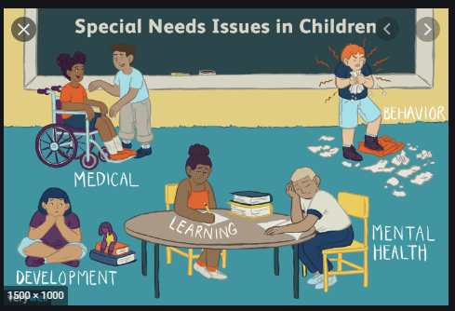

References
Camminga, B. (2020). Disregard and danger: Chimamanda Ngozi Adichie and the voices of trans (and cis) African feminists. The Sociological Review, 68(4), 817-833.

