Lab #2 - Differential Leveling

TP-1

TP-2

TBM-2 = ???

X

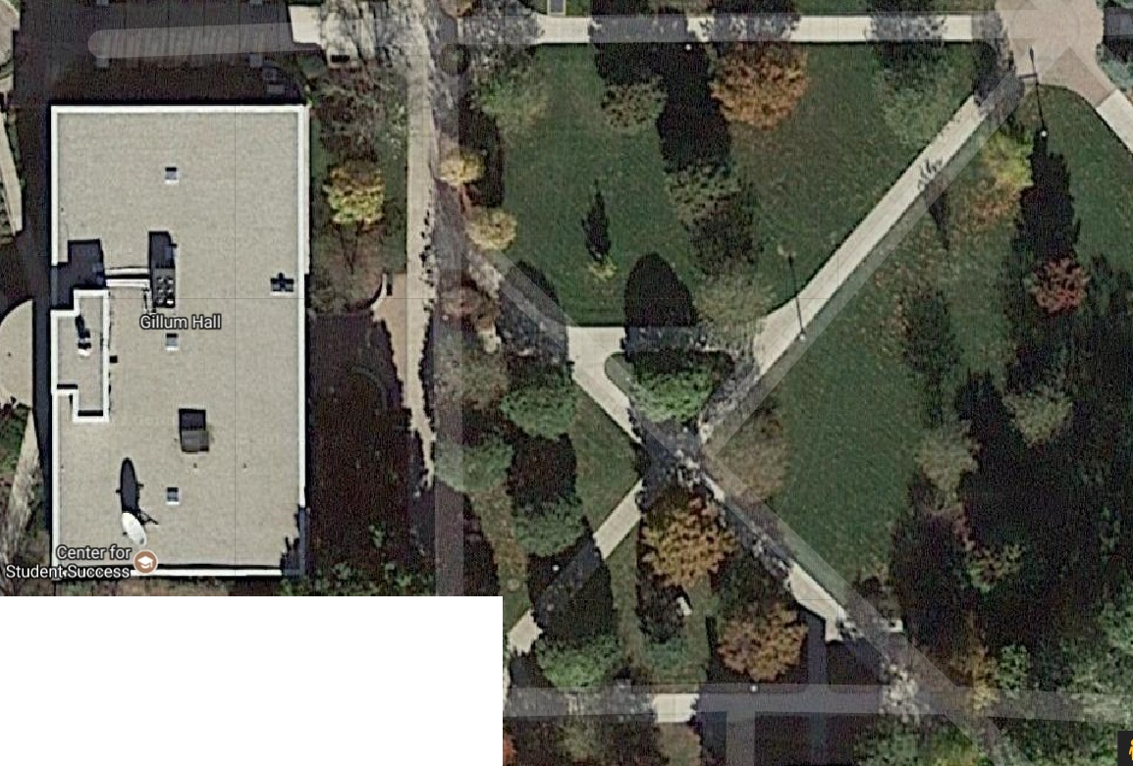


INSTRUCTIONS:
Starting at BM-1, you must set up your instrument a minimum of 3 separate times in order to provide readings at TP-1 &
X
TP-2 following the route of the arrows on this drawing. You must provide a sketch of this route in your field book showing approximate locations of your equipment. You must also include a table, labeled properly with turning points and instrument locations and the values of BS and FS.
BM-1 is the West nut on the manhole cover shown above TBM-2 is the top of the Northwest corner of concrete bench on the South side of the East entrance to Gillum hall, adjacent to the metal trash can.

BM-1 = 500.00'

Name Field Book ‐ Lab:
Date

FIRST CASE
Location | Back sight | Front sight | Instrument height | Elevation |  |  |  |  |  |  |  |  |  |  |  |  |  |  |  |  |  |  |  |  |  |  |  |  |  |  |  |  |  |  |  |  |  |  |  |  |  | TP1
BM 1 |  |  | 500.00
TP 1 | 4.42 | 5.74 | 507.55 | 501.81 |  |  |  |  |  |  |  |  |  |  |  | TP2
TBM 2 |  |  | 510.24
TP 2 | 4.99 | 3.43 | 511.55 | 508.12
 |  |  |  |  |  |  |  |  |  |  |  | TBM2
SECOND CASE |  |  |  |  |  |  |  |  |  |  |  |  |  |  |  |  |  |  |  | BM1
Location | Back sight | Front sight | Instrument height | Elevation
BM 1 |  |  | 620.25
TP 1 | 4.34 | 5.14 | 620.45 | 615.31
TBM 2 |  |  | 620.56
TP 2 | 5.64 | 6.74 | 621.86 | 615.12
THIRD CASE
Location | Back sight | Front sight | Instrument height | Elevation
BM 1 |  |  | 502.24
TP 1 | 3.45 | 4.65 | 502.45 | 497.8
TBM 2 |  |  | 502.63
TP 2 | 7.45 | 6.32 | 502.84 | 496.52

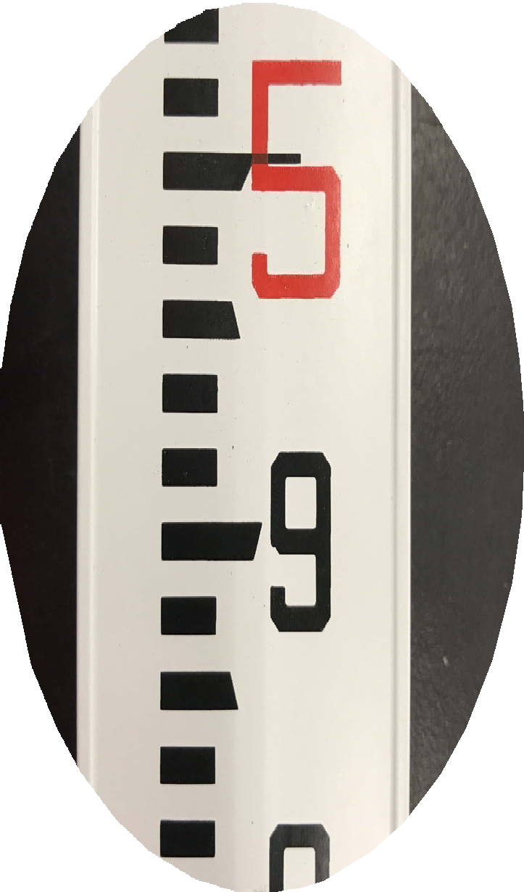

Backsight to BM-1
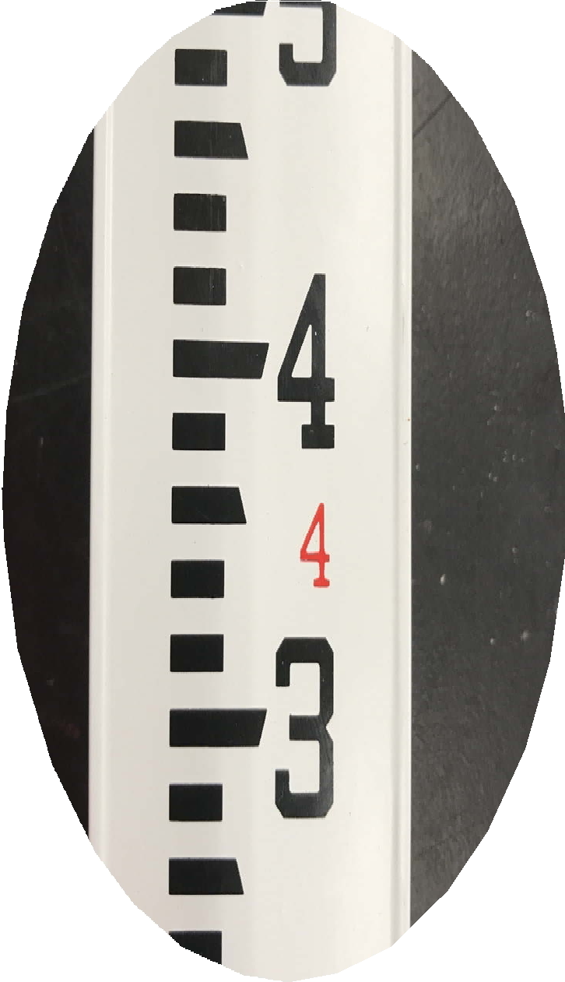
Foresight to TP-1

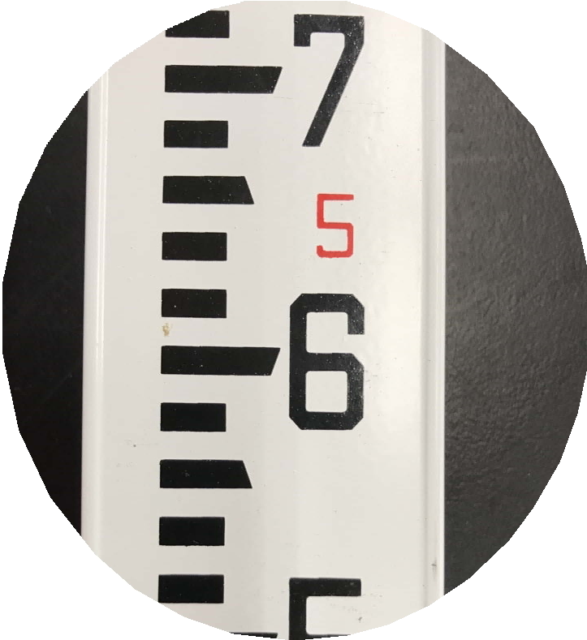

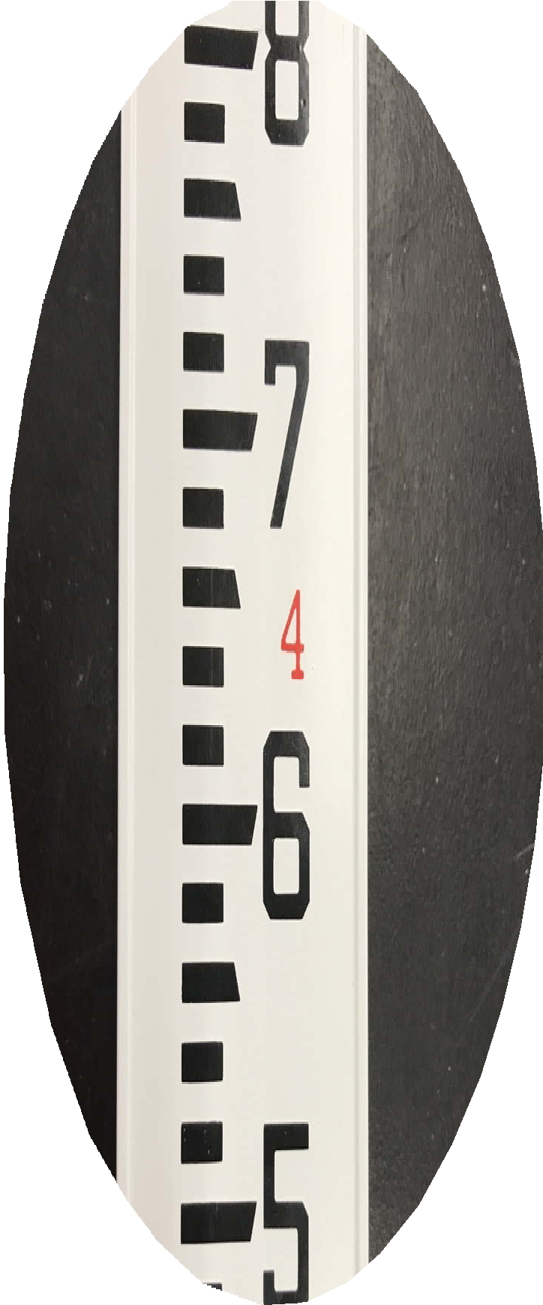
Backsight to TP-1
Foresight to TP-2

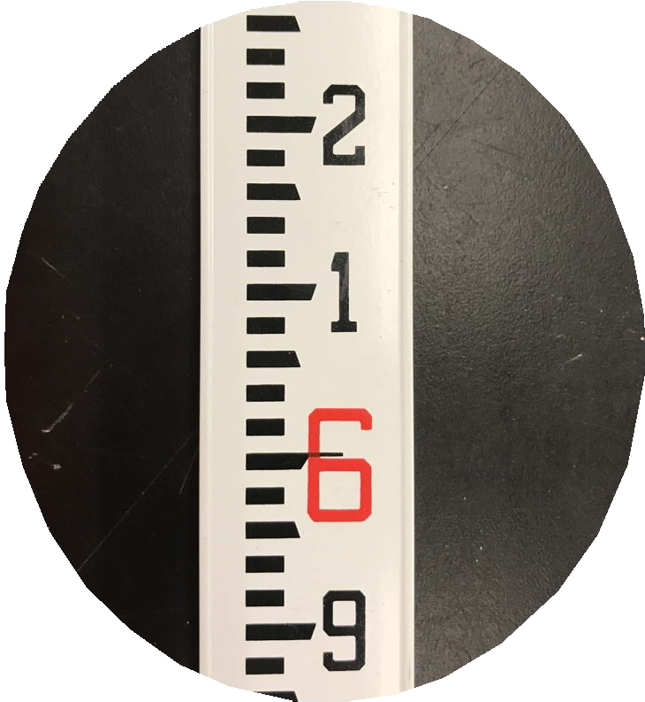
Backsight to TP-2
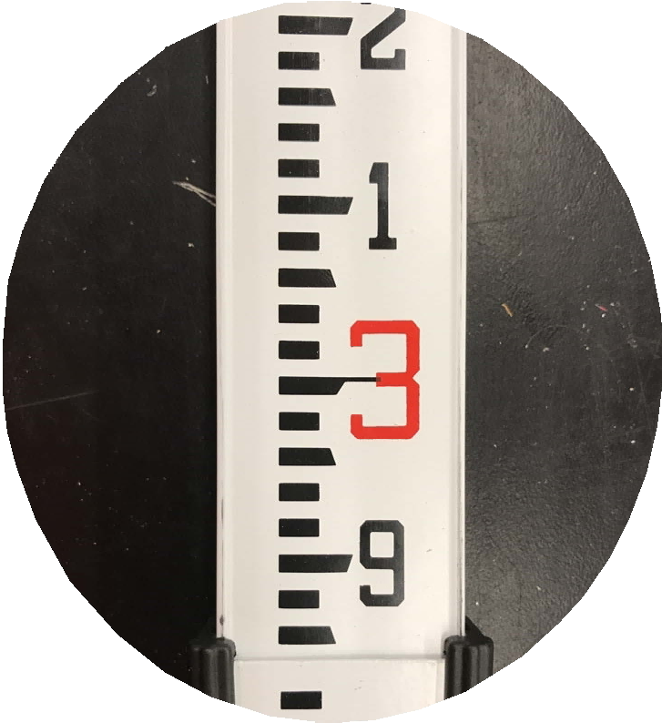
Foresight to TBM-2

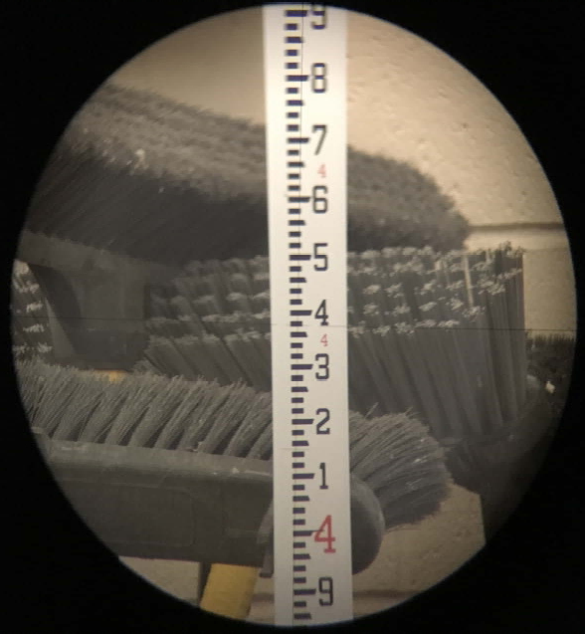

Actual image of a surveyor's rod taken from a dumpy level. This is provided to you as an example of what an actual surveyor would see when they looked through the scope at the rod. You will not use this value in any calculation

