Instructions: You are to provide a profile elevation from BM-A to TBM-1. You are required to reset your equipment at least once to take a BS reading on TP-1 to continue your profile through TBM-1. You will take profile shots along the route at 20.00' intervals starting at BM-A whose initial starting station is STA 184+24.33. TP-1 is located 100.00' from BM-A and TBM-1 is 149.64' from BM-A. Construct a profile table with the stations marked (starting from 184+24.33) through TBM-1. Your initial starting elevation is based on point BM -1 being an elevation of 513.94' then you read a backsight to BM-1 of 5.37' and finally you read a foresight to BM-A of 9.81'. After you have completed your foresight of TP-1, you relocate your equipment and shoot a BS to TP-1 of 6.48' and continue your profile elevation. Fill out the digital field book with your table information on the left and your profile grid on the right. You will need to orient the profile such that you are starting from the bottom of the page (BM-A) working to wards the top of the page (TBM-1) . Your table and profile are weighted equally for this assignment

Lab #3 - Profile Leveling
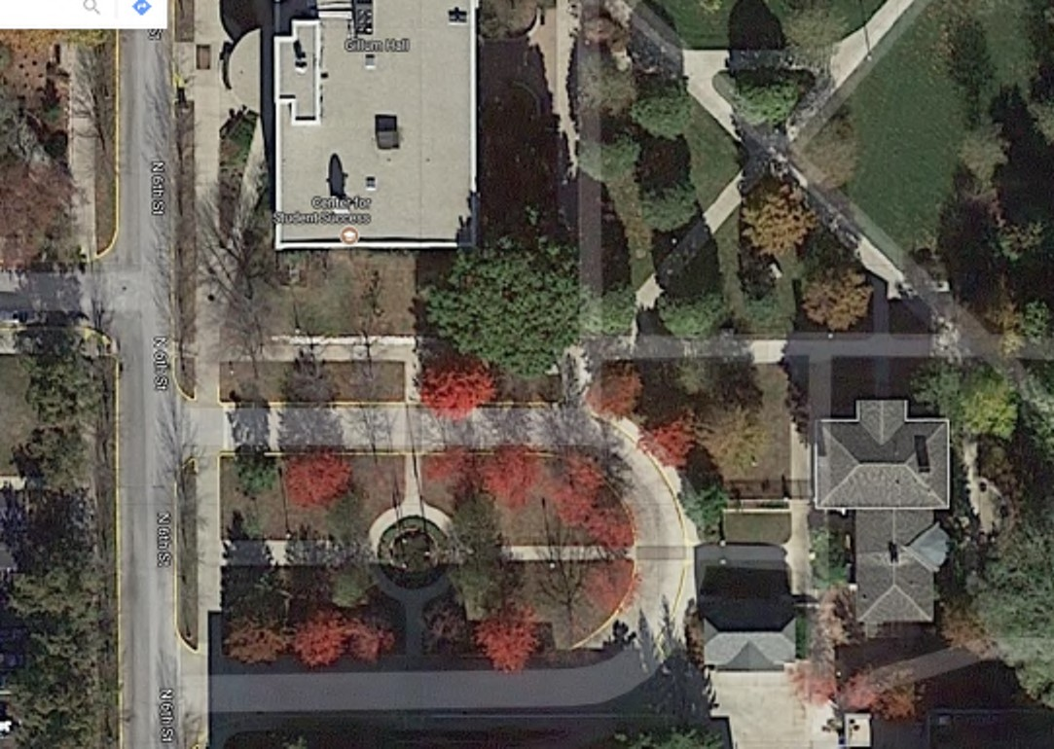
BM-A
TBM-1
TP-1
Instructions:
You are to provide a profile elevation from BM-A to TBM-1. You are required
to reset your equipment at least once to take a BS reading on TP-1 to
continue your profile through TBM-1. You will take profile shots along the
route at 20.00' intervals starting at BM-A whose initial starting station is
STA 184+24.33. TP-1 is located 100.00' from BM-A and TBM-1 is 149.64'
from BM-A. Construct a profile table with the stations marked (starting from
184+24.33)
through TBM-1. Your initial starting elevation is based on point
BM -1 being an elevation of 513.94' then you read a backsight to BM-1 of
5.37
' and finally you read a foresight to BM-A of 9.81'. After you have
completed your foresight of TP-1, you relocate your equipment and shoot
a BS to TP-1 of 6.48' and continue your profile elevation. Fill out the digital
field book with your table information on the left and your profile grid on
the right. You will need to orient the profile such that you are starting from
the bottom of the page (BM-A) working to wards the top of the page
(
TBM-1) . Your table and profile are weighted equally for this assignment.
BM-1: 513.94'
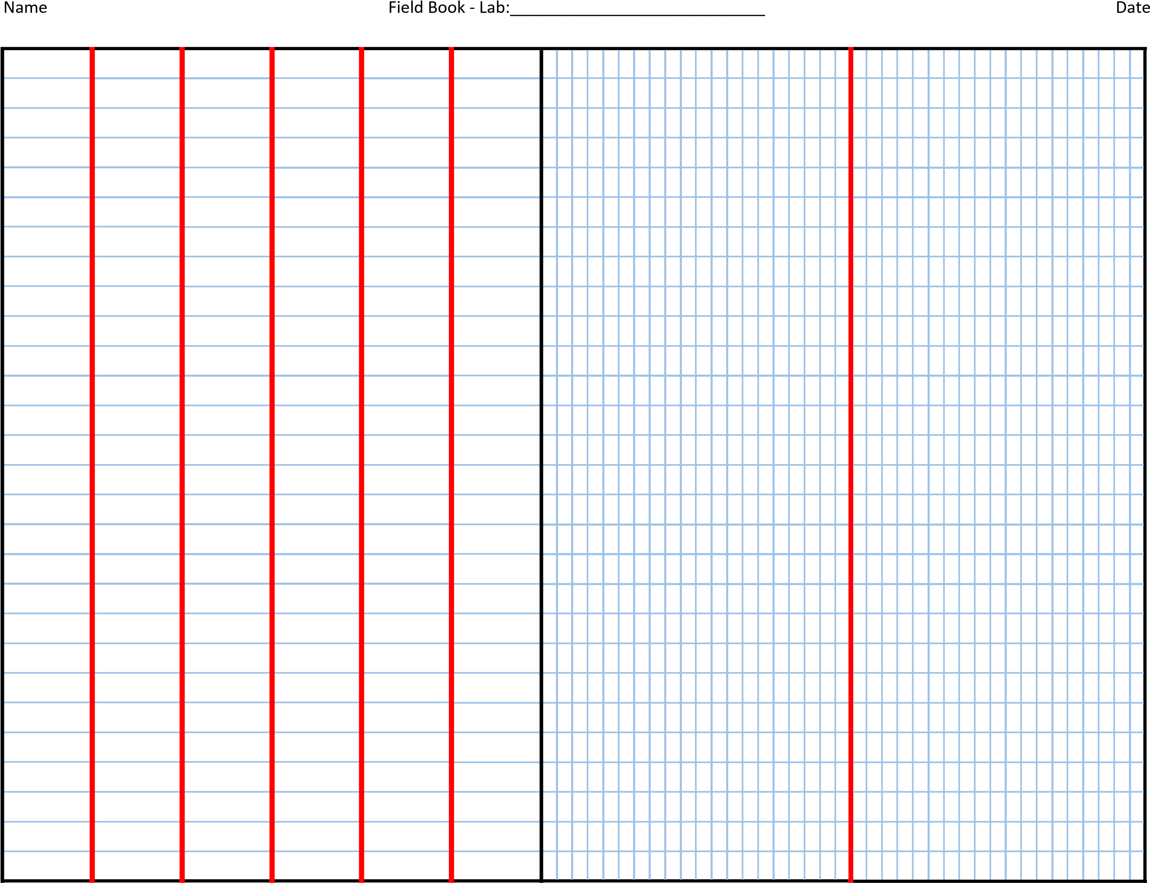

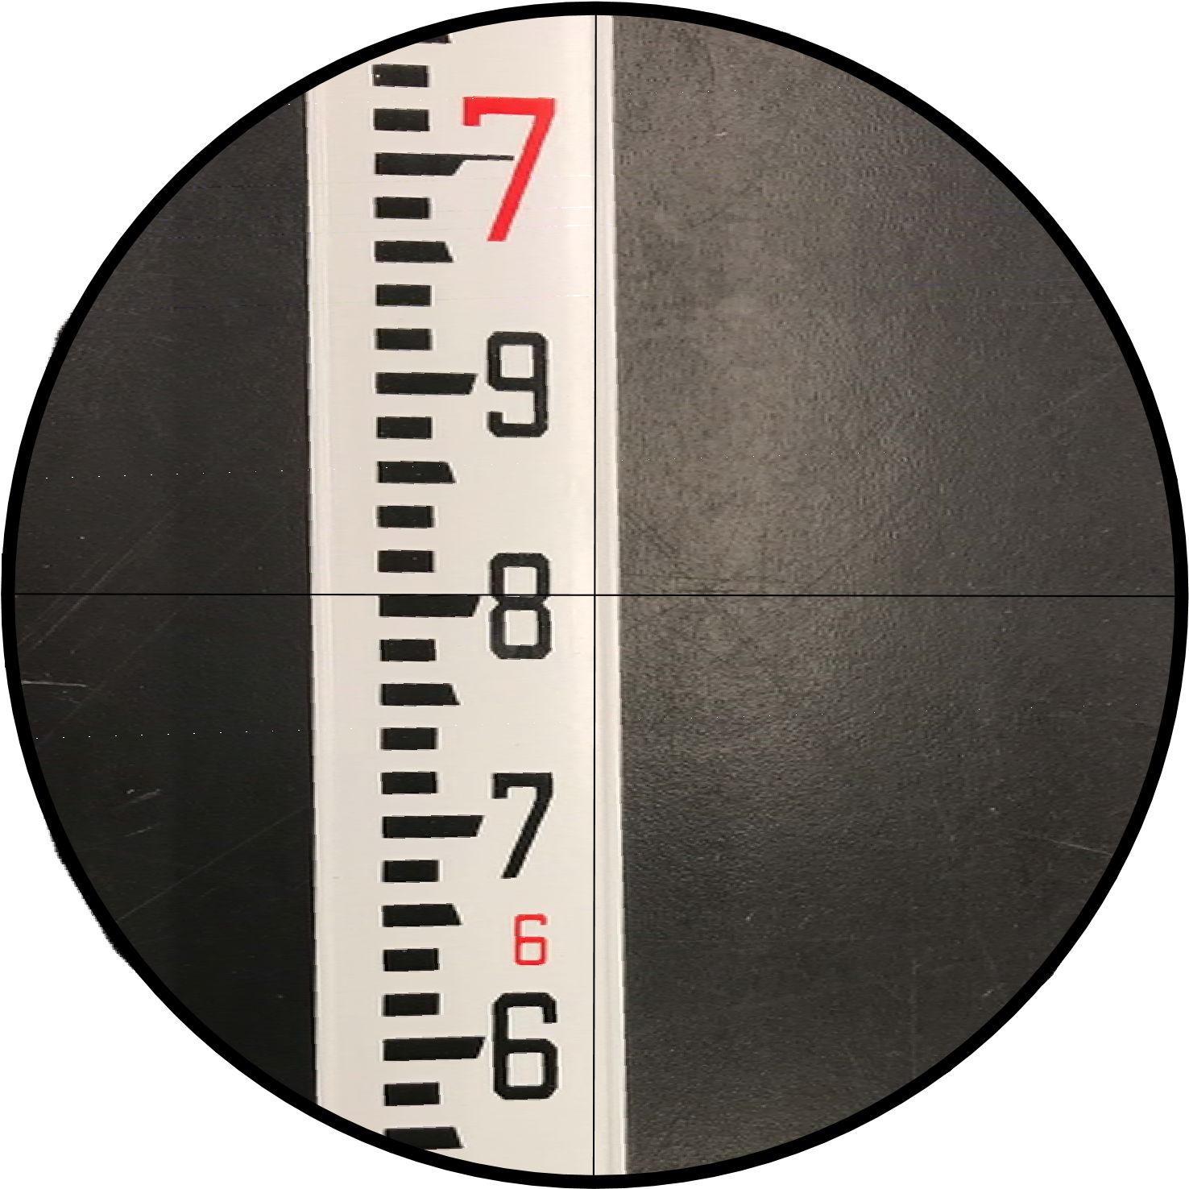

FIRST FORESIGHT READING AFTER BM-A
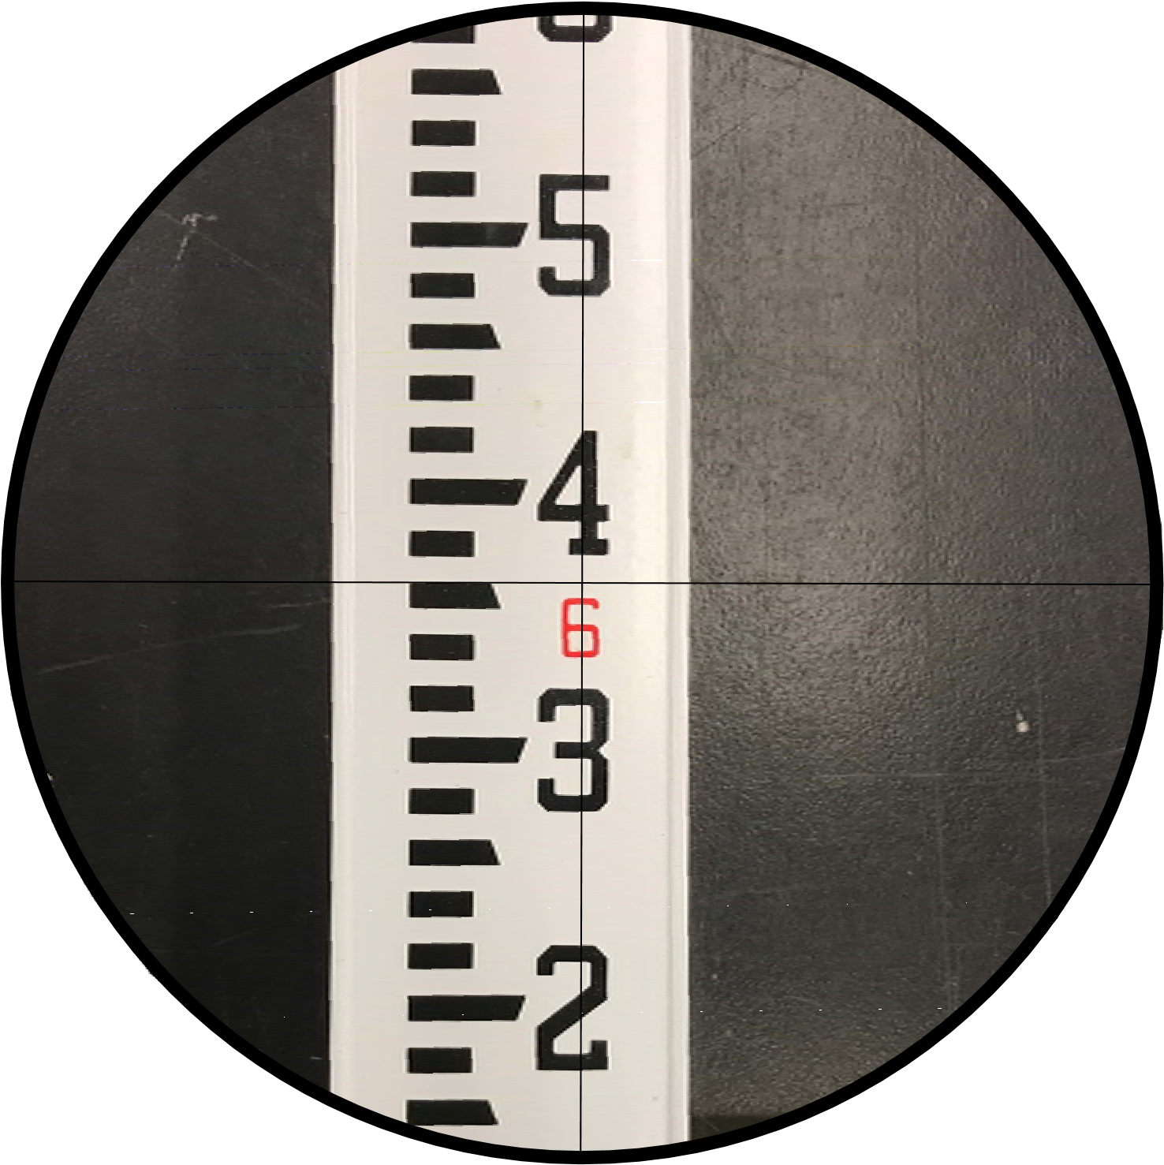

SECOND FORESIGHT READING AFTER BM-A
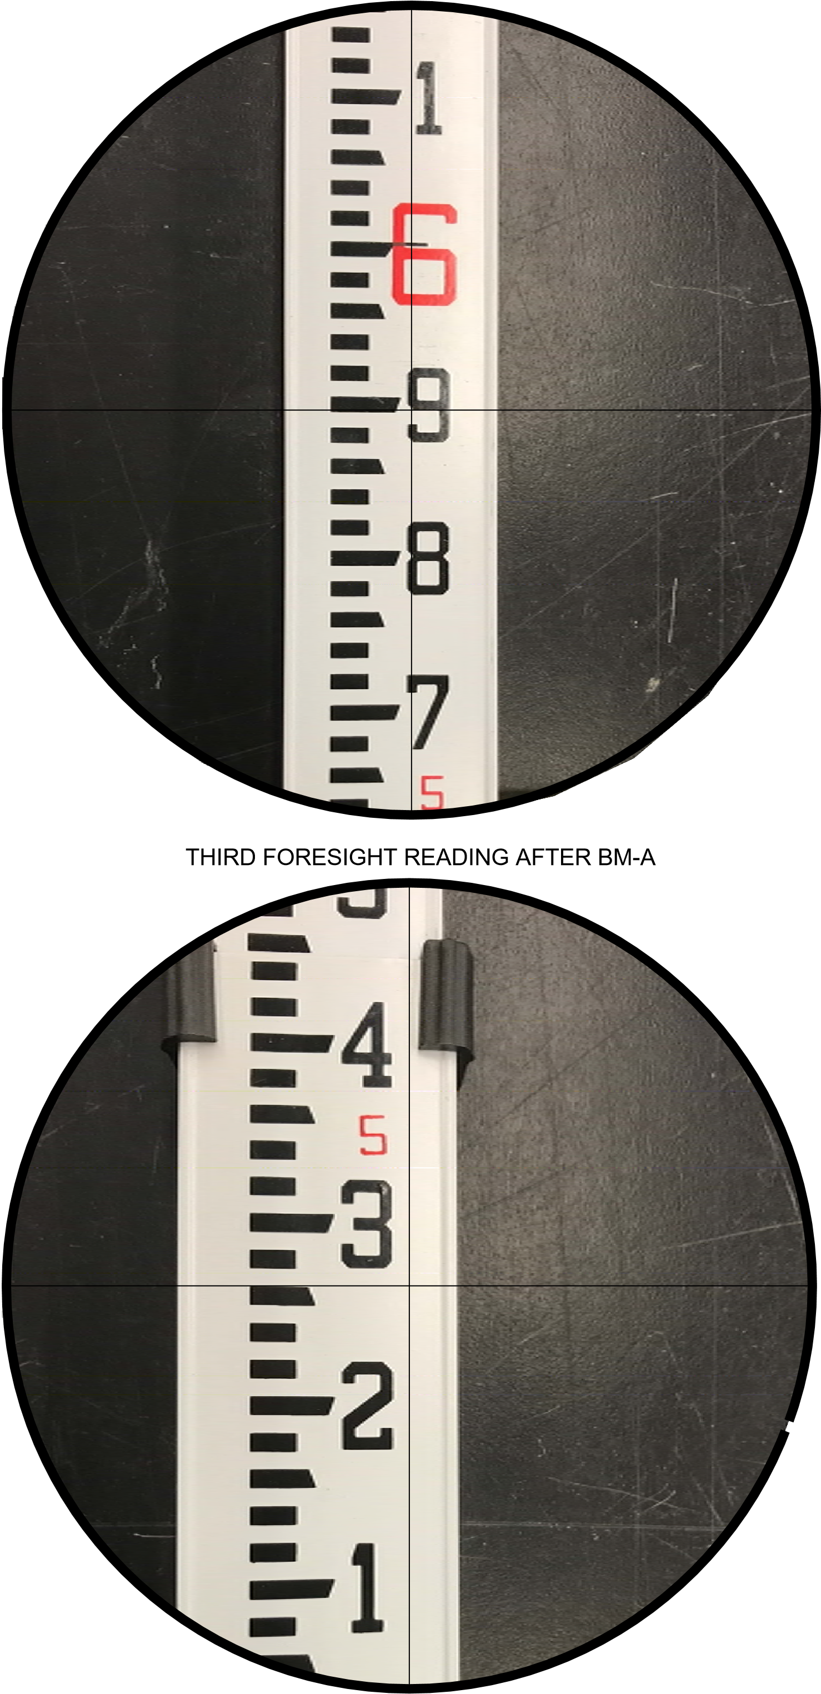

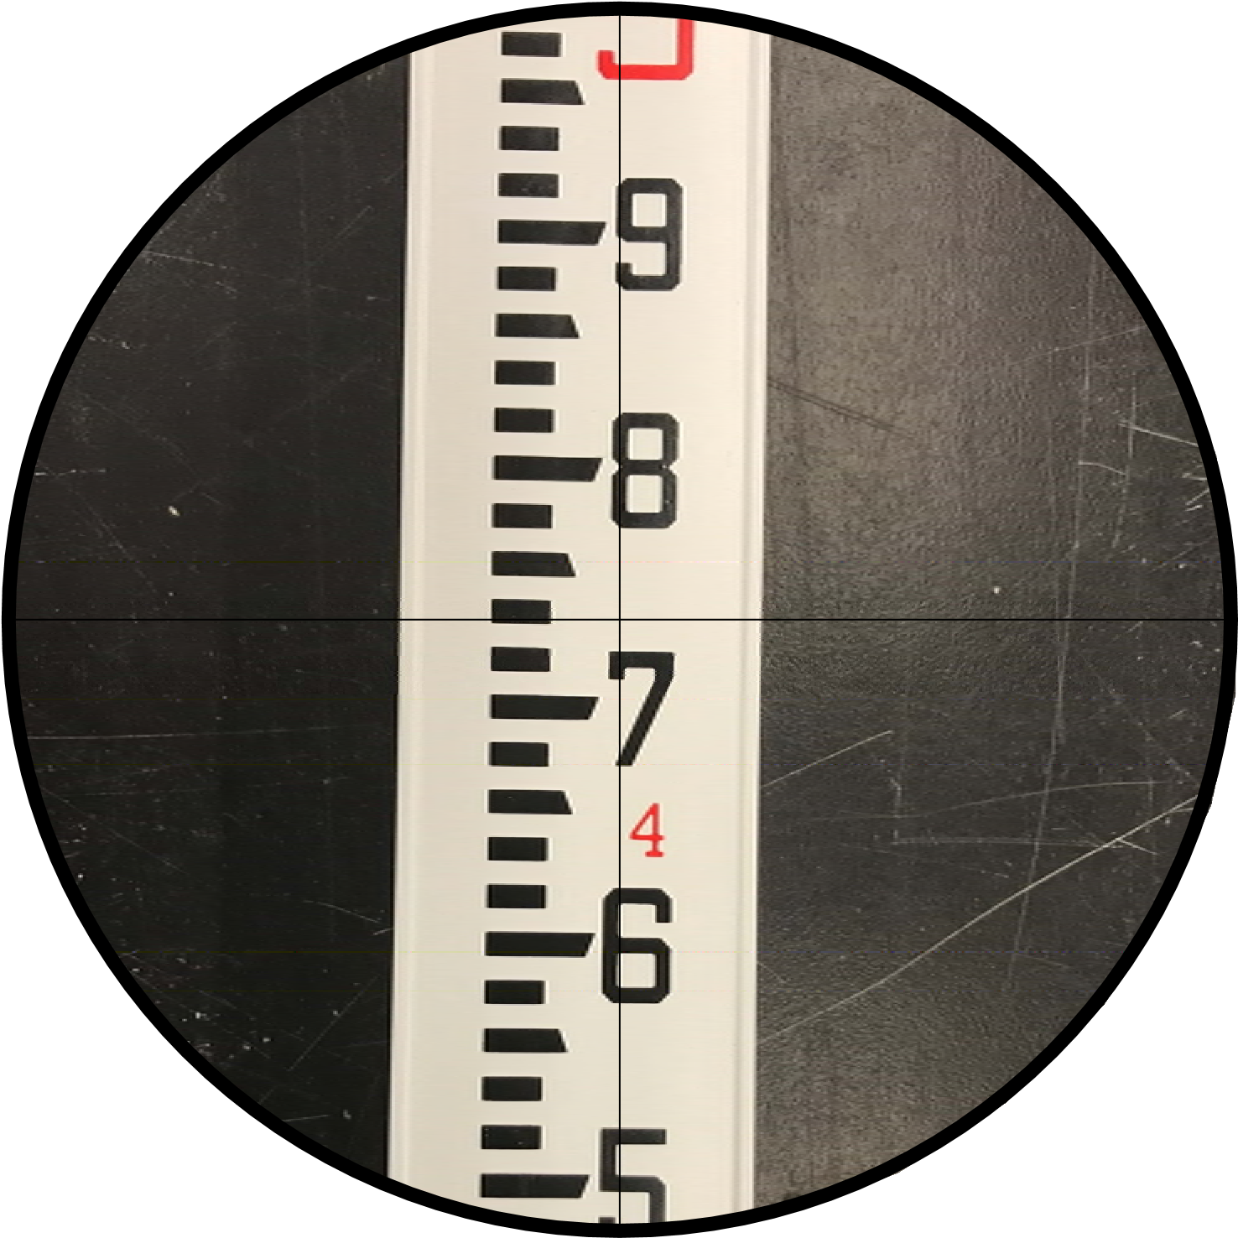
FOURTH FORESIGHT READING AFTER BM-A FIFTH FORESIGHT READING AFTER BM-A
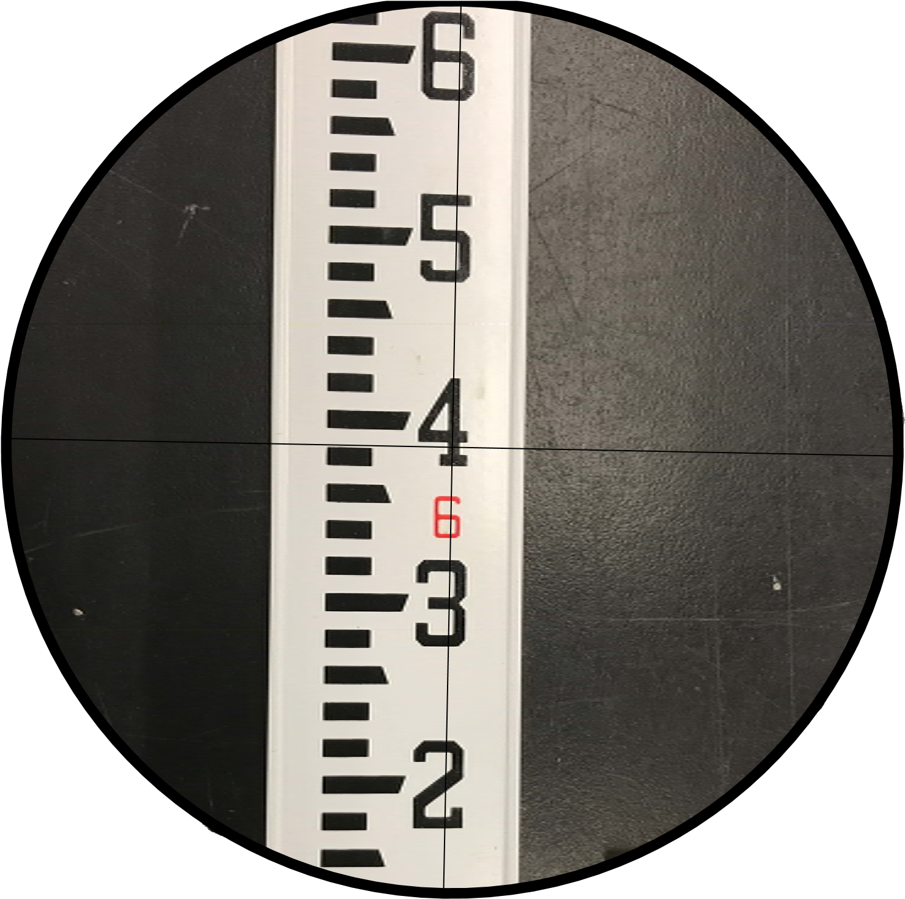

SIXTH FORESIGHT READING AFTER BM-A
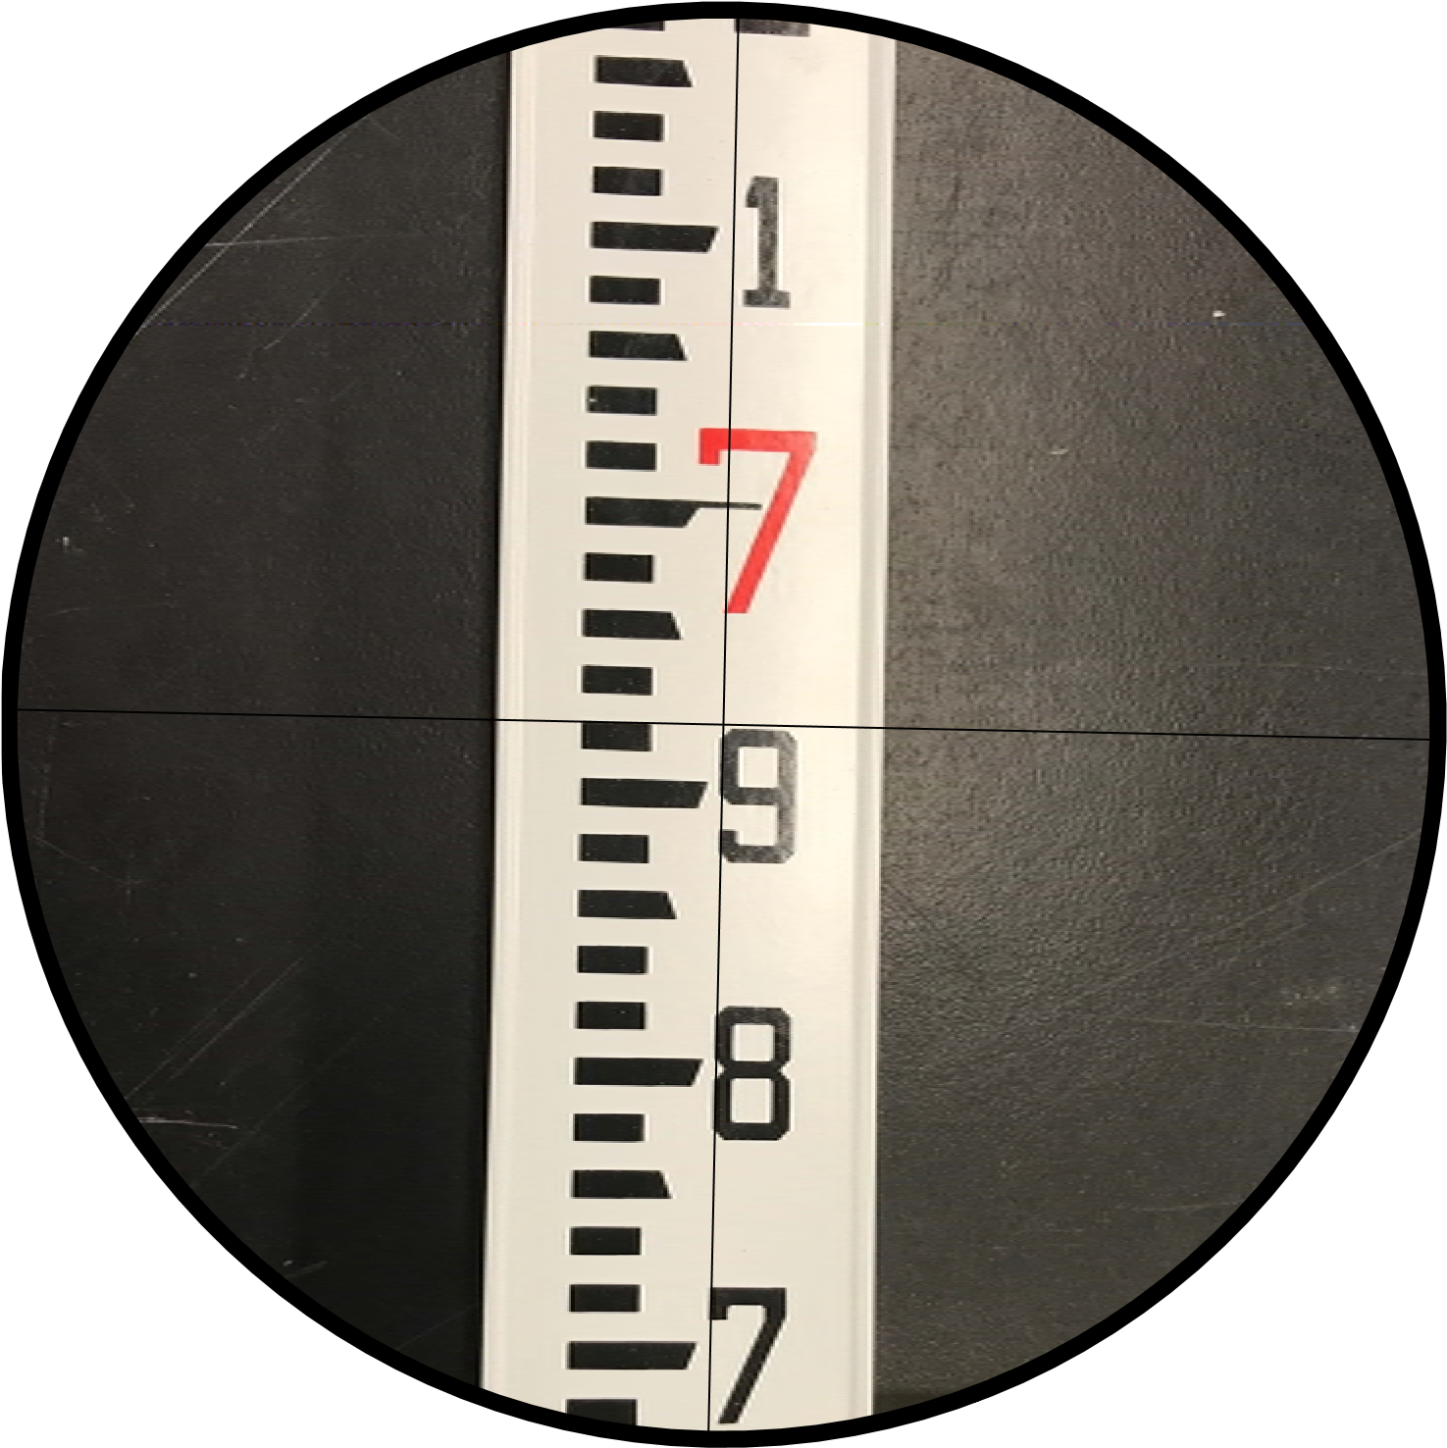

SEVENTH FORESIGHT READING AFTER BM-A
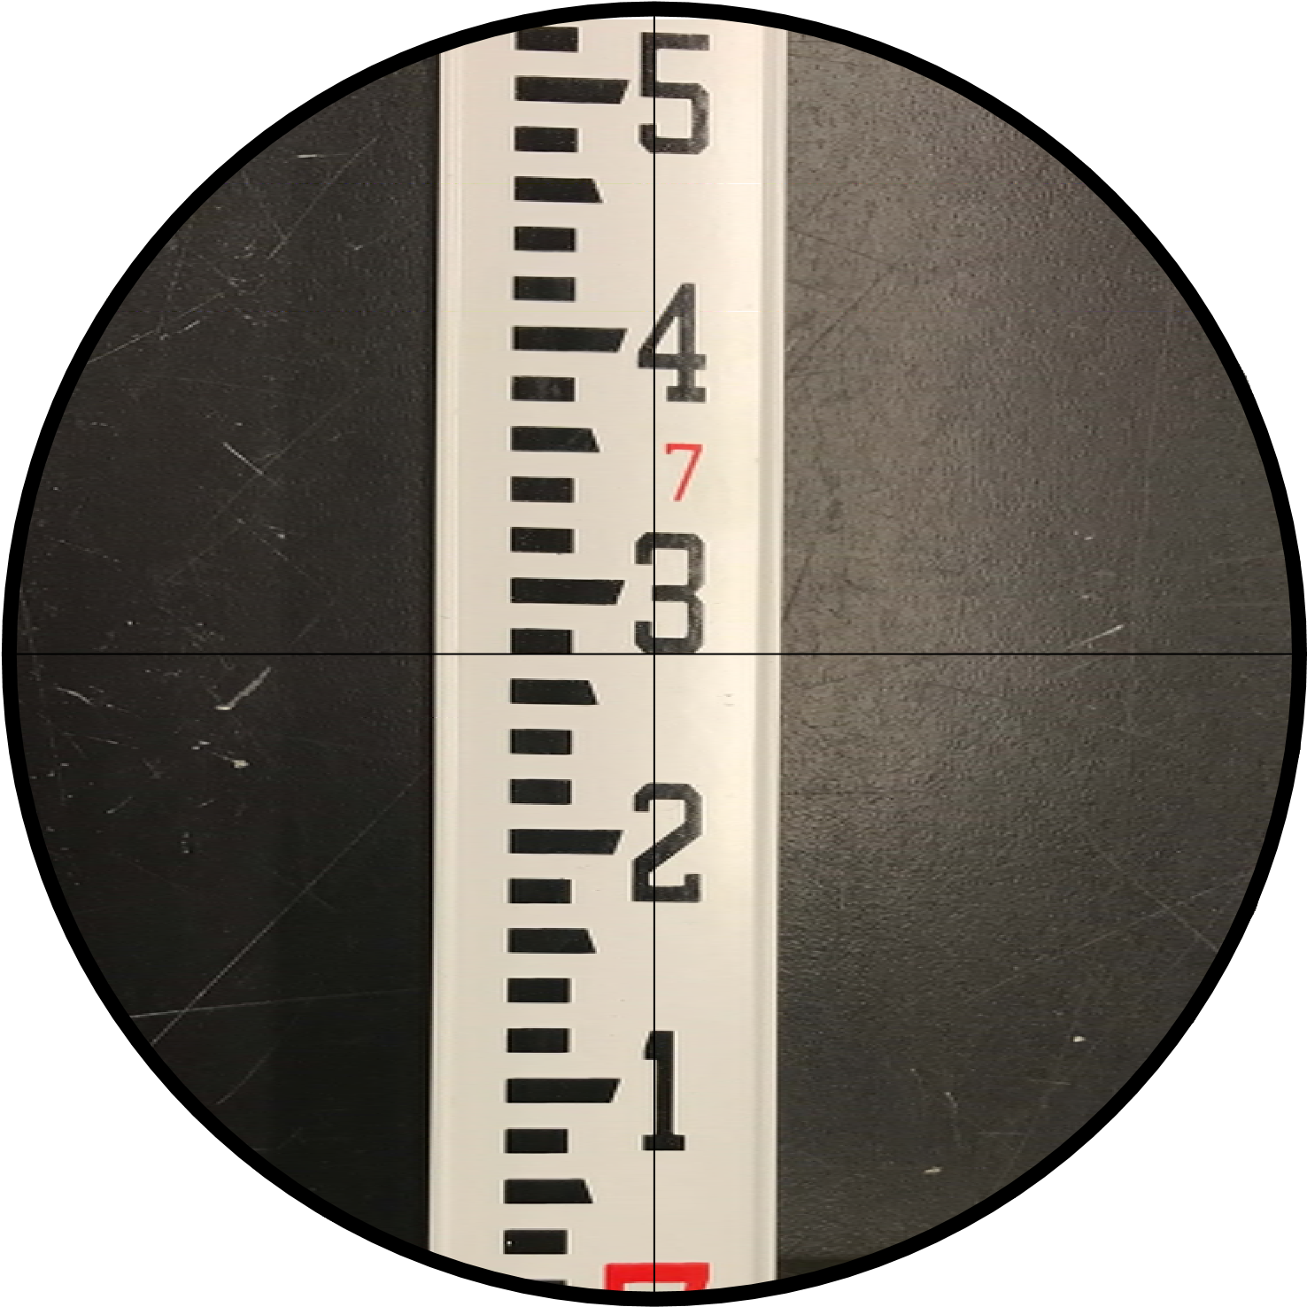

EIGTH FORESIGHT READING AFTER BM-A

