Name
Course
Professor
Date
Nutritional Self Analysis
BMI & Hamwi:
My weight is 132.6 lbs. and my height is 5’6”. The BMI calculation is 21.39. According to our textbook, I am healthy. Dudek (2014) argues that a healthy person has a BMI value ranging between 18 and 24. I agree with this outcome based on my body weight, age, gender, height and the intensity of my bones. From the Hamwi scale, my ideal body weight is 114.5 lbs. (Renee, 2016). However, I don’t consider this to be my accurate weight bearing in mind that I go for a comprehensive workout twice a week. In my workouts, I focus more on building my muscles and increasing the density and size of my bones. Considering the fact that I intend to maintain my weight, I think that 114.5 lbs. is very low and I will be so petite. Also, this will not allow me to lift weights in order to build my muscles and bones.
Food diary
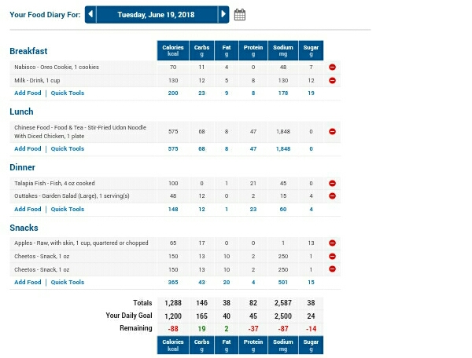
Food Notes
Breakfast: I woke up, took a warm bath and went to the kitchen. I opened the fridge and had a glass of milk and cookies. This felt refreshing and warmed me up for the rest of the day.
Lunch: I took lunch at about 1300 hours. This time I was really starving and took a whole plate of Chinese food, after which I was satisfied.
Dinner: I took Tilapia 4 oz. with garden salad.
Snacks: I had Cheetos and apples for my snacks. They enlightened my mood and I was able to play video games for hours.

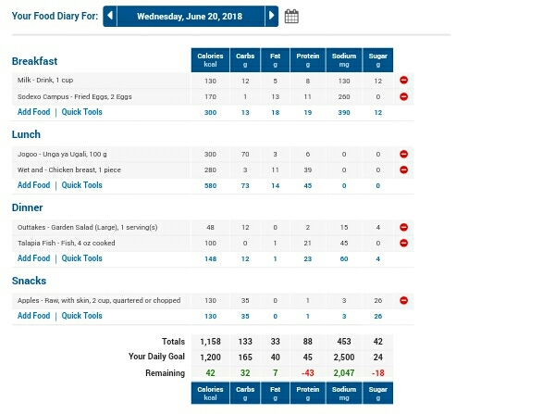
Food Notes
Breakfast: I woke up hungry and had a glass of milk with 2 fried eggs. This was a satisfying breakfast because of the energy and sodium levels which I think are essential for my exercise.
Lunch: after a busy day at the gym, I had a heavy lunch, Ugali with 1 piece of chicken breast. This lunch was good and delicious. I definitely will go back for more.
Dinner: I had a light dinner, tilapia 4 0z. with a garden salad. Fish is always good. It has all these vitamins and nutrients which aid growth.
Snacks: I had 2 chopped apples. This is always soothing.
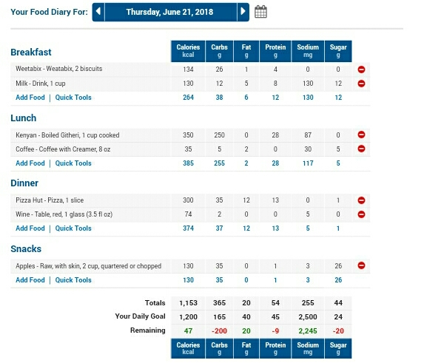
Food Notes
Breakfast: I woke up and had a 0 minutes workout. I ended up taking 2 Weetabix biscuits and a glass of milk. It was satisfying because it made me regain my energy quickly.
Lunch: I had a glass of boiled githeri and an 8 oz. serving. I didn’t like this meal though I had to change my diet to some extent.
Dinner: I had a slice of pizza and a glass of red wine. This felt refreshing especially the wine.
Snacks: I had my usual snacks, 2 chopped apples. This is always a satisfying part of my diet, especially when am watching a movie or playing a video game.
Analysis
Based on 1200 calorie diet goal of 165g carbohydrates, 40g fats, and 45g proteins (Your Fitness Goals, 2016).
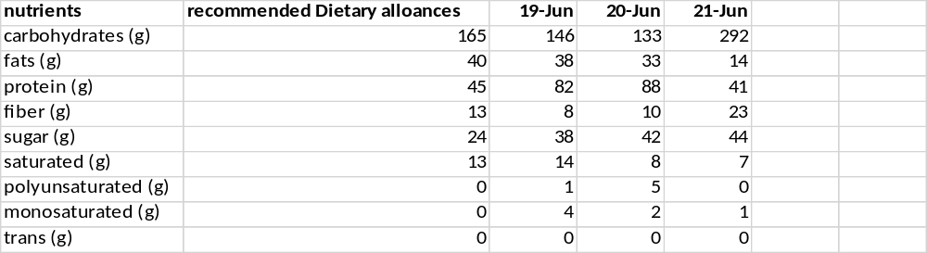Carbohydrates
I thought I was checking my carbohydrate intake well. However, to my surprise I have been fluctuating by a small margin from the recommended amount. This is why I have been able to accomplish most of my exercises on time. However, I will find an alternative for githeri, or rather increase my exercises to consume all the carbohydrates in the system. This will also ensure that I remain within the recommended daily intake of nutrients.
Fats
I always try my best to consume foods with low fat content. According to Dudek (2014) the recommended daily intake of fats is 40g. I maintained my fats below this range with the lowest being 20g. I have realized that snacks, especially Cheetos have a significant amount of fats and can be a perfect inclusion in my diet.
Protein
I have plenty of protein sources. I love fish (tilapia), eggs and chicken. These sources provide me with plenty of proteins, above the recommended daily intake. With my plan to increase my carbohydrate intake, I also intend to reduce my protein intake by approximately 40% to meet the required daily intake of 45g (Dudek 2014).
Fiber
I have a very good source of fiber in my diet. I take 2 pieces of apples. On 19th, I had garden salad, which I think is a good source of fiber. I will increase fiber intake by 2% to reach the recommended daily intake of 13g.
Sugar
My overall sugar intake was very high. I have realized that 2 apples have a high amount of sugar. Therefore, I will find an alternative source of fiber and reduce the number of apples in my snacks to 1 chopped piece. This will achieve a 50% reduction in the amount of daily sugar intake.
Saturated fats
My saturated fats were within the range I expected. As a person who does exercise twice a week, I need more sources of energy to keep my body energized.
Polyunsaturated
My polyunsaturated were high than the recommended daily intake, 0g. However, these are from healthy sources, i.e. fried eggs and Cheetos. I will reduce the number of eggs to 1 fried egg.
Monounsaturated
I will reduce the amount of saturated fats in my meals and increase foods with monounsaturated fats which are healthier (Dudek 2014).
Trans fats
My diet was good regarding intake of Trans fats. The recommended amount is 0g (Dudek 2014) which is the amount I maintained in my diet.
Cholesterol
My level of cholesterol intake was very high. According to Your Fitness Goals (2016), the daily recommended cholesterol intake is 300mg. In my case, I take 30% more than the recommended amount. I will reduce the number of eggs for my breakfast to 1 fried egg.
Sodium
The recommended intake of sodium was 2500mg. my daily intake of sodium varied very much. On 19th, the level was slightly higher than the recommended level. However, on 20th and 21st the levels were very low. I guess it’s high time I include a source of sodium in my meals.
Potassium
My potassium intake was very low, less than 35% of the recommended daily intake. I will thus substitute foods high in calories to those high in potassium. These can be whole grains, vegetables, and fruits (Dudek 2014).
Vitamin A
My sources of vitamin A were more than enough, by 24% cumulatively. This can be attributed the high intake of apples in my meals.
Vitamin C
My vitamin C were way below almost down by half. To boost this, I need foods like broccoli, cauliflower, carrots, and Brussel sprouts, which are good sources of vitamin C (Dudek 2014).
Calcium
My level of calcium is worrying. The highest was 42%. This prompts me to include foods like cheese, milk, cereals, and cabbages.
Iron
I was deeply worried with the amount of iron in my daily intake. It is like I did not have any sources of iron in my meals with the highest being 15%. I have been getting tired easily. This can be explained by my low levels of iron. Due to the fact that I exercise twice a week and I intend to have stronger bones and healthy blood cells. I will increase the frequency of fish in my meals as well as cereals.
Strengths and weaknesses
Strengths: the strengths in my diet are carbohydrates, fats, fiber, and proteins. These sources have remained within the daily recommended intake.
Weaknesses: my weaknesses are vitamins, polyunsaturated and monounsaturated fats, and cholesterol.
Medical condition: no medical conditions
Medications: no medications
Culture: culture does not influence my diet
Diet plan
With a BMI of 21.39, I plan to increase my weight to 150 lbs. This will still allow me to be within the healthy range of 18 to 24. To achieve this, I have to balance my nutrients properly. I will achieve this by increasing the calories by a 5%, increase intake of vitamins and mineral salts, vegetables and fish. I will also take a minimum of 8 glasses of water daily to help me go through my exercise without problems.
Goals /implementations
By 30th June, I will increase my fiber intake by 2%. I will achieve this by depending on easy to cook meals which have a high fiber content and low fat content. This is because I intent to reduce my fat intake and focus on consuming foods which have monounsaturated fats, which are good for human consumption.
I also intent to increase my daily intake of vitamins and mineral salts to more than 75%, to ensure that I range close to the recommended percentage, 100%. I also want to balance my protein and carbohydrate intake, to remain within the recommended range, and also give my body the required nutrients for a healthy growth.
Reflection
I have been always cautious with the type of meal I consume. I suppose this is one of the ways through which I have been able to maintain my weight and BMI within a healthy range. However, due to work and a tight schedule, I ended up consuming junk food. This led to gain of weight and reduced activeness. I have been using My Fitness Pal for 2 years now. This has allowed me to keep track of my meals and nutrients on a daily basis. Also, it has enabled me to know what type of food I should omit or include in my meals.

Works cited

