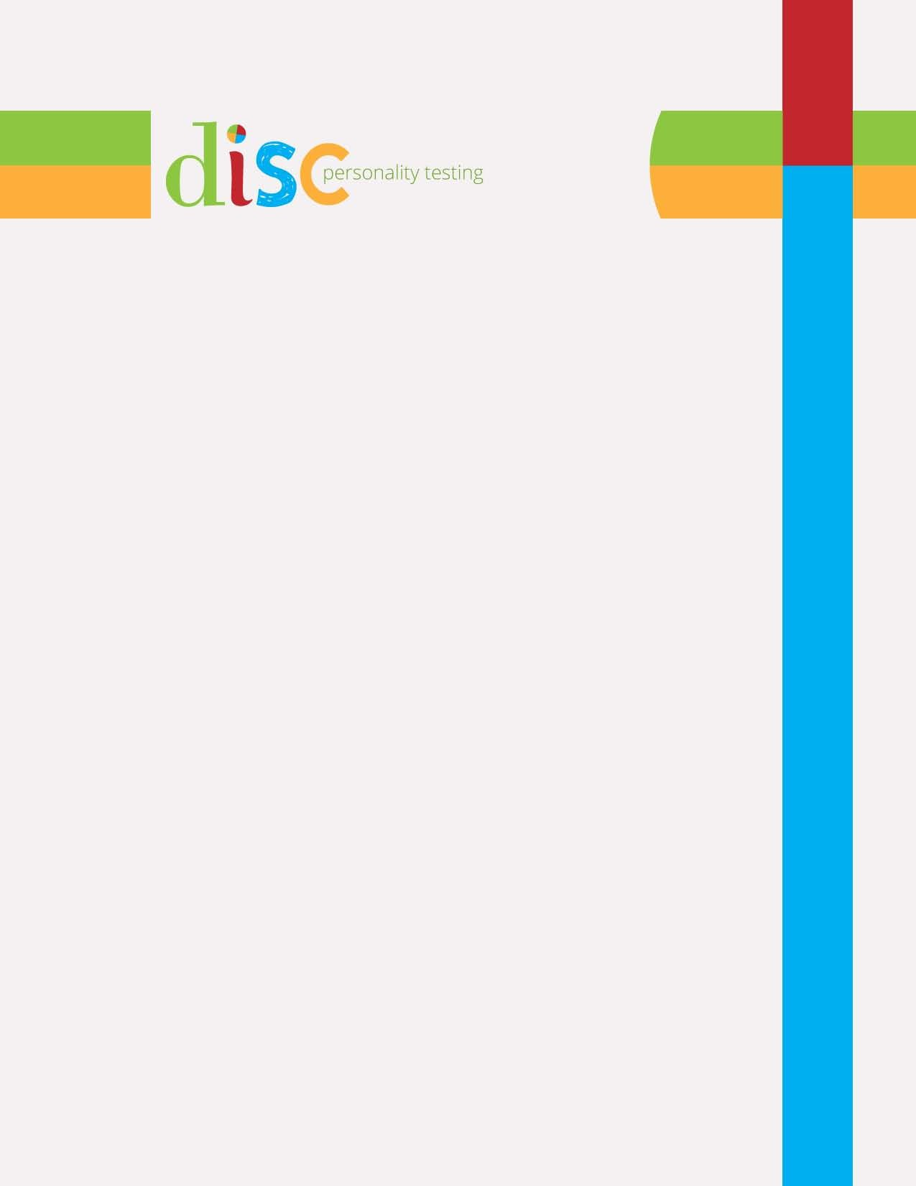

Free DISC Style Report for

Work Environment Version
Your ID Number 6

Assessment Completed May 16, 2019
at www.DISCPersonalityTesting.com
Report Build 2.0

This report is a rough estimate of your DISC style blend based on the short version of the assessment. It will estimate the styles most prevalent in your blend. It might miss the exact degree of each style in your blend.

For a more refined analysis, additional graphs, and deeper insights, take the full assessment at www.DISCPersonalityTesting.com.
Congratulations!

Your style is S

Your Natural / Internal Style Your Adapted / External Style

The bar graphs below show the intensity or consistency of each style in your blend.

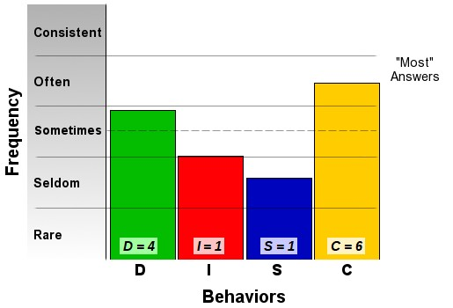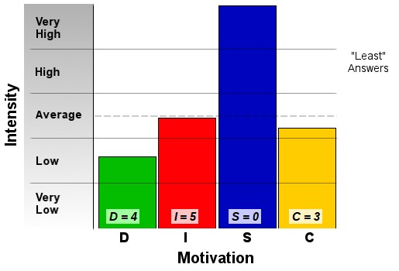

Your natural, or internal, style represents the internal motivations that drive you the most. This is the part of you that is likely to represent how you think or feel about situations more than it represents how you act or behave. Some people say that this represents who you are rather than what you do. It is also the part of you least likely to change throughout your lifetime.
Your adapted, or external, style represents the way that you tend to act or behave. It's the part of you that others are most likely to see. This part of you often represents how you have learned to adapt or adjust your behaviors to be
successful in your environment. These behaviors can change depending on the environment you are in or thinking about when you take the
assessment.

This report is a rough estimate of your DISC style based on the short version of the assessment. It will estimate the styles most prevalent in your blend. It might miss the exact degree of each style in your blend.

For a more refined analysis, additional graphs, and deeper insights, take the full assessment at www.DISCPersonalityTesting.com.
MOHAMMMAD,

You have strong Supportive traits. Your Supportive traits are much stronger than any of the other three DISC style traits.

Some words that describe you are:

• Helpful,

• Kind,

• Friendly, and

• Warm

You have primarily people-oriented and reserved traits. You probably like to help people and to make sure that others are comfortable. It's likely that you are very concerned with the well- being and happiness of other people.

Remember, your strongest style is…

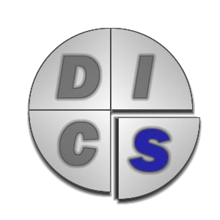

Interested in 26 more pages of personalized insights and analysis?

With a full assessment report, we can more fully differentiate your style blend, and we can give you more insights, tips, and techniques.

Complete the full DISC assessment right now and receive your complete report. With your report you will learn how to…

• Connect with other people better

• Communicate in ways that build and support relationships

• To clearly express your thoughts and feelings

• Confront difficult situations without damaging your relationship.
For just $29 you’ll get…

• Personalized analysis of both your natural style and your adapted style

• Thorough review of all four DISC styles and how you work within those styles

• Insights into the greatest gifts and greatest concerns you have in your workplace

• Overview of the styles that complement your strengths

• Strategies for communicating more effectively

• Analysis of your response to stressful situations

• A look at how others view you and your communication style

• Information on how to adapt your style

• And so much more

Get started on your complete DISC analysis right now at:

http://DISCPersonalityTesting.com/full-report

Or, continue to the next page for more information about the DISC
model.
A Summary of the DISC Model

Brief History

The foundation for the DISC model comes from the work of a Harvard psychologist named Dr. William Moulton Marston in the 1920′s. He developed a theory that people tend to develop a self-concept based on one of four factors — Dominance, Inducement, Steadiness, or Compliance. Marston’s theories form the basis on which we built this DISC assessment and report.

Based on the Range of Normal Behaviors

To graphically illustrate the DISC concept, we represent the range of normal human behaviors and perspectives with a circle as shown in Figure 1. When we say “normal human behaviors and perspectives,” we mean behaviors and perspectives derived from normal, healthy psychology. For this report and your analysis, focus on understanding what the drives
tell us and remember that nothing in this report or in the DISC model describes or discusses any type of psychosis, mental illness, or psychological abnormality.

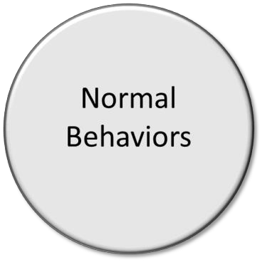

Figure 1: The Range of Normal Behaviors

Built on Understanding Two Basic Drives

We start our description of the DISC model by defining two key motivators that tend to drive our behaviors. One motivator is called our motor drive (or pace drive) and the other is called our compass drive (or priority drive).
➢ Motor Drive (also called the Pace Drive)

Divide a circle in half horizontally as shown in Figure 2. The upper half represents outgoing or fast-paced people. The lower half represents reserved or slower-paced people. Outgoing people tend to move fast, talk fast, and decide fast. Reserved people tend to speak more slowly and softly than outgoing people, and they generally prefer to consider things carefully and thoroughly before making a decision.

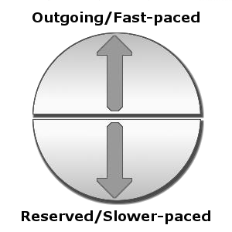

Figure 2: Motor Drive

The shading of the circle from lighter to darker indicates varying intensities of these drives as you move from the center to the ends. Close to the middle of the circle would represent less intensity in the motor activity, and we use lighter shading towards the center. Moving towards the outer edge of the circle represents higher intensity in the motor drive, and we use darker shading. Your perspectives and behaviors could lie anywhere along this line.

Most people will exhibit a bit of both of these traits depending on the situation they find themselves in. Even though this is usually true, most people will tend to exhibit more of one trait or the other – even if it is only slightly more.
➢ Compass Drive (also called the Priority Drive)

The circle can also be divided vertically as shown in Figure 3. The left half represents task- oriented people. The right half represents people-oriented people. Task-oriented people tend to focus on logic, data, results and projects. People-oriented people tend to focus on experiences, feelings, relationships, and interactions with other people.

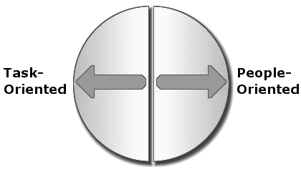
Figure 3: Compass Drive

Just as with the Motor drive diagram, the shading of the arrows from lighter to darker indicates varying intensities of the Compass drive. Close to the midline shows less intensity in the Compass drive, therefore light shading. Towards the outer edge shows more intensity in the Compass drive, therefore darker shading.

Four Basic DISC Styles or Types

When you combine the drawings for the Motor and Compass drives, you get the circle of normal behaviors and perspectives divided into four quadrants as shown in Figure 4. This
figure, sometimes called the DISC circle, represents the full graphical description of what we call

The DISC Model of Human Behavior.

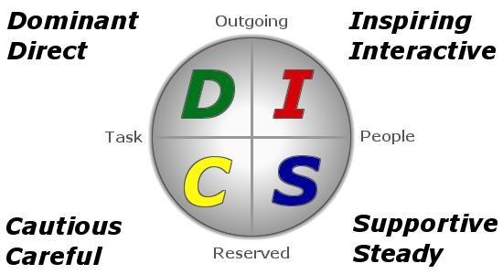

Figure 4: The DISC Model of Human Behavior

Notice that each quadrant of the DISC circle has descriptive words attached to it. These descriptive words attempt to capture the typical behavior exhibited by people who have the combination of motor and compass drives that corresponds to that quadrant. These descriptive words show behavioral traits or tendencies that describe each quadrant of the circle.

To make the quadrants easier to discuss, we often call each quadrant a behavioral type or style. While it is not strictly or technically accurate from a clinical psychology standpoint to use the phrase personality type with this model, the phrase is often used in normal, everyday conversation. We prefer to use the phrase behavioral style because it more accurately fits the model and its theoretical basis.

The main characteristic trait for each behavioral type (quadrant of the DISC circle) is used as the representative word for that type:

• Dominant,
• Inspiring,
• Supportive, and
• Cautious.

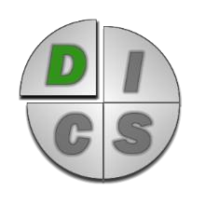People who have both Outgoing and Task-oriented traits often exhibit DOMINANT and DIRECT behaviors. They usually focus on results, problem- solving, and the bottom-line.

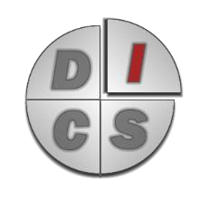People who have both Outgoing and People-oriented traits often exhibit INSPIRING and INTERACTIVE behaviors. They usually focus on interacting with people, having fun, and/or creating excitement.

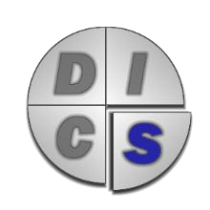People who have both Reserved and People-oriented traits often exhibit SUPPORTIVE and STEADY behaviors. They usually focus preserving relationships and on creating or maintaining peace and harmony.

People who have both Reserved and Task-oriented traits often exhibit
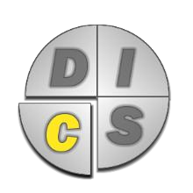CAUTIOUS and CAREFUL behaviors. They usually focus on facts, rules, and correctness.

Some shortcuts you can use in discussing the different behavioral types:

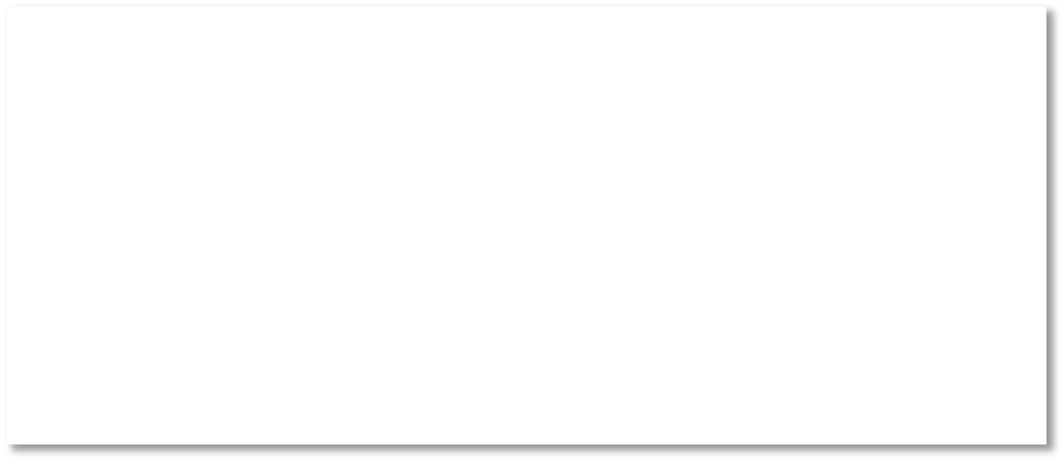the DOMINANT type is also known as High D the INSPIRING type is also known as High I the SUPPORTIVE type is also known as High S the CAUTIOUS type is also known as High C
This model can help you understand yourself and others by describing four main, or primary, behavioral styles. However, each individual person can, and likely will, display some
of all four behavioral styles depending on the situation. This blend of styles within each person

is called a style blend. Each person’s style blend will have more of some traits and less of

others. The types that are strongest in a style blend will display above the mid-line point on the DISC style bar-graphs and they are called High-Styles. The types that are less prevalent in a style blend are called low styles because they display below the mid-line point on the DISC style bar- graphs.

Behavioral Style Blends

When we speak about DISC Behavioral styles, we recommend speaking about style blends rather than focusing solely on a person’s highest trait. In reality, only a small percentage of people have a behavioral style blend that is only one High-DISC type with three low types (although it does happen for about 5% of people). Most people (about 80%) have two High- DISC types and two Low-DISC types in their personal behavioral style blend.

For you, this means that one DISC type may be the highest of the four in your style blend, and you probably have at least one secondary DISC type which is also high (meaning that it is above the mid-line in your style blend bar graph).

Your secondary type supports and influences the predominant type in your style blend. We represent your style blend with your primary style, a slash, and then your secondary style(s). For example, C/D would represent a Cautious primary style and a Dominant secondary style.

Learn more about your style blend with a full disc assessment.

Go to http://discpersonalitytesting.com/home/get-a-disc-work-assessment/ to learn more.
We said that most people have at least one secondary trait. As we said, this is true for about

80% of people and that about 5% of people have only one High-DISC style. So that we don’t forget the remaining 15%, let’s fill in some missing information.

About 15% of people have two secondary traits that support and influence their primary behavior trait. This means that they have three High-DISC types and one Low-DISC type in their style blend

When you consider this blending of behavioral styles and different degree of each type in different people, you can easily see how the four primary traits can be used to understand the large variability among people. Using the four basic style types, we can create forty-one generalized type blends with variations of degree within each basic blend type

The good news is that you don’t have to remember all 41 style blends and descriptions to use the DISC model to improve your ability to interact with people. It’s really much simpler than that, and that’s why we use it and recommend it to others. When you learn to understand the four basic types, you can use them as a way to frame your interactions with others to become more effective. From a simple model, you really can build the ability to connect and
communicate with lots of people more effectively.

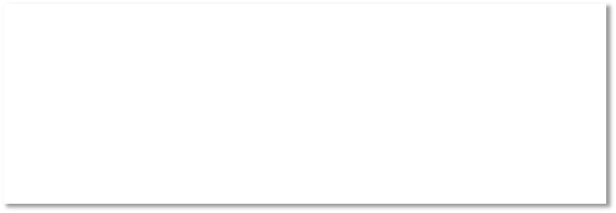Understand the four basic types, and you can use them as a way to frame your interactions with others to become more effective. Learn more with a full disc assessment and report.

Go to http://discpersonalitytesting.com/home/get-a-disc-work-assessment/ to learn more.
Your Next Steps

We hope that this report is just one of many steps that you will take to become a better:

• Leader
• Teacher
• Mentor
• Coach
• Team member
• Business owner
• Parent, or
• Spouse

Here are some things you might consider to continue learning and growing in your use of this information.

• Purchase a complete DISC assessment to get a more complete and more personalized view of your DISC style at

https://discpersonalitytesting.com/home/get-a-disc-work-assessment/

• Purchase DISC assessments for your whole team at https://discpersonalitytesting.com/multiple-assessment-purchase/

• Work with a trained DISC coach. You can learn more about that opportunity at https://discpersonalitytesting.com/home/disc-coaching/

• Get even more value from your assessment with our How to Use the DISC Model video course at
https://discpersonalitytesting.com/home/disc-resources/how-to-use-disc/

• Learn insights and perspectives to close the communication gap with our Quick Course on Using the DISC Model video
https://discpersonalitytesting.com/home/disc-resources/disc-quick-course/

• Get deeper insights into how to use the DISC Model with our Connect and Communicate
Video Course
https://discpersonalitytesting.com/home/disc-resources/using-disc-model-connect- communicate/

• Get additional resources – videos, books, etc. We use this model in our book From Bud to Boss. If you are a new or aspiring leader, this book can help you grow in your leadership skills. Learn more at https://budtoboss.com/

• Attend a live Bud to Boss workshop we lead that uses the DISC model. Learn more at https://budtoboss.com/

And, we always welcome readers at our blogs.

• Guy’s Blog – https://recoveringengineer.com/
• Kevin’s blog – https://blog.kevineikenberry.com/

Thanks for trusting us as partners in your learning and development.

Guy Harris and Kevin Eikenberry
Indianapolis, Indiana

Disclaimer and Limit of Liability

