Introduction

Name of School/Department/Unit
Current Trends in Health Care Informatics: Telemedicine
Names of Presenter
The medical practice of remotely caring for, monitoring, and treating patients is known as telemedicine. Telemedicine has grown more popular as the COVID-19 pandemic progresses. While telemedicine was already in use before the pandemic, the world wide web, smartphones, laptops, and video-conferencing technologies have made it widely accessible Barnett et al., 2018). I picked this topic because, when it pertains to diagnostics and therapy, telemedicine is ideal since it provides potential solutions for physicians and individuals seeking medical attention. It can also serve as an excellent support structure (Leite et al., 2020). Anyone may use it to access online medical and health information for consumers.

Background
Telemedicine's acceptance rate has risen by 71% in several years, making it a current trend (Pacis et al., 2018). Besides, it is predicted that the telemedicine sector is likely to develop even further in the coming years. Telehealth live audiovisual consultations are expected to rise to annually in the foreseeable future. According to the National Rural Hospital Association, one out of three rural hospitals is in financial jeopardy. At this pace, 25percent of the total rural healthcare institutions will collapse within a couple of years . Therefore, telemedicine and informatics in the sector are among the major trends that will continue beyond this year.
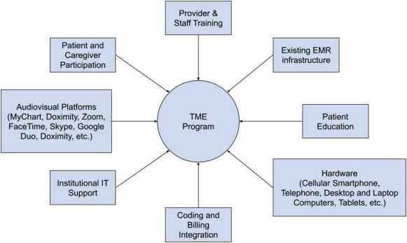

The Population Affected
This trend has the potential to affect the patients and healthcare providers significantly. Regarding the people with chronic illnesses, Covid-19 patients, and healthcare practitioners in the sector, it is pretty apparent that telemedicine will influence the healthcare industry's prospects (Wahezi et al., 2020). It will expand as it aids in the bridge-building between health care providers and patients. Given the shrinking number of doctors in rural regions, the rise of slightly elevated healthcare coverage, and the drug problem, essential technology like telemedicine is critical to tackling these challenges. Remote providers would flourish as long as new technology, such as telemedicine, is used (Cantor et al., 2021).

Costs
One of the most compelling arguments for introducing telemedicine is the potential to lower healthcare costs. Telemedicine providers may reap a wide array of financial incentives, such as getting to have lower overhead expenditures (Patel et al., 2021). For instance, they may save costs on the front desk staff or invest in an office with fewer examination rooms. In this regard, patients, healthcare practitioners, insurance companies, and even businesses benefit from telemedicine because it lowers healthcare expenses and saves money (Drake et al., 2021).

Quality of Healthcare
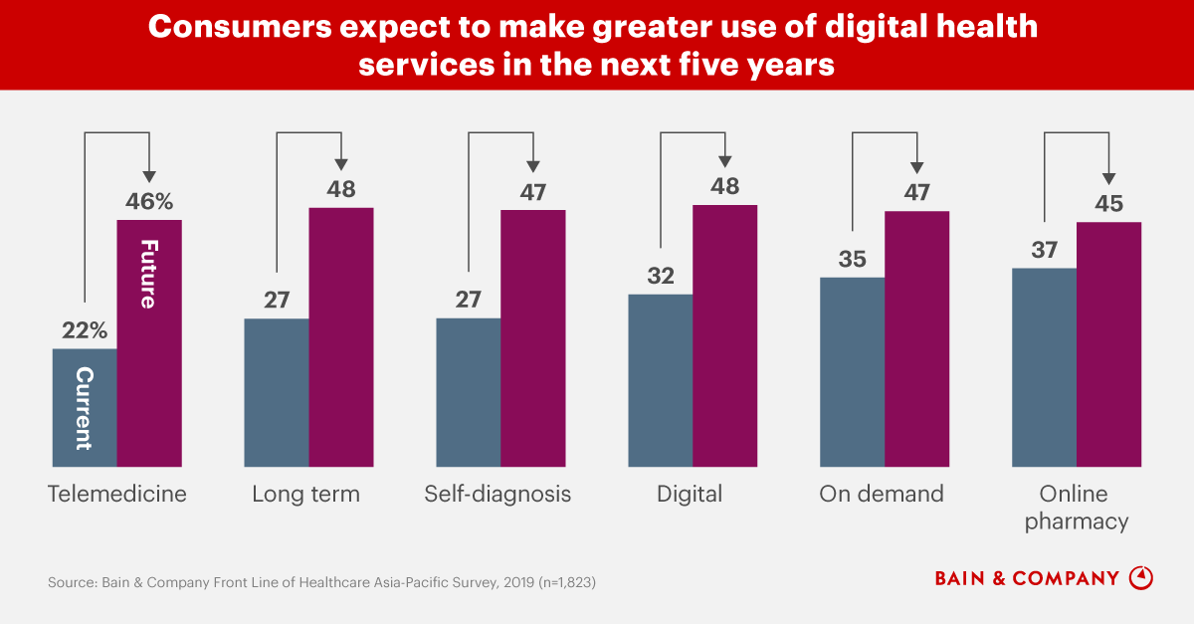
Telemedicine provides patients with high-quality treatment where and when they require it, resulting in patient-centered care. Real-time emergency consultations can be utilized to swiftly address medical issues. An early identification and care of the patient nearly always yields better outcomes and reduced expenses (Klonoff, 2016). Therefore, by assisting patients in keeping check-up visits and care regimens, telemedicine improves patient involvement. Patients can also use virtual consultations to communicate with their doctors, report signs and symptoms or health complications, and keep their appointments. Improving patient outcomes and much more have been demonstrated to be benefits of telehealth.

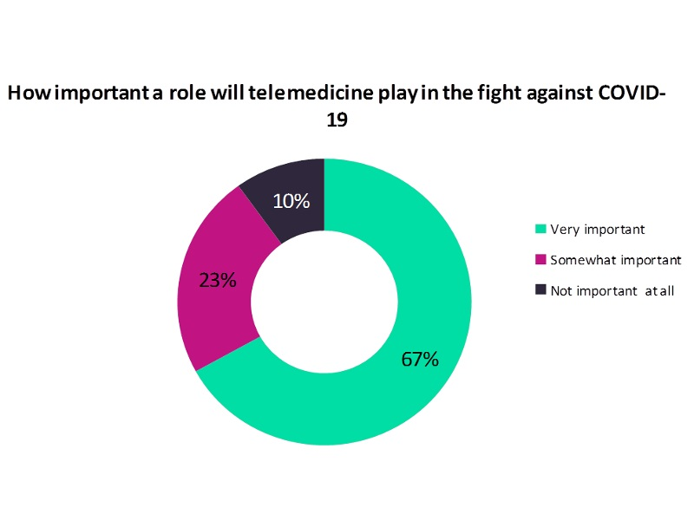

Healthcare Information
Healthcare informatics is directly involved with particular healthcare problems. Practitioners may utilize data on specific chronic health problems such as diabetes to improve operations, spot at-risk patients, increase efficiency, and promote research, all in the quest for better outcomes by correctly collecting, evaluating, and utilizing such numbers (Abbasi-Feinberg, 2020). Besides, it is a factor in a healthcare problem since patients can use informatics to offer vital data to the health professionals and share that knowledge with relatives, acquaintances, and other patients. Healthcare professionals can utilize information technology to streamline treatment and exchange information with other practitioners. for example, electronic health records.

Potential Solutions
Current research is being done to validate this trend that demonstrates that telehealth adoption is not just a component that can get incorporated into existing health care delivery to show and generate additional value to healthcare outcomes. At the system level, recent research shows that it needs to be included in innovations. Examining the current treatment flow for specific subpopulations, updating the overall care approach, including telemedicine, and altering conventional features are all part of the integration process. Using telemedicine would provide potential solutions to manage chronic illness.

References

Abbasi-Feinberg, F. (2020). Telemedicine coding and reimbursement-current and future trends. Sleep Medicine Clinics, 15(3), 417-429.
Barnett, M. L., Ray, K. N., Souza, J., & Mehrotra, A. (2018). Trends in telemedicine use in a large commercially insured population, 2005-2017. Jama, 320(20), 2147-2149.
Cantor, J. H., McBain, R. K., Pera, M. F., Bravata, D. M., & Whaley, C. M. (2021). Who is (and is not) receiving telemedicine care during the covid-19 pandemic. American journal of preventive medicine.
Creedon, T. B., Schrader, K. E., O'Brien, P. L., Lin, J. R., Carroll, C. D., & Mulvaney-Day, N. (2020). Rural-nonrural differences in telemedicine use for mental and substance use disorders among Medicaid beneficiaries. Psychiatric services, 71(8), 756-764.
Drake, C., Lian, T., Cameron, B., Medynskaya, K., Bosworth, H. B., & Shah, K. (2021). Understanding Telemedicine's “New Normal”: Variations in Telemedicine Use by Specialty Line and Patient Demographics. Telemedicine and e-Health.
Garattini, L., Badinella Martini, M., & Zanetti, M. (2021). More room for telemedicine after COVID-19: lessons for primary care?.
Klonoff, D. C. (2016). Telemedicine for diabetes: current and future trends. Journal of diabetes science and technology, 10(1), 3-5.
Leite, H., Hodgkinson, I. R., & Gruber, T. (2020). New development:‘Healing at a distance’—telemedicine and COVID-19. Public Money & Management, 40(6), 483-485.
Pacis, D. M. M., Subido Jr, E. D., & Bugtai, N. T. (2018, February). Trends in telemedicine utilizing artificial intelligence. In AIP conference proceedings (Vol. 1933, No. 1, p. 040009). AIP Publishing LLC.
Patel, S. Y., Mehrotra, A., Huskamp, H. A., Uscher-Pines, L., Ganguli, I., & Barnett, M. L. (2021). Trends in outpatient care delivery and telemedicine during the COVID-19 pandemic in the US. JAMA Internal Medicine, 181(3), 388-391.
Wahezi, S. E., Kohan, L. R., Spektor, B., Brancolini, S., Emerick, T., Fronterhouse, J. M., ... & Kaye, A. D. (2020). Telemedicine and Current Clinical Practice Trends in a COVID-19 Pandemic. Best Practice & Research Clinical Anaesthesiology.

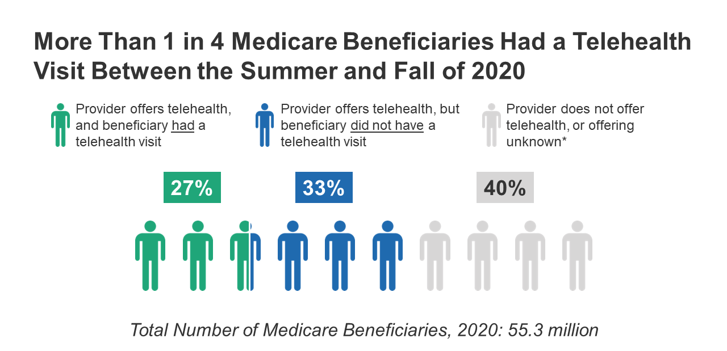
(Creedon et al., 2020)

