The Power of an Apology

Beatriz Ramirez
Florida International University
Professor Dr. Ryan Winter
Research Methods and Data Analysis in Psychology II

Methods
Participants
In this study, one hundred and thirty-eight students were chosen for the study. Out of the one hundred and thirty-eight student, 138, participants were 36% (n=56) who were male and 64% were recorded as female. The ages of the participants ranged between 18 to 60 years where the average age was 24 years (SD=6.3). the following are considered as the sample population which was used in the study. The Hispanic population was at (n=86), 8.6% and the African Americans were in the range of 22%, the Caucasian were in the bracket of (n=22) and the Asian were at 3.6%. however, the population that did not take part in the study were in the ethnicity part where n=4.4.
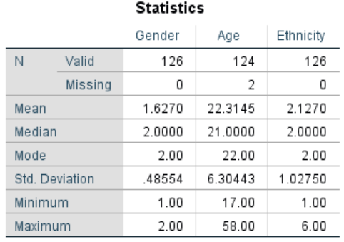

Procedures and Materials
Based on the guidelines of the study in the consent of information, participants were seen as the potential threats who would entirely benefit the ones who took part in the study during the research material formulation. The students who managed to agree verbally were given a number of three documents that were different and consistent of three parts. The first part involved the procedure where the student was supposed to read the scenario and requested more information from the colleagues. However, from the results, it would be seen that the documents managed to reflect the same number of initial circumstances, the one that can change, not change and neutral.
In situations that are changeable, the taxi driver managed to arrive with the couples but unfortunate they declined their fare because they were perceived by them to not belong to the required category. There was no enough time for the group to call for another taxi. For the group to effectively reach their destination, the crossing of the bridge had to be done thus weakening the present severe storm. There was complete collapse when on arrival. Unfortunately, the couple were drowned into the river for missing to see a portion of the bridge at night that had collapsed. The taxi driver was lucky to make it safely 15minutes earlier before the collapse. In the unchangeable situations, the condition remained the same despite the taxi driver crossed the bridge and thereafter the bridge collapsed. The driver managed to swim safely but Tina and Eugene drowned. In neutral conditions, despite the arguments between the couple and the driver, the driver declined their fare of perceiving them to be paraplegic.
In part two, the student continued reading the rest of the parts that had open, partial and closed ended questions. The participating student was told to procure as many “If Only” statements as possible supposing note the factors that would have played a critical role in altering the final outcome.
Partially three, the understudy was furnished with arrangement of inquiries concerning their reasoning and what they found from the circumstance they read. The understudy was approached to give their reaction in the wake of perusing each question in a size of one to nine. The inquiries were about how avoidable the episode was(1=Unavoidable,9=very avoidable),the most significant pretended by the driver for the demise of couple(1=uncausal,9=most significant cause),their sees on how the control the driver had(1=unnegligent,9=completely negligent),how much the driver had the right to be accused for the accident(1=no fault at all,9=total fault).
Section four was to accumulate the member 'segment data comprising the age, sexual orientation, race, language and whether the member was an understudy at Florida International University. Therefore, the member was given investigation on the commitment to the examination just as the experiences about counterfactual reasoning and the principle setting.
There were a few factors that zeroed in on the culpability of the driver and the "If Only "proclamations that the members would check and control whether the driver consented to take the driver subsequently the main three factors that were investigated.
Results
By the analysis from the above the independent variable and whether the students are able to recall whether the diver carried the paraplegic couple is perceived as independent variable therefore a manipulation check is ran to show significant effect.
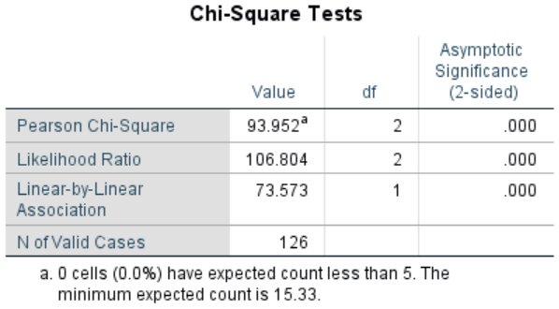Those who took part in changeable and unchangeable situations rightly said that the driver did not pick the couples. Whereby those who took part in neutral conditions said that the driver picked the couple. This shows clearly that the participants paid attention to whether the driver picked the couple.
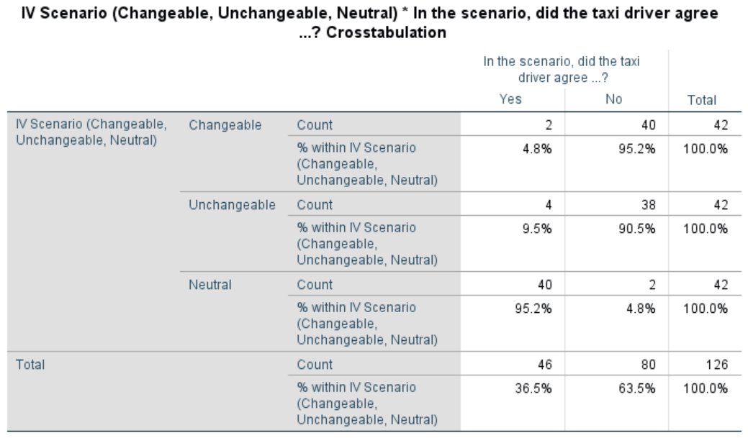

From the analysis and discovery, I revealed the important differences among the variables, the conditions and dependent variables that perceived as blameworthiness of the driver.
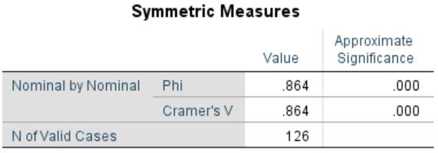The results reflects that there are situations where the outcomes are regarded as changeable while some individuals blames the actor of acting differently meaning unchangeable.
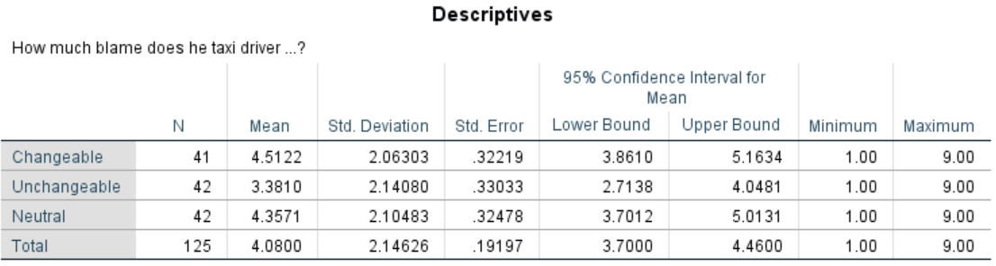
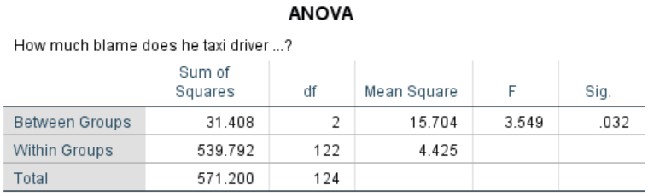
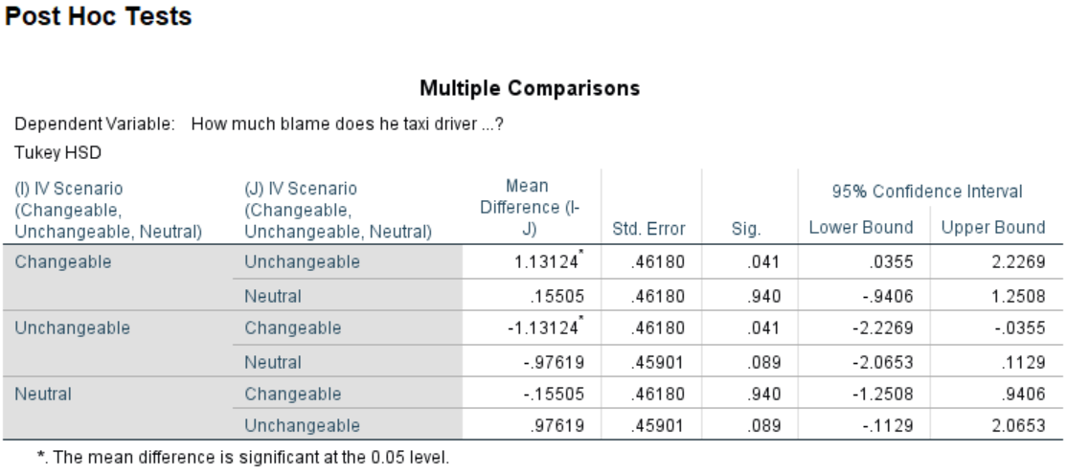
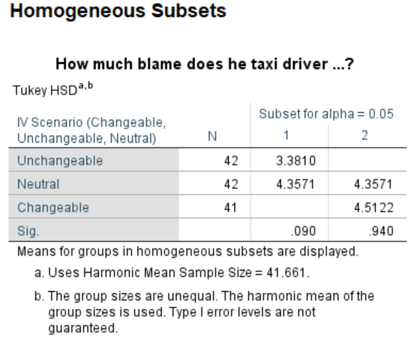
Finally, the participants perceived that the accident would be avoidable due t changeable conditions than unavoidable circumstances .The table below clearly defines the independent variables that are significant.
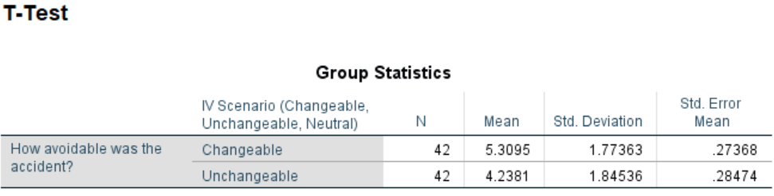
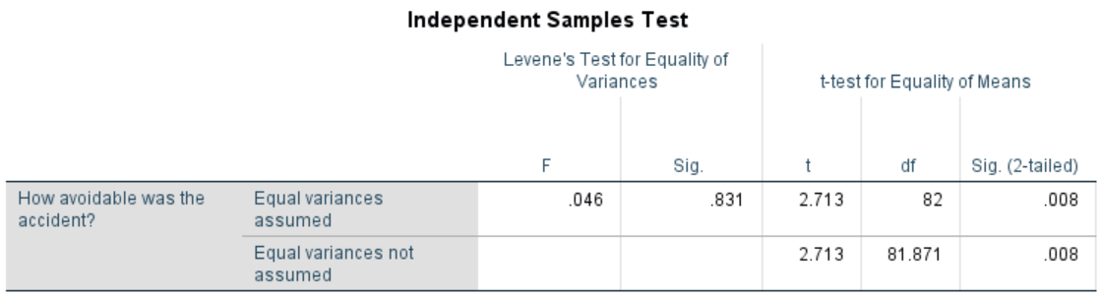
Discussion
The prediction on the participants was that they put more blame to the actor because he chose to act differently that caused the death of the couples. These participants generated “If Only “statements that were counterfactual that would enhance the define the outcome as being avoidable. On the other side we claim that the participants who would have read the undesirable outcome would have assigned less blame to the actor and would have thought of fewer counterfactual “If Only “statements. The prediction supported more that the condition was more changeable than unchangeable as the accident was more avoidable. However, the counterfactual statements that were generated by the participants were not different from the three conditions. Its is seen that the participant were not familiar with the counterfactual tasks that required deep thinking that they could have seen changeable conditions as an evidence tool of blame.

References
Cleary, M., Lees, D., & Lopez, V. (2018). “Saying Sorry”: Some Strategies for Effective Apology within the Workplace. Issues in mental health nursing, 39(11), 980-982.
Matley, D. (2018). “Let's see how many of you mother fuckers unfollow me for this”: The pragmatic function of the hashtag# sorrynotsorry in non-apologetic Instagram posts. Journal of Pragmatics, 133, 66-78.
McClure, T., Killian, G., & Pearson, J. M. (2019). OBSERVER RETALIATION: APOLOGY COMPONENTS AFFECT ON OBSERVING CUSTOMERS'REACTIONS. Journal of Consumer Satisfaction, Dissatisfaction & Complaining Behavior, 32.
Nigro, G., Ross, E., Binns, T., & Kurtz, C. (2019). Apologies in the# MeToo moment. Psychology of Popular Media Culture.
Watanabe, S., & Laurent, S. M. (2020). Volition speaks louder than action: offender atonement, forgivability, and victim valuation in the minds of perceivers. Personality and social psychology bulletin, 0146167220953996.

