The female reproductive system

Author
Institutional Affiliation
Instructor
Course code
Date of submission

Sitting in the pelvic cavity, the female reproductive system is made up of both internal and external organs performing collectively to enable the system’s primary function of reproduction (Betts, 2013). However, it is important to understand that before the system can perform reproductive functions including pregnancy and birth, it undergoes sexual maturation. Besides enabling the process of pregnancy and birth, the female reproductive system produces gametes and reproductive hormones that support the development of the fetus in the uterus before the ultimate delivery to the world through the vagina. In this sense, ovaries are responsible for the production of the oocyte (Ova).
Structures of the female reproductive system
Primarily the female reproductive system is composed of two parts that include; the internal and the external structures. Collectively the external structures of the female reproductive system are referred to as the vulva and they include;
The mons pubis: this is the fat pad usually located at the anterior over the pubic bone. After sexual maturation, the mons pubis becomes covered in pubic hair. Ideally, its specific location is over the pubic bone.
The labia majora: are folds of hair-covered skin that appear posteriorly after the mons pubis.
Labia minora: this refers to the thinner and more pigmented skin extending medially to the labia majora.
Notably, despite the varying shapes presented by different women, it is essential to understand that labia minora serves to protect the internal structures such as the female urethra and the entrance of the reproductive tracts in females (Marieb & Hoehn, 2007).
Also, the superior and the anterior portions of the labia minora encircles the clitoris, a very crucial organ in women sexual sensation and orgasm.
The internal female reproductive structures
Vagina
The vagina is the main entrance into the female reproductive tract. Usually, about 10 cm long, the vagina, a muscular canal serves as the main exist from the uterus during the menstrual cycle and even childbirth. The outer walls of the posterior and the anterior vagina are ridged. The vagina ends at the cervix which is the opening to the uterus. It is, however, important to understand that the outer walls of the vagina are lined with fibrous adventitia while the middle and the inner layers are lined with a layer of smooth muscles and mucous membranes respectively (Betts et al., 2013). To accommodate sexual intercourse and birth, it is essential to note that the middle and the inner layers of the vagina allow for its expansion. Similarly, the mucous secretions from the Bartholin’s glands help keep the vagina moist.
Interestingly, the vagina is protected from infections by a wide range of microorganisms that include bacteria and yeast. The most predominant bacteria in the vagina of a healthy woman is the Lactobacillus responsible for the secretion of lactic acid, which together with other vaginal secretions ensure the self-cleansing activity of the vagina (Marieb & Hoehn, 2007). Even though the vagina is a self-cleaning organ, washing with water or other fluids can disrupt the normal balance of the microorganisms in the vagina consequently putting the woman at the risk of getting infected.

Ovaries
These are the female gonads located at the entrance of the fallopian tube. There are two ovaries with each of them about 2-3 cm in length. In female reproduction, ovaries are responsible for the production of the ovum which is required for the fertilization of sperm for the development of the baby.
The fallopian tubes
Also known as the oviducts, the fallopian tubes are channels connecting the ovaries to the uterus. The tubes allow for the passage of female eggs to the womb. In most occasions, fertilization of the egg occurs in the fallopian tubes. The isthmus is the narrow medial end of each uterine tube that is connected to the uterus. The wide distal infundibulum flares out with slender, finger-like projections called fimbriae (Betts et al., 2013). The middle region of the tube, called the ampulla, is where fertilization often occurs. The inner layers of the fallopian tubes are mucous secreting cells that are also ciliated to enhance the movement of the fertilized ovum towards the uterus.
The uterus
Observably, this is the organ that nourishes and supports the development of the embryo. With an average size of about 5 to 7 cm, the uterus is divided into three sections namely; the fundus which refers to the opening of the uterine tubes, the middle section supports child growth and the cervix which acts as the exit to the vagina. During sexual intercourse, it is important to understand that the mucus secretions produced by the cervix facilitate the movement of sperms through the reproductive duct. The uterus is composed of three layers however the endometrium is the most important layer of the uterus since it provides a site for the implantation of the fertilized egg. Also, it is this layer that breaks when fertilization fails to occur to result in menses.
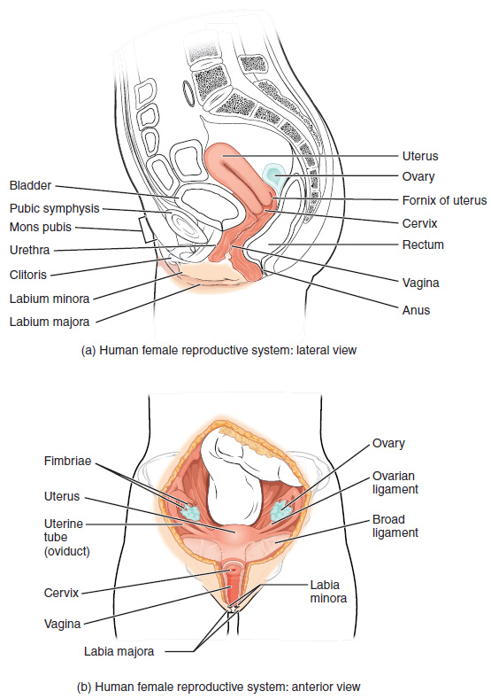

Physiology of reproduction in females
The ovum is received in the fallopian tube immediately after ovulation. And because the ovum lacks flagella and therefore cannot move on their own, high estrogen concentrations in the fallopian tube initiates contractions of the smooth fallopian muscles to move the fertilized ovum to the uterus for implantation.
The menstrual cycle
Menstrual cycle particularly occurs even there is no fertilization or when it fails to occur. The menstrual cycle is divided into three important phases which include;
The menses phases
This refers to the period during which a woman menstruates and the lining of the uterine walls are shed. The menses phase usually lasts for about 2 – 7 days depending on the female. During this period, the reproductive hormones are observably at their low.
The proliferative phase
During this phase, the menstrual flow ceases and the endometrium of the uterus begins to build. It is essential to note that the reproductive hormones at this time are working collectively to induce ovulation for the next menstrual cycle. The proliferative phase comes to an end with ovulation.
The secretory phase
During the secretory phase, the endometrium and the endometrial layer of the uterus are in readiness for the implantation of the fertilized egg. In this sense, when there is no pregnancy to hold, the lining of the endometrium begins to grow thinner within the next 10 – 12 days after which it starts shedding off to mark the beginning of the next cycle.
Phases of childbirth
The phases of childbirth involve the understanding of the typical sequence of events during labour and childbirth. Typically, this is usually divided into three steps which include;
Stage 1
Involves the feeling of regular contractions which causes the dilation of the cervix allowing the baby to move into the birth canal. Arguably, this stage represents the longest phase of childbirth and is also divided into early labour, and active labour (Mayo Clinic). During the phase of early labour, a woman feels irregular contractions accompanied by a noticeable bloody or stained discharge from the vagina. The second phase in this stage is the activity which involves the dilation of the cervix from 6 cm to about 10 cm. This phase is accompanied by intense pain with regular contractions.
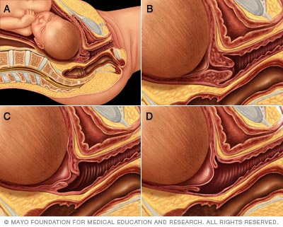
An Image showing the dilation of the cervical opening

Stage two
During this stage, the woman pushes the baby through the birth canal. The woman pushes until the head of the baby is delivered after which the rest of the body follows shortly. The umbilical cord is then cut after the necessary steps of clearing the baby’s airway (Mayo Clinic).
Stage three
The third stage involves the delivery of the placenta which may take 5 to about 30 minutes after the birth of the baby. Also, it is essential to note that this stage involves mild contractions but are however less painful.
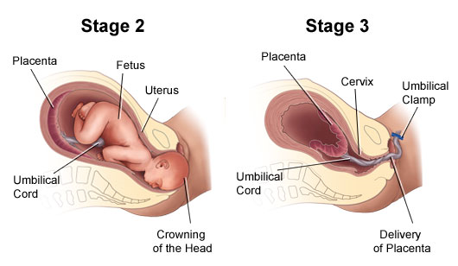
An Image showing the second and the third phases of childbirth

References
Betts, J. G. Anatomy & physiology. (2013). Open Stax College.
Betts, J. G., Desaix, P., Johnson, J. E., Korol, O., Kruse, D., Poe, B., ... & Young, K. A. (2013). OpenStax College, et al. Anatomy and Physiology.
Marieb, E. N., & Hoehn, K. (2007). Human anatomy & physiology. Pearson education.
Mayo Clinic. Labour and Delivery. Retrieved from: https://www.mayoclinic.org/healthy-lifestyle/labor-and-delivery/in-depth/stages-of-labor/art-20046545

