Part A: Multiple-Choice (K/U 1 mark each)

- What results when a tertiary alcohol is oxidized?
(a) ketone
(b) amine
(c) aldehyde
(d) no reaction

- The general formula for a cycloalkane can be represented by which of the following?
(a) C_{n}H_{n}
(b) C_{n}H_{2n}
(c) C_{n}H_{2n+2}
(d) C_{n}H_{2n-2}

- Which type of reaction will an alkene NOT undergo?
(a) addition
(b) polymerization
(c) dehydration
(d) hydration

- Which group of these compounds tends to be the most reactive?
(a) alkanes
(b) alkenes
(c) alkynes
(d) aromatics

- Which of the following compounds is 4-iodo-6-cyclopropyl-hexan-3-one?
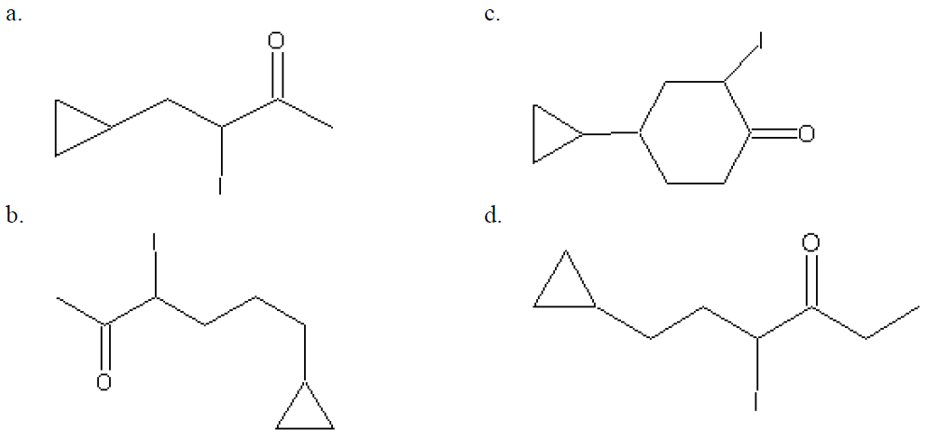
The correct answer is D
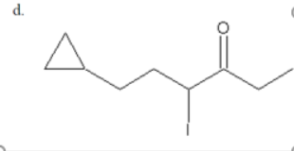
- Which compounds is most likely to a gas at room temperature?
(a) propane
(b) propanal
(c) 2-chloropropane
(d) propanone

- From the following list, select the two molecules that are isomers:
1. CH₃CH₂CH₂CH₂CH₃ 2. CH₃CH₂CH₂CH(CH₃)₂
3. CH₃CH₂CH₂CH₃ 4. CH₃CH₂CH(CH₃)CH₂CH₃
(a) (1) and (2) only
(b) (1) and (3) only
(c) (2) and (3) only
(d) (2) and (4) only

- What kind of polymer is formed when water is one of the products during the polymerization reaction?
(a) an addition polymer
(b) a condensation polymer
(c) a hydropolymer
(d) a copolymer

- Sodium benzoate is widely used as a preservative in food. Sodium benzoate is a(n)
(a) ester
(b) amide
(c) carboxylic acid
(d) alcohol

- Which organic compound is unsaturated?
(a) Ethylcyclopentane
(b) 2-methyl-3-ethylpentyne
(c) cyclohexane
(d) 4-ethyl-3,3-dimethylhexane

Answers

1. | 2. | 3. | 4. | 5. | 6. | 7. | 8. | 9. | 10.

Part B: Short Answer

- Predict the IUPAC name for the following compound. (T2)
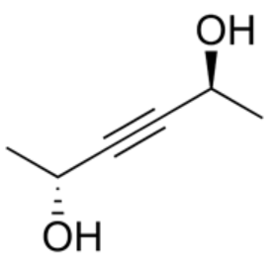

Butan-2-diol

- Write the IUPAC name for the following compound. (T2)
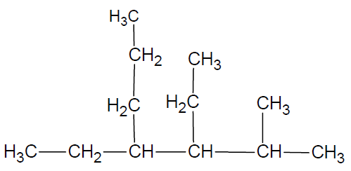

1-methyl, 2- ethyl, 3-propyl, hexane

- Write the IUPAC name for the following compound. (T2)
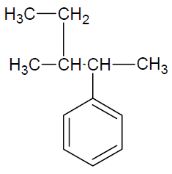

2-pentyl-hexene.
- Draw the structural formula for 5-ethyl-1-hydroxyl-3-methylcycloheptane. (T2)

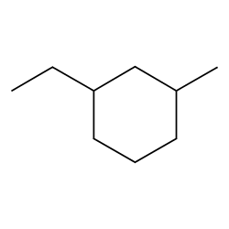

- Draw the structural formula for cis-1-chloro-3-ethyl-pent-1-en-4-ol. (C3)

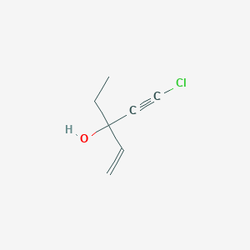

- Draw the structural formula for N,N-diethylethanamine. (C3)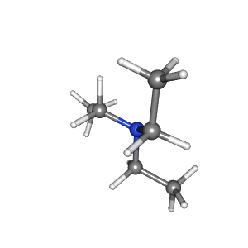
- Predict the product for the reaction between CH₃CH₂COOH and methanol with sulphuric acid as catalyst. Show all products using condensed formula. (T2)
Product is methyl propanoate
CH₃CH₂COOH_{(l)} + COOH_{(l)}C₂H₅COOCH_{3(l)}+H₂O(l)
- Using the isopropanol, show how you can synthesize a chlorinated propane. Indicate each step clearly using structural formulas and don’t forget about indicating reaction conditions if applicable. (C1, A3)
To a well-cooled mixture of 95 g (2 mols.) conc. hydrochloric acid and 135 g (2 mols.) anhydrous zinc chloride, 30 g isopropyl alcohol are added. The mixture is vigorously boiled for 4 hours under reflux. The upper layer is separated after cooling, and gently boiled under reflux in a distilling flask with closed side tube for 30 minutes. A condenser is attached to the side tube and the isopropyl chloride distilled. The distillate is washed with water, dried over calcium chloride, and redistilled, the fraction boiling at 36-38 °C being collected separately. The yield of isopropyl chloride is 70% theoretical (28 g.). Isopropyl chloride is colourless liquid; insoluble in water, b.p. 37 °C ; D=0.859 at 20°C.
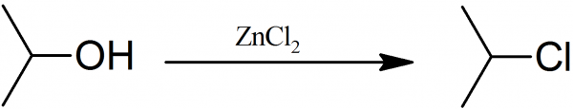

- Device how you can synthesize 2-bromo-2-methylbutane from an alkene of your choice. Note the alkene compound must contain only hydrocarbons. Present the reaction using skeletal formula. (C1, A3)

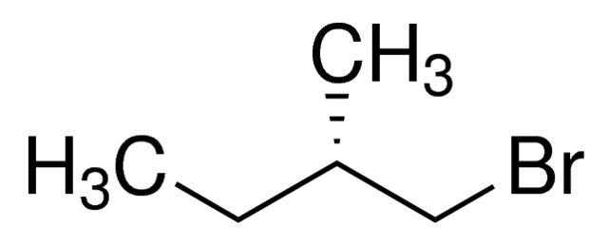

- Device a plan to synthesize butane from butan-2-ol (isobutanol), show all your steps and possible intermediates (include both the major and minor products). (C2, A4)

Alcohol is protonated by picking up a hydrogen ion from the sulphuric acid.
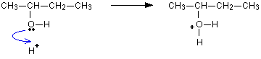

The positive ion gives out a water molecule and causes carbocation.
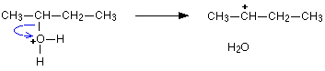
But-1-ene is formed.

