- Solve the following exponential equations. Use logarithms when necessary.
- $6^{X}=216$
$$6^{X}=6^{3}$$
$$x=3$$

- 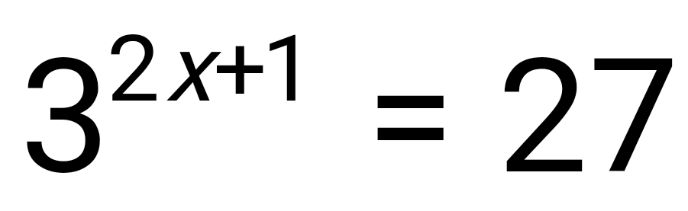
$$3^{2x+1}=3^{3}$$
$$2x+1=3$$

$$2x=2$$
$$x=1$$

c)
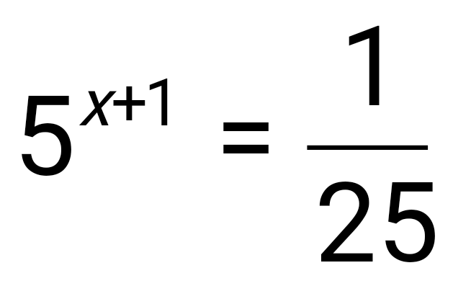
$$5^{x+1}=5^{-2}$$
$$x+1=-2$$

$$x=-3$$
d)
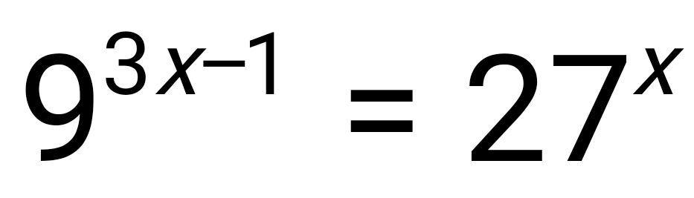
$$3^{3x-1}=3^{3}$$
$$3x-1=3$$

$$3x=4$$
$$x=\frac{4}{3}$$
e)
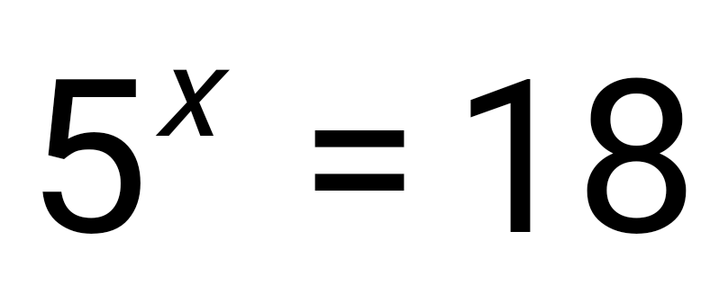
$$\ln{5^{x}=\ln{18}}$$
$$x\ln{5^{1}=\ln{18}}$$
$$x=(\ln{18)/(\ln{5 )}}$$
$$x=1.795888947$$

f) 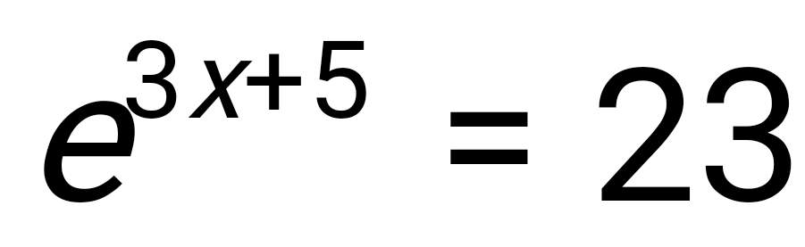
$$\ln{e^{3x+5}=\ln{23}}$$
$$3x+5=3.135494216$$

$$x=-0.621501928$$

g) 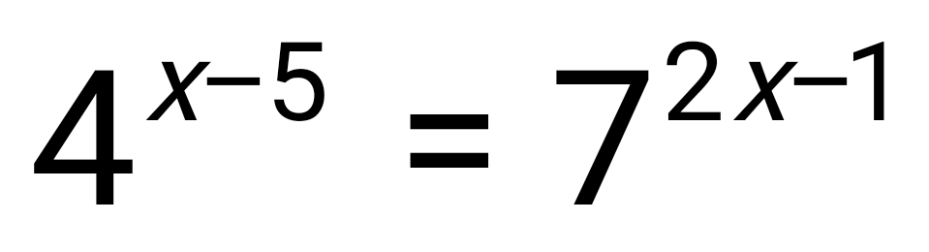

$$\ln{4^{x-5}=\ln{7^{2x-1}}}$$
$$(x-5)\ln{5^{1}=(2x-1)\ln{7}}$$
$$\frac{x-5}{2x-1}=\left(\ln{7)/(\ln{5}}\right)$$

$$\frac{x-5}{2x-1}=1.209061955$$

$$x-5=2.418x-1.209$$
$$x=-2.673$$

2) Solve the following logarithmic equations.

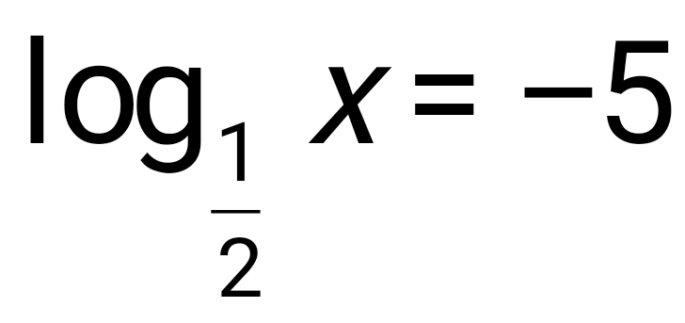
$$x={0.5}^{-5}$$
$$x=32$$
b)
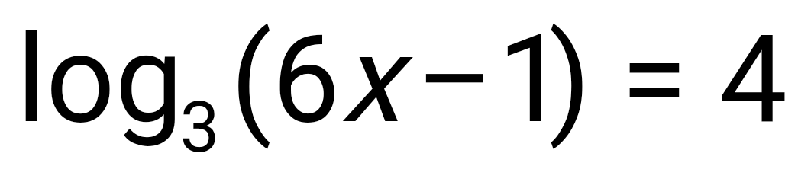
$$x(x-3)=1$$
$$x=13.667$$

c)

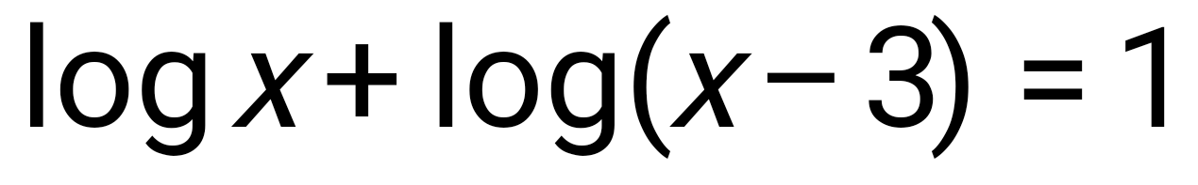
$$x(x-3)=1$$

$$\log{x^{2}+3x}=1$$
$$x^{2}+3x={10}^{1}$$
$$x^{2}+3x-10=0$$
$$x=-5 0r 2$$
d)
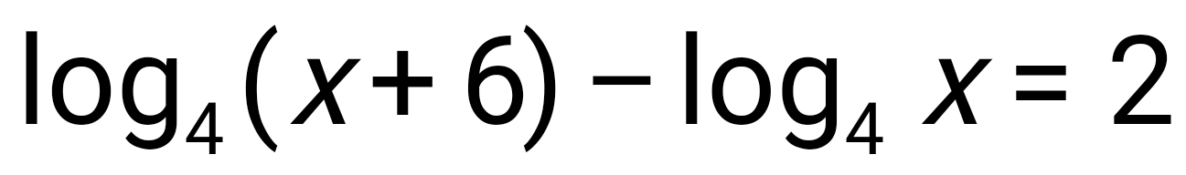
$log4({x+6)/x }$=2
$$\frac{x+6}{x}=4^{2}$$
$$x=\frac{6}{7}$$
3) How long would you have to invest $30,000 to reach $50,000 at 4% interest compounded daily?
$$30000{\left(1+0.04\right)}^{n}=50000$$
$${\left(1+0.04\right)}^{n}=\frac{5}{3}$$

$$\ln{{\left(1.004\right)}^{n}}=\ln{\frac{5}{3}}$$

$$n=(\ln{\frac{5}{3})/\ln{1.004 }}$$
$$n=127.96 days$$

4) Sally needs $20,000 in 4 years. She has $10,000 to invest. If interest is compounded continuously, what rate is required for Sally to meet her goal?

$$10000 e^{4r}=20000$$
$$e^{4r}=2$$
$$\ln{e^{4r}=\ln{2}}$$
$$4r=0.69314718$$
$$r=17.33\%$$

5) The half-life of a new experimental drug in your bloodstream is 15 hours. How long will it take for the drug to decay to 60% of the original dosage?

$$60 e^{15t}=100$$

$$e^{15t}=\frac{5}{3}$$

$$\ln{e^{15t}}=\ln{\frac{5}{3}}$$

$$15t=0.510825624$$
$$t=0.034 hrs$$

6) The population of a community was 200 people ten years ago. Today the population is 550 people. Find an exponential growth function that models the data for the past ten years. Using this model, when will the population reach 1000?

$$y=ab^{x}$$

$$200=ab^{0}$$

$$550=ab^{10}$$

This implies a=200

$$200b^{10}=550$$
$$b^{10}=2.75$$
$$b=1.106$$

exponential growth function is $$y=200*{1.106}^{x}$$
where y is the population and x is time.
$$200*{1.106}^{x}=1000$$
$${1.106}^{x}=5$$
$$x\ln{1.106}=\ln{5}$$
$$x=15.974 years$$
The population will be 1000 in the next 5.974 years

