

9B14A023

D.LIGHT DESIGN

R. Chandrasekhar wrote this case under the supervision of Professor Niraj Dawar solely to provide material for class discussion. The authors do not intend to illustrate either effective or ineffective handling of a managerial situation. The authors may have disguised certain names and other identifying information to protect confidentiality.

This publication may not be transmitted, photocopied, digitized or otherwise reproduced in any form or by any means without the permission of the copyright holder. Reproduction of this material is not covered under authorization by any reproduction rights organization. To order copies or request permission to reproduce materials, contact Ivey Publishing, Ivey Business School, Western University, London, Ontario, Canada, N6G 0N1; (t) 519.661.3208; (e) cases@ivey.ca; www.iveycases.com.

Copyright © 2014, Richard Ivey School of Business Foundation Version: 2014-06-04

In May 2014, Jaideep Mukherji was 18 months into his tenure as managing director, Asia, of d.light design (d.light), a U.S. for-profit social enterprise headquartered in San Francisco, California. The company designed, produced and distributed solar lamps targeted at the 1.4 billion people, worldwide, who had no access to electricity and an additional 1.0 billion people who had limited or sporadic access.¹ Focused on providing consumers at the larger base of the pyramid (BOP) segment with affordable lighting products, the company was driven by a vision of “empowering the lives of at least 100 million people by 2020.”²

At his office near New Delhi, Mukherji was examining d. light’s strategy for India, home to 33 per cent of the world’s population that was living in poverty.³ In 2009, d.light had inaugurated the global rollout of its product range in India, and the country now accounted for about 45 per cent of the company’s global revenues. The mandate for Mukherji was to gain leadership in a fragmented Indian solar market by 2017 and then diversify, beyond solar lamps, into other energy-saving products and services.

Although d. light had secured more than 50 per cent of the solar lighting market share in both quantity and value (see Exhibit 1), its category growth had stalled.

Said Mukherji:

In building a scalable and sustainable business in India, my immediate challenges are three-fold. First, how do we create a category for solar lamps? End user habits are entrenched; there are many substitutes; and the product concept is still in the testing stage. Second, how do we make our brand synonymous with the solar lamp category? Entry barriers are not very high; more competition is imminent; and there is risk of quick commoditization. Third, how do we improve

1 “Lighting the Way,” The Economist, September 1, 2012, www.economist.com/node/21560983, accessed November 6, 2013.
2 d.lite, “Who We Are,” www.dlightdesign.com/who-we-are/, accessed November 20, 2013.
3 Pedro Olinto and Hiroki Uematsu, “The State of the Poor: Where Are the Poor and Where Are They Poorest?” www.worldbank.org/content/dam/Worldbank/document/State_of_the_poor_paper_April17.pdf, accessed April 10, 2014.

channel productivity? Selling solar lamps is not core to the operations of our distributors; they do not market solar lamps on their own; they merely sell them to customers who walk in.

CUSTOMER PROFILE

A 2007 study by the World Resources Institute had estimated a total of 4.0 billion people were living at the BOP, defined as those living on incomes below $3,000⁴ per annum in local purchasing power terms. A vast number of these people lived in the developing countries of Africa, Asia, Eastern Europe, Latin America and the Caribbean. The value of their collective consumption was estimated to be $5.0 trillion (see Exhibit 2).⁵

Due to variations in purchasing power, consumers earning less than $3.35 a day in Brazil, $2.11 in China,
$1.89 in Ghana and $1.56 in India were said to be at the BOP. The benchmark also varied between urban and rural settings. The largest density of BOP population prevailed in the income band of $1,000 to
$1,500 per annum. Said Mukherji:

The BOP community has several common characteristics. Its members have unmet needs at many levels. They are mostly illiterate. Many live in make-shift settlements they don’t own. They lack access to water, sanitation services and basic health care. They depend on livelihoods in which incomes are not only meagre but also erratic. A majority has no bank accounts. Their trades are not adequately integrated into the formal economy that, in turn, limits the opportunities for improving their incomes. As consumers, they have limited choice. As producers of goods and services, they have limited connection with end-users. They deal with intermediaries who exploit them. Their legacy has conditioned many of them to being risk-averse.

BOP consumers were also affected by what was called “the BOP penalty,” which was an outcome of local monopolies, inadequate access, poor distribution and strong intermediaries.⁶ As a result, BOP consumers paid higher prices than their wealthy counterparts in urban and semi-urban areas for basic goods and services of poor quality. For example, compared with on-grid consumers, off-grid consumers spent 615 per cent more on electricity, 175 per cent more on cooking fuel and 175 per cent more on drinking water.⁷

In India, 75 million households lacked access to a reliable electricity supply, representing the largest off- grid demographic worldwide (see Exhibit 3). Ninety-four per cent of this population (71 million households) lived in rural India. Their primary source of lighting was kerosene lanterns, which produced noxious fumes that were bad for the environment and caused eye and respiratory tract ailments. The rural Indians who were living in poverty were forced to either time their activities according to the daylight available or continue their activities in inadequate and poor quality light. This segment represented the market that d.light India focused on.

4 All currency amounts are shown in U.S. dollars unless otherwise noted.
5 Allen Hammond, William J. Kramer, Julia Tran, Rob Katz and Courtland Walker, “Introduction and Market Overview,”
Chapter 1 of The Next 4 Billion: Market Size and Business Strategy at the Base of the Pyramid, World Resources Institute, Washington, DC, 2007, www.wri.org/publication/next-4-billion, accessed March 1, 2014.
6 C. K. Prahalad, The Fortune at the Bottom of the Pyramid, Wharton School Publishing, San Francisco, 2004.
7 Tina Rosenberg, “The Next Wireless Revolution, in Electricity,” Opinionator blog, New York Times, September 11, 2013, http://opinionator.blogs.nytimes.com/2013/09/11/the-next-wireless-revolution-in-light/?_r=1, accessed November 6, 2013

SOLAR INDUSTRY

Globally, energy consumption was following three major trends: rapid growth in the use of renewable energy technologies, a retreat from nuclear power in many countries and a resurgence in oil and gas production in countries such as the United States. Fossil fuels were expected to remain dominant in global energy consumption for the foreseeable future, but the fastest growth was in renewable energy (see Exhibit 4).

As of March 2012, India’s power sector had an installed capacity of 236.38 gigawatts (GW), an increase of 14 per cent over March 2011. Captive (privately owned) power plants generated an additional 36.5 GW. Thermal power plants constituted 66 per cent of the installed capacity, hydroelectric about 19 per cent. The remainder was a combination of wind, small hydro-plants, biomass, waste-to-electricity plants, and nuclear energy.⁸

Among developing countries, where investments in grid power did not match the growing demand for electricity, off-grid power generation was increasing — with local wind, solar, small hydro and biomass plants supplying electricity for captive needs. The solar industry was at the forefront of the change, particularly among BOP communities. Its underlying concept aligned “what is good for those living in poverty” with “what is good for the planet.”

The cost of energy for a BOP household ranged between 10 per cent and 25 per cent of its domestic expenditure. While each individual BOP household was frugal in its consumption, cumulatively, the demand for energy was huge. The total BOP household energy market was estimated to be $433 billion, representing the spending of 3.96 billion people. Asia was the largest BOP energy market, estimated at
$351 billion, representing the spending of 2.9 billion people. Within Asia, India was the largest energy market, with $163 billion in annual household spending. Within India, the rural sector accounted for 63 per cent of the national energy market.⁹

Solar Industry in India

The solar industry in India was in its nascent stage. Many initiatives were being coordinated by the central government’s Ministry of New & Renewable Energy (MNRE). For example, the ministry was implementing the National Solar Mission with a goal of installing 20 GW of grid-connected solar power and 2 GW of off-grid solar power by 2022. As part of the latter goal, MNRE was providing a subsidy of
$52 per solar lantern for households located in off-grid villages that had been identified as “a special category.” By December 2013, the MNRE had subsidized and distributed nearly one million solar lanterns.¹⁰ The lanterns were manufactured by more than 200 small solar enterprises that had received MNRE approval and were thus allowed to bid on government tenders.

In 2008, two new sets of players entered the industry. The first were large producers of power systems and consumer durables (e.g., among others, Tata Power, Reliance Power and Eureka Forbes) who set up

8 Central Statistics Office, National Statistical Organisation, Ministry of Statistics and Programme Implementation, Government of India, Energy Statistics 2013, Installation of Off-grid / Decentralised Renewable Energy Systems/Devices as on 31.03.2012 page 16 of 89, http://mospi.nic.in/mospi_new/upload/Energy_Statistics_2013.pdf?status=1&menu_id=216 accessed February 12, 2014.

9 Allen Hammond, William J. Kramer, Julia Tran, Rob Katz and Courtland Walker, “The Energy Market,” Chapter 7 of The Next 4 Billion: Market Size and Business Strategy at the Base of the Pyramid, World Resources Institute, Washington, DC,
2007, www.wri.org/publication/next-4-billion, accessed March 1, 2014.
10 International Finance Corporation, Lighting Asia: Solar Off-Grid Lighting — Market Analysis of India, Bangladesh, Nepal, Pakistan, Indonesia, Cambodia and Philippines, February 2012, www.ifc.org/report-lightingasia, accessed April 9, 2014.

solar divisions for manufacturing and marketing; the second were social enterprises (such as d.light) that focused on a single solar product and a single market segment. For the latter group, however, their product specifications prevented them from being eligible for MNRE subsidies. For example, the MNRE promoted solar lanterns that used compact fluorescent lamps (CFLs), which were typically priced between $90 and $100, whereas the large social enterprises were manufacturing solar lamps that used light emitting diodes (LEDs), which were priced at a more competitive $50 to $60. CFL lanterns were technologically ahead of the traditional incandescent lighting but LED lamps were a step ahead of CFLs. LED lamps were light in weight (and hence portable), more convenient to use (with no accessories) and more efficient (in terms of lumens). They were also more easily scalable (in their manufacturing operations).

The market was fragmented with individual market shares of less than one per cent. The price– performance ratios of solar products differed widely. For example, the electronic circuits performed inconsistently, varying in terms of charging, efficiency and the type of circuit protection. Even globally, no harmonized framework was available for testing and certifying solar products. In India, lack of consumer awareness was a definite barrier. Larger corporate houses did not actively promote their solar lamps because they were part of a larger product portfolio; social enterprises did not promote their solar lamps because they were short of capital. The market as a whole lacked momentum because it was not only fragmented but also disorganized. Said Mukherji:

Solar energy is a perfect example of the decentralization of manufacturing, distribution and consumption of energy to the level of the end user. It is clean, safe, reliable and affordable. It is also of better quality than the energy generated by conventional fuels. Still, despite the success of an “off-grid” communication tool such as the mobile phone in India, the rate of adoption of solar lamps in the country has been very slow.

Mobile phones had caught on in developing countries, and people in rural India had no difficulty in leapfrogging to this modern technology because few had ever experienced a landline phone. Mukherji believed that the change promised by a solar lamp could be equally transformational and appealing. But one barrier was the legacy of kerosene lanterns.

Another barrier was the solar industry’s business model. At the macro level, attracting investments was difficult. Commercial lenders were uncomfortable with the solar industry as a bankable business. The World Bank and its private-sector development wing, the International Finance Corporation, had set up projects to help raise the industry profile, including Lighting Africa, Lighting Asia and Lighting Global. They were also helping establish standards for product certification. But, lenders at the grassroots level were still conservative and cautious. At the micro level, the problem was to find ways for those living in poverty to be able to afford to pay for the lanterns. Very few households at the BOP could afford single lights, let alone light packages. The industry was still searching for an equivalent to the mobile phone industry’s pay-as-you-go model or another innovative payment solution that would make the lamps affordable.

D.LIGHT DESIGN – COMPANY BACKGROUND

In May 2007, d.light was founded by Sam Goldman and Ned Tozun, then students at the Graduate Business School of Stanford University. They had won a $250,000 prize in a business plan competition and used it as seed capital, supplementing it with venture capital funding of $1.6 million. The founders

saw no conflict of interest between sustaining a social enterprise and earning a profit; to the entrepreneurs, the two goals were mutually reinforcing.

The company started off by producing 20,000 solar lamps per month at its manufacturing plant in the free trade zone of Shenzhen, China. The plant was modular and designed to be easily scalable. By 2013, d.light had a capacity of 3.5 million units per annum. The company also had research and development and supply chain centres on site. It served customers in 40 countries in Sub-Saharan Africa and the Indian subcontinent.

As of February 2014, d.light had received funding totalling $40 million from private equity investors. The company had revenues of around $45 million in 2013 and had been growing at 50 per cent per annum for the past two years. Said Mukherji:

d.light has three competitive advantages. It is the first mover in the solar lamp market. We are the first social enterprise to launch the product in India, which is the single largest concentration of BOP consumers in the world. It has given us credibility, particularly among investors specializing in social enterprise. Our second advantage is our product quality. We have incorporated customer insights into our product design. The reliability of our product is borne out by the fact that our warranty claims over the last three years average less than one per cent of sales. Finally, we have a unique distribution model. It is based on strategic alliances with distributor partners, which have the last mile reach and a life cycle engagement with end-consumers.

The company was focused on rural rather than urban BOP customers because the density of population in urban areas made options such as mini-grid solutions more viable than a stand-alone solar lamp.

For distribution, d.light had partnered with four different types of channels — post offices, common service centers (CSCs), distributors of liquid petroleum gas (LPG) cylinders and general retailers of consumer durables. Each channel partner brought the benefit of its long-standing knowledge of and relationships with its own customers.

India had the largest postal network in the world with more than 155,000 post offices, 90 per cent of which were located in rural India. Each post office served an area of 21 square kilometres covering, on average, a population of 7,175 persons.¹¹ Most rural post offices were managed by a single postal worker, who usually worked from home. d.light had distribution arrangements with 400 post offices in semi-urban centres, all of which were brick-and-mortar structures and therefore doubled as depots serving the needs of the interior.

CSCs were part of India’s National e-Governance Plan developed by the central government. Nationwide, India had 130,000 CSCs, each serving a cluster of five to six villages. Managed by trained and incentivized staff, each CSC was housed in 150 square foot space and included a personal computer, a printer, a digital camera, a generator, and broadband connectivity. It served as the front end for delivery of government, financial, social and private sector services in the areas of agriculture, health, education, entertainment, banking, insurance, pension, utility payments and retail products.¹² d.light had distribution partnerships with 2,600 CSCs nationwide.

11 India Post, “Post Office Network,” www.indiapost.gov.in/Our_Network.aspx, accessed April 9, 2014.
12 Common Services Centers Scheme, Department of Electronics and Information Technology, Government of India, “About Common Services Centers Scheme,” http://csc.gov.in, accessed April 9, 2014.

LPG cylinders were distributed in India through dealers appointed by the three national oil companies. d.light had tied up with two of them, which together had 9,500 LPG dealers nationwide, of which, d.light had partnerships with 3,000. In addition, d.light had relationships with more than 1,000 general retailers in rural India.

The average margins for d.light’s partners were 10 per cent for the distributors and 15 per cent for end- point sellers. These margins were consistent with the trends in the consumer durables industry and higher than the margins in the consumer goods industry where the norms were 8 to 10 per cent for both distributors and end-sellers.

Some of d.light’s competitors had set up their own direct-to-home (DTH) models and had signed up part- time independent promoters, known locally as Saathis, to act as their ambassadors. Saathis worked at the grassroots level as teachers, nurses or insurance agents, and were trusted sources of information on a variety of issues. The quality of their interface with potential customers was high because every Saathi had a personal rapport with members of the community and could influence their purchase decisions. The model was costly, however, requiring investments in recruitment, training and retention. Another limitation of this approach was that it was not easily scalable. An individual Saathi could at best manage
50 accounts, whereas an LPG distributor had the infrastructure to reach and manage hundreds of customers.

SOLAR LAMP

Right from the start, d.light’s objective had been to develop an “affordable” product. As part of doing so, the company’s designers had travelled through various developing countries seeking personal interactions with rural families, shopkeepers and local distributors in an effort to understand their needs. Insights from the field were complemented by market research from professional agencies. This research was followed by concept brainstorms, initial sketches, prototypes, user testing, engineering and industrial design, leading finally to a go-to-market product.

India was chosen for d.light’s global launch in 2009, followed by a launch in Tanzania later the same year. The countries of Sub-Saharan Africa (SSA), which together housed 34 per cent of the world’s population living in poverty, followed in quick succession. The market reception for d.light’s products in SSA varied, however, from their reception in India. Distribution had been eased in SSA, thanks to d.light’s relationships with not only an oil conglomerate that was actively promoting d.light’s products but also a financial institution that was promoting mobile payments. Beyond the customer profile, which was similar across the two markets, the conditions for executing product strategy differed and, as a result, as was the situation with the d.light team in India, the transfer of learning was of limited use.

In India, d.light sold three models: S2, S20 and S300 (see Exhibit 5A, 5B and 5C). The S2 was a study lamp with entry-level pricing of INR450.¹³ The S20 was a household lamp with differential power settings, priced at INR645, and S300 was a solar lamp with a mobile charging feature, priced at INR1,845. All the three products carried a two-year free replacement warranty.

Mukherji explained that d.light’s products brought five major advantages to end-users:

First, an average BOP family spent between 10 and 25 per cent of its monthly income on kerosene. The d.light solar lamp was priced to pay for itself in a few months. A kerosene lamp cost between INR120 and

13 US$1 = INR53.17.

INR150 and consumed approximately INR150 of kerosene and maintenance every month, assuming four hours of usage per night.

Second, the solar lamp could be used to support income-generating activities outside of normal working hours. This benefit was particularly evident among people who were self-employed, such as tailors or weavers, who could extend their workday and, thus, their earnings.

Third, the solar lamp allowed for longer studying hours for children. A World Bank project study had shown that the pass rates at a Sudanese village school increased from 57 per cent in 2007 to 100 per cent by 2009 after the introduction of solar lighting. The trend had been maintained in 2010.¹⁴

Fourth, the solar lamp reduced indoor air pollution. It did not emit any pollutants and was safe in contrast to kerosene lantern that emitted noxious fumes and led to eye and respiratory tract ailments.

Finally, on a broader plane, each solar lamp could, over its 10-year lifetime, replace the use of approximately 600 litres of kerosene, thereby mitigating 1.5 tons of carbon dioxide (CO2) emissions.¹⁵

ISSUES BEFORE D.LIGHT

Creating a Category

As a category, solar lamps were present in fewer than 1 per cent of the 225 million households in India. The potential, Mukherji believed, was 40 times larger.

Category creation involved two activities: building an infrastructure for physical distribution and promoting the product. After-sales service, which was usually the third activity in the creation of a category, was not as important, given the durability and reliability of d.light’s solar lamps. Service consisted of processing a warranty claim.

Distribution was crucial because the solar lamp was a mass-market product. It was only through large volume sales that the product could be profitable. Demand was price-elastic. For the end-user, the cost of purchase was high in relation to the typical income. Solar lamps had a higher initial cost than their substitutes, although their running costs were lower in the long run (see Exhibit 6). But it was no easy task to convince consumers at the BOP to spend more now in order to save on the lifetime value of the product. Lack of affordability was one of the main obstacles in product adoption. Credit financing was common for consumer durables in India but was largely confined to urban areas and to salaried employees who earned regular incomes. Credit schemes, where they existed, were operated by retailers in association with finance companies, rather than by manufacturers.

In Sub-Saharan Africa, d.light had established a partnership with MKOPA, an energy retailer that sold solar home systems. Mobile banking had not yet developed in India to a degree it had developed in such countries as Kenya. In any event, Mukherji felt that a financing option for the purchase of a solar lamp would accelerate demand, but creating demand would still require a deep distribution network and mass- market promotion.

14 Abu Hasheem, “In Sudan, Where There Is Power, There Is Development,” World Bank, http://web.worldbank.org/WBSITE/EXTERNAL/COUNTRIES/AFRICAEXT/0,,contentMDK:22826981~menuPK:2246551~pa gePK:2865106~piPK:2865128~theSitePK:258644,00.html, accessed February 22, 2014.
15 United Nations Framework Convention on Climate Change, “Solar Sister: A Women Powered Clean Energy Revolution,” https://unfccc.int/secretariat/momentum_for_change/items/7072.php, accessed March 1, 2014.

Relative to its local competitors, d.light saw its distribution network as an advantage. The limitation was that the distributor partners did not promote the product because the solar lamp was not part of their core offerings, and its contribution to their own overall revenue was relatively low.

Advertising and sales promotion costs represented between 3 and 4 per cent of d.light’s revenue. Although the company had increased the outlay to 6 per cent of its revenue in 2013, it continued to face several challenges in creating awareness. Like consumers everywhere, Indians were comfortable in their routines and habits. They were risk-averse and would not easily switch to novel products. Most of what they bought regularly were daily or weekly “refills” of staple categories. Stores in rural India stocked tried and tested products that had a track record of being sure-sells. Indeed, given their limited working capital, many Indian consumers could not afford to take a chance by purchasing a novelty item. Still, Mukherji noted:

The success of mobile phones is an indication that customers in the BOP market are receptive to new categories. Technology is not a deterrent for them, in spite of lack of formal education. Consumers intuitively understand the benefits of a new technology and are quick to adopt it if they see value. d.light has been innovative in product design. It has been innovative in its distribution model. How do we now crack the code in creating the solar lamp category? A first time product needs a change in consumer behavior, a buzz, to get started. How do we create that buzz in India? Social media is a powerful instrument but rural India is not yet amenable to it.

Making the Brand Synonymous with the Category

Leading multinationals — such as Philips and Panasonic — had recently entered the solar lamps market in India. Their brands were well known worldwide, even in the BOP markets. But solar lamps were a very small part of their product portfolio. These multinational companies were in the same league as home- grown power companies, such as Tata and Reliance, which had added solar products to their portfolio.

It first-mover status gave d.light a lead, but that lead would make the d.light brand synonymous with the category only if it could achieve mass-market penetration. Mukherji believed it was necessary to create an emotional connection between the brand and the target customers. One way to do this was by communicating real-life stories of consumers whose lives had been transformed by d.light’s product. To build the brand, d.light had the option of using “above-the-line” media (e.g., radio, television, billboards, print, film and the Internet) or “below-the-line” media (e.g., direct-mail campaigns, trade shows and catalogues). The former would not reach the BOP consumers, and the latter would be expensive. Said Mukherji:

Our competitor is kerosene. We have a dilemma in developing the competitive messaging for solar lamps. What should we focus on — the positive elements of the solar lamp or the negative elements of kerosene? The latter comes up regularly as a pain point in our one-on-one interactions with consumers. It resonates with them. Should we therefore address it head-on?

Improving Channel Productivity

In 2013, d.light sold a total of 1.7 million solar lamps: 200,000 through post offices, 400,000 through CSCs, 800,000 through LPG distributors and 300,000 through general retailers. The company believed it could improve sales in each of the channels by aiming at strengthening d.light’s competitive advantage. Said Mukherji:

Our partners give us the benefit of reach. They also give us the benefit of their own credibility with their customers. But selling solar lamps is not their core activity. It is unrelated to what they do. It is also a minor part of their income. How do we keep the staff at our distributor channels motivated? How we generate a higher share of their attention? We can’t really incentivize them because we don’t employ them.

Overall, Mukherji believed that d.Light had achieved much progress. Although most of the potential of solar lamps for BOP customers had yet to be realized, the future for d.light and for providing solar- powered light to BOP populations continued to be bright.

EXHIBIT 1: SOLAR LAMP MARKET IN INDIA AND D.LIGHT’S MARKET SHARE, 2008 TO 2013

Year | Volume |  | Value
Year | All India Units (000) | d.light’s Market Share% | All India (INR millions) | d. light’s Market share%
2008 | 300 | – | 330 | –
2009 | 400 | 50 | 400 | 42
2010 | 600 | 51 | 570 | 44
2011 | 1,000 | 52 | 850 | 45
2012 | 1,800 | 52 | 1,420 | 46
2013 | 3,000 | 56 | 2,460 | 50
Source: Company files.

EXHIBIT 2: POPULATION AND HOUSEHOLD INCOME IN BASE OF THE PYRAMID MARKETS

Region | Population(in millions) | Aggregate Household Income (in US$ millions)
Asia  Eastern Europe Latin America Africa | 2,860  254  360  486 | 3,470  458  509  429
Total | 3,960 | 4,866
Source: Allen Hammond, William J. Kraemer, Julia Tran, Rob Katz and Courtland Walker, “Introduction and Market Review,” Chapter 1 of The Next 4 Billion: Market Size and Business Strategy at the Base of the Pyramid, World Resources Institute, – Washington, DC, 2007, www.wri.org/publication/next-4-billion, accessed March 1, 2014.

EXHIBIT 3: SHARE OF PEOPLE WITHOUT ELECTRICITY (IN DEVELOPING COUNTRIES)
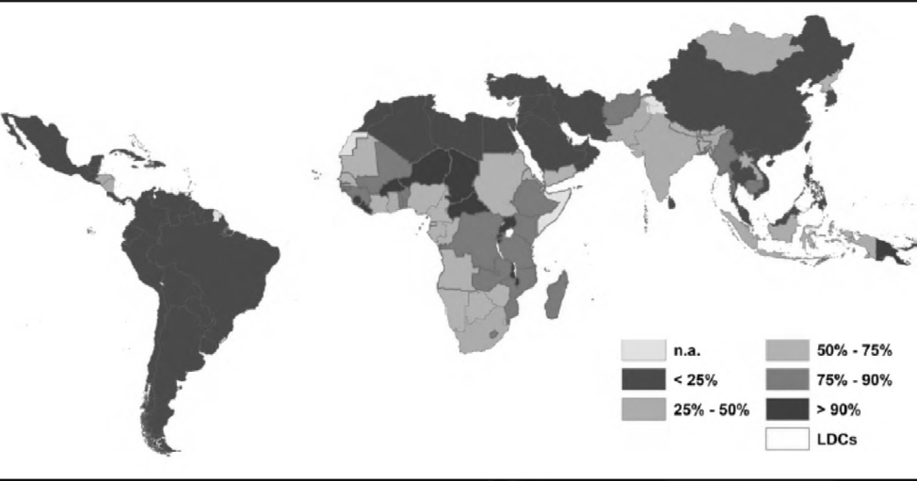
Note: The data pertains to 2008.

Source: United Nations Development Programme and the World Health Organization, The Energy Access Situation in Developing Countries, November 2009, www.who.int/indoorair/publications/energyaccesssituation/en/, accessed May 27, 2014.

EXHIBIT 4: GLOBAL PRIMARY ENERGY DEMAND BY FUEL TYPE
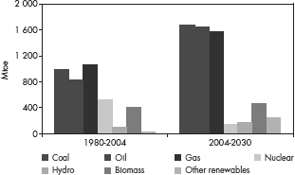
Source: International Energy Agency, World Energy Outlook Report 2006, www. worldenergyoutlook.org/media/weowebsite/2008-1994/WEO2006.pdf, accessed March 2, 2014.

Page 12
9B14A023
EXHIBIT 5A: D.LIGHT SOLAR LAMP S2
Source: Company files.

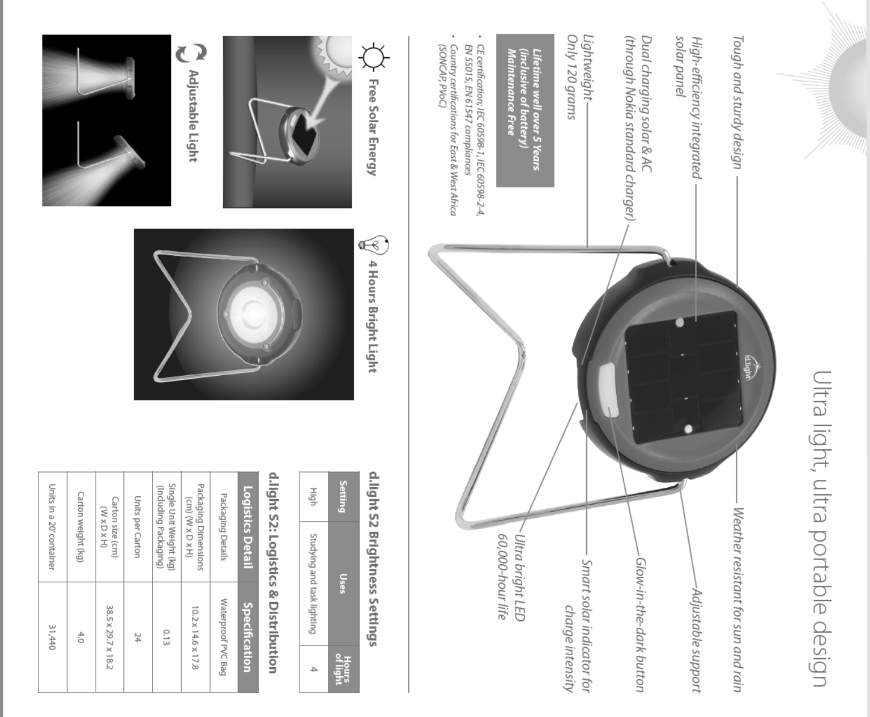

Authorized for use only by Abdullah Alwasmi in International business at Oakland University from Sep 05, 2018 to Dec 15, 2018.
Use outside these parameters is a copyright violation.

Page 13
9B14A023
EXHIBIT 5B: D.LIGHT SOLAR LAMP S20
Source: Company files.

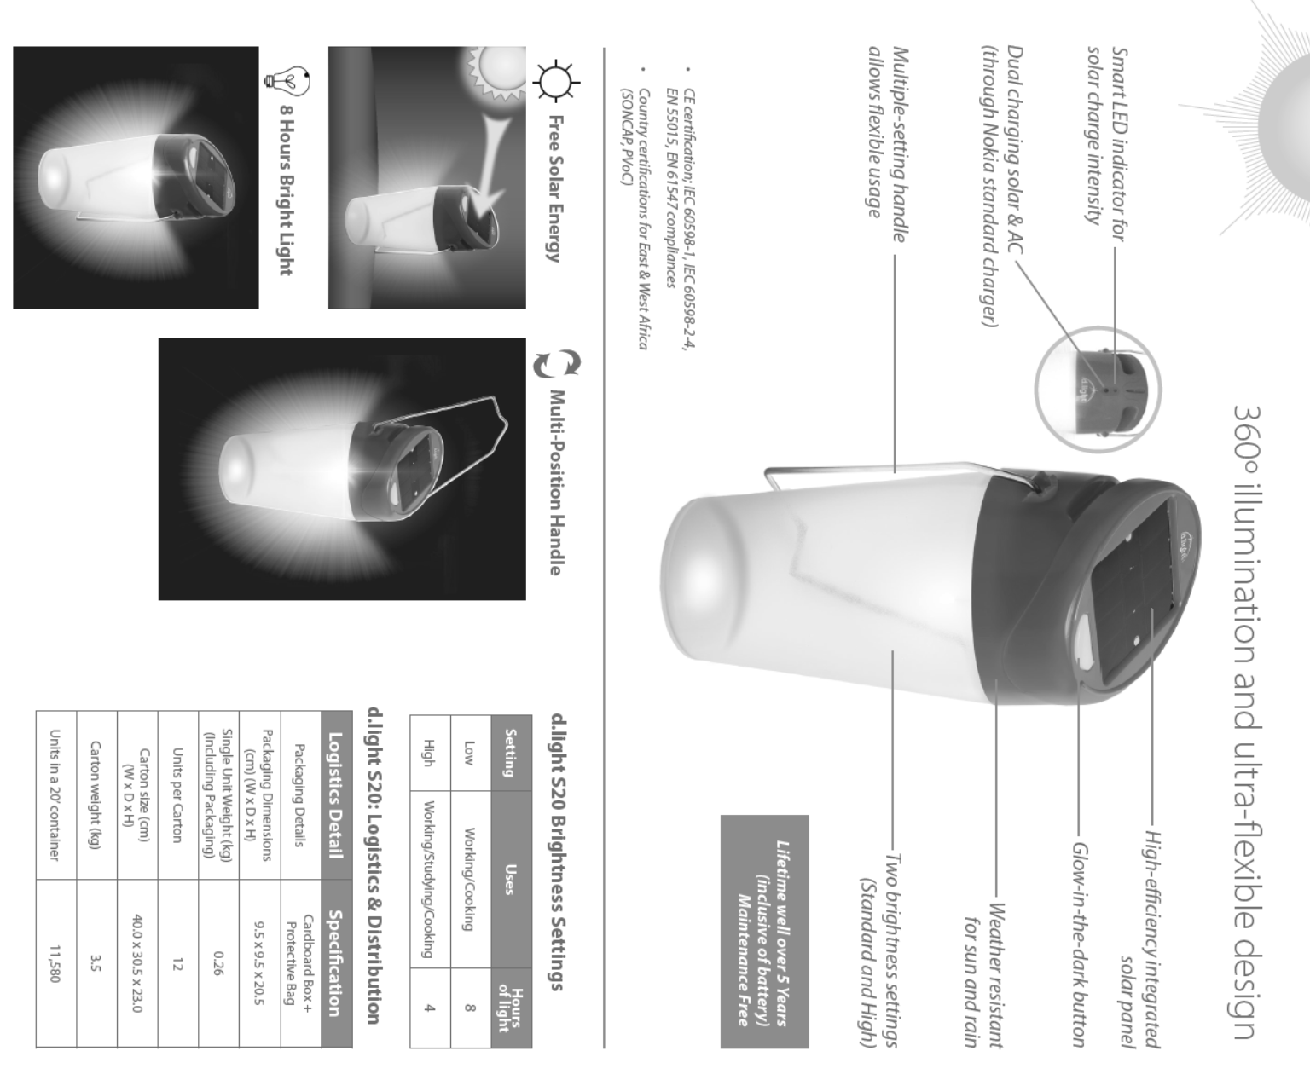

Authorized for use only by Abdullah Alwasmi in International business at Oakland University from Sep 05, 2018 to Dec 15, 2018.
Use outside these parameters is a copyright violation.

Page 14
9B14A023
EXHIBIT 5C: D.LIGHT SOLAR LAMP S300
Source: Company files.

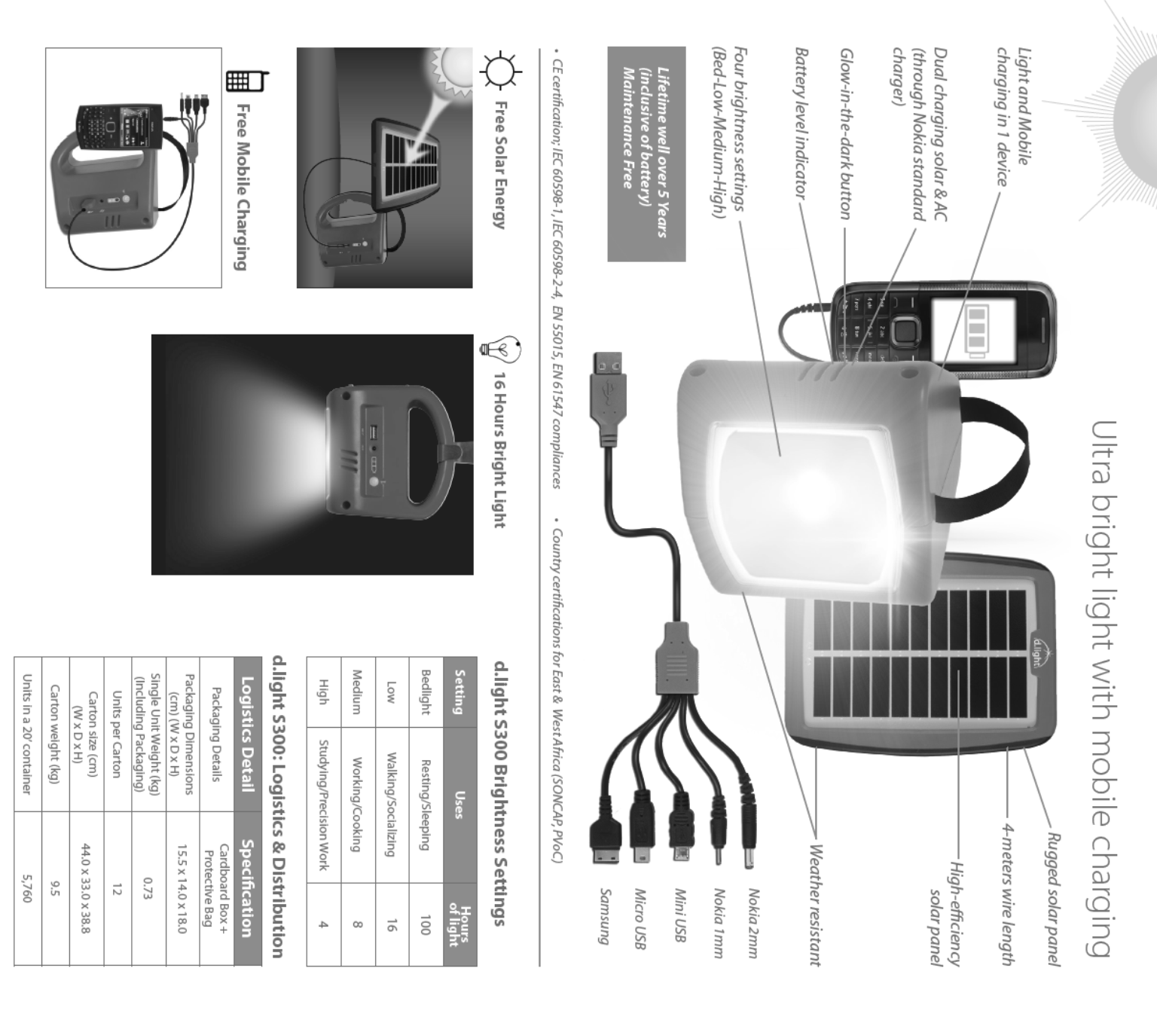

Authorized for use only by Abdullah Alwasmi in International business at Oakland University from Sep 05, 2018 to Dec 15, 2018.
Use outside these parameters is a copyright violation.

Page 15 9B14A023

EXHIBIT 6: COMPARATIVE COSTS OF LIGHTING SOLUTIONS
Authorized for use only by Abdullah Alwasmi in International business at Oakland University from Sep 05, 2018 to Dec 15, 2018.
Use outside these parameters is a copyright violation.

 |  | Initial cost (in INR) | Recurring cost (in INR) | Cost per annum per household (in INR)
1 | Candle | 5 per unit | Minimum 2 candles per night | 3,600
2 | Flashlight | 100 | 3 batteries per month @ 15 | 540
3 | Diesel Generator | 12,000 | 2 litres diesel per day @ 55 per liter | 39,600
4 | Petromax | 1,000 | 250 grams of gas per hour for 4 hours @ 30 per kilogram | 10,800
5 | Kerosene | 120 | INR5 per day on kerosene and consumables | 1,800
6 | Solar Lamp | 645 | None | None
7 | Electricity | 1,500 for connection  & 150 for 1 bulb | INR20–30 for 1 light bulb CFL per month | 360

Note: The solar lamp battery runs for five years and is replaceable at INR150 per battery. Source: Company

