1-Assignment
Which patient do you see first, second, and third and why?
A. Patient A is receiving a blood transfusion that has been infusing for over 2 hours
B. Patient B has an IVPB of penicillin infusing which was just started 10 minutes ago
C. Patient C presents with a fever and a history of asthma

I would see patient A first. This is because during blood transfusion, blood should be allowed to infuse for a maximum of thirty minutes in the body of the patient. This is not even near to the two hours blood has been infusing in the body of patient A.

Of the following patients, which will require the most immediate attention due to their current status? Who
would you assess second and third?
A. 34-year-old African American female with scleroderma was admitted last evening for increased shortness of breath. She is on O2 per nasal cannula at 3L/minute, BP this a.m. 158/94, 1+ bilateral pedal edema, urinary output 150 ml over the last 8-hour shift, input 1150 (including oral and IV intake), 4 a.m. serum creatinine 3.6,
GFR 22 (both values were within normal limits on admission), O2 saturation 90%. Medications include lisinopril 10 mg daily, nifedipine 30 mg daily, and omeprazole 40 mg daily.

B. 67-year-old Hispanic male with a history of severe rheumatoid arthritis is now 3 days post–total knee
arthroplasty. Patient report from evening shift included increased pain, redness, swelling, and warmth noted to the replaced knee, sutures intact with no drainage noted. BP 160/88, pulse 90,
respirations 16, temperature 101.9 degrees F. Medications include methotrexate 25 mg weekly, last dose was 7 days prior to surgery, Enbrel 50 mg weekly, last dose 7 days prior to surgery. He is taking 7.5 mg of Lortab every 6 hours for pain and is now complaining that it isn’t helping his pain as much as is did yesterday.

C. 22-year-old Caucasian female 10 weeks gestation with a recent history of miscarriage (4 months ago)
was admitted yesterday morning for observation due to having contractions with scant amount
of vaginal bleeding. The cause of her previous miscarriage (at 8 weeks gestation) is unknown at this time, but she has been told by her primary care physician that she may have systemic lupus erythematosus due to ANA of 1:1280, recurring oral ulcers, photosensitivity, and a new rash that appeared on her face about 6 months ago. She was referred to rheumatology for a consult with full laboratory assessment but did not keep her
appointment. Morning report from the previous shift included BP 118/72, pulse 80, respirations 32
temperature 98.4 F. Patient-reported 15 minutes ago that she feels like she is now having shortness
of breath even though she is resting in the bed.

I would see patient C first. This is because systemic lupus erythematosus that the patient’s primary doctor had diagnosed had higher chances of causing cardiovascular disease which is life threatening. On the other hand, the bleeding may make the patient lose a lot of blood that would give space for other diseases such as anemia. Severe loss of blood is also fatal.

2Assignment
Take a few minutes and answer the following questions, your instructor will review and discuss the responses during class.
1. Infections can be transmitted by:
A. Contact
B. Air
C. Vehicle
D. Vector
E. All of the above

2. The following are components of the inflammatory
process: (Select all that apply.)
A. Tachycardia
B. Tachypnea
C. Normothermia
D. Abnormal WBC

3. What is the largest organ in the immune system?
A. Spleen
B. Thymus
C. Skin
D. Mucus membranes

4. B type lymphocytes:
A. Directly attack antigens
B. Produce antibodies which attack antigens
C. Release chemicals called cytokines
D. Play a role in cell mediated immunity

5. T type lymphocytes:
A. Play a role in the humoral immune response
B. Produce antibodies
C. Release cytokines
D. Indirectly attack antigens

6. Which immunoglobulin is responsible for the
hypersensitivity reaction Type I?
A. IgA
B. IgG
C. IgE
D. IgM

7. Lymph nodes:
A. Are a reservoir for blood
B. Contain lymph
C. Guard the body against airborne and ingested
pathogens
D. Contain stem cells

8. The spleen:
A. Filters and removes bacteria that enter the blood
B. Has lymph that contains WBC
C. Contains stem cells
D. Is a two-lobed mass of lymphoid tissue

9. Which structure is responsible for connecting
muscles to bone?
A. Ligaments
B. Cartilage
C. Tendons
D. Synovium

10. Which of the following structures is connective
tissue?
A. Lymphatic tissue
B. Cartilages
C. Ligaments
D. Tendon
E. All of the above

11. Which of the following is not a function of
cartilage?
A. Provides joint protection
B. Provides a smooth joint surface
C. Disperses loads evenly across the joint
D. Produces synovial fluid for joint lubrication
3Assignment
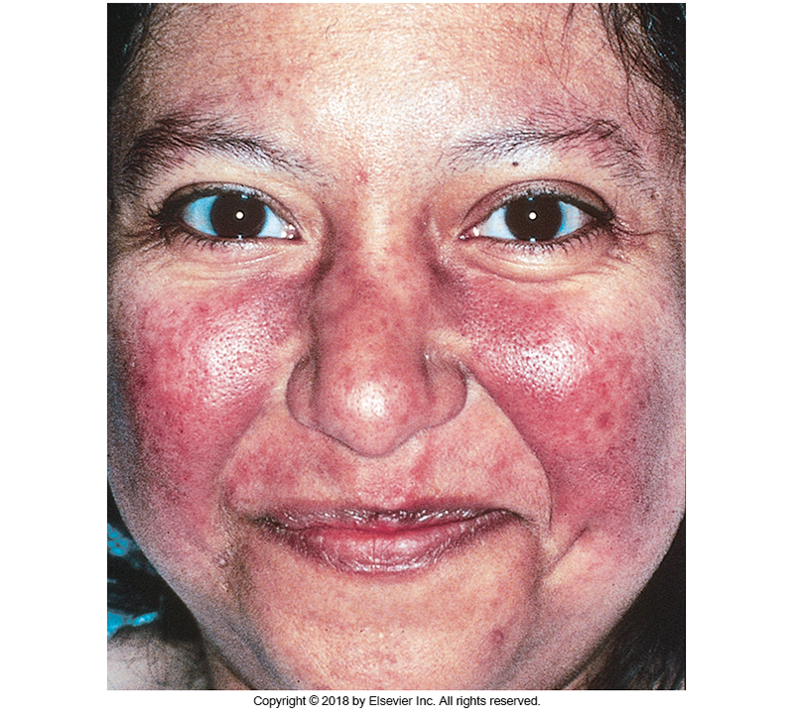
Using this picture and the information from your readings, what medical diagnosis do you believe this client has? Your instructor is going to break you into groups and based on the diagnosis you believe the client is experiencing research specific characteristics of the disorder and 3-4 medical and nursing interventions appropriate for this client.

The client might be suffering from Seborrheic dermatitis. This is due to the red rash that appeared on the face of the patient. The disease can be healed by frequent cleansing with oil that usually removes oils from the affected areas. Besides, this treatment improves seborrhea.
The patient can also use pharmacologic treatment option that include antifugal preparations. These include pyrithione zinc, selenium sulfide, topical terbinafine, sodium sulfacetamide and azole agents.
On the other hand, the patient can be cured by shampooing daily. Some of the best shampoos to use contain 1.5% pyrithione zinc and 2.5%selenium sulfide.
4Assignment
For this activity, you will create a chart comparing and contrasting Osteoarthritis and Rheumatoid arthritis. Class discussion will follow to complete an overall comparison of the disorders.
Differences
Osteoarthritis | Rheumatoid arthritis
Affects a few joints and typically develops on one side | Affects multiple joints and develops symmetrically
Symptoms are limited to the affected joints | Causes systemic inflammation and can cause fever or flu-like symptoms
Symptoms develop slowly | Symptoms develop and worsen quickly
Mostly develops on the knees, thumb and small finger joints. | Usually develops on the hands, elbows, hips, feel and knees joints on both sides of the body.
Usually begins at the isolated joints | It is an autoimmune disease

Some similarities between Osteoarthritis and Rheumatoid arthritis is that there patient suffering from one of the diseases may experience joint pain, joint warmth, joint tenderness, joint stiffness and joint swelling.
5Assignment
Using your Davis Lab and Diagnostic Test book along with your ATI lab values look up the following labs:
- Complete Blood Count (WBC, Hemoglobin, Hematocrit, RBC). What is a differential? What are monocytes, lymphocytes, eosinophils, neutrophils, and basophils?
The normal WBC count for an adult is considered to be between 4000 and 11000. While the normal count for hemoglobin is usually 13.5 to 17.5 grams per deciliter in men and 12.0 to 15.5 grams per deciliter in women. On the other hand, the normal levels of hematocrit in women range between 36% to 48% while it ranges between 41% to 50% in men. The normal count for RBC is 4.7 to 6.1 million cells per microliter in men and 4.2 to 5.4 million cells per microliter in women.
- C-Reactive Protein (CRP)
If the CRP levels are elevated one should be serious in reducing all the cardiac risk factors. This can be achieved by avoiding smoking, exercising, watching your diet and controlling blood pressure.
A lower CRP level does reduces the chances one is exposed to suffer from cardiovascular disease hence having a lower CRP level is not a challenge.

- TB Testing (What is the test? What are normal results? What are abnormal results?)
Normal results are indicated when the size of induration is less than 5mm illustrates that the patient is negative for TB. If the size of induration is at least 5mm, one would be positive if they are HIV positive, had a recent contact with someone who is suffering from TB or maybe one is taking immunosuppressants.
- Antinuclear Antibody (ANA)
A ratio that is greater than 1:640 usually indicates a high possibility of Autoimmune disorder. Low titers would be considered to range between 1:4 and 1:60. Low ANA levels can be raised by performing activities that increase Vitamin D.
- CD4
CD4 are white blood cells that usually fight infection and play a vital role in the immune system. A lower count of CD4 means that HIV has lowered the immune system of the patient. In this case, one should take antibiotics that prevent infections. A high CD4 count means that the immune system of the individual has not been weakened by any infection.
What would you do if the values were either too high or too low?
6Assignment
Independently, in small groups, or as a class as directed by your instructor you will complete the ATI Targeted Medical Surgical 2019 practice assessments. This is not a graded activity but should be utilized to evaluate your understanding of the content and concepts as well as provide additional practice with NCLEX style questions.

In concise, well-planned sentences, please answer the two questions below on a piece of paper about HIV/AIDS concepts (question 3 is optional):
- What are the two [three, four, five] most significant [central, useful, meaningful,
surprising, disturbing] things you have learned during this session?
HIV has a high mutation rate that makes it to evolve rapidly.
The high evolution rate is the main cause why doctors find it challenging to develop a vaccine for HIV
There are different forms of HIV that exist in different communities.

2. What question(s) remain uppermost in your mind?
- What is the correct theory that explains the origin of HIV?
- Should pharmacists consider developing different vaccines for HIV forms in case the vaccine is finally obtained?
3. Is there anything you did not understand?
You do not need to include your name, you will hand this into your instructor as directed by your instructor

