1-Assignment
Which patient do you see first, second, and third and why?
A. Patient A is receiving a blood transfusion that has been infusing for over 2 hours
B. Patient B has an IVPB of penicillin infusing which was just started 10 minutes ago
C. Patient C presents with a fever and a history of asthma

Of the following patients, which will require the most immediate attention due to their current status? Who
would you assess second and third?
A. 34-year-old African American female with scleroderma was admitted last evening for increased shortness of breath. She is on O2 per nasal cannula at 3L/minute, BP this a.m. 158/94, 1+ bilateral pedal edema, urinary output 150 ml over the last 8-hour shift, input 1150 (including oral and IV intake), 4 a.m. serum creatinine 3.6,
GFR 22 (both values were within normal limits on admission), O2 saturation 90%. Medications include lisinopril 10 mg daily, nifedipine 30 mg daily, and omeprazole 40 mg daily.

B. 67-year-old Hispanic male with a history of severe rheumatoid arthritis is now 3 days post–total knee
arthroplasty. Patient report from evening shift included increased pain, redness, swelling, and warmth noted to the replaced knee, sutures intact with no drainage noted. BP 160/88, pulse 90,
respirations 16, temperature 101.9 degrees F. Medications include methotrexate 25 mg weekly, last dose was 7 days prior to surgery, Enbrel 50 mg weekly, last dose 7 days prior to surgery. He is taking 7.5 mg of Lortab every 6 hours for pain and is now complaining that it isn’t helping his pain as much as is did yesterday.

C. 22-year-old Caucasian female 10 weeks gestation with a recent history of miscarriage (4 months ago)
was admitted yesterday morning for observation due to having contractions with scant amount
of vaginal bleeding. The cause of her previous miscarriage (at 8 weeks gestation) is unknown at this time, but she has been told by her primary care physician that she may have systemic lupus erythematosus due to ANA of 1:1280, recurring oral ulcers, photosensitivity, and a new rash that appeared on her face about 6 months ago. She was referred to rheumatology for a consult with full laboratory assessment but did not keep her
appointment. Morning report from the previous shift included BP 118/72, pulse 80, respirations 32,
temperature 98.4 F. Patient-reported 15 minutes ago that she feels like she is now having shortness
of breath even though she is resting in the bed.

2Assignment
Take a few minutes and answer the following questions, your instructor will review and discuss the responses during class.
1. Infections can be transmitted by:
A. Contact
B. Air
C. Vehicle
D. Vector
E. All of the above

2. The following are components of the inflammatory
process: (Select all that apply.)
A. Tachycardia
B. Tachypnea
C. Normothermia
D. Abnormal WBC

3. What is the largest organ in the immune system?
A. Spleen
B. Thymus
C. Skin
D. Mucus membranes

4. B type lymphocytes:
A. Directly attack antigens
B. Produce antibodies which attack antigens
C. Release chemicals called cytokines
D. Play a role in cell mediated immunity

5. T type lymphocytes:
A. Play a role in the humoral immune response
B. Produce antibodies
C. Release cytokines
D. Indirectly attack antigens

6. Which immunoglobulin is responsible for the
hypersensitivity reaction Type I?
A. IgA
B. IgG
C. IgE
D. IgM

7. Lymph nodes:
A. Are a reservoir for blood
B. Contain lymph
C. Guard the body against airborne and ingested
pathogens
D. Contain stem cells

8. The spleen:
A. Filters and removes bacteria that enter the blood
B. Has lymph that contains WBC
C. Contains stem cells
D. Is a two-lobed mass of lymphoid tissue

9. Which structure is responsible for connecting
muscles to bone?
A. Ligaments
B. Cartilage
C. Tendons
D. Synovium

10. Which of the following structures is connective
tissue?
A. Lymphatic tissue
B. Cartilages
C. Ligaments
D. Tendon
E. All of the above

11. Which of the following is not a function of
cartilage?
A. Provides joint protection
B. Provides a smooth joint surface
C. Disperses loads evenly across the joint
D. Produces synovial fluid for joint lubrication
3Assignment
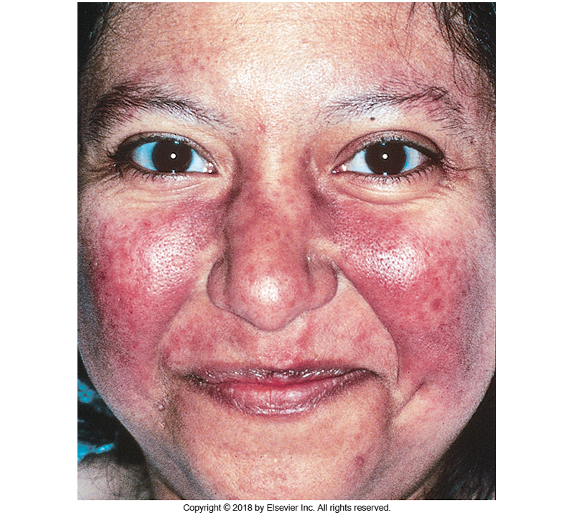
Using this picture and the information from your readings, what medical diagnosis do you believe this client has? Your instructor is going to break you into groups and based on the diagnosis you believe the client is experiencing research specific characteristics of the disorder and 3-4 medical and nursing interventions appropriate for this client.
4Assignment
For this activity, you will create a chart comparing and contrasting Osteoarthritis and Rheumatoid arthritis. Class discussion will follow to complete an overall comparison of the disorders.
5Assignment
Using your Davis Lab and Diagnostic Test book along with your ATI lab values look up the following labs:
- Complete Blood Count (WBC, Hemoglobin, Hematocrit, RBC). What is a differential? What are monocytes, lymphocytes, eosinophils, neutrophils, and basophils?
- C-Reactive Protein (CRP)
- TB Testing (What is the test? What are normal results? What are abnormal results?)
- Antinuclear Antibody (ANA)
- CD4
What would you do if the values were either too high or too low?
6Assignment
Independently, in small groups, or as a class as directed by your instructor you will complete the ATI Targeted Medical Surgical 2019 practice assessments. This is not a graded activity but should be utilized to evaluate your understanding of the content and concepts as well as provide additional practice with NCLEX style questions.

In concise, well-planned sentences, please answer the two questions below on a piece of paper about HIV/AIDS concepts (question 3 is optional):
1. What are the two [three, four, five] most significant [central, useful, meaningful,
surprising, disturbing] things you have learned during this session?
2. What question(s) remain uppermost in your mind?
3. Is there anything you did not understand?
You do not need to include your name, you will hand this into your instructor as directed by your instructor

