Name: __________________________ Slot: _____ Date: ___________________________

Accountability Check: Trigonometry #1 /18 Pre-Calculus 30S

- Find the exact value for sinθ, cosθ, and tanθ for the angle whose terminal arm passes through the point given. Then find the value of θ to the nearest degree. Draw a diagram.

  - (4,-5)

(5)
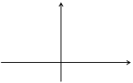

- a) Sketch the angle 170˚in standard position.

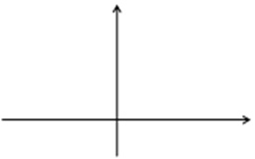
(3)

- Find the reference angle θ_{r}.

- Identify the other 3 angles from that have the same reference angle.

- To the nearest degree, which angles satisfy the following equations from [0˚, 360˚]. For exact values, use the unit circle, for non-exact values, use your calculator. Draw a diagram.

$$a) cosθ=\frac{-1}{3} b) sin θ=\frac{-1}{2}$$

(4)

- Using the unit circle only, no calculator, find the sine, cosine, and tangent of the following angles. First sketch the angle and also identify its reference angle.

  - 225˚

  - 270˚
(6)

  - 120˚

  - 330˚

