Ad1. Intrepid is a commercial travel agency which offers travel services to different places around the world. The agency works to provide its clients with unmatched experiences, satisfaction, and unforgettable memories. The organization also offers travel services for groups. The experiences provided by the company on the trips are not tangible. In advertisements, the organization however ensures that their adverts are convincing to their clients. The positive experiences are displayed through the wide smiles of the clients in the photo. The aspect of adventure is also promoted by the pyramids in the background.

Ad 2
MetLife is an insurance company that provides insurance services to millions of clients around the world. it provides a variety of insurance services to its clients including insurance on the property, travels as well as health insurance like dental and vision as a way of elevating lives. The company ensures the idea of investing in self is demonstrated in its ads. In the advertisements, the company shows the importance of investing in self. The individual offering the advice is cited at a higher level with a bright face. The individual receiving the advice has a gloomy face and sited at a lower level. This promotes the idea of elevated life after insurance.
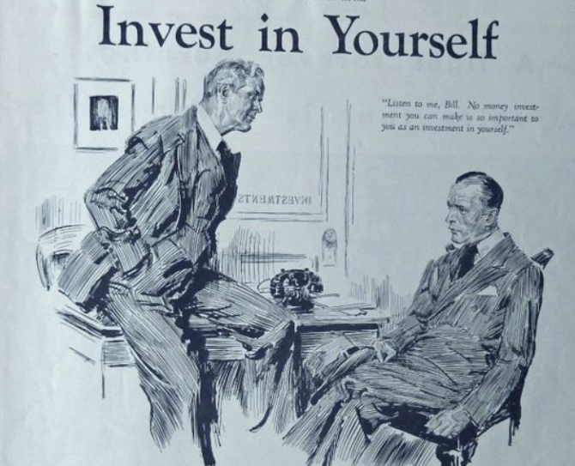

Ad 3
Dollar Bank offers online banking services to individuals in various parts of the United States. The services offered include checking and savings accounts, corporate banking as well as loans. The online services are intended to ensure the customers can efficiently transact at their comfort without having to visit the banks. This can also save their fatigue. This comfort is promoted in the company’s creative adverts. The advert shows money resting on a seemingly comfy chair. The comfy chair illustrates the comfort provided by the banking services. The money resting on a chair also shows relaxation and calmness of using online banking services from home.


Ad 4
Stamford university promotes the idea of #NextGreatDiscovery through the empowerment of children. It uses advertisements that promote more investment in children instead of basic science. To promote these ideas, the campaign shows different generations of microscopes used in discoveries with books on the shelf. This shows the evolution in information over the years while scientific appliances evolve slowly. Children learning comfortably from the couch promotes the idea of education over scientific discoveries.

