ECON 102

Quiz 2

Question 1 (10 points)

Business cycles are
Question 1 options:
movements in stock prices.
the transfer of executives between firms.
used to describe fluctuations in GDP.
a description of the time required to bring a new product to market.

Question 2 (10 points)

Economists define the unemployed as individuals who are
Question 2 options:
not currently working.
not currently working but are actively looking for work.
working but looking for a different job.
working less than their desired amount of time.

Question 3 (10 points)

Economists define the labor force to include
Question 3 options:
only people who are working full time.
people who are working.
people who are not working but are actively looking for a job, and people who are working.
all individuals of work age, regardless of whether they are working or looking for a job.

Question 4 (10 points)

People who want to work but have stopped looking for work because they could not find jobs after actively searching are called
Question 4 options:
employed.
unemployed.
discouraged workers.
empowered.

Question 5 (10 points)

Unemployment that naturally occurs during the normal workings of an economy as people change jobs and move across the country is called
Question 5 options:
natural unemployment.
frictional unemployment.
structural unemployment.
cyclical unemployment.

Question 6 (10 points)

________ unemployment occurs due to a mismatch between the jobs that are available and the skills of workers seeking jobs.
Question 6 options:
Structural
Cyclical
Frictional
Voluntary

Question 7 (10 points)

At full employment the unemployment rate equals the
Question 7 options:
cyclical unemployment rate.
structural unemployment rate.
structural unemployment rate plus the cyclical unemployment rate.
structural unemployment rate plus the frictional unemployment rate.

Question 8 (10 points)

Economists consider an economy to be at "full employment" when
Question 8 options:
the unemployment rate equals the natural rate of unemployment.
there is only a small amount of cyclical unemployment.
there is no frictional unemployment.
there is no structural unemployment.

Question 9 (10 points)

Economists say that the economy is at "full employment" when the
Question 9 options:
structural unemployment rate is zero.
total unemployment rate is zero.
frictional unemployment rate is zero.
cyclical unemployment rate is zero.

Question 10 (10 points)

The economy needs some unemployment to operate efficiently, because without it
Question 10 options:
firms will find it difficult to recruit workers, leading to increased wages and prices.
firms will find it difficult to recruit workers, leading to reduced wages and prices.
workers will find it difficult to find a job, leading to increased wages and prices.
workers will find it difficult to find a job, leading to reduced wages and prices.

Quiz 3

Question 1 (10 points)

Which of the following is a problem with the price system that can lead to a breakdown in the coordination of economic activity?
Question 1 options:
The price system works silently in the background.
Prices can be slow to adjust.
Prices may be flexible.
all of the above

Question 2 (10 points)

If prices are sticky
Question 2 options:
economic activity will be coordinated efficiently.
economic activity will not be coordinated efficiently.
prices will quickly adjust to changes in demand.
quantity supplied will always equal quantity demand.

Question 3 (10 points)

What are some reasons why coordination of economic affairs through the price system may not work perfectly?
Question 3 options:
may be too few prices (that is, more markets than prices),
prices may not contain sufficient information
prices may be "sticky."
all of the above

Question 4 (10 points)

One reason the aggregate demand curve is downward sloping is because of the
Question 4 options:
interest rate effect.
welfare effect.
price effect.
tariff effect.

Question 5 (10 points)

Which of the following would cause an increase in aggregate demand in the short run?
Question 5 options:
an increase in the supply of money
a decrease in the price level
an increase in taxes
a crop failure

Question 6 (10 points)

The long-run aggregate supply curve is
Question 6 options:
downward sloping.
upward sloping.
a vertical line at potential output.
a horizontal line at the current price level.

Question 7 (10 points)

In the long run
Question 7 options:
price and output levels are mutually dependent.
the level of output depends on the price level.
the level of output is independent of the price level.
the price level depends on the level of output.

Question 8 (10 points)

What are the two tools of fiscal policy that governments can use to stabilize an economy?
Question 8 options:
government spending and technology improvements
government spending and taxation
taxation and controlling imports
taxation and controlling exports

Question 9 (10 points)

An increased federal budget deficit resulting from a recession can actually help stabilize an economy through transfer payments because an increased budget deficit will ________ transfer payments and thereby ________ the income of some households.
Question 9 options:
increase; increase
increase; decrease
decrease; increase
decrease; decrease

Question 10 (10 points)

Using expansionary policies to combat a recession would
Question 10 options:
increase a budget deficit.
increase a budget surplus.
decrease discretionary spending.
increase federal revenue.

Quiz 4

Question 1 (10 points)

The supply of money in the U.S. economy is determined primarily by
Question 1 options:
decisions made by the Federal Reserve and the U.S. Treasury.
the actions of the Federal Reserve and the banking system.
consumers and the banking system.
the demand for money in the economy.

Question 2 (10 points)

One of the essential functions that a bank performs is
Question 2 options:
purchasing government bonds.
creating deposits by lending required reserves.
transferring money from savers to lenders.
owning assets like real estate.

Question 3 (10 points)

At lower interest rates the
Question 3 options:
money supply is indeterminate.
money supply is lower.
quantity of money demanded is higher.
quantity of money demanded is lower.

Question 4 (10 points)

From time to time, the Federal Reserve buys back government bonds from the private sector through a process called
Question 4 options:
bond recall procedures.
open market purchases.
backflip bond investments.
voluntary redemption procedures

Question 5 (10 points)

Selling government bonds through open market operations allows the Federal Reserve to
Question 5 options:
decrease money in the treasury.
decrease the money supply in the private sector.
receive discounts on future sales.
receive a high rate of interest on the bonds.

Question 6 (10 points)

How can the Federal Reserve actually increase the money supply?
Question 6 options:
by delaying transfer of money among banks
by raising the discount rate
by printing more money
by purchasing more government bonds in the open market

Question 7 (10 points)

An increase in the discount rate
Question 7 options:
reduces the cost of reserves borrowed from the Fed.
signals the Fed's desire to increase the money supply.
signals the Fed's desire to lend increased reserves to banks.
increases the cost of reserves borrowed from the Fed.

Question 8 (10 points)

The Federal Reserve influences the level of interest rates in the short run by changing the
Question 8 options:
demand for money through open market operations.
demand for money through changes in reserve requirements.
supply of money through open market operations.
supply of money through changes in stock market operations.

Question 9 (10 points)

If the quantity of money demanded exceeds the quantity of money supplied, then the
Question 9 options:
interest rate stays the same.
interest rate will increase.
interest rate will decrease.
effect on the interest rate is indeterminate.

Question 10 (10 points)

If the Fed wished to decrease inflation, it could
Question 10 options:
increase the reserve requirement or conduct an open market sale.
increase the reserve requirement or conduct an open market purchase.
decrease the reserve requirement or conduct an open market sale.
decrease the reserve requirement or conduct an open market purchase.

Quiz 5

Question 1 (10 points)

Technological progress occurs when the economy gets more output
Question 1 options:
without any more capital or labor.
by using more capital per worker.
by using more capital but not more workers.
by using more labor but not more capital.

Question 2 (10 points)

If a firm increases its use of capital while holding constant the number of workers employed, the firm is said to experience
Question 2 options:
capital augmentation.
investment deepening.
labor intensity.
capital deepening.

Question 3 (10 points)

Increases in net investment generally result in
Question 3 options:
lower levels of capital stock and lower levels of depreciation.
lower levels of capital stock and higher levels of depreciation.
higher levels of capital stock and higher levels of depreciation.
higher levels of capital stock and lower levels of depreciation.

Question 4 (10 points)

Nations that borrow from abroad to support current investment will
Question 4 options:
always be better off in the future.
always sacrifice future consumption.
be better off in the future if the investments are profitable.
sacrifice future consumption only if the investments are profitable.

Question 5 (10 points)

Nations that borrow from abroad to support current consumption
Question 5 options:
will always be better off in the future.
will always sacrifice future consumption.
may sacrifice future consumption.
will always sacrifice current consumption.

Question 6 (10 points)

Trade deficits always lead to future decreases in consumption if the trade deficits
Question 6 options:
support current investment.
support current consumption.
support either current investment or current consumption.
require borrowing from abroad.

Question 7 (10 points)

An event that allows the economy to operate more efficiently by producing more outputs without using any more inputs is referred to as
Question 7 options:
absolute progress.
efficiency progress.
capital investment.
technological progress.

Question 8 (10 points)

It is possible for an economy to become more productive and per-capita output to increase if
Question 8 options:
new ideas are generated.
inventions are developed.
technology is improved.
all of the above

Question 9 (10 points)

Knowledge and skills are part of ________ in an economy.
Question 9 options:
educational functions
human capital
market growth
innovation

Question 10 (10 points)

Economic growth is severely impeded in economies
Question 10 options:
with a lack of clear property rights.
with a strong central government.
with high rates of convergence.
which encourage induced innovation.

W2: GDP as a measure of well-being
Contains unread posts
Week 2 Discussion Post2: Gross Domestic Product (GDP) is the broadest measure of output for an economy. However, GDP does not perfectly measure well-being of a nation and its citizens' welfare. Discuss what GDP is and what it measures? Discuss what the shortcomings (limitations) of GDP as a measure of well-being and welfare of a nation are?

W3: Types of Unemployment
Week 3 Discussion Post 3
What are the three types of unemployment? Unemployment is seen by some as undesirable. Are all three types of unemployment undesirable? Could the advent of the Internet completely eliminate frictional unemployment? Are all three types of unemployment undesirable? Explain.

W4: Wage-Price Rigidity
Week 4 Discussion Post 4: Classical economists believe that prices and quantities adjust to the changes in the forces of supply and demand and that the economy produces its potential output in the long run. On the contrary, Keynesian economists believe because of price and wage rigidities the economy's equilibrium output in the long run may be less than its potential output. What is price-wage rigidity? Do you agree with Keynes assessment that wage-price rigidity requires government's involvement in the markets? Why? Why not?

W5: Paradox of Thrift
Week 5 Discussion Post 5
An interesting paradox called the "Paradox of Thrift" arises when households become concern about their future and attempt to increase their saving. As a consequence of such action the overall economy will suffer. Explain. Do you agree with this assessment?

W6: Objective of Monetary Policy
Week 6 Discussion Post 6
What are the basic objectives of monetary policy? Comment on the cause-effect chain through which monetary policy is made effective. What are the major strengths of monetary policy?

W7: Limits to Long-term Economic Growth
Week 7 Discussion Post 7
What are the limits to the U.S. long-term economic growth? Is there anything that our government can do to address these limits, or would it be a bad idea to try?

W8: Course Reflection
Course Reflection
In no more than 250 words, please (1) describe how you feel this course has helped you to improve your economic knowledge and analytical skills, and (2) assess the course objectives you still do not understand and suggest how to improve the course to meet those objectives, and 3) did the course content and instructor's facilitation of this course meet your expectations.

ART CLASS

Week 5 Museum paper
Top of Form
Instructions
Art Museum Assignment
Course Objective(s):
- CO-1: Identify major works of Western and Non-Western art from the Neo-Lithic to the Post-Modern periods.
- CO-2: Identify major artists and their time periods in Western and Non-Western art.
- CO-3: Interpret art terminology in relationship to works of art.
- CO-4: Describe major works of art.
- CO-5: Compare and contrast works of art.
- CO-6: Analyze works of art within their social and historical contexts.
Write a 2 page description, formal analysis, and interpretation of one work of art from a virtual museum online. Visit the museum virtually. Please visit an art museum, not a children's museum for this project. Use the Week 1 How to Write a Critique format. You are writing in an informal manner and are discussing/describing the object with us. Be sure to review the lesson of Description, Formal Analyze, and Interpretation learned in Unit 2. It may be helpful to review the Third of May, 1808 short videos in Unit 2 lecture.
Submit your work in the Museum Assignment section. Optionally: also post your paper to the Week 5 Forum designed for the papers.
Museum Paper Grading Rubric:
The Museum Paper is an analysis paper, not a history or research paper. It is worth 100 points.
60 points: If the student demonstrates a clear understanding of the topic being discussed and addresses all required points in the writing prompt. Be sure to describe the artwork, name and discuss line, texture, space, color and shape, and arrive at an interpretation. What does the artwork say to you personally? Be sure that the paper is two full pages aside from the description of the museum. The museum description should not be included as part of the two page length requirement. Try to choose a museum locally so that you can visit in person at some point and see the artwork that you wrote about. Have fun!
30 points: If the student follows the Writing a Critique Guide provided
10 points: If the student has no spelling or grammatical errors
Bottom of Form

Week 7: Art Presentation
Top of Form
Instructions
Course Objective(s):
- CO-7: Demonstrate the ability to locate and incorporate art historical research sources in a scholarly paper.
- C0-8: Examine an artist’s biography and artistic production.

Description:
A 4 page Power Point Presentation is due at the end of Week 7. Visit the APUS online library, look at the course guides and optionally use the "Ask the Librarian" resource to help you locate scholarly references. They have electronic rights to JSTOR, which is a journal storage database and other data bases.

Choose one artist or architect that is included in any week of our course lessons, readings, or other areas. In this essay, fully discuss the artist and one art sample.

It is best to choose an artist we have studied in the class, but it doesn't have to be. Do not include any artwork that you have already written about in class. Your analysis should be 2 pages in length and cannot be a work of art we have discussed in Forums. The analysis portion of this assignment must follow the Writing a Critique format you used for your Museum Paper.
Here is a summary of what you will submit for your Power Point Presentation:
- A Cover Slide including your artist's name, your name, the course title and date.
- A 2 page/slide biography of your artist.
- A 2 page/slide description, formal analysis, and interpretation of the one work of art
- A Reference list slide properly citing 6 references cited in the MLA citation style.

DO NOT FORGET: Use your Writing a Critique Art Notes that is in your Week 1 Lesson for the analysis which includes information for description formal analysis.

Use the Required Reading Videos and Resources in Lesson Two to help you with this paper and the Museum Paper.
Wikipedia note: It is an unjuried source, meaning that anyone can post there, even those who know nothing about the subject. AMU/APUS has a great library for source material. Start there.
Writing Resources:
- Purdue OWL Writing Resources
- Questions to Ask as You Look at a Work of Art
Art and Architecture Sites:
- Louvre Museum in France
- Metropolitan Museum
- British Museum
- The National Gallery
- Rodin Museum
- Musee d'Orsay
- The Musee Matisse
- Andy Warhol Museum
- Late 19th century artists
- Buildings by Frank Lloyd Wright
- Great Buildings Resources
- There are also many museums near you that have outstanding collections. It might be interesting and fun to research a paper and then take a small trip to see it in person sometime. It’s like meeting a celebrity!
- You can also start with the name of an artist that you appreciated, conduct an internet search, and resources will be available.

Please consider the following:
- Of course you may do an internet search for any of your artists/architects, do keep them scholarly.
- DO NOT USE WIKIPEDIA as a reference.
- You may use Museum websites or other scholarly sources.
- Images are interesting but shouldn't take the place of written content. Cite all references.
- Do not use voice on this PPT or Notes. It is often unreliable for this type of presentation.
- Please see the attached Term Paper Grading rubric.
- Please see the Power Point Tips in the Week 7 Discussion before creating your Power Point.

Bottom of Form

W2: Reading Masterpieces in Art: Goya and Manet
Course Objective(s):
  - CO2: Identify major artists and their time periods in Western and Non-Western art.
  - CO3: Interpret art terminology in relationship to works of art.
  - CO4: Describe major works of art.

Description: Reading and Looking
Reading Masterpieces in Art: Goya and Manet: This assignment is designed to help you master the careful reading of sources about art images and to help you apply the basic mechanics of analyzing and interpreting images appropriately.
In order to participate fully in this week's discussion, do the following steps.

TOPIC 1.) Examine and discuss in detail Francisco de Goya's painting, The Third of May, 1808 created in 1815-16. The original painting, which currently hangs in the Prado museum, is very large (about 10 x 14 feet), and it was painted in 1816. It depicts the invasion by the French army into Spain in the early 1800s. Examine your book for other images by Goya, in order to understand his work better. Imagine you are looking at this painting while visiting the Prado Museum in Spain. Consider what the size of the painting means or does for/to the viewer.
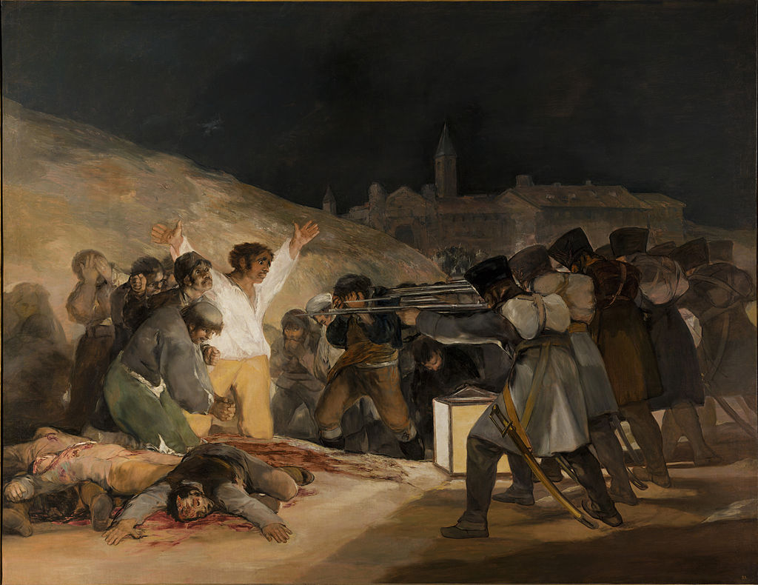
El Tres de Mayo, by Francisco de Goya, from Prado in Google

W3: Printmaking and Photography
Course Objective(s):
  - CO2: Identify major artists and their time periods in Western and Non-Western art.
  - CO3: Interpret art terminology in relationship to works of art.
  - CO4: Describe major works of art.
  - CO6: Analyze works of art within their social and historical contexts.

Description: An Examination of 2-Dimensional Art (Printmaking and Photography)
Choose one of the following to write about:

Photography
Topic 2.) Dorothea Lange, Migrant Mother, 1936. This photograph is important on many levels, but examine it in the context of the Farm Security Administration, discussing the FSA’s involvement. What was the FSA? Why was it important? Why do we consider this photograph a significant art object? Explain the reason for its creation. Then think about the photograph and answer the following:
- Is it art and/or documentation, or both?
- Provide solid details about what makes an image art or documentation, and defend your answer. Find a website that has reliable information about Lange and/or this topic, and provide a link to the site in your post for proper attribution.

W4: Sculpture and Architecture
Course Objective(s):
  - CO2: Identify major artists and their time periods in Western and Non-Western art.
  - CO3: Interpret art terminology in relationship to works of art.
  - CO4: Describe major works of art.
  - CO6: Analyze works of art within their social and historical contexts.

Description: An examination of 3-dimensional media: Sculpture and Architecture
This is a research, read, consider, think, and write exercise. You may list sources if helpful, but use your own words.
Choose one of the following to write about:

Topic 2.) Examine and discuss all of the following buildings:
- The Pantheon
- Alexandre Gustave Eiffel, The Eiffel Tower
- Frank Lloyd Wright, Fallingwater
Architecture is often discussed in terms of 3 dimensions, as though it was large scale sculpture, but architecture always has a specific function. Architecture conveys meaning and is “read” like paintings and sculpture are “read.” Each element has a function and a meaning; therefore, buildings communicate messages to the viewer. During this Discussion, imagine yourself in the spaces while you examine it and discuss it. Include in your answer:
- Who is the architect?
- From what era and what culture is the building?
- What was its function and location?
- What are the building materials --what is it made of?
- Are there any special construction techniques used?
- Why is the building important? Be specific.

W6: Issues of Art in Service of Religion
Course Objective(s): CO6: Analyze works of art within their social and historical contexts.

Description: Italian Renaissance and Baroque Masters
Fully answer 1 of the Following Topics.

Topic 1:
Donatello is considered the finest of the early Italian Renaissance sculptors. He was known for advancing the ideas of naturalism in the sculpted human figure. Conduct internet research, then examine and discuss two of his works, such as "St. Mark" and "David." Answer all of the following in your post:
- What does the word renaissance mean?
- What does humanism mean?
- How might the term renaissance apply to these figures?
- What correlation is there between the figures based on what you researched about the artist?
- What differences do you see between the figures?
- What is the function of each of these objects, and where were/are they found?
- What do they each mean?
- What techniques did the artists use, and how did they fit into their respective cultures?
- What is your personal reaction/response to these figures, and how (if at all) do they apply to your life and past experiences?

W8: Exploring the Figure in Modern Art
Course Objective(s):
  - CO1: Identify major works of Western and Non-Western art from the Neo-Lithic to the Post-Modern periods.
  - CO2: Identify major artists and their time periods in Western and Non-Western art.
  - CO4: Describe major works of art.
  - CO6: Analyze works of art within their social and historical contexts.
  - CO8: Examine an artist's biography and artistic production.

Early Modern Masters: Picasso and Matisse: Exploring the Figure in Modern Art
Choose one of the following to write about:
The human figure has been a popular subject matter for artists throughout art history. Modern artists introduced their innovative styles using the human figure. Two early 20th century artists were Picasso and Matisse. They were influenced by the Post Impressionists (Vincent van Gogh and Paul Cezanne, for example.) Select one of the two artists below, or you can select another artist from the late 19th or 20th century of your choice. Be sure to tell us something about the contributions of the artist, their style, and select a specific artwork to discuss. Be sure to include references.
Examine and discuss Picasso's Early Cubist painting, Les Demoiselles d' Avignon . Answer the following questions:
- What is cubism?
- What is the painting about?
- What does the title mean?
- Why do we see shattered forms?
- Is it possible to describe it from the background?
- What did this painting do for the art world? Use your art terminology to discuss it and its importance.

-

ECON 600 CLASS

W2: Small Mistakes
Contains unread posts
Small mistakes are the stepping stones to large failures. How might this saying apply to this lesson, and do you agree?
In your responses, provide an example of a real-life seemingly small mistake with large consequences. By real-life, I mean a situation that actually happened, not a theoretical one.

W3: Demand Estimation
Why is knowing (or estimating) the product demand so crucial for a firm?
In your response, include an example of a business that has suffered from poorly estimating the demand of its products. Evaluate how or why the business made such a mistake.

W5: Flexible Manufacturing Plants
Honda uses flexible plants in the manufacturing of its cars. Discuss whether this method of production results in optimum output. For further information, read The Wall Street Journal, September 23, 2008, p. B1. How to Access the Wall Street Journal through the Online Library:
1. Go to the Online Library/Article Database page.
2. Select "Journal Title Search".
3. Type in "Wall Street Journal".
4. From the list of results, select "Wall Street Journal. Eastern edition" from ABI/INFORM Complete.
5. Use the search box entitled "Search for articles within this publication" to find articles by topic within the Wall Street Journal.
The article can be accessed directly at Honda's Flexible Plants Provide Edge.

W6: Economies of Scale
Discuss whether economies of scale have any relevance to such companies as Wal-Mart.

W7: Venture Capitalists
In the hope of high returns, venture capitalists provide funds to finance new (start up) companies. However, potential competitors and structures of the market into which the new firm enters are extremely important in realization of profits. Among different market structures, which one do you believe provides the highest possible return for a new company and why?

