Chi-Square Analysis

Student’s name
Institution affiliation
Instructor’s name
Course
Date

1.Income vs. product style
The results of data analysis also showed an existence between income and product characteristics like style. The chi-square analysis through cross-tabulation shown in the table below shows a p-value of 0.021, which is less than 0.05 at 95% confidence level and hence indicating a significant relationship. The respondents were across different income levels were significantly influenced by the presence or absence of style in jackets 53% of the participants of 50,000 and above income agreed that they would pay more for a sleek and stylish jacket, while the majority of the respondents (52.9%) of incomes between 25000 and 49,000 indicated that they would pay more for sleek and stylish jacket. However, only 45.3% of the respondents with income below 25000 agreed with the statement. This indicates an increasing trend of agreement with an increase in the income levels, which shows a strong and positive relationship between income levels and sleek and stylish jacket characteristics.

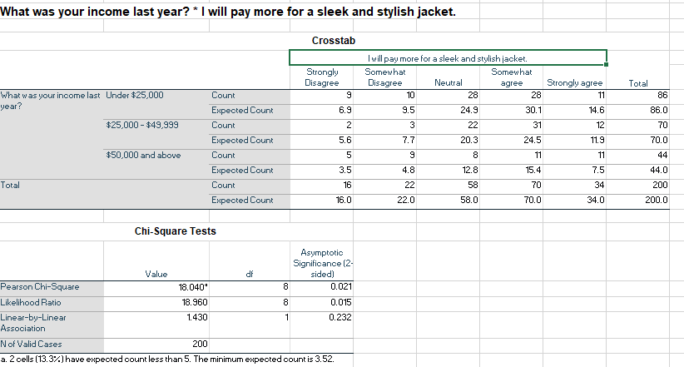
2. Age and price sensitivity
The analysis also showed an absence of a relationship between the age of the participants and age sensitivity. According to the results of the analysis presented in the graph below, the Pearson chi-square has a p-value of 0.053, which is greater than 0.05 for a 95% confidence level, hence insignificant. This indicates that the age and sensitivity of the prices are independent variables, with insignificant associations. About 43.5% of the respondents under the age of 25 years indicated an agreement with a question, while about 19.3% disagreed. Consequently, 40.9% and 30.6% of the participants aged between 25-29 and 30 and above years respectively agreed with the statement, with only 21.2% and 19.4% from ages 25-29 and 30 years and above years disagreeing. Ange of the participants and price sensitivity of jackets are independent variables.
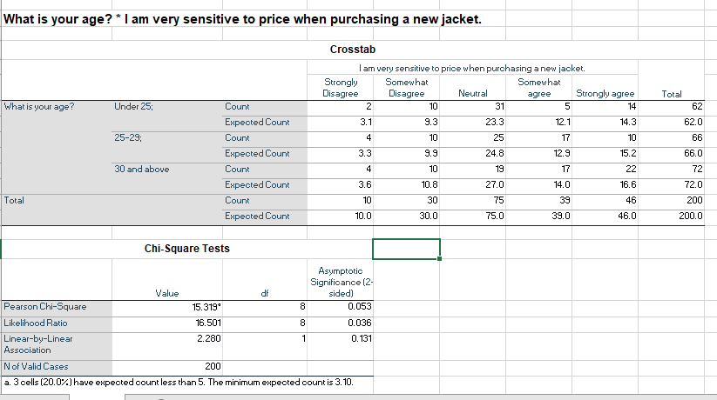

3. Relationship between gender and shipping fee
The chi-square correlation between gender and the influence of shipping fees on the purchase decision shows a strong correlation between the two variables. Accordant to the chi-square analysis results shown in the table below, the chi-quire p-value is 0.032, which is less than 0.05 for a 95% confidence interval, hence a significant relationship. This shows that gender that there is a significant relationship between gender and the shipping fee. The shipping fee influences men's and women's shopping decisions in a significantly different manner.
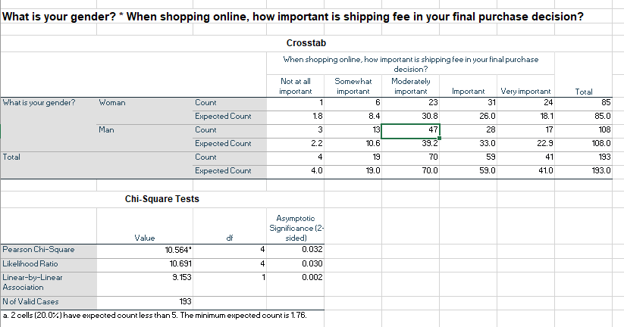

4. Income vs. Prices of different brands
The analysis showed a significant correlation between the income of the participants and how they are influenced by different brand prices. According to the table below, the chi-square p-value is0.010, which is 0.05 at a 95% confidence level. This implies that there is a strong and positive relationship between income and prices of different brands. 58% of the participants (42+16) with income below $25000 indicated an agreement with the statement that they compare prices of different brands. Significantly while only 15 of the total 86 disagreed. Consequently, 65 of total 114 (43+33), which accounts for 57%, of the respondents with income level above 25000 indicated that they compare prices of different brands before making a final decision
