Question 1:

- Below, please focus on the ANOVA table. The dependent variable is highest year of school completed by the respondent (EDUC). The independent or grouping variable is LIFE. This is based on the question: “Is Life Exciting?” The choices to be selected were: Exciting, Routine, or Dull.

- State the null and alternate hypotheses.
Ho: There is no difference between life choices in determining highest year of school completed
Ha: Atleast one life choice will differ in determining highest year of school completed
- Select your alpha level for hypothesis testing
The alpha level is 0.05 or 5%

- Test your null hypothesis by indicating its rejection or non-rejection. If you reject the null, what is your conclusion?
P value is 0.00 which is below 0.05. Therefore, reject null hypothesis
We reject null.Life choices differ in determining highest year of school completed

- Please determine if the means are significantly different across groups. If so, how did you come to this conclusion?
Means are significantly different across groups because they differ in size. Some means are positive while others are negative
- When and if the null hypothesis is rejected in ANOVA, we know that some means are different, but we have no idea which specific means are different. As a curious researcher, you likely wish to know which of the comparisons are different. To achieve this, please examine the multiple comparisons in the Post Hoc Tests table. Indicate which specific group means are statistically different from each other. In your decision making, focus on the Sig. column.

Exciting with routine. The p-value is .000, meaning reject the null and conclude the choices differ.
Exciting with dull. The p-value is .000, meaning reject the null and conclude the life choices differ.
Routine with Dull. The p-value is .000, meaning reject the null. Conclude the life choices differ

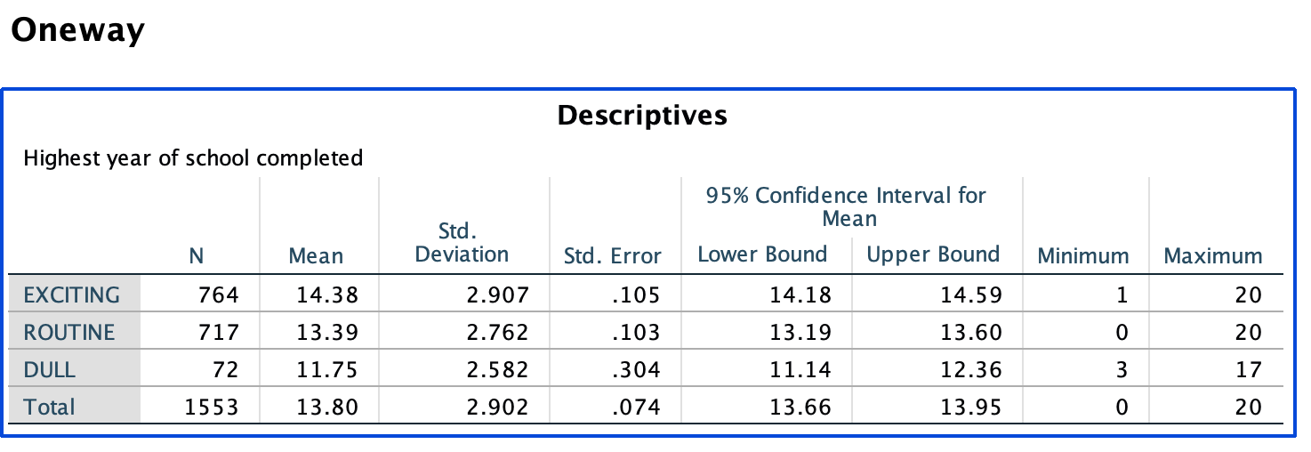
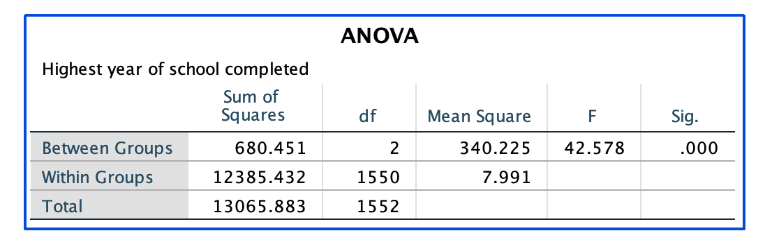

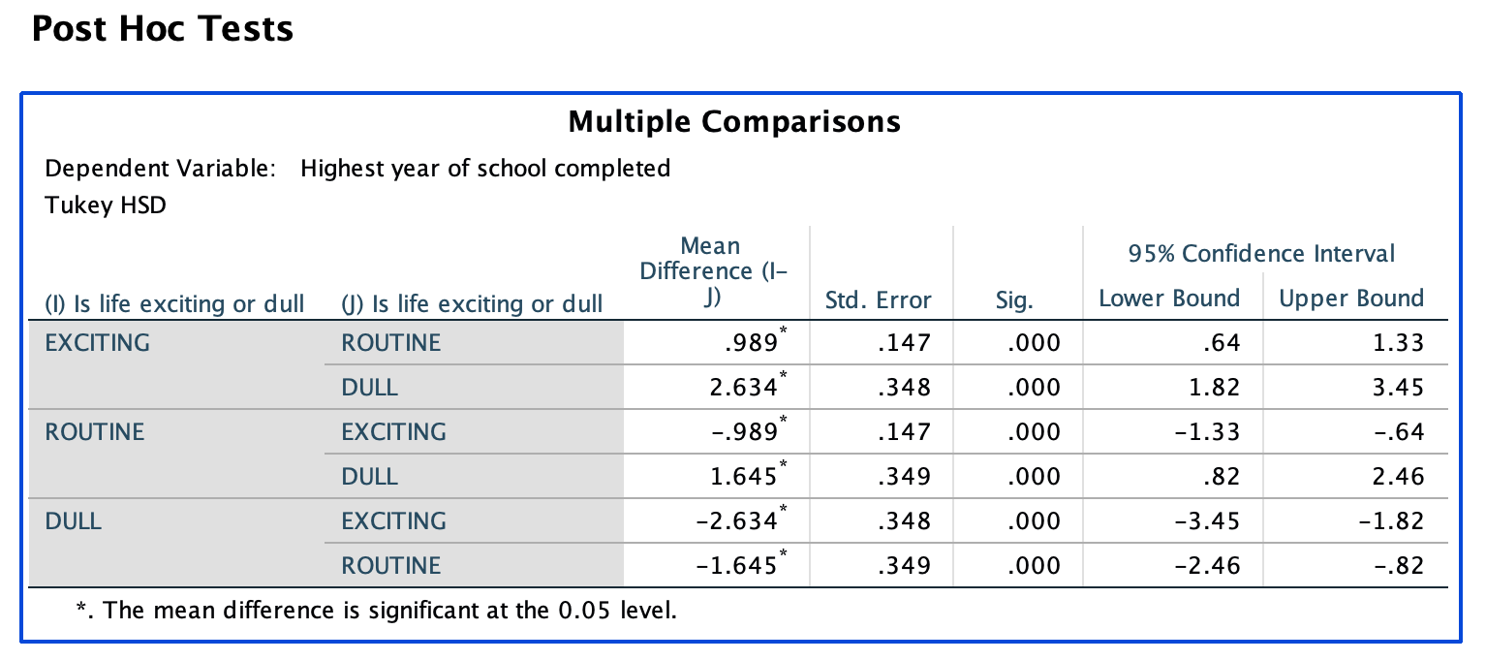
- In the correlation table below,
- Please indicate which variables are significantly related.
Highest year of school completed is related with the age of the respondent significantly
Highest year of school completed isrelated with father’s highest year of school and also mother’s highest year of school

- Discuss the strength of the relationship and the direction.
In answering question 2, please focus on the sub-diagonal matrix (coefficients under 1) as this may be an easier approach. Focus on only the correlation coefficients, and use either the significance level printed below the coefficients or the information provided by SPSS shown at the bottom of the table.

Highest year of school completed is related with the age of the respondent has a strength of 0.23 and a negative direction
Highest year of school completed is related with father’s highest year of school with a strength of 0.413 with a positive direction
Highest year of school completed is related with an and mother’s highest year of school with a strength of 0.395 with a positive direction

