ANSWERS
1. Fall to the right
2. ½
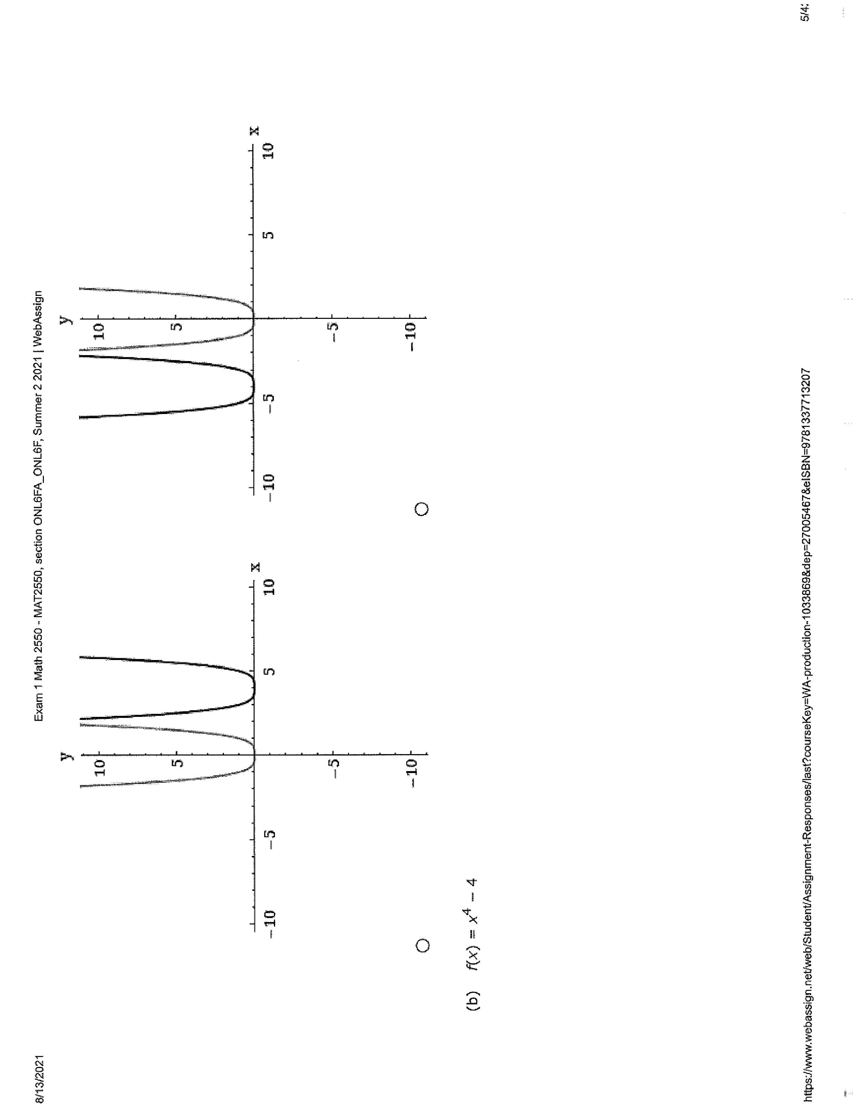
3. a) (third graph)

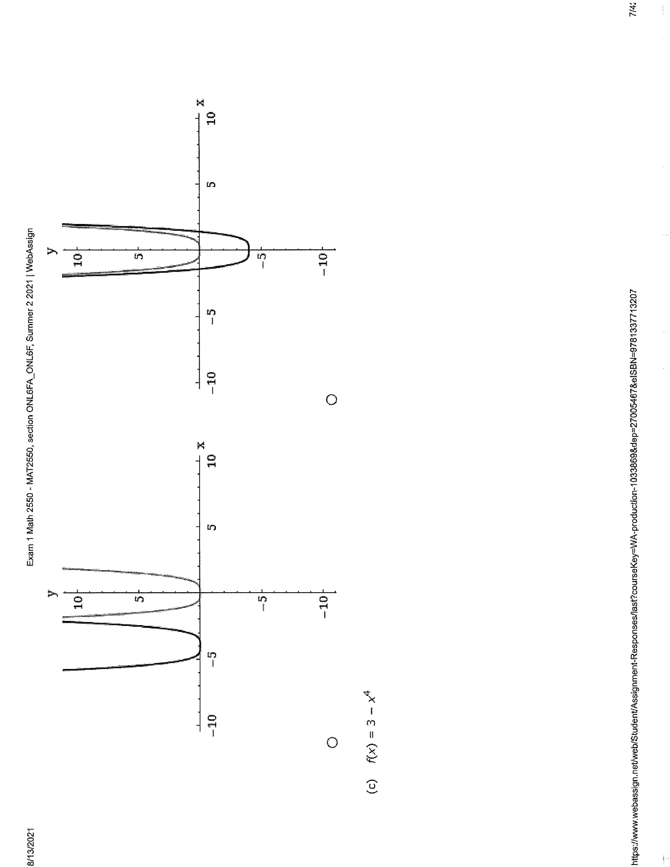
b) (fourth graph)

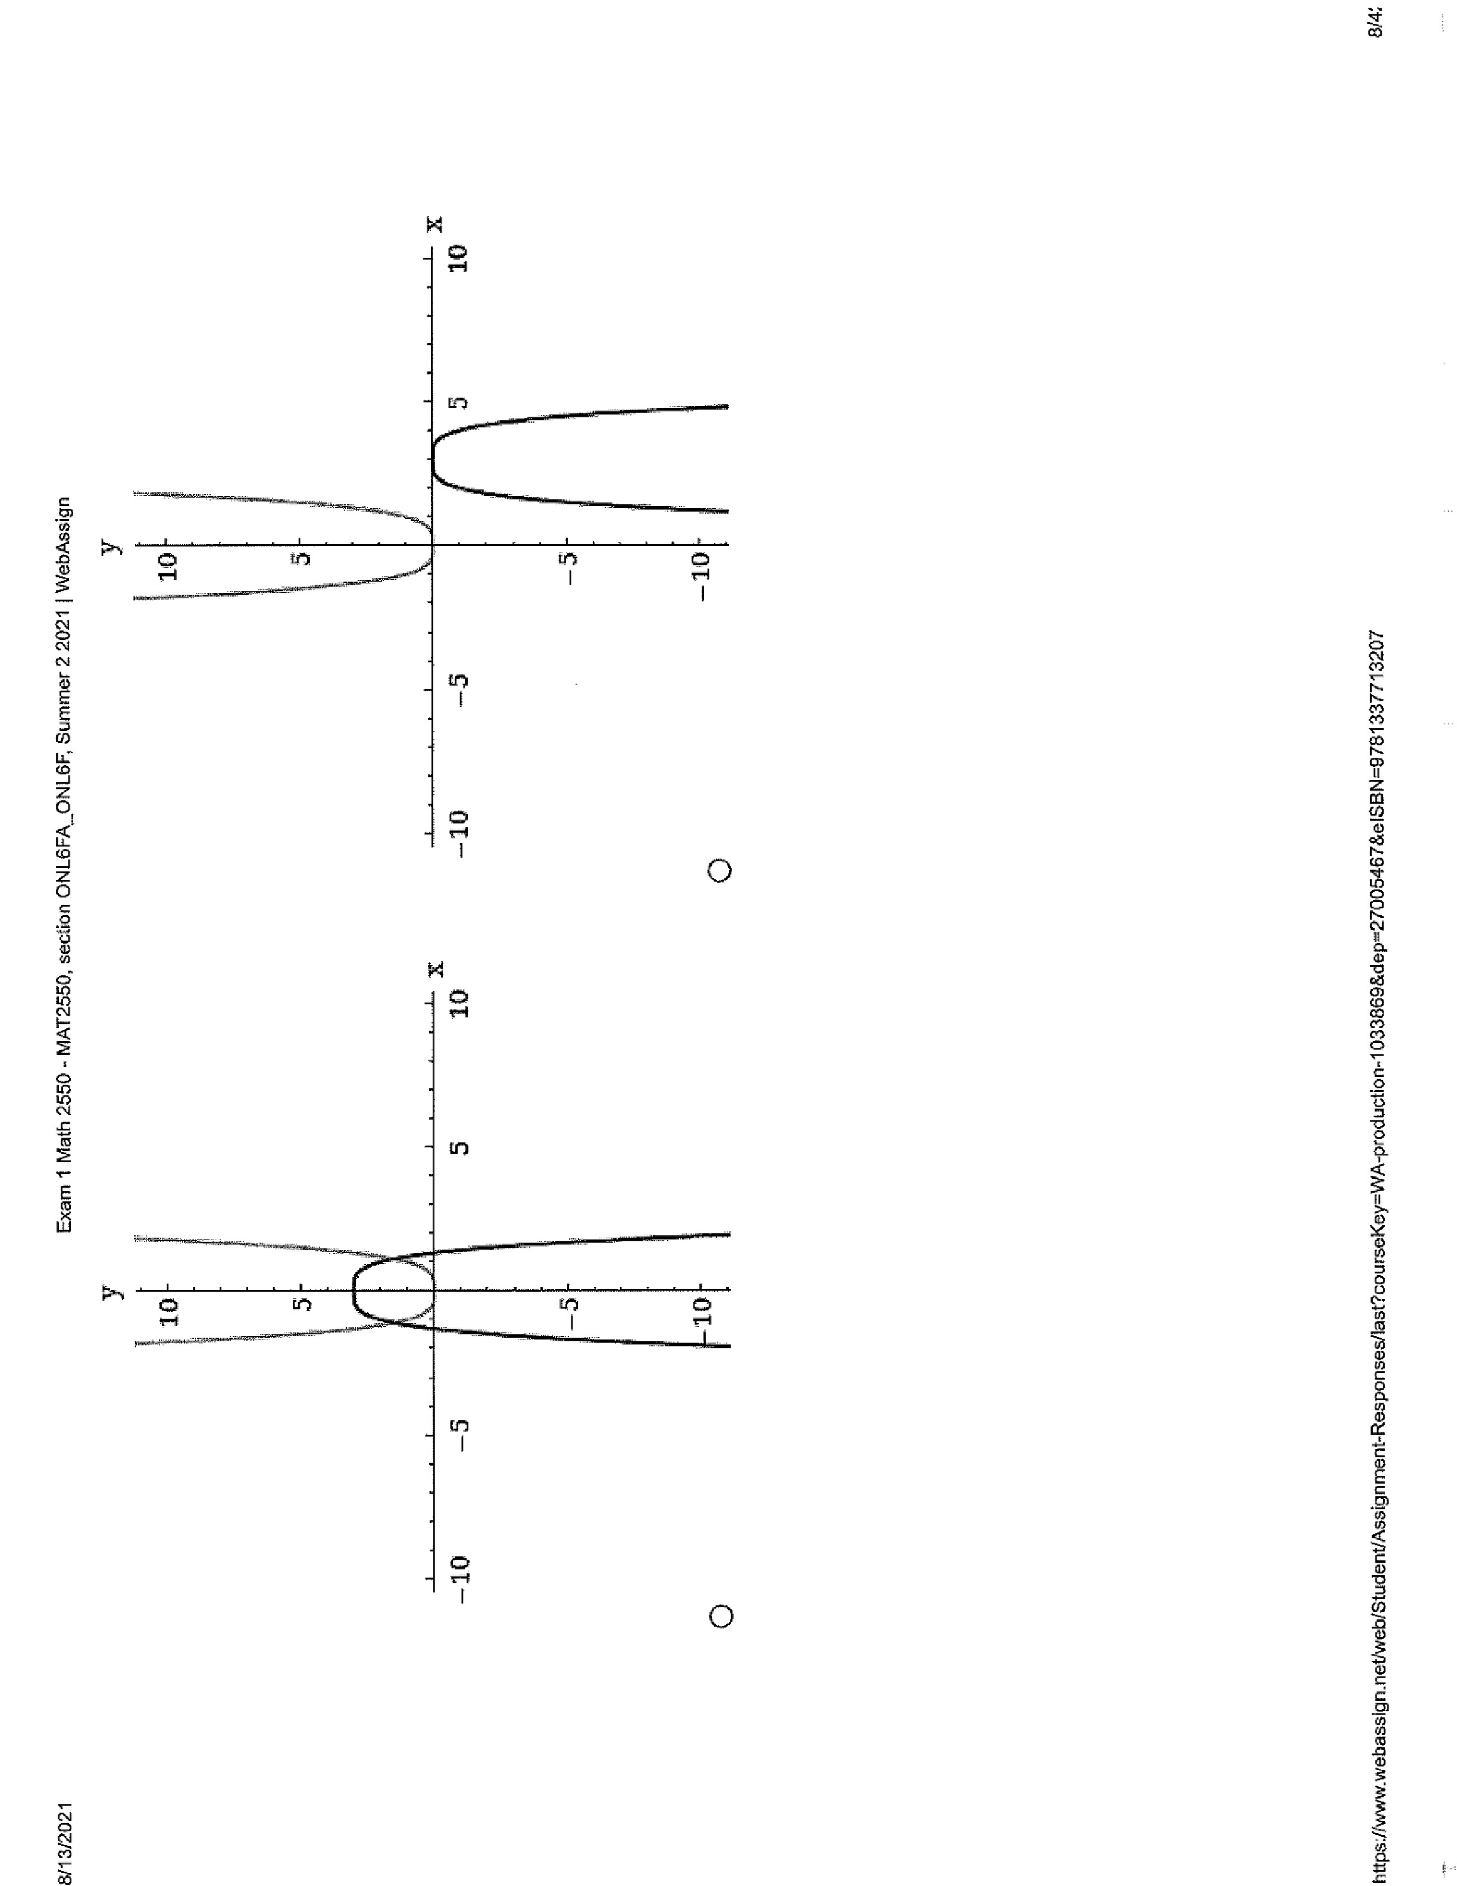
c) (first graph)

d) (fourth graph)
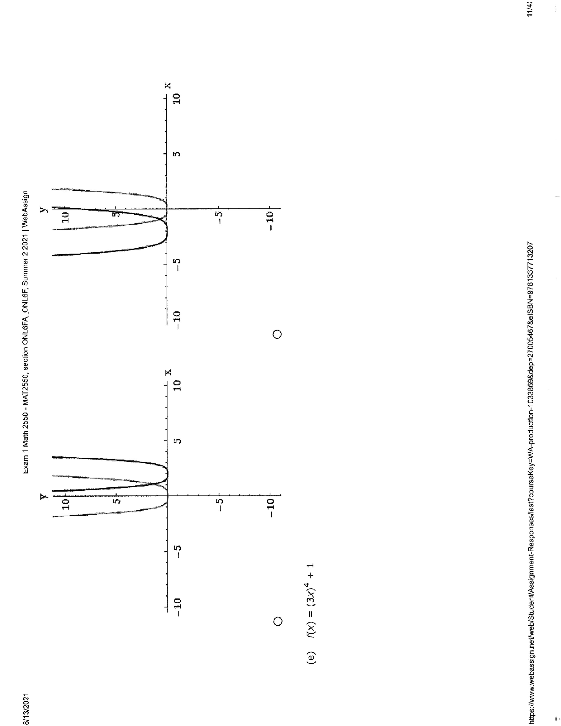
e) (Third graph)
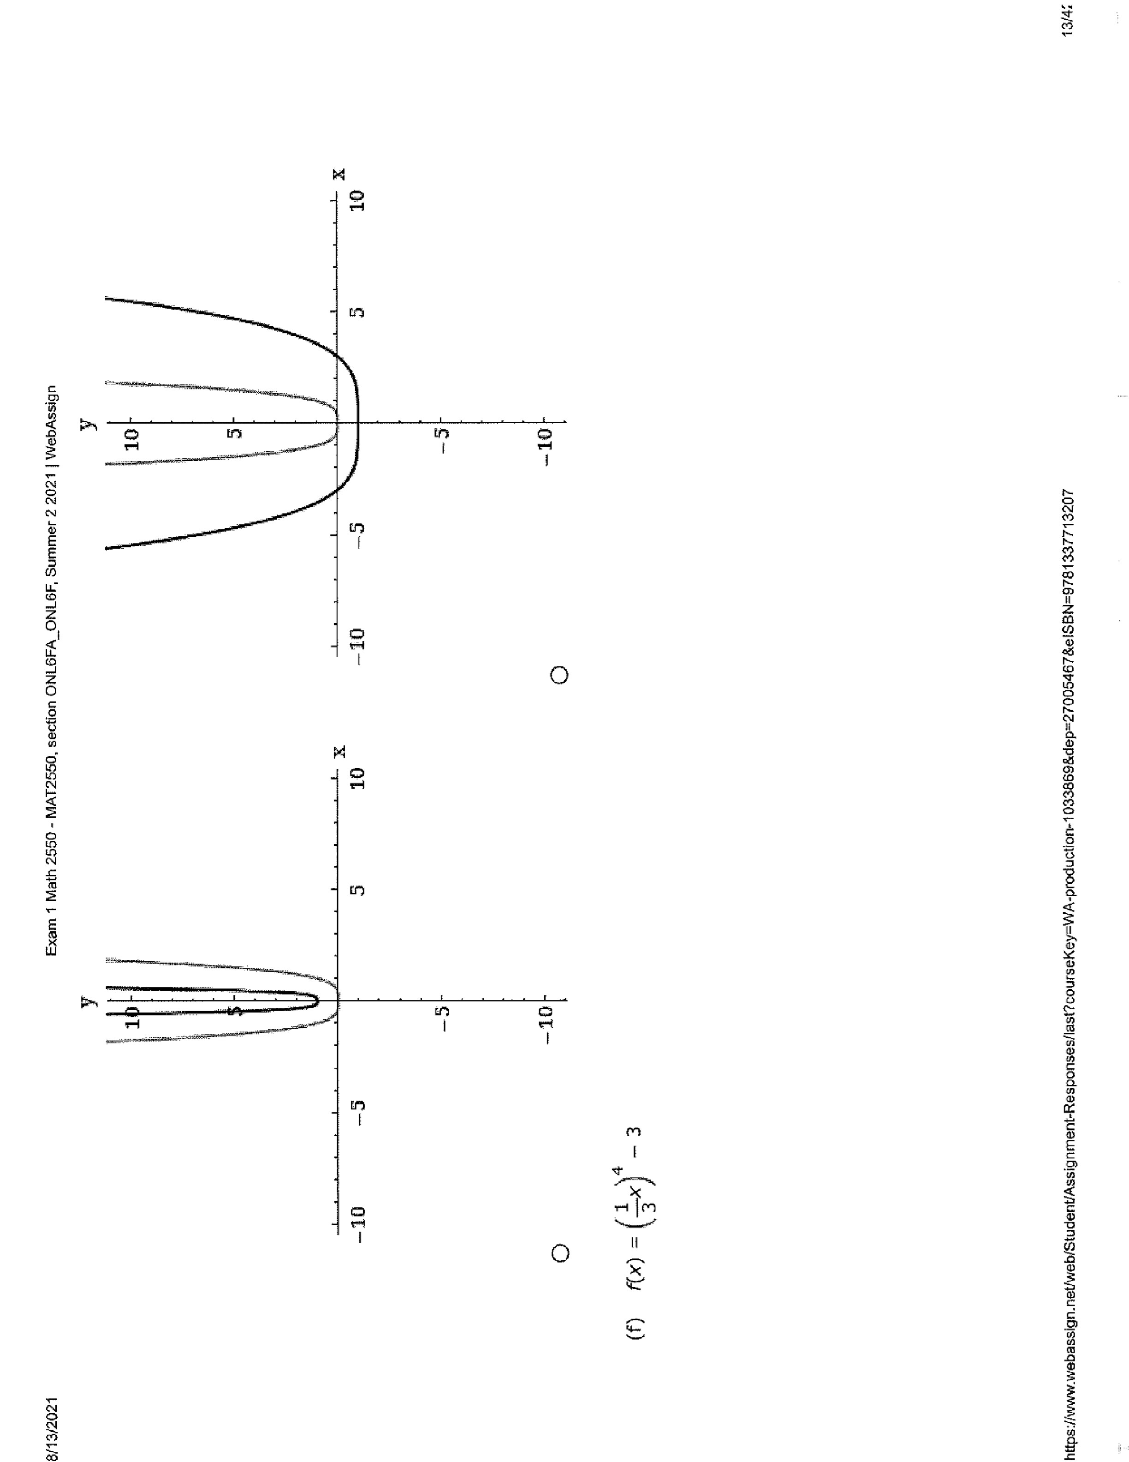

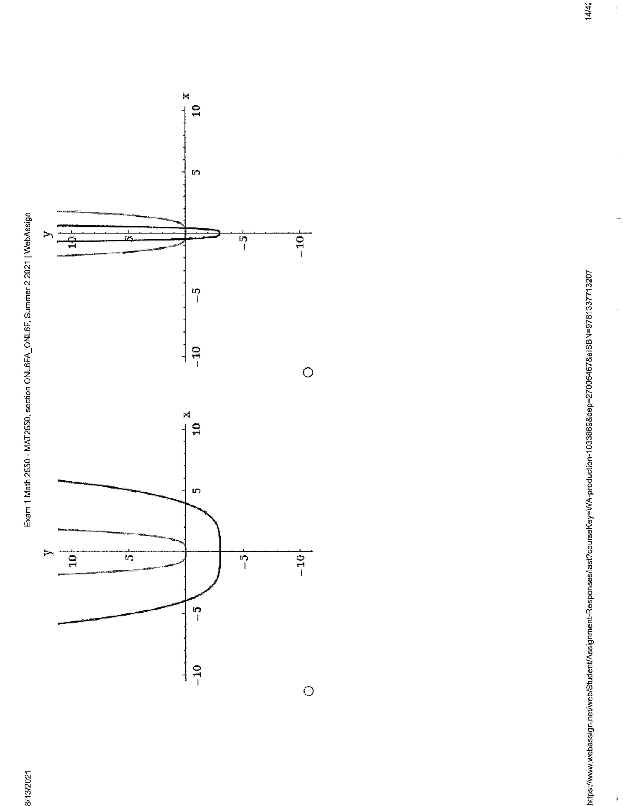
f) (first graph)

4.
Conjugate = (3-3i)
Multiply the number by its conjugate
(3+3i) (3-3i) = 18
5.
(x – 1)(x – 3i)(x+3i)
ANS f(x) = x³-x²+9x-9
6. f(g(x)) = f($∛$x-9)
= 9+($∛($x – 9)³
=x

g(f(x)) = g(x3+9)
=$∛($x+9 – 9)
=x
7.
(x+4)(3x+4)
x= -4/3
8.
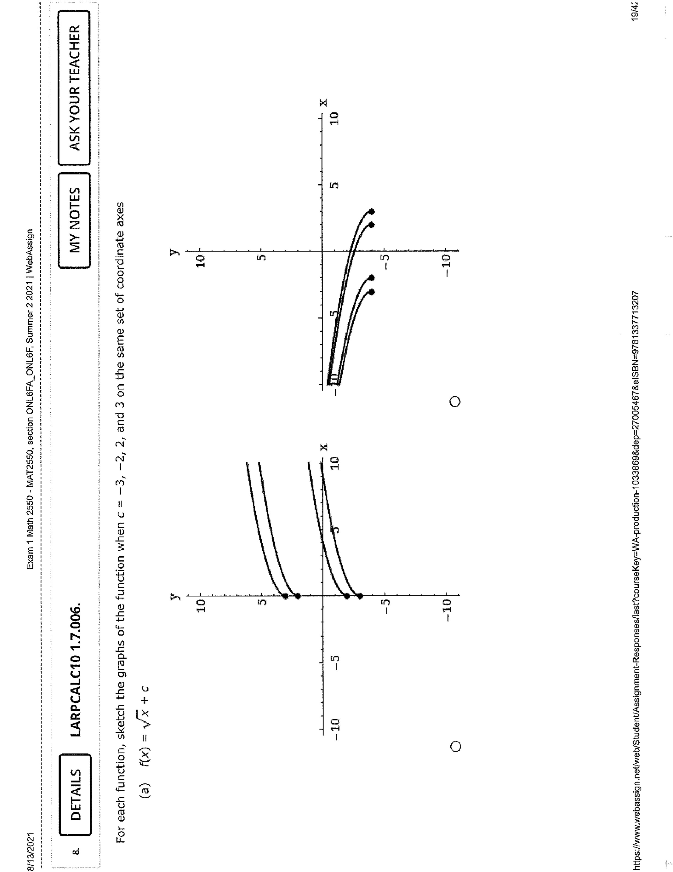
(the first graph)

9.
a) q(0) = 1/(0²-9)
=-1/9
b) q(3) = 1/(3²-9) = ∞
=UNDEFINED
c) q(y+3)=1/((y+3)² – 9)
=1/(y²+6y)
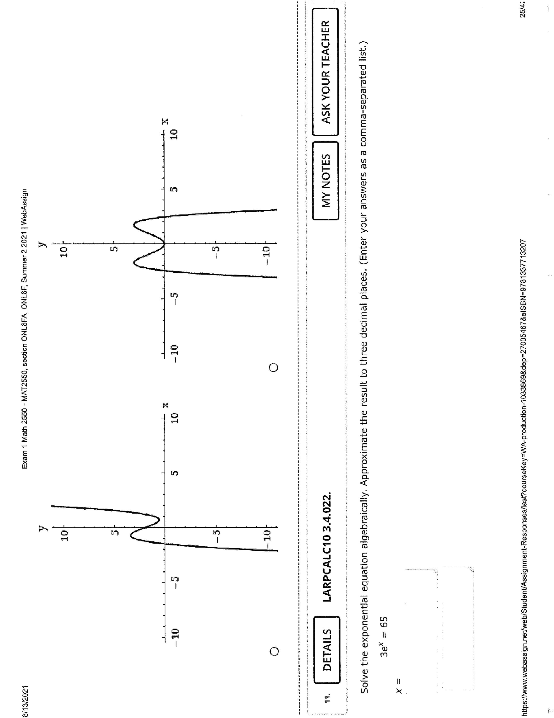
10. (The fourth graph)

11.
x = ln(65/3)
= 3.076
12.
f(x)= (x+3)(x-1)(x-i)(x+i)
= f(x)=2x⁴+4x³-4x²+4x-6
13. -2
14. -2-14= -16
15.
x=2/7 or
x= -8
16.
Domain = – 4.2 – 4.2
Range 9 - – 9
a) f(4) = – 7
b) f(3)=0
c) f(0) = 9
d) f(4)= – 7
17. 4x² – 4x + 3
18.
a) f(1) = – 5
b) f(–3)= –17
c) f(x + 5) = 3x + 7
19.
a) all real number x except x= –2
b) y - intercept = ½
x intercept = NDE
c) Vertical asymptotes = +-2
Horizontal asymptotes = 1
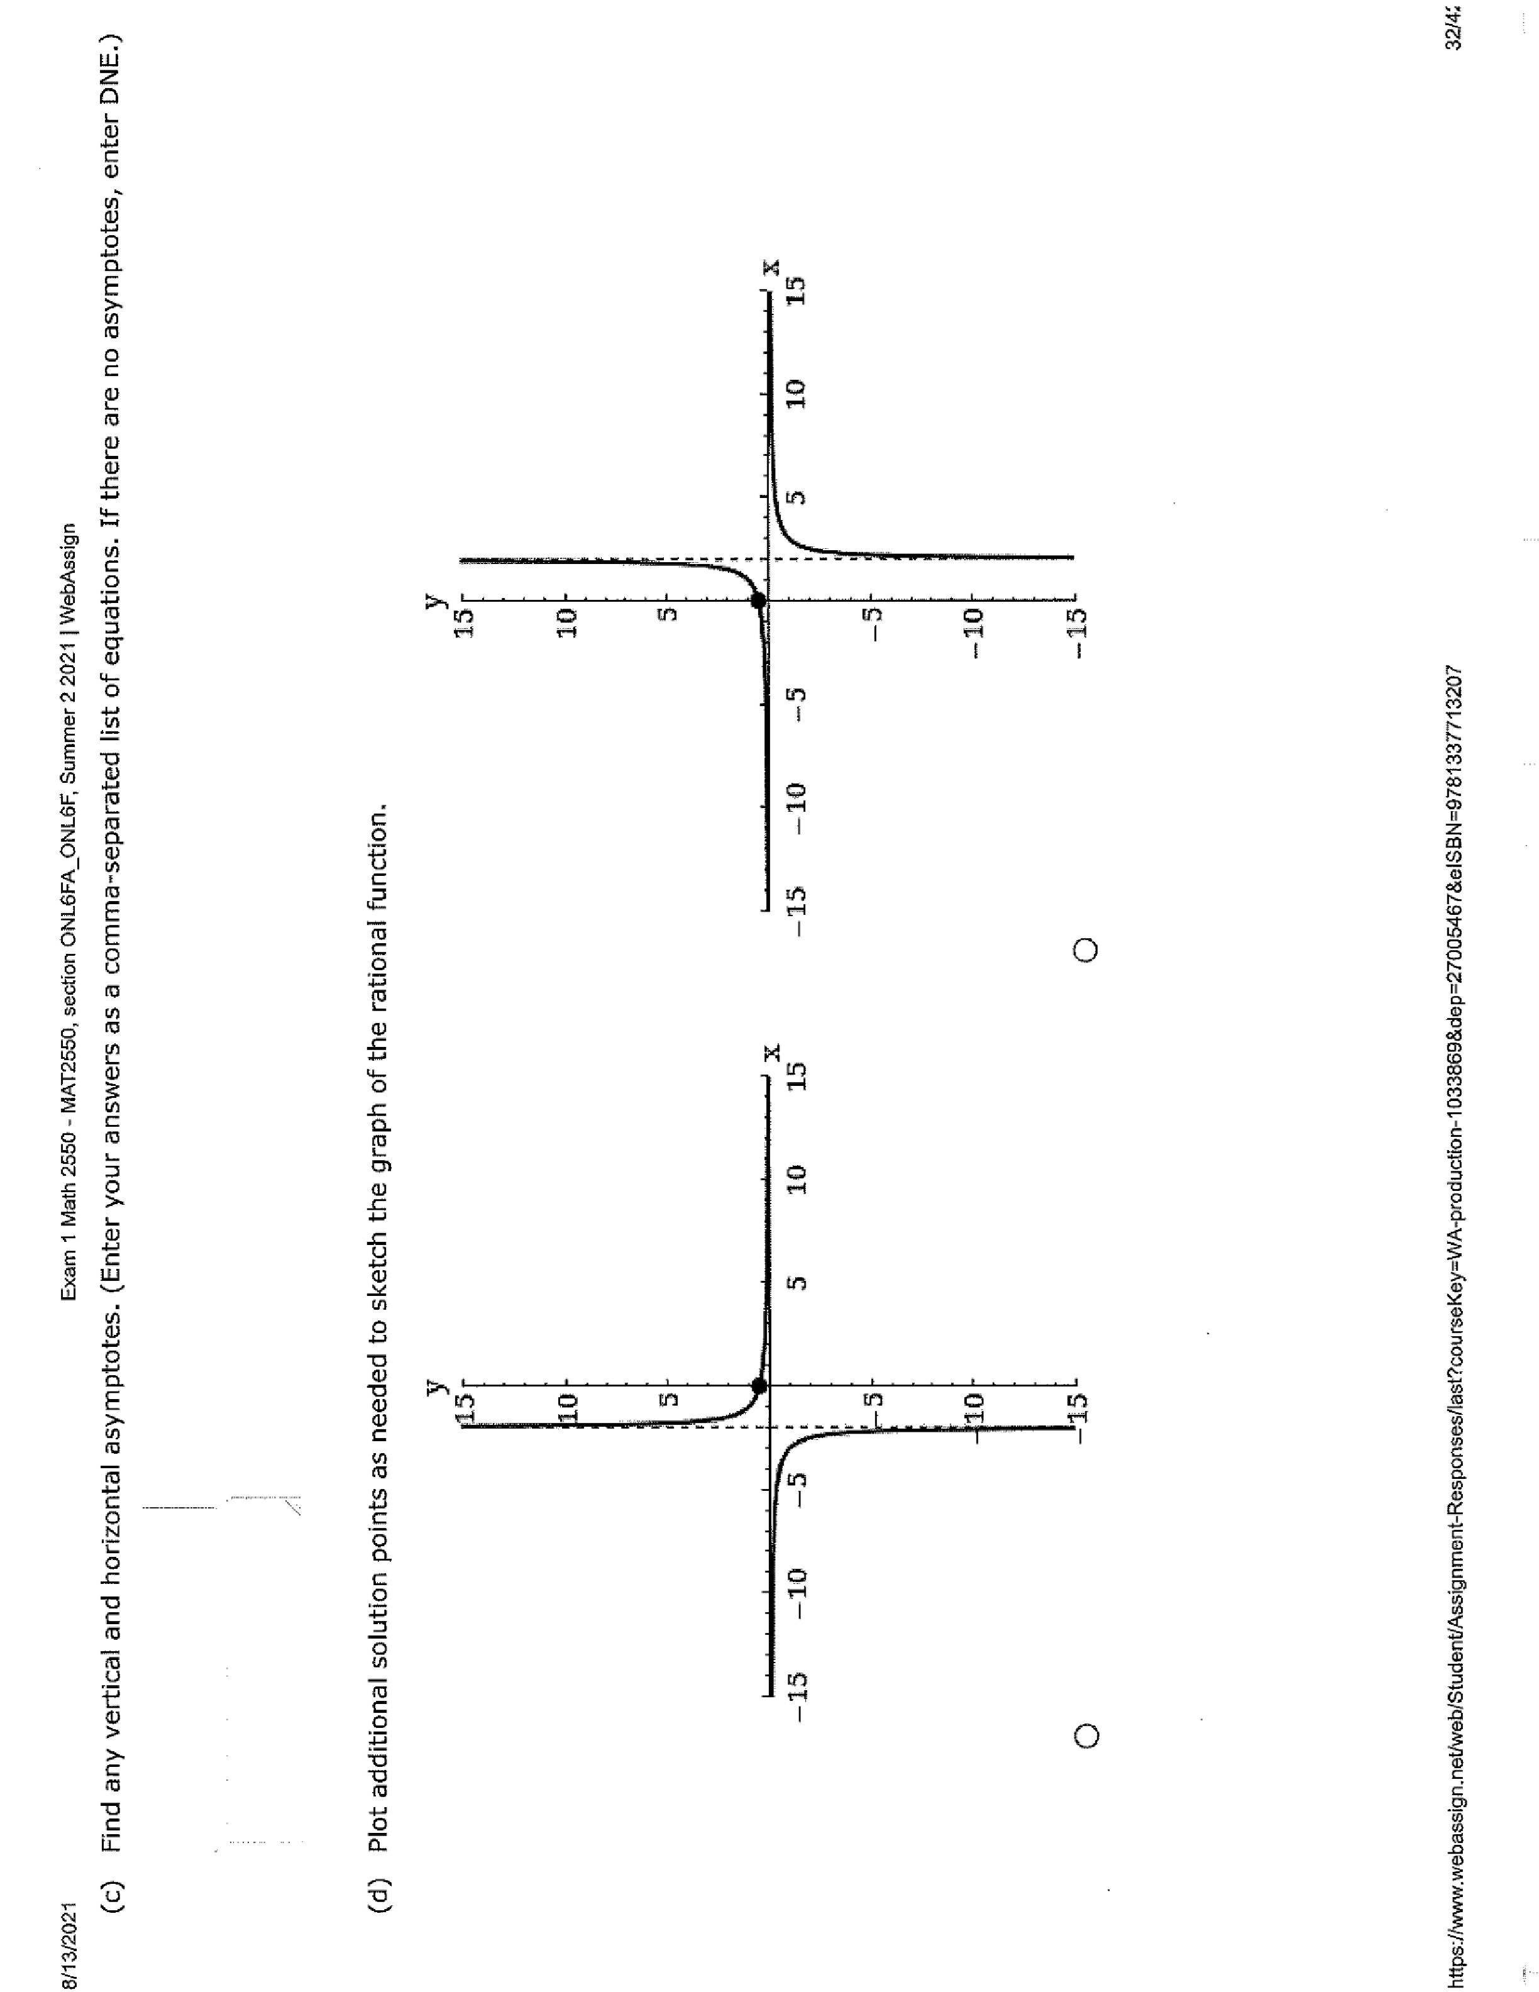
d)

20.
X | –2 | –1 | 0 | 1 | 2
F(x) | 25 | 5 | 1 | 0.2 | 0.04

(The first graph)
21.
Log₇( (2*7)/5)= 1
= 1 + log₇2 – log₇5
22. (–6, 6)

23.
a) x² +2x –3
b) x² – 2x + 3
d) ½x +3/2(2x–3)
= 1/2x + 3x/(4x–6)
Domain x for all real numbers
24. x = 29/2 = 14.5
25. f(x) = (x – 3)² – 5
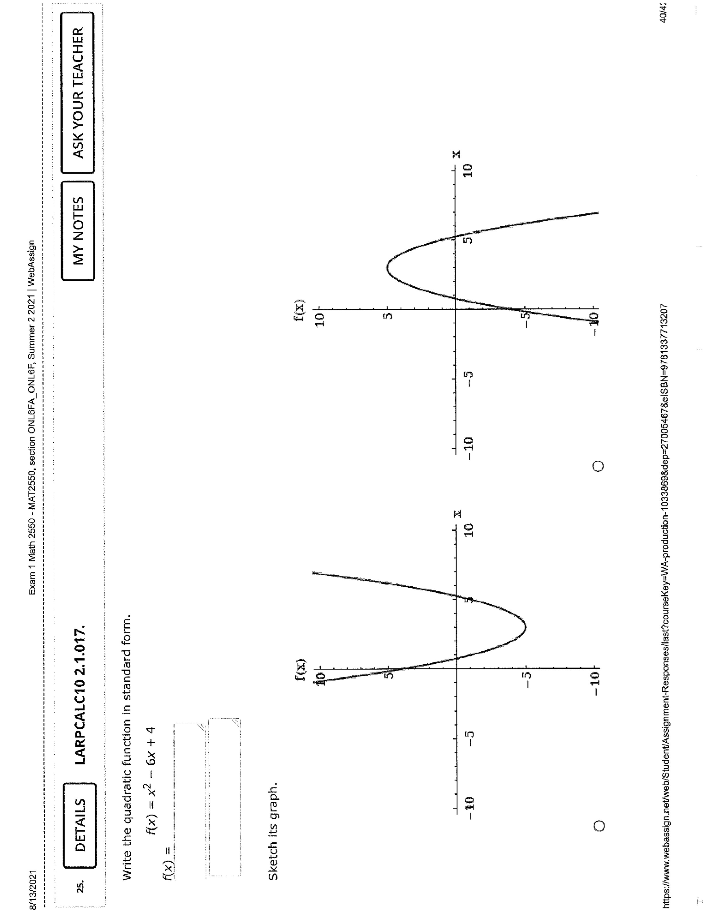
(The first graph)

Vertex = (3, - 5)
Axis of symmetry x= 3
X – intercept = (3 - $\sqrt{5},$ 0) and 3+ $\sqrt{5}$, 0)

