Abstract
Drones in recent years have undergone tremendous development. This maybe has been brought by the ease of using drones and the low price and drones have been utilized widely in many scenarios. However, as more and more drones are being used, they have the potential of posing to both public security and personal privacy great treats. These threats need to be mitigated and therefore anti-drone systems needs to be deployed. The anti-drone systems after being deployed in sensitive areas will localize, detect and defend against drones intruding. Counter-drones technology is also referred to as counter-UAS or counter-UAV technology. A new market is, therefore, emerging for the anti-drones system as threats posed to both military entities and civilian has been on the rise. In this paper, comprehensive anti-drone system technologies, market growth, how anti-drones are used, and anti-drone challenges will be provided. Besides, the security implications of anti-drones and the benefits of anti-drone systems will also be explored.
Introduction
Drones have been experiencing a growth that is very explosive in the digital world today and are used widely in many areas including monitoring of traffic, aerial photography, and management of disaster among others. Many researchers have been drawn in to the issue of drones with an intention to understand the path planning, attack detection, and their secure communication. However, prevalent drone uses have posed great threats to both personal privacy and public security. A good example is an attack carried out where an attacker straps explosive or other materials which are dangerous to a drone. Another example is where drones are used to spy private information of an inhabitant where a camera of high-fidelity is attached to the drones. These two examples show how drones can pose great threat. The frequency of these threats has been significantly on the rise and therefore, it is of great significance to ensure anti-drone systems are deployed into areas of sensitivity and geofencing-free. In these areas, an anti-drone system will adequately detect any drone when flinging in the sensitive areas and estimate its location for drone defence including controlling, detecting or jamming the drone that has been detected. To some extent, it has been a challenging task to detect drones since their size is small and flies at a low speed and a low altitude. Therefore, each anti-drone system must utilize its strength in order to detect the drones as they fly in sensitive areas. Examples of technologies used in anti-drone include audio surveillance, radio frequency (RF) surveillance, video surveillance, and radar surveillance. These technologies have the potential in detecting drones and localization and each should aim at improving on its strengths. An anti-drone systems performance depends on the kind of technology which has been utilized and their application scenarios also depend on the technologies utilized. Anti-drones system should maximize on these technologies to detect drones which are low flying.
These increased incidents involving drones have rapidly grown due to the scope of systems that use drones both in the civilian areas and on the battlefield. Drones have become a criminal tool because of their high availability. The use of drones has continued to be a threat to the citizens’ health and property and business functions. An anti-drone system will detect, alert, track and record the drone actions which are not authorized and reduce any risk of incurring any further losses. Anti-drones will also allow actions to be taken against the aggressor.
Background
The issue of countering unmanned aircraft has been given a thought by groups of the military for quite several years. A good example is NATO launching a ten-year study on how to defend against small, low, slow aerial targets by the use of defence systems that are ground-based in 2003. The threat that is posed by drones to both wartime environments and civilians is directly tied to the growth of C-UAS technology. In the domain of the military, small drones have been proliferating at a very high rate of alarming battlefield commanders and planners. A wide variety of drones are operated at least half a dozen groups in Syria and Iraq conflicts. Drones have been widely used by ISIS in guiding vehicle-borne IEDs to their targets more accurately. ISIS has even claimed to have used drones more than 200 times to carry out attacks in just 12 months.
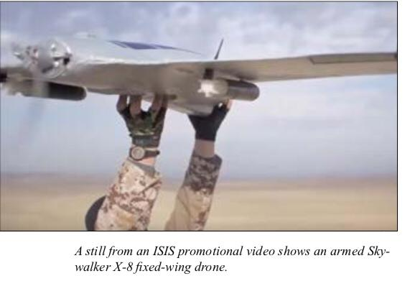
Many people worldwide have worried about drones being used domestically to scale terrorist attacks. Germany's Pirate Party in 2013 for instance flew a small drone close proximity to Angela Merkel at a rally that was open-air. This led to so much speculation about how drones are used with ease and could be used to attack a highly secured area. When it comes to the issue of drones, air defence systems are ineffective despite being given the mandate to traditionally protect airspace from aircraft which are manned. The anti-craft radars used by military are only designed to detect objects that are large and moving very fast and therefore are unable to pick drones which are small, slow and low-flying. It is ineffective to rely on visual observation so to detect drones and hence the need for the anti-drone system.

The technologies for surveillance and anti-drone systems
Surveillance Technologies
- Radar Surveillance
This surveillance technology is very useful when detecting and tracking a large aircraft. This technology however, when tracking and detecting drones, it faces severe challenges from the fact that across section drones have a low radar while they fly, they do so at a speed and an altitude which is very low. Nonetheless, this surveillance technology is very promising when drones are detected and tracked. To detect and track drones with very high accuracy, the micro-Doppler signatures obtained by multistatic radar needs to be analyzed so that there is an improvement on the clutter/target discrimination. The DJI Phantom 2 series of experiments revealed that the range of detection of radar rarely exceeds 300 meters. Radar has an electromagnetic energy which is very high and operates day and night since it is a sensor which is very active. Therefore, this technology may be very inappropriate or even forbidden to be deployed in an urban area which is crowded.
- Radio Frequency (RF)
Specific frequency bands e.g. 5.725-5.825GHz is the one being used for communication between the market existing or customized drones with their controllers for DJI Phantom 4. In a sensitive practical environment, however, Radio Frequency based drone detection becomes quite a challenge as there exist many RF signals including WiFi signals. Monitoring of a wide range of RF is one simple way of taking any unknown RF signals transmitter as a drone. The method induces a probability which is high of alarms that are false as the RF transmitter unknown is not necessarily a drone. Identifying drone media access control (MAC) is also a feasible method. This method however is capable only in detecting drones which have a MAC address which is open. Building and updating a MAC database of drones which is comprehensive gets more difficult as a variety of drones are ever-increasing. Besides, for a drone to avoid detection, the MAC address of a drone can be spoofed very easily. Extracting the RF signals spectrum feature is very promising and can be taken as the drone RF signature which is distinguishable even in urban environments. Other factors which should be taken into consideration include multipath and non-line-of-sight concerning the localization of drones based on RF signals, methods of localization based on received signal strength (RSS), and applicable measurements of DOA.
- Video surveillance
The detection of drones with the basis on video images is a problem of object detection essentially in the computer vision area and recognition of the pattern. The appearance feature which includes contour lines, edges, or colors can be used while detecting an object. Also, motion features of an object across its consecutive frames are used for detection purposes. There is a great difficulty when drones are being distinguished from other small objects that are similar based on appearance feature-based methods. An example is birds which are not in motion and are in a background which is cluttered. Motion-based methods which are also used in the tracking of an object can be used while comparing images which are consecutive, position and moving in the direction of a moving object. Therefore, the suggestion offered in distinguishing a drone from birds is merely looking at their patterns of flight. Often, birds fly in a pattern which is more random than a drone will fly. However, in a situation where the bird is gliding, then such a method ends up failing. In order for a drone to be detected, then it is promising for a combination of both appearance features and motion features which would facilitate higher accuracy detection. Object detection and tracking based on video images despite a lot of investigation I still suffering from issues such as occlusions which is not different from the case of detecting and tracking drones.
- Audio Surveillance
A system that has been equipped with acoustic sensors can be used to detect, classify, and localize drones. This is because drones have motors and propellers which rotate fast and whenever they are on a flight they generate sounds. The analysis in both time domains and frequency domains can be utilized in order to obtain the drones' acoustic signatures. For the detected drone location to be obtained, the direction of the acoustic signal of arrival (DOA) can be estimated by the use of array signal algorithms of processing. An example of this algorithm is the Multiple Signal Classification (MUSIC) and beamforming. The surveillance systems audio in terms of implementation requires a low cost. Audio surveillance is very sensitive when it comes to ambient noise and always suffers from a limited detection range. Therefore, audio surveillance always depends on the testing environment and the type of drone being used. The table 1 below compares the four drones’ surveillance technologies and is as shown here.
Table 1
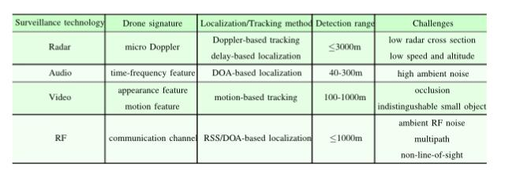
Anti-Drone Systems
In the existing literature, there are several available anti-drone systems both commercial and military. For example, Drone-Detector detects drone by audio-based and has the ability to detects drones with fixed-wing and rotary-wing. In an environment which has a background noise of less than 40Db, the detection range of Drone-Detector can reach 100m. Dronelabs also developed another DroneDetector with a reported 1km range of detection and used RF and audio surveillance technology. Another drone, Dedrone comprises of several products which include RF sensor, Drone Jammer, and DroneTracker. WiFi sensors, optical cameras and microphones are combined by DroneTracker and can detect a drone within 500m. All drones which are connected through RF and WiFi within 1 km can be detected by an RF sensor. In order to disrupt the communication of drones, RF signals at a multiple frequency bands through omni-directional antennas are transmitted by Drone Jamner. Rohde & Schwarz developed ARDROINS anti-drone system and based it on RF surveillance. An RF library for detection of drones was built by ARDROINS for the drones using both Frequency-Hopping Spread Spectrum (FHSS) and Direct Sequence Spread Spectrum (DSSS). ARDRONIS detection range can be from 1km to 2 km and depends on the transmission power of RF, the antenna gain, and the condition of radio. Besides, ARDRONIS can also realize the localization of both the drone and the operator through direction-finding. An integrated detection, as well as defence solution, is provided by DroneShield which utilizes audio, radar, video and RF surveillance to detect drones with the nominal detection range, which is 200m for radar, 600m for video, 1km for RF and 1.5 km for radar. In terms of defence of drone, DroneShield uses RF jamming in ceasing the transmission of the video to the operator from the drone. A distance of 2 km is the nominal jamming distance maximum. Another anti-drone system is Falcon Shield which utilizes radar, RF, and video surveillance in realizing detection, defence, and localization of drones. However, this system has no clear maximum effective range. AUDS is another anti-drone system which combines both video surveillance and radar where the system with radar can detect a drone with a distance of up to 3.6 km. On the other hand, AUDS with RF inhibition has the ability to defeat communication of drone at multiple bands of frequency like 2.4 GHz and 5.8 GHz and GNSS bands.
Table 2

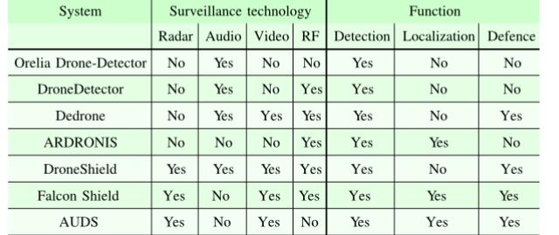 The above table illustrates the surveillance technologies which are utilized in already available anti-drones systems and most of these systems combine more than one surveillance technologies. The reason for this is because more than one technology offers for information and accuracy for detecting and localizing a drone.
How are anti-drones systems used?
In recent years, anti-drone systems have been subjected in certain application to extensive use. These systems have commonly been used on the battlefield where they ensure base protection and complement weapons existing which includes surveillance platforms and counter-mortar systems. Anti-drones systems are also seeing big demand in portable and mobile systems where they can be used to ensure the security of convoys and ground units. When it comes to the environment of civilians, the anti-drone systems have been used primarily at airports for airspace protection, VIP protection, used at prisons in countering smuggling operations, and used as security during sports games and even political rallies. Anti-drones systems will continue to be used and future applications will include port security, personal use in private property, and as a defence in sensitive facilities.
Anti-Drones Capabilities and Markets
Anti-drones have continued to becoming ubiquitous ranging from small models that are not expensive to systems which are large, complex and expensive operated by military groups. These systems can either be classified by their purpose, user and their technical and physical characteristics. In the modern digital world, anti-drones are serving a range of applications which are ever-increasing and are used by individuals, commercial organizations, agencies of government, military and intelligence organizations as well as academia. The list of users expands accordingly as more threats arise from new and affordable drones. There are very extensive uses of the number of uses the anti-drones systems can be put into. The classification of anti-drones systems depends on both physical and technical characteristics. This includes features which are distinguishable e.g. weight, size, surfaces and lift means., source of power, propulsion means, communication method, sensors and so on.
Growing markets for commercial and military anti-drone systems
In accordance with Polaris Market Research new study, there is anticipation that the anti-drone market by 2026 will reach over $3 billion. In terms of revenue, the defence and military segment dominated the market globally in 2015. In the forecasted period, there is an expectation that the global market will be dominated by North America. The drone misuse incidence which has been significantly rising is expected to drive this market as well. Drones have continued to be used by traffickers and smugglers for activities that are malicious and criminal. The outcome of their activities is an increased anti-drone system demand which will expand the market. “Other factors which will contribute to the growth of the anti-drone system market are increased investment in R&D and vast technological advancement where there will be both branded and customized anti-drones.” [3]
Cases of spoofing and cyber-attacks have increased significantly. Spoofing enables a drone radio signal to be hacked and taken control where commands will be sent from another control station to the aircraft. Cyber-attacks facilitate valuable data being stolen or deleted. Other registered complaints which involve the misuse of drones include mid-air near misses, snooping, smuggling, and burglary among many others. Valuable intelligence has been gathering by terrorists regarding their enemies. These factors have contributed majorly to anti-drones systems being adopted both in the military and by civilians. In the forecasted period by Polaris Market Research study, North America recorded the highest revenue in 2017 and is expected to have the highest revenue even in this period. In this region, the anti-drone systems market driving force includes increased incidences of breach of security by drones which are unidentified and terrorist activities which are on the rise. For instance, North America has been lately experiencing civil unrest and riots which have increased anti-drone system demands in the area. This region also is well known for spending high budgets for military expenditure and for development programs and research which augments the anti-drone system growth market. Defence and military sector just like 2017 is expected to maintain its lead during the forecasted period. The military sector demand for the anti-drone system has risen in order to monitor cases of smuggling, trespassing, spying and military base security. Adoptions of the anti-drone system are also needed to monitor border security and neighboring countries threat.
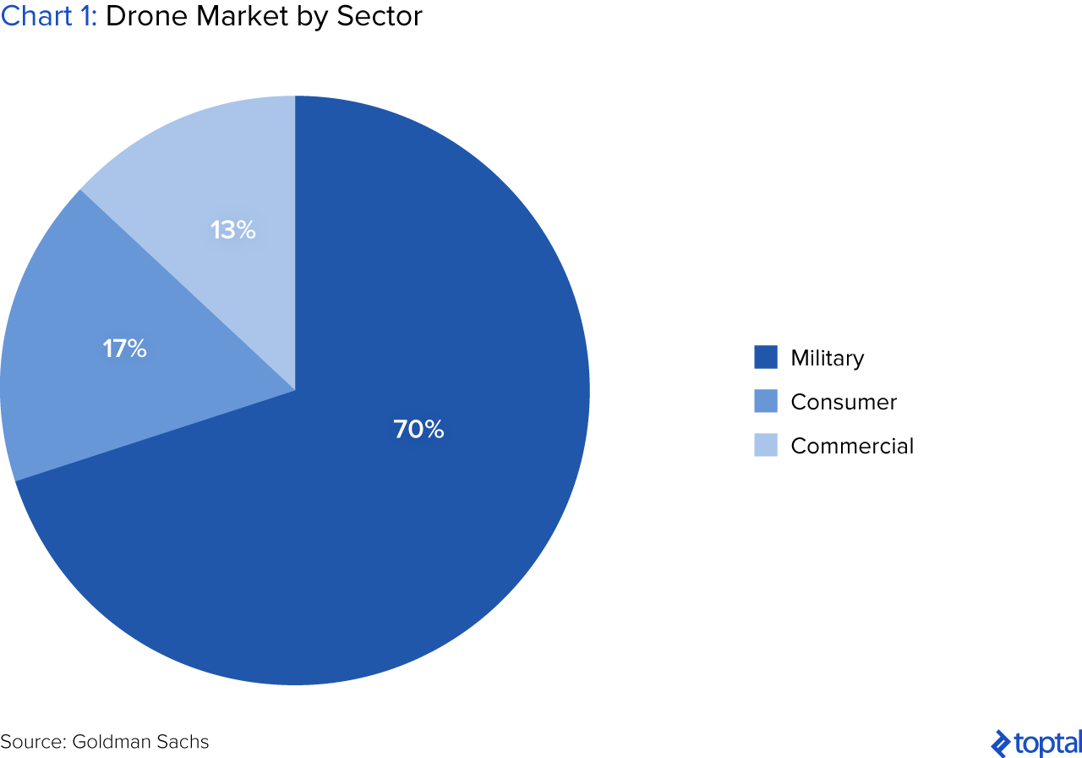
The chart shows the drone market by sector which reflects anti-drone system as well.

Market Leaders
Presently, the military anti-drone market leader is the United States of America followed by Israel. On the other hand, China leads in the production of non-military anti-drones systems and are used more even by non-civilians applications. The United States has been experiencing steady growth and by 2035, drones will approximately account for half of the military aircraft in the country. The country has also loosed rules for export of drones and therefore US companies can directly sell drones to a wider market. Israel is the largest exporter of an anti-drones system for military and sells to the United Kingdom, China, and India. It is estimated that 78 countries are using anti-drone system due to increased threats posed by use of drones and therefore the need to track these drones. Many countries have continued to adopt the use of anti-drone systems as threats have continued due to terrorist activities. It is, however, worth to mention that, not all large-scale anti-drone systems users are manufacturers. Commercial anti-drones are used by countries in order to counter contraband and illegal goods which are transported.
Anti-drones system industry trends
The latest technology evolution is enabling anti-drones systems to spread their wings across many sectors. These were only available for purposes of the military some years ago and their power is often used in harnessing their power across many applications. While drones are filling our skies, the anti-drones system will also be a common thing and more investments will be made and this will be a game-changer in the industry as technology innovation continues to be revealed. Anti-drones will be significantly used to combat crimes and security threats as more drones continue to be used. Many countries will soon realize the threats that can be avoided by the use of the anti-drone system. Few years to come, massive investments will be made by many countries toward exploring the full benefits of anti-drones systems.
Challenges of anti-drone systems
Challenges come along with anti-drones systems particularly in their performance level, policy, practicality and legality. Therefore, these challenges should be considered by any group planning or hopping into using these systems as well as those establishing the role technology plays in drone's integration into the airspace. These challenges are described below;
- Distinguishing between legitimate and illegitimate drone
Anti-drones systems will soon be required to be able to differentiate between drones which are legitimate and the ones which have the potential of posing a threat. This will soon become the case particularly in an environment where legitimate drones are commonly used. An example of this environment is a football stadium where drones are used as security surveillance and have zero probability of posing a security threat. In such an environment, anti-drones systems should be able to recognize these drones from an intruder drone which is rogue and is flying with malicious intent. Presently, despite the technological evolution there exist no anti-drone system which is capable to differentiate between peaceful drones and the ones which are malicious commercially. Besides, this is the same case in the military domain and the anti-domain system used since they cannot tell the difference between a drone that is allied or an aircraft which is unmanned and could shoot friendly drones by accident.
- detection effectiveness
There are always some drawbacks associated with any system. Many of consumer drones are very small and it becomes very hard to detecting them since they tend flying at low altitudes. Systems of electro-optical on the other hand only operate during the day-time and to a large extent might confuse a drone with a bird or even an airplane. IR systems, EO and RF systems require to have a line of sight which is direct with the drone intruding. A library of sound which is emitted by drones which are known is what acoustic sensors rely on and in case of a drone which is not covered in the library, they are therefore deaf. Certain frequency bands in the library are only detected by the RF detection system and require a regular update. RF detection systems, therefore, are less effective whenever a drone is operating out of their direct line of sight of the sensor. Drones are emerging on the market and proliferating at a vast rate and even with updating of libraries often, 100 per cent of drones operating at a certain given time might not be covered.
- False negatives and false positives
Low levels of false negatives and false positives must be generated for the anti-drone system to be useful. This scenario is very difficult to achieve as it requires the system elements to be sensitive enough and detect all drones which are operating within the area of use. However, too sensitive systems may create a number of false positives in an overwhelming number and render the system unusable. False negatives are also created by systems which are not sensitive enough which even form the standpoint of the operator is less desirable.
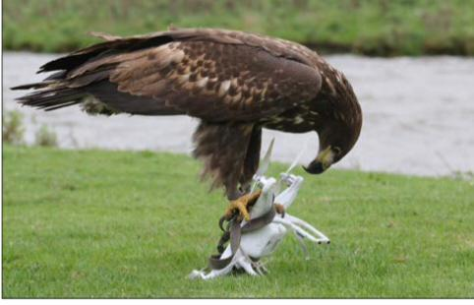
- Lack of standards
In designing and use of anti-drones systems, there are no international standards which exist. This is a very important issue which needs to be addressed as the way it is now, these systems when designed they will have variances which are significant between their reliability and performance of the system. Safety questions are also raised due to the albescence of standards. A public safety threat can be presented by an anti-drone system which is malfunctioning in the civilian environment. An example is a jamming system which interferes with emergency radio communications or a kinetic system which misses its target. Besides, not all the anti-drone systems are as effective as seen from the advertisements. Many of these anti-drone systems have not had enough time to mature since their technology just erupted a few years ago. Many companies are not properly maturing their systems or field-testing them and are just only appearing capitalizing on their growing interest in this technology. The Department of Homeland Security System Assessment and Validation for Emergency Responders Program in 2017 recommended only 13 anti-drone systems showing many of these systems fail to perform to satisfactory levels.
- Interdiction legality
Interdiction systems in many countries including the United States have a common drawback which is that there is a high chance they are illegal. In many countries which are developed, it is illegal or it is restricted in signal jamming devices with inclusion of more directed systems which are advanced. The White Act in the United States of America, for instance, is violated by jamming systems which forbids electronic communications interception. The provision of the White Act was enacted way before use of anti-drone system became common but despite this, the act covers the communication between the operator and anti-drone system. The law might also be violated by systems which merely detect and track the anti-drone system when they download information concerning the location and telemetry.
The United State Aircraft Sabotage Act may also be violated by both kinetic and non-kinetic systems. This Act imposes heavy fines and to some extent prison sentences. This applies even to anti-drone systems which are defined as “aircraft” by FAA and by electronic means, it will be illegal.
- Interdiction hazard
The drawback which is most obvious when it comes to the anti-drones system is that they are dangerous. Drones will fall to the ground at a considerable speed when their flight is interrupted by any physical means. “Therefore, kinetic interdiction systems will be no appropriate for use over crowds and only liked to be limited in remote areas or military basement.” [1]
Conclusion
In conclusion, technology has made it for more drones to continue being used. These drones have become faster, smaller, cheaper and deadlier as well as the ability for adding a payload. This calls for necessary countermeasures to ensure the threat posed by these drones is dealt with accordingly. Wide arrays of threats are posed by drones to both public and national security. This has demanded the growth of anti-drones systems which are flexible, and multi-layered. Anti-drone systems technologies have also significantly evolved to counter the threat posed by drones by ensuring customized anti-drones systems are produced. This has led to a wide range of technologies being used in anti-drone systems which includes radar, audio, video and radio frequency (RF) surveillances. There are many anti-drone systems available in the market today which apply more than one combination of these technologies. These systems are extensively applied in many scenarios and have a big capability and their market continues to grow as the drone industry grows. However, despite the good things brought by anti-drone systems, they have some challenges which include detection effectiveness, interdiction hazards, and legality interdiction among many others.

REFERENCES
[1] A. H. Michael, “COUNTER-DRONE SYSTEMS”, February 2018
[2] S. M. Saeed, C. A. Balanis, Life Fellow, IEEE and C. R. Bircher, “Radiation of Flexible Reconfigurable Antenna with Curved Cylindrical Configuration”,
[3] W. Zwijnenburg and F. Postma, “Unmanned Ambitions: Security Implications of growing proliferation in emerging military drone markets”

