1.
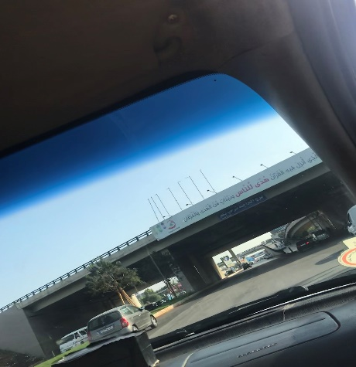
The month of Ramadhan [is that] in which was revealed the Qur’an, a guidance for the people and clear proofs of guidance and criterion. So whoever sights [the new moon of] the month, let him fast it; and whoever is ill or on a journey – then an equal number of other days. Allah intends for you ease and does not intend for you hardship and [wants] for you to complete the period and to glorify Allah for that [to] which He has guided you; and perhaps you will be grateful.
2.

It says that the month of Ramadan is to learn to be patient and equal
3.
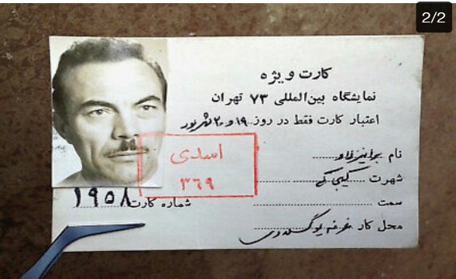
This is not Arabic, it is Iran language.

4.

This is not Arabic but Israel language.
5.

II didn’t know the translation for this one.

6.

Special Forces
7.
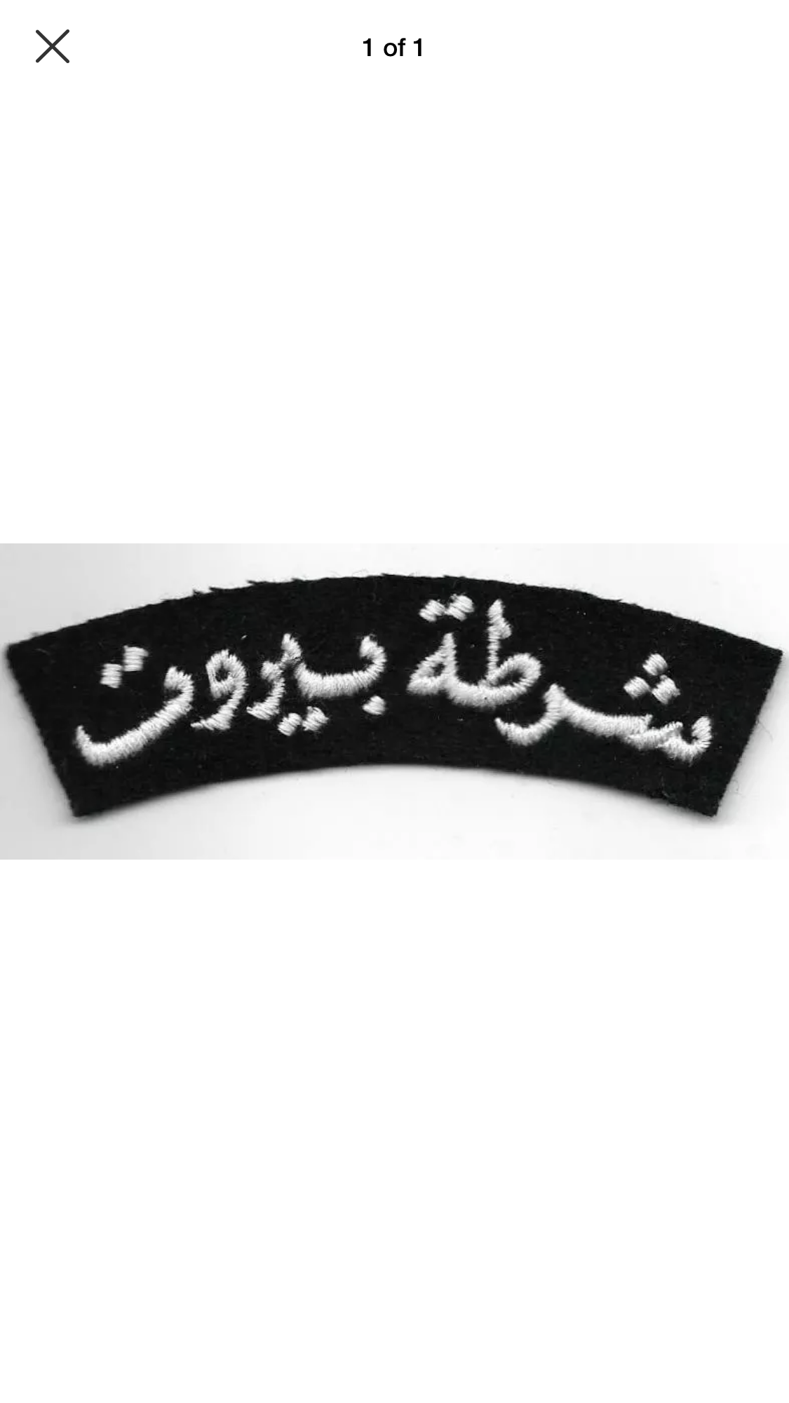
Police of Beirut

