ART

Student's name
Course name
Instructor's name
Date submitted

Part 1: scavenger hunt

Image Name: Century Vase

Year of make: 1877
Artist: Karl L. H. Müller
Origin: American
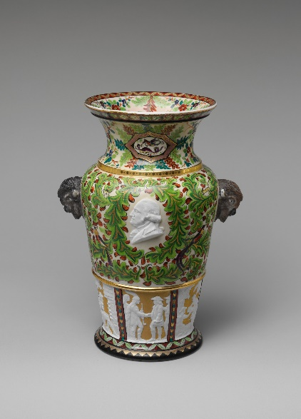
The art on the phase is unique; the structure and the colours used were amazing. The colour is one thing I liked about this art. The combination of green and brown colours gives the phase a natural feel making it unique. The phase handles also caught my attention, and the unique art has parrot head as handles. The grey coloured parrot head art adds glamour to the art making it more unique. Another important feature I liked about the art is the images of people on the base of the phase. Adding a white colour makes them more visible to the observer making the combination of the art amazing.

Image name: Broken Eggs

Year: 1756
Artist: Jean-Baptiste Greuze
Origin: French
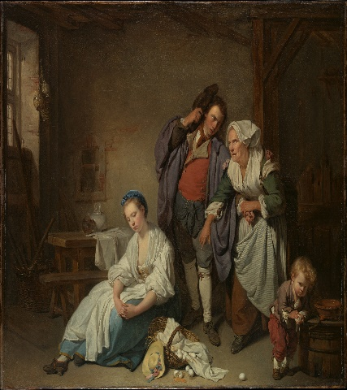
Broken eggs art is unique, and the name makes one want to understand more about the art. The image of people that look like a family is vivid in this art. The best part about this part showed the family with an angry mother after eggs have been broken. The youngest member of the family seems to be scared of the mother's wrath after the eggs have been broken and lying on the ground. Another interesting thing I see is that the family man is seen to stop the mother from punishing the girl for breaking the girl. The girl as well seats on the floor and is sorry for breaking the eggs.

Art name: Dress

Year: 1860–1865
Origin: American
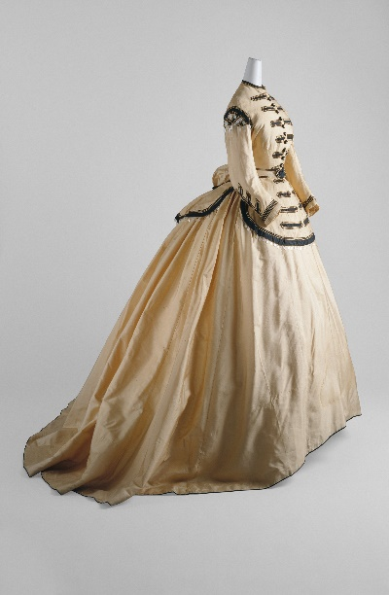The art of a brown dress with black decorations on the upper part. I like the design of this dress, especially the unique decorations on the chest. The black buttons on the front bring some glamour to the dress, making it very beautiful and unique. The length of the dress as well as notable and shows some sense of royalty (Doe Stone, 2020). The unique feature that I have noted is the lengthy hand, and the dress's collar neck is very amazing. The other unique and notable feature is the decorations on the upper part of the dress. This makes the dress more beautiful, as well as exceptional.
Part 2:
Artist choice: Edouard Manet

Art name: Boating

Year: 1874
Artist name: Edouard Manet
Origin: French
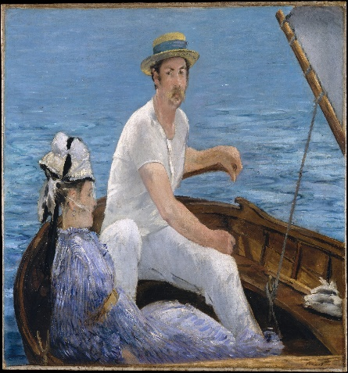
The image is an artist painting with two people on the boat. I notice a lady seated on the boat. The lady is seen wearing woollen clothes and a woollen hat as well. The hat is seen to have a black hanging woollen extension as well tired on the head. The lady has a blue dress with a brown belt on her waist. The man seated next to her is in white clothes and a brown hat on his head with a blue ribbon on the hat. The boat is as well seen to be in the middle of the sea, and the sea as well is seen to be blue.
The artwork may have some hidden meaning. The name of the art is descriptive, and the boat is that name as seen on the art. The two people seen in the art are on a boat. The art could represent the people on the boat, either going fishing or just crossing the waters. The lady on the boat is seen to be relaxed as if they were out for fun on the waters. On the other hand, the man is seen to be having a conversation with the lady. This could mean that they did not have any serious schedule on the boat but rather out for fun.
My main concern could be why they are on the boat with no main agenda like fishing on the water. I wonder why people would be out on the sea to have a conversation on the boat. The sailor and the lady may be at leisure or just having a conversation in a safe, quiet place. The sea waves tend to be peaceful, and hence they prefer the place.
According to the artist, this was the sailor's image and an unidentified lady out on the sea. The sailor was his relative, and hence he knew him on a personal level (Рыков, 2020). The sailor was having fun and on a leisure boat ride with the lady. The colours used and the diagonals were of Japanese print origin. My main concern is why the sailor chose boating for leisure instead of a place he is not used to be. The sailor was introducing the lady to his day to day life which is the sea work and boating.
Part 3
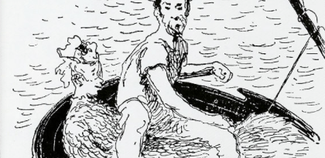a sketch of the boat painting.
Having a clear image of art by sketching is different from just copy. The drawing of each diagonal adding the colours and glamour is as well very fulfilling. This gives one a sense of belonging and understanding better. When doing a sketch, one can note every corner and line they may have not noted during the copy and studying the painting. In my opinion, sketching made me realize some part of the art I had not noted, like the vessels on the boat besides the sailor.

References
Doe Stone, E. (2020). American Art at the 1897 Stockholm Exhibition. Konsthistorisk tidskrift/Journal of Art History, 89(4), 231-248.
Рыков, А. В. (2020). Absent Look. Edouard Manet and Timothy Clark’s Theory of Modernism. Вестник Санкт-Петербургского университета. Искусствоведение, 10(2), 266-273.

