Wooden Bowls
Student:
Institution Affiliation:

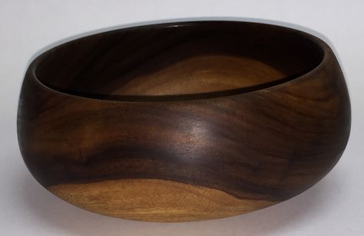
Wooden Bowls
The image above is a Kou Wood Calabash bowl hand carved by a certain local artist of the Hawaiian Islands. The bowl is made from the rarest wood known as Kou which grows in the coastal region of the Hawaiian Island. The image size is 6 1/2 × 2 ¾”. The color of the image is beige-brown which is most common in the Hawaiian Islands. Kou Wood Calabash bowl is found in the Phoebe Hearst Museum of Anthropology. This particular museum mostly has the finely carved wooden bowls, trays, and flatters. Kou Wood Calabash bowl was collected in the year 1902 from the Hawaiian island. The bowl initially was owned by the local artists in the Hawaiian Island.
Reference
Size 6 1/2 x 2 3/4". Kou Wood calabash bowl hand carved by a local artist of the Hawaiian Islands. Kou is considered a rare wood. It grow? | Wood Bowls | Pinterest | Wood, Wood turning and Wood bowls. (n.d.). Retrieved from https://www.pinterest.com/pin/499266308674642103/

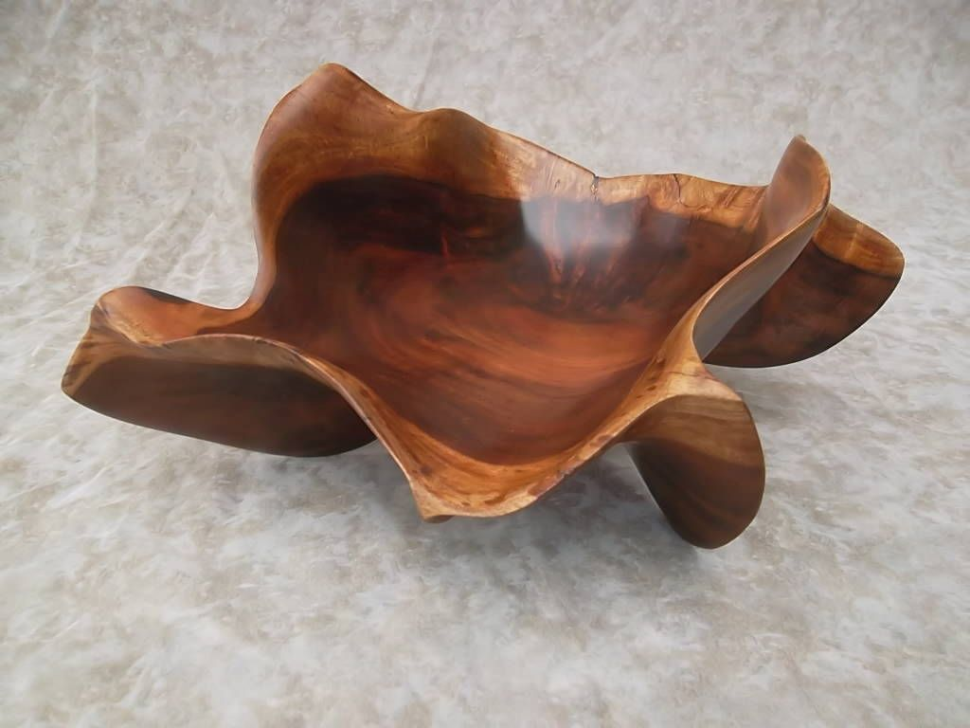
The above image is a picture of the Ocean Harmony Bowl which is made from the milo wood. The Ocean Harmony Bowl is of size 20138×15×12.5 inches. The color of the image is beige-brown which is common in all Hawaiian milo wood bowls. The color of the image is beige-brown is also found in the Phoebe Hearst Museum of Anthropology. It was collected in 1905 from Hawaiian Island.
Reference
Ocean Harmony. Hawaiian Milo wood, 20138 x 15 x 12.5 inches Valentines Day is February 14, find your gift at www.derekbencomomauiartist.? | wood idea | Pinterest | Wood art, Wood and Wood carving art. (n.d.). Retrieved from https://www.pinterest.com/pin/788059634765726375/
The artist made it from Kou tree since the wood grains were soft and even relatively easy to cut. Kou Wood Calabash bowl was mostly used as a food bowl. To remove the bitterness in the Kou wood, the artist soaked the bowl in the sea water. Sweetening of this bowl was done by the application of fermented taro or what is known as sweet potato. Polishing of the bowl was done using pumice or even shark skin and later rubbed to a very high gloss with nut oil. The important of the coating was to provide waterproof to the wood which made the bowl lifespan longer than most of the artists expected.
Kou Wood Calabash bowl was mostly used for serving poi which is the traditional Hawaiian staple food. Poi is usually made from taro roots which have been deeply boiled or even steamed. This staple food is mostly observed in a liquid state and sometimes is usually fermented hence Kou Wood Calabash bowl becoming useful. Mostly, Kou Wood Calabash bowl was used by the chiefs to make Poi. Other members of the community used other gourd bowls and cups (Lowell, et al., 2017).
The Hawaiian Milo wood bowl, on the other hand, was used for storing poi. Serving and also salting meat including large fish, dog, and pork. It was also used for storing feathers and tapa cloth. Particularly, this bowl was used to store food for chefs and loyalty. The Hawaiian community never used metal tools during the ancient time hence the excessive utilization of these wooden bowls. The bowls could store both hot and cold poi and other food substances due to how it was made by the local artists. The artists were much respected due to their good work (Lowell, et al., 2017).

References
Hawaiian Poi Bowls – Phoebe A. Hearst Museum of Anthropology. (2018, February 21). Retrieved from https://hearstmuseum.berkeley.edu/hawaiian-poi-bowls/
Lowell, E. C., Wilson, K., Wiedenbeck, J., Chan, C., Friday, J. B., & Evans, N. (2017). Consumer preference study of characteristics of Hawaiian koa wood bowls. BioProducts Business, 42-51.

