Q1
Use the HDR source calibration worksheet to calculate the source strength on the day of measurement and compare with the value stated on the source certificate. In your answer booklet show your workings
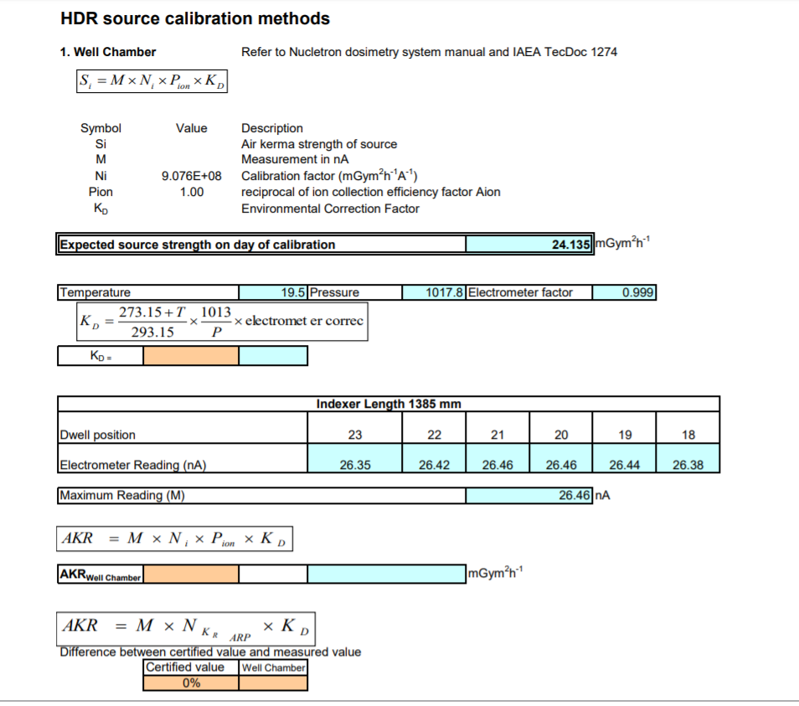

Q2
Consider a prostate treatment that involves the implantation of around 15 needles. The source is required to step thorough these needles delivering a total dose to the prostate which is prescribed by the radiation oncologist. Describe each of the uncertainties associated with such treatment and discuss suitable margins that you think might be appropriate to account for these uncertainties. Your answer should consider the uncertainties in the parameters used in the TG-43 formalism along with any other errors that you think may impact on the ability to accurately deliver the prescribed dose.

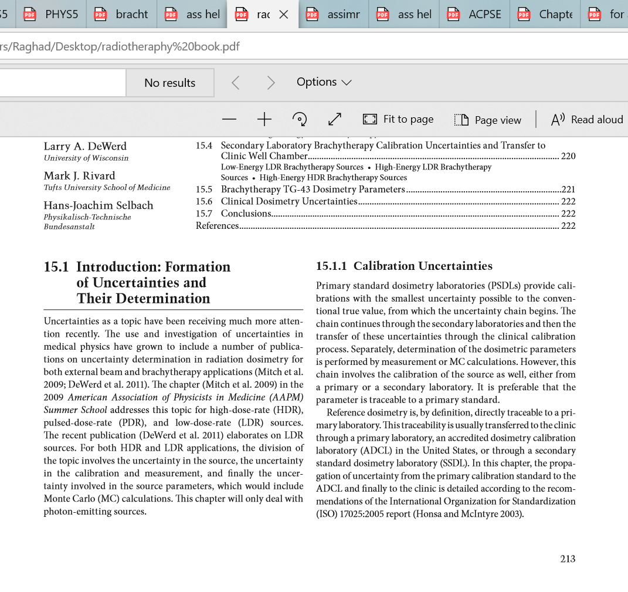
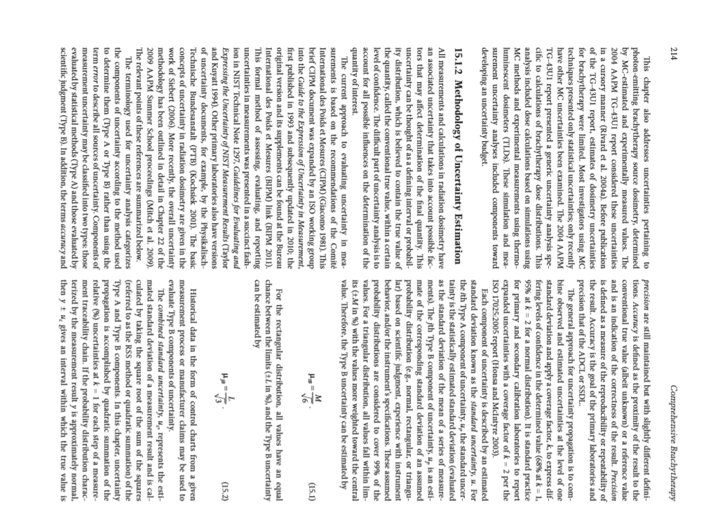

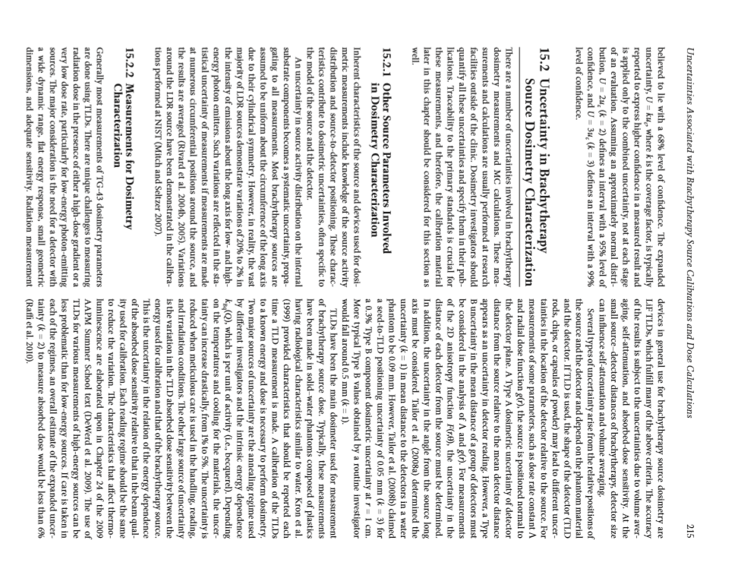
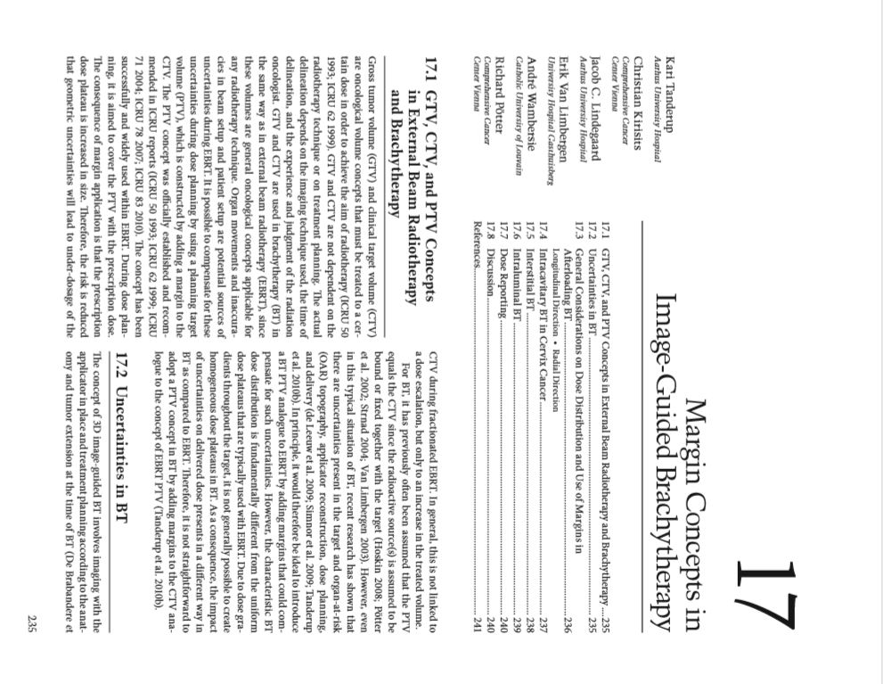

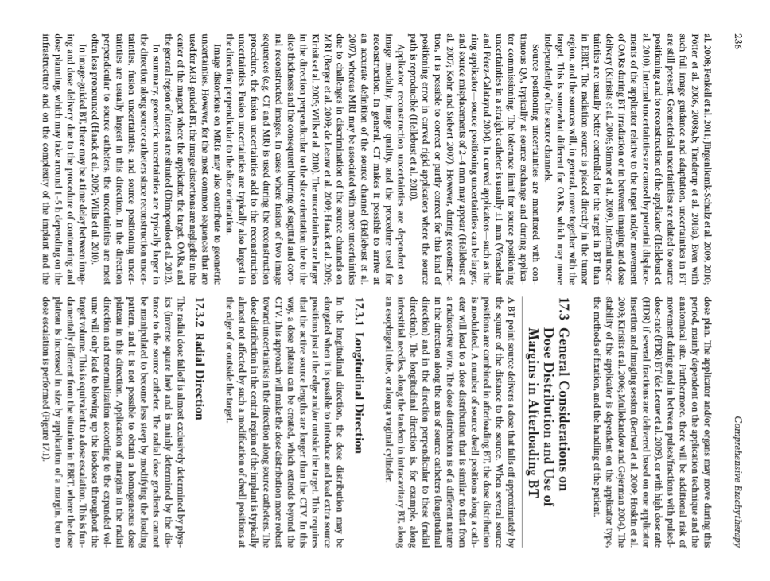

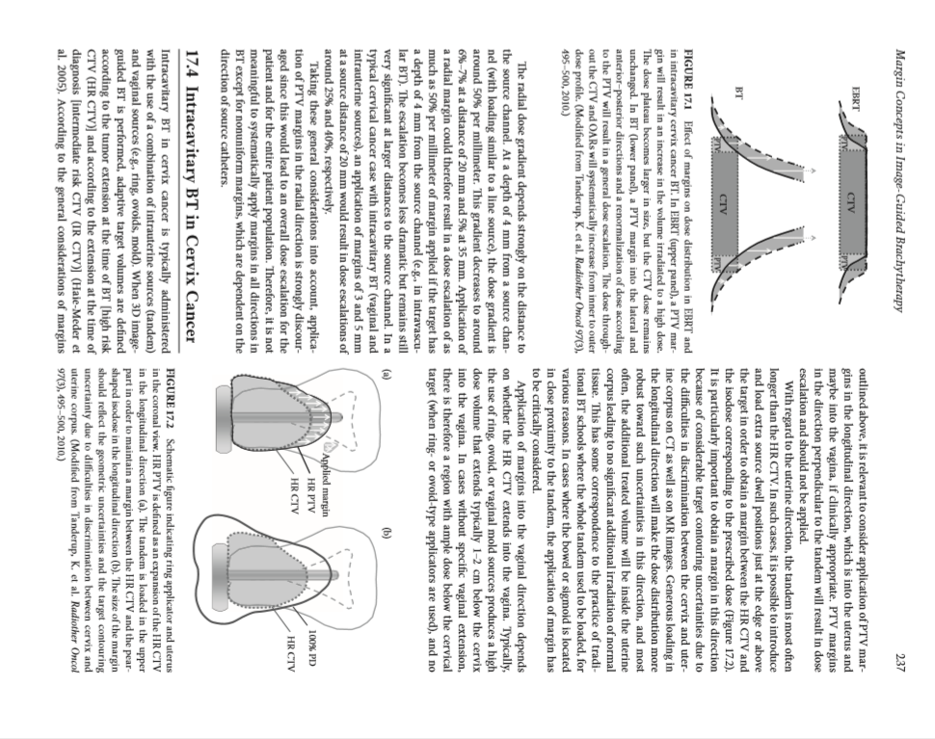

Q3

Review Section VI of Comprehensive Brachytherapy – Physics and Clinical Aspects, Edt. Jack L M Venselaar et al, Taylor and Francis Publishers (CRG Group), 2013 http://opac.library.usyd.edu.au:80/record=b4964596~S4) and discuss the advantages and disadvantages of 3D treatment planning for cancer of the cervix compared with the recommendations of ICRU 38.
