MT. SAN ANTONIO COLLEGE
CISB11
ACCESS DATABASE ASSIGNMENT
Part 1

PURPOSE:

This assignment will help you become familiar with the use of a database management system, specifically Microsoft Access 2007.

With this assignment you will:
Add to an existing database in Microsoft Access.
Learn some of the terminology used when working with a database management system.
Answer questions related to the database.
Expand your knowledge of Graphical User Interfaces (GUIs).

ASSIGNMENT:

1. If you are not doing this assignment at Mt. SAC make sure you are using Access 2007. You cannot use previous versions of Access to complete this assignment. If you are doing this assignment in the lab, remember that you need a blue print card to use the lab printer.

Make sure you have already copied the CDCAT Access file onto a storage device or saved it to your computer’s desktop.

2. To access Microsoft Access:

Click the Start button on the bottom left corner of the Taskbar.

Select "All Programs" on the Start menu, then select the "Microsoft Office" folder. Next, select the Microsoft Office Access 2007 application.

3. The initial Microsoft Access screen will be displayed. Let’s retrieve the CDCAT file from storage. The instructions below are assuming that the file has been saved to a flash drive. If the file is in any other location, you will need to take the appropriate steps to open the file from where it was saved.

At the top-left corner of the screen select the Office Button. It is a round circle with a multicolored logo.

A drop-down menu will appear. Click the mouse button on the word Open.

A dialog box will appear. Make sure that the “Look In” textbox indicates the location of your flash drive. If it does not, click the down arrow to the right of the Look in text box and select the location corresponding to your flash drive. Choose CDCAT by clicking on it, then click on the Open button in the bottom-right corner of the window.
4. The screen now visible is called the database window. An example of this screen is shown below. The database window contains the same interface design as other Office 2007 applications, including the Office Button, Quick Access Toolbar, Tabs, and the Ribbon. If you have not yet completed the Word Assignment, you may want to do so in order to become familiar with the new design of the Office 2007 user interface.

Office Button
Quick Access Toolbar

Tabs

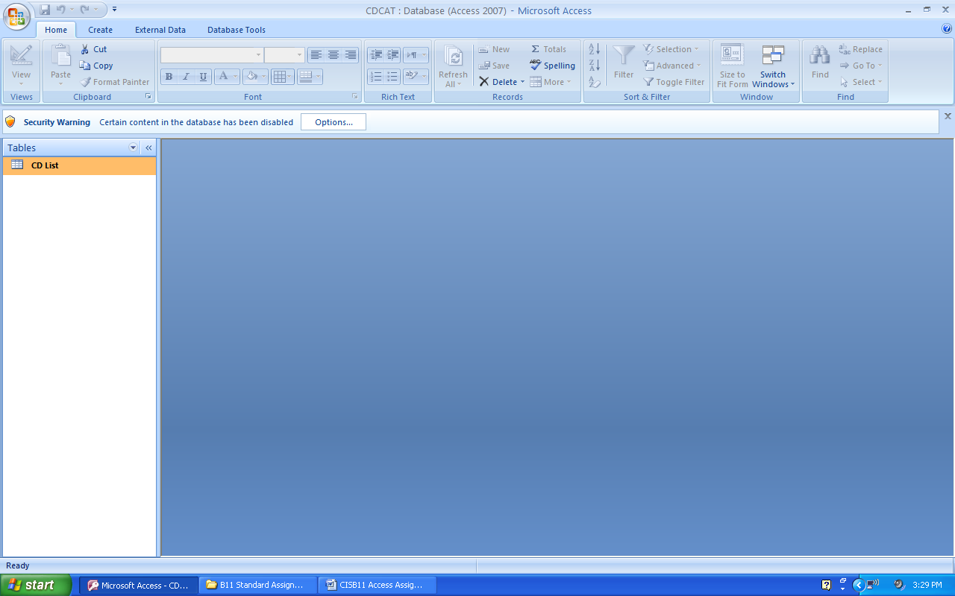
Navigation Pane
Ribbon

5. By default, the Access Window displays the Ribbon corresponding to the Home tab. Review the tool buttons available on the Home Ribbon. Next, select each of the other three tabs (Create, External Data, and Database Tools) and review the tool buttons available within each Ribbon.

6. A database management system (called a DBMS) is used to store lists of data such as names and addresses, inventory records, or even a list of your CDs (Compact Disks). These lists are often stored in database tables. Tables are just one type of database object. Other common objects are queries, forms, and reports. Queries allows you to ask questions of the database. Forms are used to display a form for easier data entry. It shows only one record of a table on a page. Reports display customized reports.

7. The objects contained within a database are listed in the navigation pane--which is located on the left side of the database window. The top of the navigation pane indicates the type of objects currently being displayed. An Access database opens by displaying table objects by default. The CDCATdatabase only contains one table—named CD List.
8. To view other database objects, select the down-arrow at the top of the navigation pane.

Select the Queries, Forms, and Reports categories to view the objects available within
each of these categories.

Select the Tables category once again so that the table CD List is displayed in the
navigation pane.

9. To open a database object, double-click on its name within the navigation pane. Open the CD List table. Notice that a new “Datasheet” tab appears at the top of the Access window. Select this tab and review the tool buttons available within the Datasheet Ribbon.

10. There are two ways of looking at a database table: Datasheet view and Design view. Datasheet view allows you to view and edit the data within the table. Design view allows you to view and edit the design (or structure) of the table. You are currently in Datasheet view. To display the Design view select the View button located at the far left side of the Ribbon.

11. Notice that the Datasheet tab changed to a Design tab and that the Ribbon changed to display tool buttons that correspond to design tasks. To switch back and forth between Design view and Datasheet view, simply click on the View button.

12. Read and become familiar with the following terminology that is associated with databases.

DBMS – a software package used to create and manipulate data in databases. For example, Microsoft Access is a DBMS.

Relational Database – a type of DBMS that uses tables to associate (or relate) tables to each other.

Table – a collection of data with the same subject or topic, such as a list of CDs.

Record – all of the information for one thing, such as one CD.

Field – a single characteristic of a record, such as the CD Title or the Producer’s Name.

Key – a field, or collection of fields, whose values uniquely identify each record in a table.

13. CDCAT is a database that has already been created for you. CD List is a table containing a list of CDs. With this table, you could maintain a list of your CDs.

Display the Design view of the CD List table. You know that you are in Design view when the tab under Table Tools is Design. Notice the 3 columns in the Design window. The titles of the three columns are Field Name, Data Type, and Description, respectively. The first column contains the name of each field in the DB. The second column contains the type of data to be found in the field, such as text, numbers, currency, or date/time. Text contains alphabetical and numerical characters, such as a name or address, or even a CD number. Number fields contain numbers that will be used in some calculations. Number fields cannot have any alphabetic characters in them, while text can have numbers, letters and even special characters, such as the & or the # sign. Currency is a special type of number that is used to hold money amounts. Date and time fields contain full dates or times and can be formatted in one of several date or time formats.

Notice the 5 rows. If you can’t see all 5 rows of information, use the scrollbar on the right to view all of the rows. Each row describes a different field in the record. For instance, CD Number is a field in our record.

Answer question 1 on the Answer Sheet and then return here.

At the bottom of the screen is an area called Field Properties. This area further describes the current field above. The current field is indicated by an orange square to the left of the Field Name. The Field Properties will tell you the length of the current field (Field Size), as well as other information such as what should be automatically put in the field if nothing is entered (Default Value) and whether a value must be entered into the field. (Required).

You can change the current field to another simply by clicking the mouse pointer somewhere in the row of the desired field. Make sure that CD Number is the current field. If it is not on the correct row, click the mouse pointer somewhere in the first row (CD Number). Now look at the Field Properties list at the bottom half of the screen.

Answer question 2 on the Answer Sheet and then return here.

Make Year Created the current field by clicking on it with the mouse.

Answer questions 3 and 4 on the Answer Sheet and then return here.

For numbers, the type of number is listed for the Field Size instead of its field length. An integer is a whole number with no decimal portion. A double is a number with decimal portions included, such as the number 15.055.

Click the View button to display the Datasheet View.

14. The Datasheet View shows the contents of the table in a grid of rows and columns. The
field names are the column headings. Each row contains a different record in the table.

Answer questions 5 through 8 on the Answer Sheet and then return here.

15. The Datasheet View is convenient for looking at records, but if you want to add new records, there is a better way. Let’s see what our records look like from the Form view.

First, let’s close the table by clicking on the Close icon (indicated by an x) in the top-right corner of the table window. IMPORTANT: Do not select the close button in the top-right corner of the Access window—as this will close the entire database.

Within the navigation pane, select the down arrow to display the list of object categories. Select the Forms category. Notice that there is only one Form defined and it is called CD List. Double click on CD List to view the Form. In Form view you see only one record at a time. You can scroll through the records in the table by using the buttons at the bottom of the Form window. The bottom line of the Form window tells you which record is the current one (the one shown) and it also tells us how many records there are in this table. The number following the word of is the number of records in the table.

Answer questions 9 and 10 on the Answer Sheet and then return here.

Look at the last line of the Form window again. The left-pointing triangle will take you back (toward the beginning) of the table one record. The right-pointing triangle will take you forward (toward the end) of the table one record. The left-pointing triangle with the vertical line to the left of it will take you to the first record in the table. The right-pointing triangle with the vertical line to the right of it will take you to the last record in the table. Each of these triangles is a button that can be pushed by clicking the mouse button on it. Practice this a bit by clicking on all four buttons and seeing the records change.

Click the right-pointing triangle with the vertical line. This should take you to the last record in the table.

Answer question 11 on the Answer Sheet and then return here.

Let’s add a new record to the table. You should still be on the last record in the table.

With the mouse click the right-pointing triangle with the orange square next to it. This should get you to an empty form (record 15). You can now fill in the record yourself. Enter CISB11 for the CD Number. Use the <TAB> key to get to the next field. Put your name in the Group/Singer Name field and <TAB> to the next field. Use your imagination to give your CD a name. Fill in the CD Name field with a name of your choice. Use the <TAB> key to get to the next field. The Producer’s name should be your instructor’s name. Type your instructor’s name in this field and press the <TAB> key to go to the last field. For the Year Created, type in the current year. Press <ENTER> to complete your record and save it.

Click on the appropriate triangle button at the bottom of the Form to go to the first record in the table.

Answer question 12 on the Answer Sheet and then return here.

16. With Microsoft Access you can design special command buttons in your forms. See the command button at the bottom of the Form window. It says Print Report, and has been created for you to use. Use the mouse to click this button. You may see a dialog box that tells you that a report is being printed. Pick up your printed report. The report is entitled CD List. Your added record should be the first one in the printed list. Notice that not all of the CDs in the table appear on the report. This report was made to include only CDs that were created after 1986.

Answer questions 13 through 16 on the Answer Sheet and then return here.

17. Please attach this report to your answer sheet before turning it in to your instructor.

18. Exit the Access Database Management program by doing the following:

Click on the Office Button.

Remove your flash drive before leaving.

19. Upload your Answer Sheet and CDCAT.accdb database to Blackboard for grading.

THIS PAGE INTENTIONALLY LEFT BLANK

Name ___________________________________________

ACCESS DATABASE ASSIGNMENT
ANSWER SHEET

1. What data type is used for CD Number? Short text

2. What is the Field Size of CD Number? 7

3. What is the data type for Year Created? Number

4. What does it say for Field Size for Year Created? Integer

5. What is the CD Name for the first (top) record in the table? Brick by Brick

6. What is the Group/Singer Name for the last (bottom) record in the table? Green Day

7. How many records are in the table? 14

8. List the CD Name for all records created in 1986 or before.
Invisible Touch- 1986
Revolver- 1966

9. What is the CD Number (not record number) for the first record in the table? V291381

10. How many records are there currently in the table? 14

11. What is the current record number? 14

12. How many records are there in the table now? 15

13. How many CDs printed on this report? 13

14. Subtract the answer in question 13 from the answer in question 12. This difference is the number of CDs in the table that did not appear in the report. What is this number? 2

15. Does this number match with the number of CD Names listed in question 8? Yes / No

16. What is the Year Created of the last CD (bottom record) on the report? 1987

Remember to attach the printed report to this page for full credit.

