- Log in to Cengage:
https://www.cengage.com/dashboard/#/login
Username: xk7012wv@my.century.edu
Password: Mercedees25!
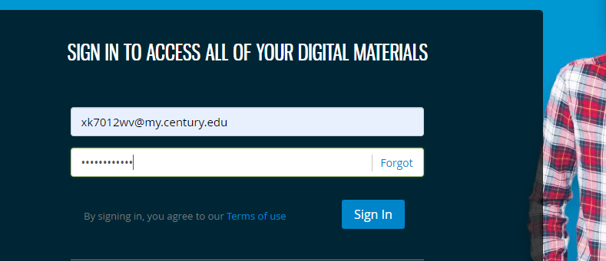

- Select Managerial Accounting Course
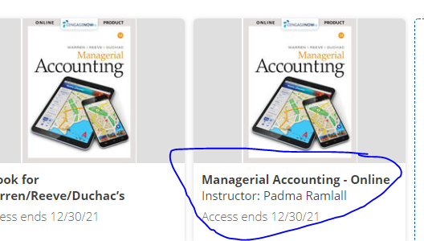

- Complete the rest of Chapter 3 Homework

